Top 10 Best Electric Trolling Motors in 2018
When you go fishing
You do not want to be in a boat that is traveling so fast that you can’t catch any fish. That is why a good trolling motor is vital to your fishing experience. Using one of the top 10 best electric trolling motors in 2018 is a smart move.
They will make sure your boat will go at the proper speed without harming the environment.
Our Electric Trolling Motor Review
#10. Newport Vessels Kayak Series Trolling Motor
Click here
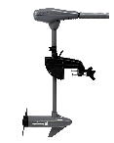
The 24-inch shaft gives you enough room to attach this motor to your boat. Then the 8 speeds ensure that you can find the right speed for your fishing purpose. Its 6-inch adjustable handle handles the 5 forward and 3 reverse speeds.
You also get a 5 ½ foot battery cable. This allows you to place the battery in a safe spot. The aluminum and steel construction allow for salt water use. This trolling motor is durable and will meet your expectations.
#9. Cloud Mountain LBS Thrust Electric Trolling Motor
Click here
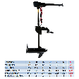
With 5 forward and 3 reverse speeds you should be able to use this 8-speed trolling motor at the speed you want. Then an LED light indicator lets you know how much power you have left in your battery.
The nylon bracket is versatile enough to attach to a variety of fishing boats or other water craft. Its adjustable handle keeps you in control of your speed and your direction. The fiberglass and aluminum construction is corrosion resistant and keeps the motor durable and long lasting.
#8. Newport Vessels Kayak Series Electric Trolling Motor
Click here
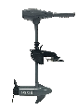
With its 8 speeds, you get 55 pounds of thrust to propel your boat through the water safely. Then the aluminum and magnesium construction allow you to take this motor into saltwater with few problems. Also, its 6-inch adjustable handle leaves you in control of your boat and motor.
The 24” fiberglass shaft is strong and durable. It is versatile enough to attach to a variety of water craft. Plus, the extra long battery cable keeps your battery in a safe location as you fish.
#7. Motorguide Bow Mount Motor
Click here
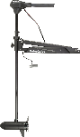
You get a quiet motor with a 3-pronged prop propelling you through the water at just the right speed. The adjustable handle makes sure you have total control over the motor and your boat.
Its composite constructed shaft is durable and should last you a long time. This trolling motor is designed for fresh water only. Then it will give you about 45 pounds of thrust. A foot control leaves your hands free to fish and get that fish out of the water.
#6. SEAMAX 12V Electric Trolling Motor
Click here
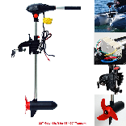
65 pounds of thrust coming from a 12v motor on a 32-inch shaft. That is more than enough power on this compact trolling motor. Its anti-theft mount has 7 adjustable settings for better trolling.
Then its 8 speeds give you the options you need to fish correctly. Also, the powder coated steel and aluminum makes this trolling motor perfect for both fresh and salt water. All the control is in the adjustable handle. You stay in control of everything as you fish.
#5. Goplus Electric Trolling Motor
Click here
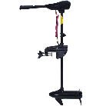
You get variable thrust from this electric trolling motor. The 6-inch adjustable handle lets you select the amount of thrust you need. Then the 5 forward and 3 reverse speeds gives you the options to use when fishing.
Its 3-blade propeller is designed to handle underwater grass and marsh like conditions with little problem. A nylon bracket holds the motor securely to your boat. Its 10-point LED battery indicator lets you know how much power you have left.
#4. Minn Kota Endura Max Trolling Motor
Click here
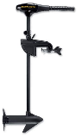
Its versatility is one of its attractive features. It should fit on a variety of boats with ease. Then it variable speeds should provide you with the options you need to catch all the fish you want. Its nylon bracket will keep the motor securely in place on your favorite fishing vessel.
It is powerful enough to move a lot of weight. Then the propeller is designed to help you remove any weeds or grass easily.
#3. Newport Vessels Saltwater Electric Trolling Motor
Click here
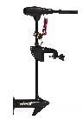
The LED light battery indicator may be your best friend out on the water. It will let you know if you have enough power to make it back to shore or not. Then this 8-speed motor has an adjustable handle which helps you navigate the 5 forward and 3 reverse gears.
A 30-inch shaft keeps the motor flexible and versatile. It should fit any number of fishing boats. It is also saltwater compatible.
#2. Newport Vessels 8 Speed Trolling Motor
Click here
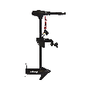
Like most models from this company, this 55-pound thrust trolling motor comes with standard equipment. You get a 30-inch shaft, 8 speeds, 5 forward and 3 reverse, an LED battery light indicator and more.
Plus, you stay in control of everything with its adjustable handle. The trolling motor is also compatible with both fresh and saltwater use. Its 3-pronged prop is designed to keep the weeds off.
#1. Newport Vessels Electric Trolling Motor
Click here
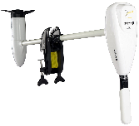
Don’t let the white color fool you. This trolling motor will produce 62 pounds of thrust. Made from stainless steel, this motor is rated for salt water fishing. It also has 8 speeds, a 40-inch shaft and a nylon bracket to keep it secure.
Its 10-inch prop provides you with the power you need to move quickly through the water. The Led light indicator also lets you know when you are running out of power.
Some Final Words
When you go fishing, you need one less worry to distract your mind. That is why using one of the top 10 best electric trolling motors in 2018 is so vital. Using one of the best of the best allows you to concentrate on your fishing and not on your motor

