Title: 5 Fashion Trends to Try This Season
Meta Description: From bold prints to statement accessories, these 5 fashion trends are sure to make a statement this season. Discover how to add comfort and style to your wardrobe!
Keywords: fashion trends, bold prints, statement accessories, oversized blazers, neon colors, wide-leg pants, chic, stylish, sophisticated, effortless.

5 Fashion Trends to Try This Season

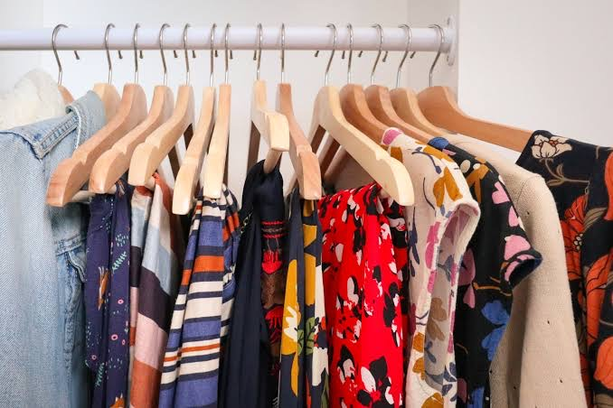

As the seasons change, so do the latest fashion trends. This season, there are a few key trends that are dominating the runway and the streets. From bold prints to statement accessories, these trends are sure to make a statement. Here are 5 fashion trends to try this season:

Bold Prints

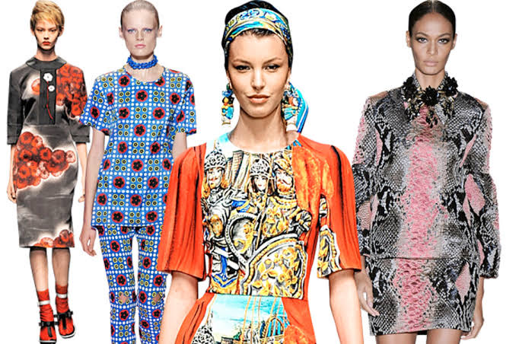

This season, bold prints are in. From animal prints to abstract patterns, bold prints are the perfect way to make a statement. Pair a bold printed blouse with a simple skirt or pants for a chic and stylish look.

Statement Accessories

Accessories are the perfect way to add a pop of color and personality to any outfit. This season, statement earrings and necklaces are in. Choose a bold pair of earrings or a chunky necklace to add some flair to your look.

Oversized Blazers

Oversized blazers are a great way to add some structure and sophistication to any outfit. This season, try pairing an oversized blazer with a simple dress or jeans and a t-shirt for a chic and effortless look.

Neon Colors

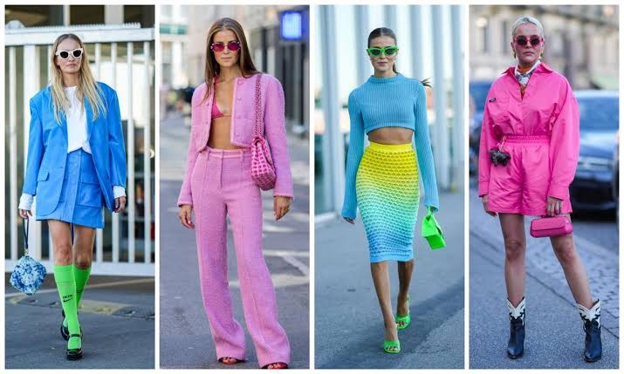

Neon colors are back in a big way this season. From bright greens to bold pinks, neon colors are the perfect way to add some fun and excitement to your wardrobe. Pair a neon blouse or skirt with neutral pieces for a balanced and stylish look.

Wide-Leg Pants

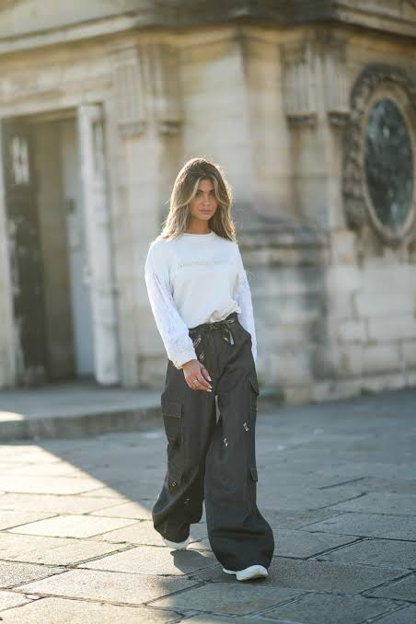

Wide-leg pants are a great way to add some comfort and style to your wardrobe. This season, try pairing wide-leg pants with a simple blouse or t-shirt for a chic and effortless look.

Conclusion

These are the top 5 fashion trends to try this season. Whether you prefer bold prints, statement accessories, oversized blazers, neon colors or wide-leg pants, there's a trend for everyone. So go ahead and try something new this season - you may just fall in love with a new style!

