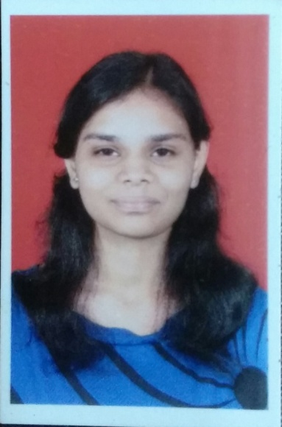
Priyanka Kiran Shirodkar
Address: 2-2-1148, New Nallakunta, Renuka Apartments,
Hyderabad-500044
Cell: (+91)-9700778816 Landline: (040)-27565626
Email: priyankashirodkar18gmail.com Date of Birth: 18th February 1995
Objective:
To take a challenging role on business operations and give an efficient and effective solution that would help the organization to achieve the best solution in business which would increase its productivity in market.
Education:
Year/Month Of Passing | Qualification | Percentage Secured
May 2016 | B.E. (ECE)  Methodist College of Engineering and Technology,  Affiliated to Osmania University, Telangana | Distinction
March 2012 | HSC Board  Board of Intermediate Education, A.P. | 88.2%
March 2010 | SSC Board  St. Paul’s High School,  Hyderabad. | 92%

Certification Courses:
- Java SE 7 Programming
[As part of Oracle’s Workforce Development Program, Oracle University]
- ‘C’ language, MS-Office, Flash-MX, Web Designing
[Training under Dept. of Computer Science, St. Paul’s High School, Hyderabad]
- Cambridge Young Learners English Starters (YLE Starters)
[University of Cambridge, Local Examinations Syndicate, Chennai]
- In-House Training Program on PCB Designing and Testing Organised by Department of ECE, MCET, Hyderabad
Professional Affiliations:
Member of IEEE (Dec’14 onwards)
Member of IEEE-Signal Processing Society (IEEE SPS)
Member of IEEE-Communications Society (IEEE ComSoc)
Member of Women in Engineering, Affinity Group (IEEE WIE, AG), Hyderabad Section
Participation Certifications:
- First IEEE Communications Colloquium, organised by IEEE COMSOC/SP JOINT CHAPTER-HYDERABAD SECTION
- Workshop on Advances in Video Processing and Applications, B.I.T.S., Hyderabad Campus
- Section Student Congress’14 organised by IEEE Hyderabad Section Student Network
- Mini Project Exhibition at a National level Technical Symposium
- “The Motherhood Walkathon” part of Limca Book of Records
- Montryst-2009, XVII Montfort Literary & Cultural Festival, Vijayawada
- Tata-Tea Outlook Speak Out Debate Competition
Other Achievements:
- Organised the Methodist Bicycle Ride Event at Hyderabad
- Served as a Public Relations Ambassador for IEEEXtreme 9.0 Programming competition that hosted 6,414 participants on 24th Oct’15
- Project Intern at DRDL (Defence Research and Development Laboratory) since August’15
- Volunteered for the Online Quiz under WIE-AG, IEEE Hyderabad Section held on 27th Feb'14
- Content Writer for the WIE e-Newsletter - WIE-ZINE by WIE-AG of IEEE Hyderabad Section
- Certificate of Merit in SSC Public Examination, March/April-2010 for securing 92 marks in English
- Awarded for securing fourth place in a State Level Debate Competition under Seniors Category
- Certificate of General Proficiency during the academic year 2000-01 & 2004-05
- Certificate of Merit at a Talent Search Competition in Hindi Essay Writing Competition for the year 2006-07
- Secured First Place in English & Hindi Debate Talent Search Competition for the years 2007-08 & 2008-09 respectively
- Appeared for Akhila Bharatiya Gandharva Mahavidyalaya Mandal’s Vocal Examination, Nov’06, Mumbai
Language Proficiency:
English, Hindi, Telugu, Marathi

Declaration:
I, Priyanka Kiran Shirodkar hereby declare that the above furnished detail is true according to the best of my knowledge.

