Name: Hema Malini B
Designation: Data Analyst
Google Analytics Data Studio Reports
- Xataka Data Studio Report
  - Page 1
  - Page 2
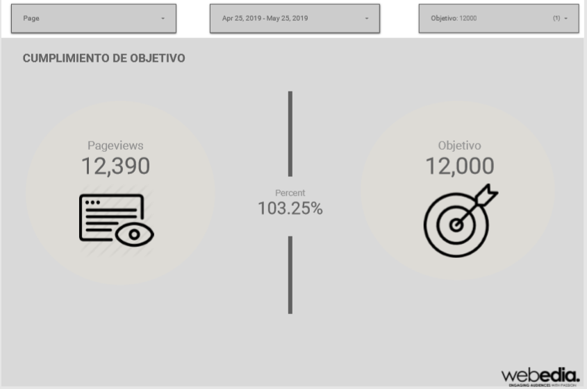

  - Page 3
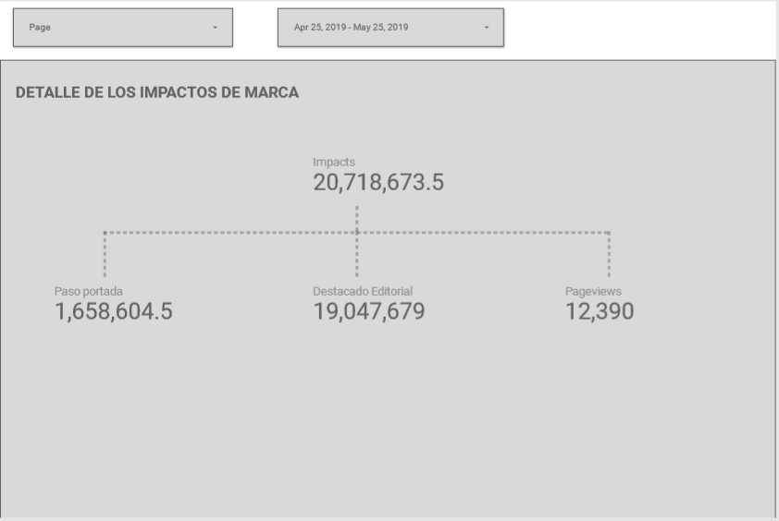
  - Page 4
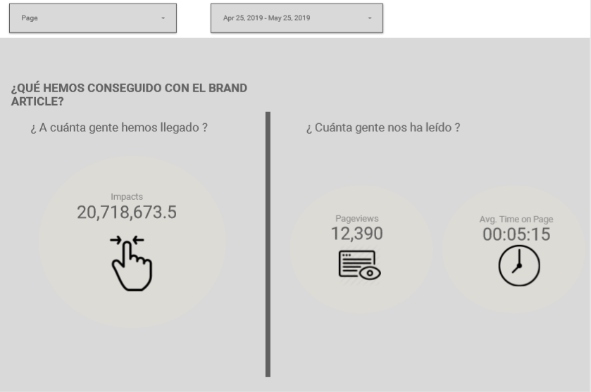

  - Page 5
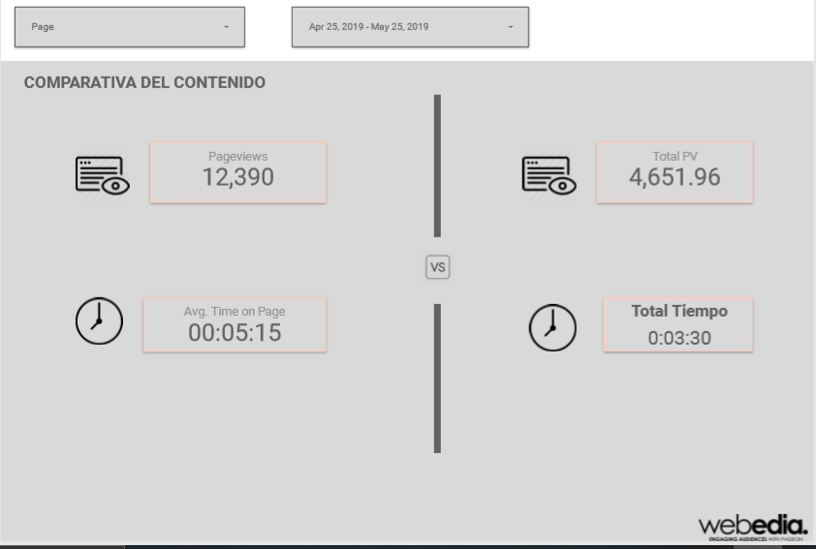

- App Script Sample
var startDate = '';
var pagePath = '';
var results = '';
var profileId = '';
var tableId = '';
var index = 0;
var sheet = '';
function runDemo() {

try {
clearSheets()
var data_sheet = SpreadsheetApp.getActive().getSheetByName('Input');
for (index = 2; index<=10; ++index) {
check_value = 'A'+index;
profileId = data_sheet.getRange(check_value).getValue();
if(profileId != '') {
results = getReportDataForProfilePP(index);
outputToSpreadsheetPP(index,results);

results = getReportDataForProfileDE(index);
outputToSpreadsheetDE(index,results);

/*results = getReportDataForProfilePD(index);
outputToSpreadsheetPD(index,results);

results = getReportDataForProfileAVT(index);
outputToSpreadsheetPD(index,results);*/
// Set Up the query arguments

check_value = 'A'+index;
profileId = SpreadsheetApp.getActive().getSheetByName('Input').getRange(check_value).getValue();

var tableId = 'ga:' + profileId;

check_value = 'B'+index;
var sDate = new Date(SpreadsheetApp.getActive().getSheetByName('Input').getRange(check_value).getValue());
startDate = Utilities.formatDate(sDate, 'GMT+02:00', 'yyyy-MM-dd');

check_value = 'C'+index;
var eDate = new Date(SpreadsheetApp.getActive().getSheetByName('Input').getRange(check_value).getValue());
var endDate = Utilities.formatDate(eDate, 'GMT+02:00', 'yyyy-MM-dd');

check_value = 'F'+index;
pagePath = SpreadsheetApp.getActive().getSheetByName('Input').getRange(check_value).getValue();

var metrics = ['ga:pageviews,ga:avgTimeOnPage,ga:bounceRate'];
var options = {
'dimensions': 'ga:PagePath',
'filters': 'ga:PagePath=@'+pagePath,
'sort': '-ga:pageviews',
//'segment': '',
'samplingLevel': 'HIGHER_PRECISION',
'max-results': '5' // To limit the results to 5. Maximum number of results: 10000
}

// Fetch the report
var report = gaGet(tableId, startDate, endDate, metrics, options);
var data = report.rows;

var current_sheet = SpreadsheetApp.getActive().getSheetByName('PageData');

// Get the range to write and write the results
var writeRange = current_sheet.getRange(index, 1, data.length, data[0].length) // Read reference for getRange arguments
writeRange.setValues(data);

}
}
} catch(error) {
throw new Error(error);

}
}

function clearSheets() {
sheet = SpreadsheetApp.getActive().getSheetByName('PasoPorPortada');
sheet.clear();
sheet = SpreadsheetApp.getActive().getSheetByName('DestacadoEditorial');
sheet.clear();
sheet = SpreadsheetApp.getActive().getSheetByName('PageData');
sheet.clear();
sheet = SpreadsheetApp.getActive().getSheetByName('AverageTimeOnPage');
sheet.clear();
}

/************************** Paso Por Portada Start ********************************/
function getReportDataForProfilePP(index) {
var check_value = '';
check_value = 'A'+index;
profileId = SpreadsheetApp.getActive().getSheetByName('Input').getRange(check_value).getValue();

tableId = 'ga:' + profileId;

check_value = 'B'+index;
var sDate = new Date(SpreadsheetApp.getActive().getSheetByName('Input').getRange(check_value).getValue());
startDate = Utilities.formatDate(sDate, 'GMT+1:00', 'yyyy-MM-dd');

check_value = 'D'+index;
var eDate = new Date(SpreadsheetApp.getActive().getSheetByName('Input').getRange(check_value).getValue());
var endDate = Utilities.formatDate(eDate, 'GMT+1:00', 'yyyy-MM-dd');

var optArgs = {
'dimensions': '', // Comma separated list of dimensions.
'metrics': 'ga:pageviews',
'sort': 'ga:pageviews', // Sort by sessions descending, then keyword.
'filters': 'ga:pagepath==/;ga:country=@spain', // Display only google traffic.
'max-results': '250' // Display the first 250 results.
};

// Make a request to the API.
results = Analytics.Data.Ga.get(
tableId, // Table id (format ga:xxxxxx).
startDate, // Start-date (format yyyy-MM-dd).
endDate, // End-date (format yyyy-MM-dd).
'ga:pageviews', // Comma seperated list of metrics.
optArgs);

if (results.getRows()) {
return results;

} else {
throw new Error('No views (profiles) found');
}
}

function outputToSpreadsheetPP(index,results) {
var check_value = '';
var resultVar = 0;
var sheet = SpreadsheetApp.getActive().getSheetByName('PasoPorPortada');

var cell = sheet.getRange("A1");
cell.setValue("Date");
var cell = sheet.getRange("B1");
cell.setValue("PasoPorPortado");

check_value = 'A'+index;
var cell = sheet.getRange(check_value);
cell.setValue(startDate);
resultVar = resultVar + results.getRows();
check_value = 'B'+index;
var cell = sheet.getRange(check_value);
cell.setValue(resultVar);
}
/************************** Paso Por Portada End ********************************/

/************************** Destacado Editorial Start ***************************/
function getReportDataForProfileDE(index) {
var check_value = '';
check_value = 'A'+index;
profileId = SpreadsheetApp.getActive().getSheetByName('Input').getRange(check_value).getValue();

var tableId = 'ga:' + profileId;

check_value = 'B'+index;
var sDate = new Date(SpreadsheetApp.getActive().getSheetByName('Input').getRange(check_value).getValue());
startDate = Utilities.formatDate(sDate, 'GMT+1:00', 'yyyy-MM-dd');

check_value = 'E'+index;
var eDate = new Date(SpreadsheetApp.getActive().getSheetByName('Input').getRange(check_value).getValue());
var endDate = Utilities.formatDate(eDate, 'GMT+1:00', 'yyyy-MM-dd');

var optArgs = {
'dimensions': '', // Comma separated list of dimensions.
'metrics': 'ga:pageviews',
'sort': 'ga:pageviews', // Sort by sessions descending, then keyword.
'filters': 'ga:country=@spain;ga:pagepath!@/quienes-somos;ga:pagepath!@/autor;ga:pagepath!@/respuestas',
'max-results': '250' // Display the first 250 results.
};

// Make a request to the API.
var results = Analytics.Data.Ga.get(
tableId, // Table id (format ga:xxxxxx).
startDate, // Start-date (format yyyy-MM-dd).
endDate, // End-date (format yyyy-MM-dd).
'ga:pageviews', // Comma seperated list of metrics.
optArgs);

if (results.getRows()) {
return results;

} else {
throw new Error('No views (profiles) found');
}
}

function outputToSpreadsheetDE(index,results) {
var resultVar = 0;
var check_value = '';
var sheet = SpreadsheetApp.getActive().getSheetByName('DestacadoEditorial');
//sheet.clear();

var cell = sheet.getRange("A1");
cell.setValue("Date");
var cell = sheet.getRange("B1");
cell.setValue("DestacadoEditorial");

check_value = 'A'+index;
var cell = sheet.getRange(check_value);
cell.setValue(startDate);
resultVar = resultVar + results.getRows();
check_value = 'B'+index;
var cell = sheet.getRange(check_value);
cell.setValue(resultVar);
}
/************************** Destacado Editorial End ***************************/

/************************** Page Data Start ***********************************/
function getReportDataForProfilePD(index) {
var check_value = '';
check_value = 'A'+index;
profileId = SpreadsheetApp.getActive().getSheetByName('Input').getRange(check_value).getValue();

var tableId = 'ga:' + profileId;

check_value = 'B'+index;
var sDate = new Date(SpreadsheetApp.getActive().getSheetByName('Input').getRange(check_value).getValue());
startDate = Utilities.formatDate(sDate, 'GMT+02:00', 'yyyy-MM-dd');

check_value = 'C'+index;
var eDate = new Date(SpreadsheetApp.getActive().getSheetByName('Input').getRange(check_value).getValue());
var endDate = Utilities.formatDate(eDate, 'GMT+02:00', 'yyyy-MM-dd');

check_value = 'F'+index;
pagePath = SpreadsheetApp.getActive().getSheetByName('Input').getRange(check_value).getValue();

var optArgs = {
'dimensions': 'ga:hostname', // Comma separated list of dimensions.
'metrics': 'ga:pageviews',
'sort': 'ga:pageviews', // Sort by sessions descending, then keyword.
'filters': 'ga:PagePath=@'+pagePath,
'max-results': '250' // Display the first 250 results.
};

// Make a request to the API.
var results = Analytics.Data.Ga.get(
tableId, // Table id (format ga:xxxxxx).
startDate, // Start-date (format yyyy-MM-dd).
endDate, // End-date (format yyyy-MM-dd).
'ga:pageviews', // Comma seperated list of metrics.
optArgs);

if (results.getRows()) {
return results;

} else {
throw new Error('No views (profiles) found');
}
}

function outputToSpreadsheetPD(index,results) {
var check_value = '';
var sheet = SpreadsheetApp.getActive().getSheetByName('PageData');

var headerNames = [];
for (var i = 0, header; header = results.getColumnHeaders()[i]; ++i) {
headerNames.push(header.getName());
}
sheet.getRange(1, 1, 1, headerNames.length)
.setValues([headerNames]);

sheet.getRange(index, 1, results.getRows().length, headerNames.length)
.setValues( results.getRows());
}
/************************** Page Data End ***********************************/

/************************** Average Time on Page Start ***********************************/
function getReportDataForProfileAVT(index) {
var check_value = '';
check_value = 'A'+index;
profileId = SpreadsheetApp.getActive().getSheetByName('Input').getRange(check_value).getValue();

var tableId = 'ga:' + profileId;

check_value = 'B'+index;
var sDate = new Date(SpreadsheetApp.getActive().getSheetByName('Input').getRange(check_value).getValue());
startDate = Utilities.formatDate(sDate, 'GMT+02:00', 'yyyy-MM-dd');

check_value = 'C'+index;
var eDate = new Date(SpreadsheetApp.getActive().getSheetByName('Input').getRange(check_value).getValue());
var endDate = Utilities.formatDate(eDate, 'GMT+02:00', 'yyyy-MM-dd');

check_value = 'F'+index;
pagePath = SpreadsheetApp.getActive().getSheetByName('Input').getRange(check_value).getValue();

var optArgs = {
'dimensions': 'ga:PagePath', // Comma separated list of dimensions.
'metrics': 'ga:avgTimeOnPage',
'sort': 'ga:avgTimeOnPage', // Sort by sessions descending, then keyword.
'filters': 'ga:PagePath=@'+pagePath,
'max-results': '250' // Display the first 250 results.
};

// Make a request to the API.
var results = Analytics.Data.Ga.get(
tableId, // Table id (format ga:xxxxxx).
startDate, // Start-date (format yyyy-MM-dd).
endDate, // End-date (format yyyy-MM-dd).
'ga:avgTimeOnPage', // Comma seperated list of metrics.
optArgs);

if (results.getRows()) {
return results;

} else {
throw new Error('No views (profiles) found');
}
}

function outputToSpreadsheetAVT(index,results) {
var check_value = '';
var sheet = SpreadsheetApp.getActive().getSheetByName('AverageTimeOnPage');

var headerNames = [];
for (var i = 0, header; header = results.getColumnHeaders()[i]; ++i) {
headerNames.push(header.getName());
}
sheet.getRange(1, 1, 1, headerNames.length)
.setValues([headerNames]);

sheet.getRange(index, 1, results.getRows().length, headerNames.length)
.setValues( results.getRows());
}
/************************** Page Data End ***********************************/

function gaGet(tableId, startDate, endDate, metrics, options) {
// Apply standard options
options = options || {};
options['max-results'] = options['max-results'] || '10000';
// If errors persist up to 5 times then terminate the program.
for (var i = 0; i < 5; i++) {
try {
return Analytics.Data.Ga.get(tableId, startDate, endDate, metrics, options); // 503
} catch (err) {
// https://developers.google.com/analytics/devguides/reporting/core/v3/coreErrors
if (err.message.indexOf('a server error occurred') > -1) {
Logger.log('Backend Error');
// Note: Don't listen to Google's reply and retry request after 2 minutes
Utilities.sleep(2 * 60 * 1000);
} else if (err.message.indexOf('User Rate') > -1) {
Logger.log('Rate Limit Error');
// Exponential Backoff
Utilities.sleep(1000 * Math.pow((i + 1), 2));
} else if (err.message.indexOf('too many concurrent connections') > -1) {
Logger.log('Concurrent Connections Error');
// Exponential Backoff
Utilities.sleep(1000 * Math.pow((i + 1), 2));
} else {
Logger.log(err);
throw err;
}
}
}
throw 'Error. Max retries reached';
}

