Name: Hema Malini B
Designation: Data Analyst
Google Analytics Data Studio Reports
- Xataka Data Studio Report
  - Page 1
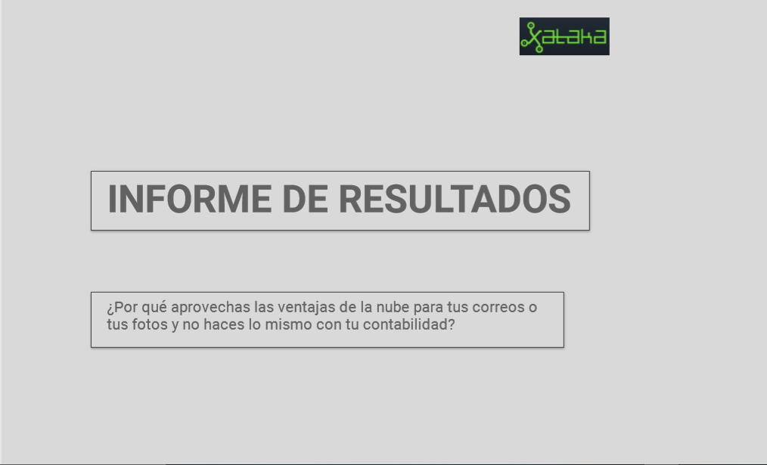
  - Page 2
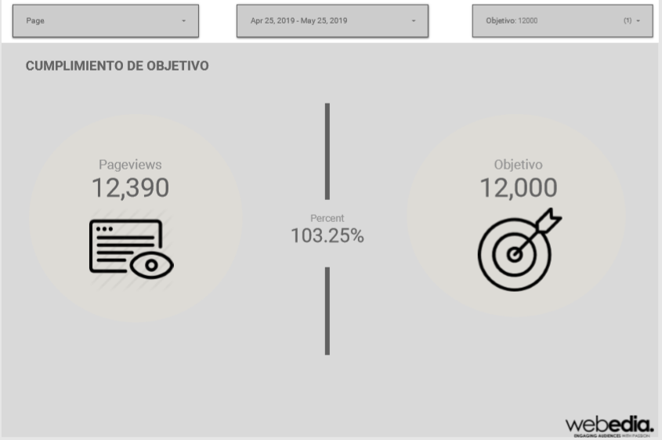

  - Page 3
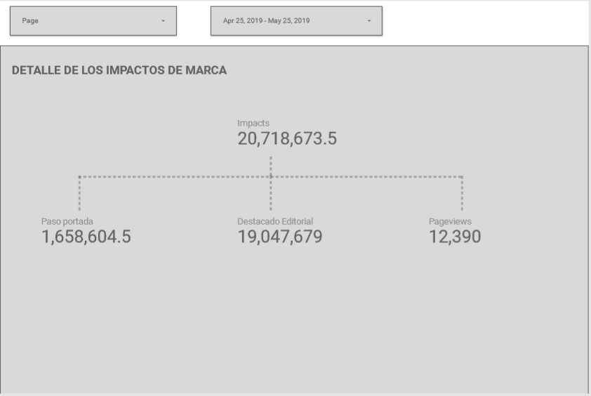
  - Page 4
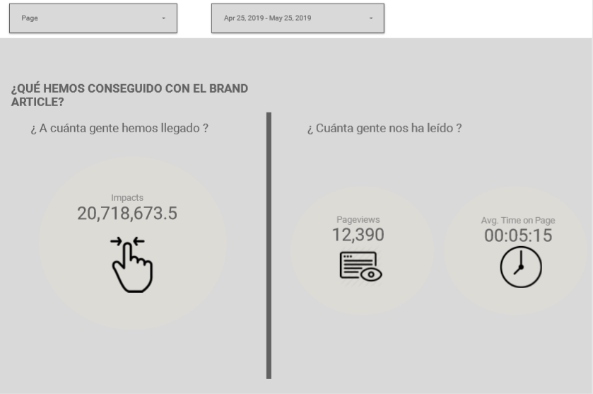

  - Page 5
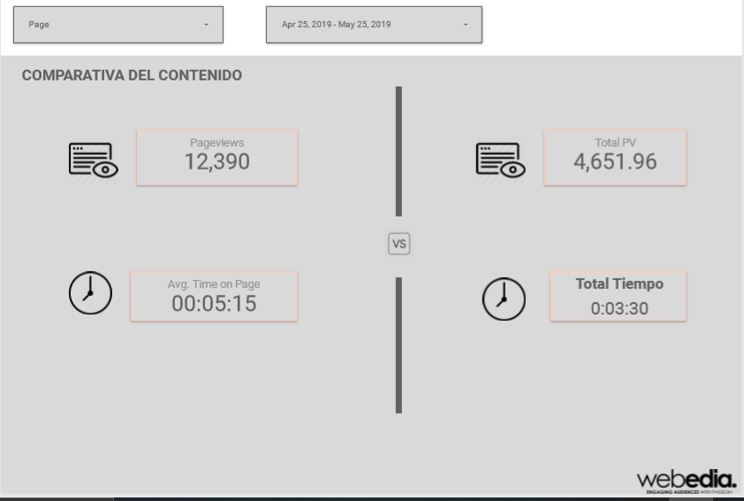

- App Script Sample
var startDate = '';
var pagePath = '';
var results = '';
var profileId = '';
var tableId = '';
var index = 0;
var sheet = '';
function runDemo() {

try {
clearSheets()
var data_sheet = SpreadsheetApp.getActive().getSheetByName('Input');
for (index = 2; index<=10; ++index) {
check_value = 'A'+index;
profileId = data_sheet.getRange(check_value).getValue();
if(profileId != '') {
results = getReportDataForProfilePP(index);
outputToSpreadsheetPP(index,results);

results = getReportDataForProfileDE(index);
outputToSpreadsheetDE(index,results);

/*results = getReportDataForProfilePD(index);
outputToSpreadsheetPD(index,results);

results = getReportDataForProfileAVT(index);
outputToSpreadsheetPD(index,results);*/
// Set Up the query arguments

check_value = 'A'+index;
profileId = SpreadsheetApp.getActive().getSheetByName('Input').getRange(check_value).getValue();

var tableId = 'ga:' + profileId;

check_value = 'B'+index;
var sDate = new Date(SpreadsheetApp.getActive().getSheetByName('Input').getRange(check_value).getValue());
startDate = Utilities.formatDate(sDate, 'GMT+02:00', 'yyyy-MM-dd');

check_value = 'C'+index;
var eDate = new Date(SpreadsheetApp.getActive().getSheetByName('Input').getRange(check_value).getValue());
var endDate = Utilities.formatDate(eDate, 'GMT+02:00', 'yyyy-MM-dd');

check_value = 'F'+index;
pagePath = SpreadsheetApp.getActive().getSheetByName('Input').getRange(check_value).getValue();

var metrics = ['ga:pageviews,ga:avgTimeOnPage,ga:bounceRate'];
var options = {
'dimensions': 'ga:PagePath',
'filters': 'ga:PagePath=@'+pagePath,
'sort': '-ga:pageviews',
//'segment': '',
'samplingLevel': 'HIGHER_PRECISION',
'max-results': '5' // To limit the results to 5. Maximum number of results: 10000
}

// Fetch the report
var report = gaGet(tableId, startDate, endDate, metrics, options);
var data = report.rows;

var current_sheet = SpreadsheetApp.getActive().getSheetByName('PageData');

// Get the range to write and write the results
var writeRange = current_sheet.getRange(index, 1, data.length, data[0].length) // Read reference for getRange arguments
writeRange.setValues(data);

}
}
} catch(error) {
throw new Error(error);

}
}

function clearSheets() {
sheet = SpreadsheetApp.getActive().getSheetByName('PasoPorPortada');
sheet.clear();
sheet = SpreadsheetApp.getActive().getSheetByName('DestacadoEditorial');
sheet.clear();
sheet = SpreadsheetApp.getActive().getSheetByName('PageData');
sheet.clear();
sheet = SpreadsheetApp.getActive().getSheetByName('AverageTimeOnPage');
sheet.clear();
}

/************************** Paso Por Portada Start ********************************/
function getReportDataForProfilePP(index) {
var check_value = '';
check_value = 'A'+index;
profileId = SpreadsheetApp.getActive().getSheetByName('Input').getRange(check_value).getValue();

tableId = 'ga:' + profileId;

check_value = 'B'+index;
var sDate = new Date(SpreadsheetApp.getActive().getSheetByName('Input').getRange(check_value).getValue());
startDate = Utilities.formatDate(sDate, 'GMT+1:00', 'yyyy-MM-dd');

check_value = 'D'+index;
var eDate = new Date(SpreadsheetApp.getActive().getSheetByName('Input').getRange(check_value).getValue());
var endDate = Utilities.formatDate(eDate, 'GMT+1:00', 'yyyy-MM-dd');

var optArgs = {
'dimensions': '', // Comma separated list of dimensions.
'metrics': 'ga:pageviews',
'sort': 'ga:pageviews', // Sort by sessions descending, then keyword.
'filters': 'ga:pagepath==/;ga:country=@spain', // Display only google traffic.
'max-results': '250' // Display the first 250 results.
};

// Make a request to the API.
results = Analytics.Data.Ga.get(
tableId, // Table id (format ga:xxxxxx).
startDate, // Start-date (format yyyy-MM-dd).
endDate, // End-date (format yyyy-MM-dd).
'ga:pageviews', // Comma seperated list of metrics.
optArgs);

if (results.getRows()) {
return results;

} else {
throw new Error('No views (profiles) found');
}
}

function outputToSpreadsheetPP(index,results) {
var check_value = '';
var resultVar = 0;
var sheet = SpreadsheetApp.getActive().getSheetByName('PasoPorPortada');

var cell = sheet.getRange("A1");
cell.setValue("Date");
var cell = sheet.getRange("B1");
cell.setValue("PasoPorPortado");

check_value = 'A'+index;
var cell = sheet.getRange(check_value);
cell.setValue(startDate);
resultVar = resultVar + results.getRows();
check_value = 'B'+index;
var cell = sheet.getRange(check_value);
cell.setValue(resultVar);
}
/************************** Paso Por Portada End ********************************/

/************************** Destacado Editorial Start ***************************/
function getReportDataForProfileDE(index) {
var check_value = '';
check_value = 'A'+index;
profileId = SpreadsheetApp.getActive().getSheetByName('Input').getRange(check_value).getValue();

var tableId = 'ga:' + profileId;

check_value = 'B'+index;
var sDate = new Date(SpreadsheetApp.getActive().getSheetByName('Input').getRange(check_value).getValue());
startDate = Utilities.formatDate(sDate, 'GMT+1:00', 'yyyy-MM-dd');

check_value = 'E'+index;
var eDate = new Date(SpreadsheetApp.getActive().getSheetByName('Input').getRange(check_value).getValue());
var endDate = Utilities.formatDate(eDate, 'GMT+1:00', 'yyyy-MM-dd');

var optArgs = {
'dimensions': '', // Comma separated list of dimensions.
'metrics': 'ga:pageviews',
'sort': 'ga:pageviews', // Sort by sessions descending, then keyword.
'filters': 'ga:country=@spain;ga:pagepath!@/quienes-somos;ga:pagepath!@/autor;ga:pagepath!@/respuestas',
'max-results': '250' // Display the first 250 results.
};

// Make a request to the API.
var results = Analytics.Data.Ga.get(
tableId, // Table id (format ga:xxxxxx).
startDate, // Start-date (format yyyy-MM-dd).
endDate, // End-date (format yyyy-MM-dd).
'ga:pageviews', // Comma seperated list of metrics.
optArgs);

if (results.getRows()) {
return results;

} else {
throw new Error('No views (profiles) found');
}
}

function outputToSpreadsheetDE(index,results) {
var resultVar = 0;
var check_value = '';
var sheet = SpreadsheetApp.getActive().getSheetByName('DestacadoEditorial');
//sheet.clear();

var cell = sheet.getRange("A1");
cell.setValue("Date");
var cell = sheet.getRange("B1");
cell.setValue("DestacadoEditorial");

check_value = 'A'+index;
var cell = sheet.getRange(check_value);
cell.setValue(startDate);
resultVar = resultVar + results.getRows();
check_value = 'B'+index;
var cell = sheet.getRange(check_value);
cell.setValue(resultVar);
}
/************************** Destacado Editorial End ***************************/

/************************** Page Data Start ***********************************/
function getReportDataForProfilePD(index) {
var check_value = '';
check_value = 'A'+index;
profileId = SpreadsheetApp.getActive().getSheetByName('Input').getRange(check_value).getValue();

var tableId = 'ga:' + profileId;

check_value = 'B'+index;
var sDate = new Date(SpreadsheetApp.getActive().getSheetByName('Input').getRange(check_value).getValue());
startDate = Utilities.formatDate(sDate, 'GMT+02:00', 'yyyy-MM-dd');

check_value = 'C'+index;
var eDate = new Date(SpreadsheetApp.getActive().getSheetByName('Input').getRange(check_value).getValue());
var endDate = Utilities.formatDate(eDate, 'GMT+02:00', 'yyyy-MM-dd');

check_value = 'F'+index;
pagePath = SpreadsheetApp.getActive().getSheetByName('Input').getRange(check_value).getValue();

var optArgs = {
'dimensions': 'ga:hostname', // Comma separated list of dimensions.
'metrics': 'ga:pageviews',
'sort': 'ga:pageviews', // Sort by sessions descending, then keyword.
'filters': 'ga:PagePath=@'+pagePath,
'max-results': '250' // Display the first 250 results.
};

// Make a request to the API.
var results = Analytics.Data.Ga.get(
tableId, // Table id (format ga:xxxxxx).
startDate, // Start-date (format yyyy-MM-dd).
endDate, // End-date (format yyyy-MM-dd).
'ga:pageviews', // Comma seperated list of metrics.
optArgs);

if (results.getRows()) {
return results;

} else {
throw new Error('No views (profiles) found');
}
}

function outputToSpreadsheetPD(index,results) {
var check_value = '';
var sheet = SpreadsheetApp.getActive().getSheetByName('PageData');

var headerNames = [];
for (var i = 0, header; header = results.getColumnHeaders()[i]; ++i) {
headerNames.push(header.getName());
}
sheet.getRange(1, 1, 1, headerNames.length)
.setValues([headerNames]);

sheet.getRange(index, 1, results.getRows().length, headerNames.length)
.setValues( results.getRows());
}
/************************** Page Data End ***********************************/

/************************** Average Time on Page Start ***********************************/
function getReportDataForProfileAVT(index) {
var check_value = '';
check_value = 'A'+index;
profileId = SpreadsheetApp.getActive().getSheetByName('Input').getRange(check_value).getValue();

var tableId = 'ga:' + profileId;

check_value = 'B'+index;
var sDate = new Date(SpreadsheetApp.getActive().getSheetByName('Input').getRange(check_value).getValue());
startDate = Utilities.formatDate(sDate, 'GMT+02:00', 'yyyy-MM-dd');

check_value = 'C'+index;
var eDate = new Date(SpreadsheetApp.getActive().getSheetByName('Input').getRange(check_value).getValue());
var endDate = Utilities.formatDate(eDate, 'GMT+02:00', 'yyyy-MM-dd');

check_value = 'F'+index;
pagePath = SpreadsheetApp.getActive().getSheetByName('Input').getRange(check_value).getValue();

var optArgs = {
'dimensions': 'ga:PagePath', // Comma separated list of dimensions.
'metrics': 'ga:avgTimeOnPage',
'sort': 'ga:avgTimeOnPage', // Sort by sessions descending, then keyword.
'filters': 'ga:PagePath=@'+pagePath,
'max-results': '250' // Display the first 250 results.
};

// Make a request to the API.
var results = Analytics.Data.Ga.get(
tableId, // Table id (format ga:xxxxxx).
startDate, // Start-date (format yyyy-MM-dd).
endDate, // End-date (format yyyy-MM-dd).
'ga:avgTimeOnPage', // Comma seperated list of metrics.
optArgs);

if (results.getRows()) {
return results;

} else {
throw new Error('No views (profiles) found');
}
}

function outputToSpreadsheetAVT(index,results) {
var check_value = '';
var sheet = SpreadsheetApp.getActive().getSheetByName('AverageTimeOnPage');

var headerNames = [];
for (var i = 0, header; header = results.getColumnHeaders()[i]; ++i) {
headerNames.push(header.getName());
}
sheet.getRange(1, 1, 1, headerNames.length)
.setValues([headerNames]);

sheet.getRange(index, 1, results.getRows().length, headerNames.length)
.setValues( results.getRows());
}
/************************** Page Data End ***********************************/

function gaGet(tableId, startDate, endDate, metrics, options) {
// Apply standard options
options = options || {};
options['max-results'] = options['max-results'] || '10000';
// If errors persist up to 5 times then terminate the program.
for (var i = 0; i < 5; i++) {
try {
return Analytics.Data.Ga.get(tableId, startDate, endDate, metrics, options); // 503
} catch (err) {
// https://developers.google.com/analytics/devguides/reporting/core/v3/coreErrors
if (err.message.indexOf('a server error occurred') > -1) {
Logger.log('Backend Error');
// Note: Don't listen to Google's reply and retry request after 2 minutes
Utilities.sleep(2 * 60 * 1000);
} else if (err.message.indexOf('User Rate') > -1) {
Logger.log('Rate Limit Error');
// Exponential Backoff
Utilities.sleep(1000 * Math.pow((i + 1), 2));
} else if (err.message.indexOf('too many concurrent connections') > -1) {
Logger.log('Concurrent Connections Error');
// Exponential Backoff
Utilities.sleep(1000 * Math.pow((i + 1), 2));
} else {
Logger.log(err);
throw err;
}
}
}
throw 'Error. Max retries reached';
}

PYTHON SPSS SAMPLES
- Code Sample
* Encoding: UTF-8.
* Encoding: .
* Encoding: .
* Encoding: .
BEGIN PROGRAM PYTHON3.
import spss, datetime as dt
v3 = []
v4 = []
v5 = []
v6 = []
modifier = []
i = 1
spss.Submit("INSERT FILE='C:/PPA/MASTER_IMPORT_GENERIC_UNICODE_PROTO.sps'.")
spss.Submit("!MASTER_INPUT group = 11 rvu_year = '17' data_end = '123117' price_end = '123117' generic_limit = 99 .")
from savReaderWriter import *
with SavReader('C:/PPA/G11_SETUP_LABELS_ALL_ACTIVE.SAV', returnHeader=True) as reader:
header = reader.__next__()
for line in reader:
v3_append = str((line[1]).decode('utf-8')) + '_line_' + str(i)
v3.append(v3_append)
v4_append = str((line[2]).decode('utf-8')) + '_line_' + str(i)
v4.append(v4_append)
v5_append = str((line[9]).decode('utf-8')) + '_line_' + str(i)
v5.append(v5_append)
v6_append = str((line[6]).decode('utf-8')) + '_line_' + str(i)
v6.append(v6_append)
modifier_append = str((line[14]).decode('utf-8')) + '_line_' + str(i)
modifier.append(modifier_append)
i = i + 1

from datetime import datetime
try:
import tkinter as tk
from tkinter import ttk
except ImportError:
import Tkinter as tk
import ttk
from tkcalendar import Calendar, DateEntry

def run():
global v3_in,v4_in,v5_in,v6_in,modifier_in, v3_entry_in, v4_entry_in, v5_entry_in, v6_entry_in
v3_in = (str_v3.get()).split('_line_')[1]
v4_in = (str_v4.get()).split('_line_')[1]
v5_in = (str_v5.get()).split('_line_')[1]
v6_in = (str_v6.get()).split('_line_')[1]
modifier_in = (str_modifier.get()).split('_line_')[1]
v3_entry_in = v3_entry.get()
v4_entry_in = v4_entry.get()
v5_entry_in = v5_entry.get()
v6_entry_in = v6_entry.get()
modifier_entry_in = modifier_entry.get()

spss.Submit("GET FILE='C:/PPA/G11_SETUP_LABELS_ALL_ACTIVE.SAV'.")
spss.StartDataStep()
datasetObj = spss.Dataset()
v3_in = int(v3_in) - 1
datasetObj.cases[v3_in,3] = str(v3_entry_in)
v4_in = int(v4_in) - 1
datasetObj.cases[v4_in,4] = str(v4_entry_in)
v5_in = int(v5_in) - 1
datasetObj.cases[v5_in,10] = str(v5_entry_in)
v6_in = int(v6_in) - 1
datasetObj.cases[v6_in,7] = str(v6_entry_in)
modifier_in = int(modifier_in) - 1
datasetObj.cases[modifier_in,15] = float(modifier_entry_in)

str_len = len(datasetObj.cases)
for j in range(0, str_len):
datasetObj.cases[0,3] = '123'
datasetObj.cases[0,4] = '123'
datasetObj.cases[0,10] = '123'
datasetObj.cases[0,7] = '123'
datasetObj.cases[0,15] = 2

mainframe.destroy()
spss.EndDataStep()

spss.Submit("SAVE OUTFILE='C:/PPA/G11_SETUP_LABELS_ALL_ACTIVE.SAV'.")
spss.Submit("INSERT FILE='C:/PPA/MASTER_UPDATE_GENERIC_UNICODE_PROTO.sps'.")
spss.Submit("!MASTER_UPDATE group = 11 rvu_year = '17' data_end = '123117' price_end = '123117' . ")

def cancel():
mainframe.destroy()
exit()

root = tk.Toplevel()
root.withdraw()
root.geometry('1000x500')
root.resizable(width=False, height=False)

root.rowconfigure(0, weight=0)
root.columnconfigure(0, weight=1)
root.update()

# Create a Tkinter variable
mainframe = tk.Frame(root)
mainframe.grid(column=0,row=0, sticky=('N','W','E','S') )
mainframe.columnconfigure(0, weight = 1)
mainframe.rowconfigure(0, weight = 1)
mainframe.pack(pady = 100, padx = 100)

str_v3 = tk.StringVar(root)
popupMenu_v3 = tk.OptionMenu(mainframe, str_v3, *v3)
tk.Label(mainframe, text="Select Primary Provider").grid(row = 1, column = 1)
popupMenu_v3.grid(row = 1, column =2)
# on change dropdown value
def change_dropdown(*args):
print( str_v3.get() )
# link function to change dropdown
str_v3.trace('w', change_dropdown)
tk.Label(mainframe, text='CURRENT_PROVIDER_LABEL', fg="black", font=("Courier", 10)).grid(row=1, column=5)
v3_entry = tk.Entry(mainframe, text='', width=20)
v3_entry.grid(row=1, column=6)

str_v4 = tk.StringVar(root)
popupMenu_v4 = tk.OptionMenu(mainframe, str_v4, *v4)
tk.Label(mainframe, text="Select Supervising Provider").grid(row = 2, column = 1)
popupMenu_v4.grid(row = 2, column =2)
# on change dropdown value
def change_dropdown(*args):
print( str_v4.get() )
# link function to change dropdown
str_v4.trace('w', change_dropdown)
tk.Label(mainframe, text='CURRENT_SUPERVISOR_LABEL', fg="black", font=("Courier", 10)).grid(row=2, column=5)
v4_entry = tk.Entry(mainframe, text='', width=20)
v4_entry.grid(row=2, column=6)

str_v5 = tk.StringVar(root)
popupMenu_v5 = tk.OptionMenu(mainframe, str_v5, *v5)
tk.Label(mainframe, text="Select Location of Service").grid(row = 3, column = 1)
popupMenu_v5.grid(row = 3, column =2)
# on change dropdown value
def change_dropdown(*args):
print( str_v5.get() )
# link function to change dropdown
str_v5.trace('w', change_dropdown)
tk.Label(mainframe, text='CURRENT_LOCATION_LABEL', fg="black", font=("Courier", 10)).grid(row=3, column=5)
v5_entry = tk.Entry(mainframe, text='', width=20)
v5_entry.grid(row=3, column=6)

str_v6 = tk.StringVar(root)
popupMenu_v6 = tk.OptionMenu(mainframe, str_v6, *v6)
tk.Label(mainframe, text="Select Primary Insurance").grid(row = 4, column = 1)
popupMenu_v6.grid(row = 4, column =2)
# on change dropdown value
def change_dropdown(*args):
print( str_v6.get() )
# link function to change dropdown
str_v6.trace('w', change_dropdown)
tk.Label(mainframe, text='CURRENT_INSURANCE_LABEL', fg="black", font=("Courier", 10)).grid(row=4, column=5)
v6_entry = tk.Entry(mainframe, text='', width=20)
v6_entry.grid(row=4, column=6)

str_modifier = tk.StringVar(root)
popupMenu_modifier = tk.OptionMenu(mainframe, str_modifier, *modifier)
tk.Label(mainframe, text="Select Modifier").grid(row = 5, column = 1)
popupMenu_modifier.grid(row = 5, column =2)
# on change dropdown value
def change_dropdown(*args):
print( str_modifier.get() )
# link function to change dropdown
str_modifier.trace('w', change_dropdown)
tk.Label(mainframe, text='CURRENT_MODIFIER_WEIGHT', fg="black", font=("Courier", 10)).grid(row=5, column=5)
modifier_entry = tk.Entry(mainframe, text='', width=20)
modifier_entry.grid(row=5, column=6)

run_button = ttk.Button(mainframe, text="SUBMIT", command=run)
run_button.grid(row=6, column=3, sticky=('N','W','E','S'))
cancel_button = ttk.Button(mainframe, text="CANCEL", command=cancel)
cancel_button.grid(row=6, column=4, sticky=('N','W','E','S'))

mainframe.grid_columnconfigure(6, minsize=120)

root.wm_deiconify()
root.mainloop()
print()

END PROGRAM.
- Output Sample
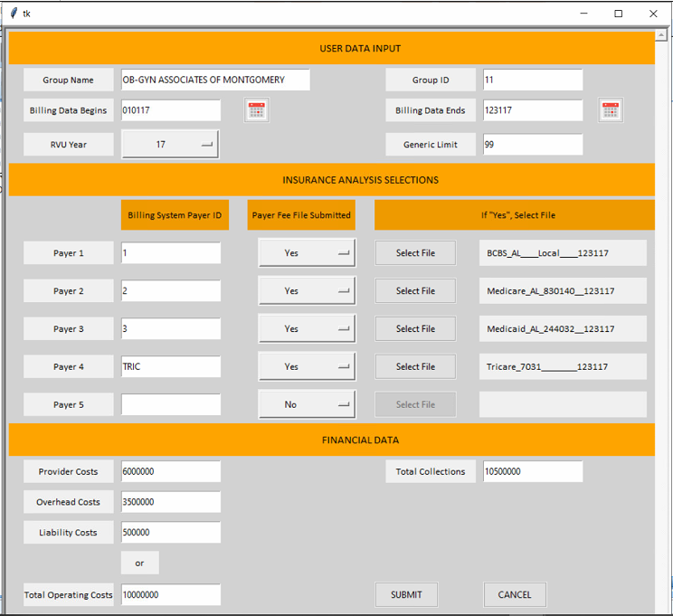

TABLEAU WORK SAMPLES
- Bixi Montreal Rentals: Daily bike rentals Viz
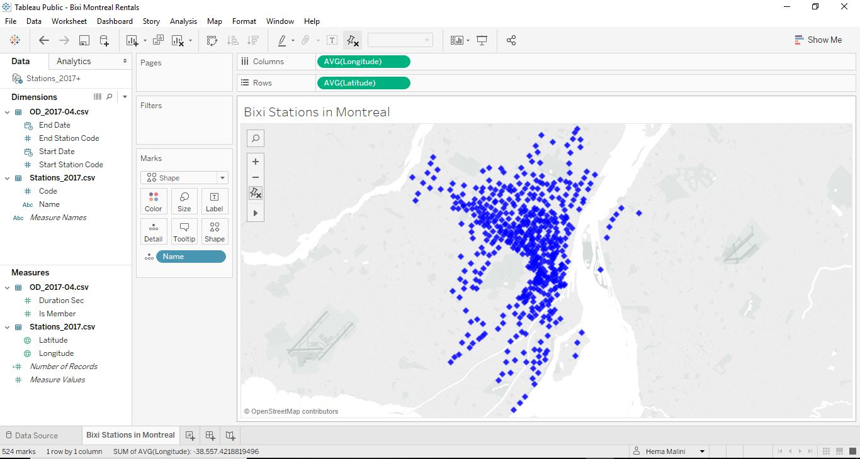

- Be Wiser Cancer Project; Excel Connection, Website Analytics, Visitors by Device, Visitors by social network, Visitor Acquisition and other event, page and keyword analytics.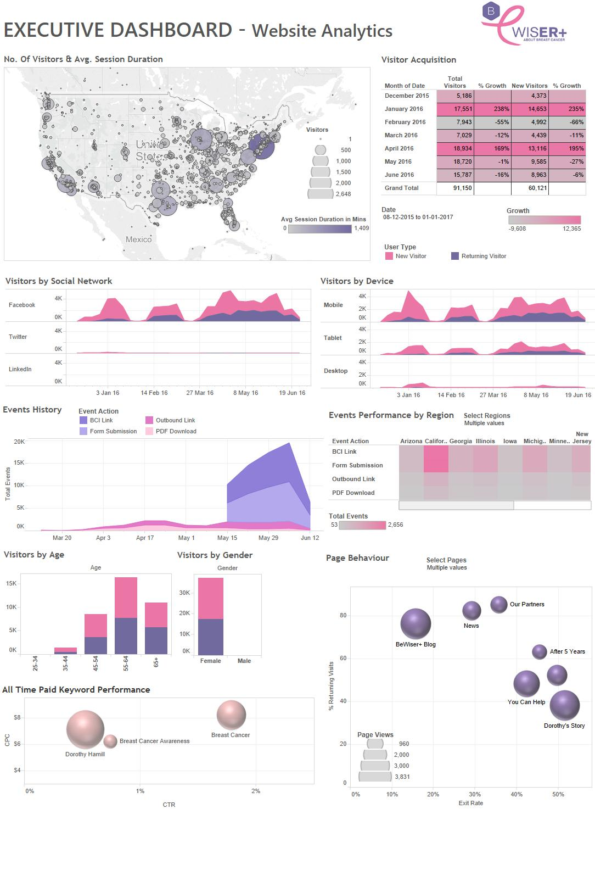

- Be Wiser Cancer Project; Excel Connection, MailChimp Analytics, Campaigns Summary & Activity, Open & Click Rate Statistics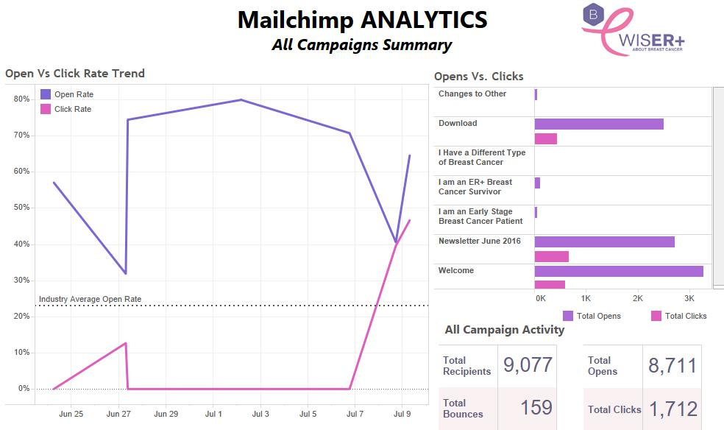
- Guru Sales Project Story; Excel Connection, Sales Across all Regions
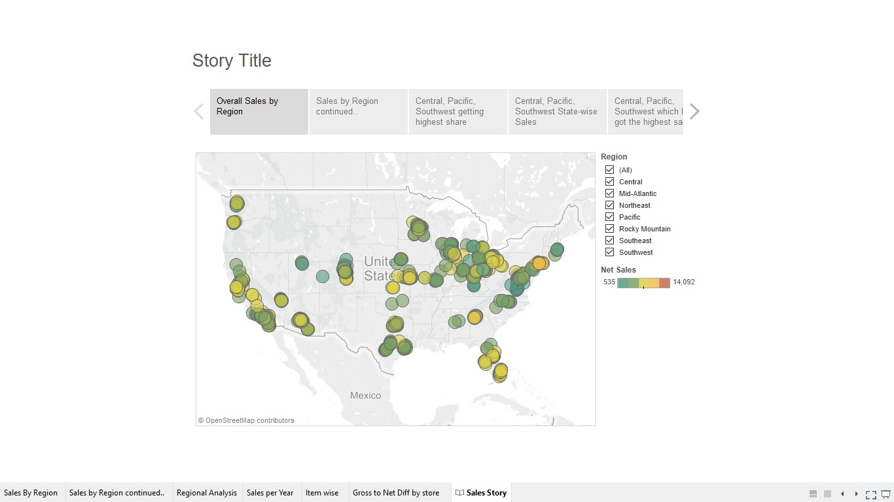

  - Sales by region in bubble
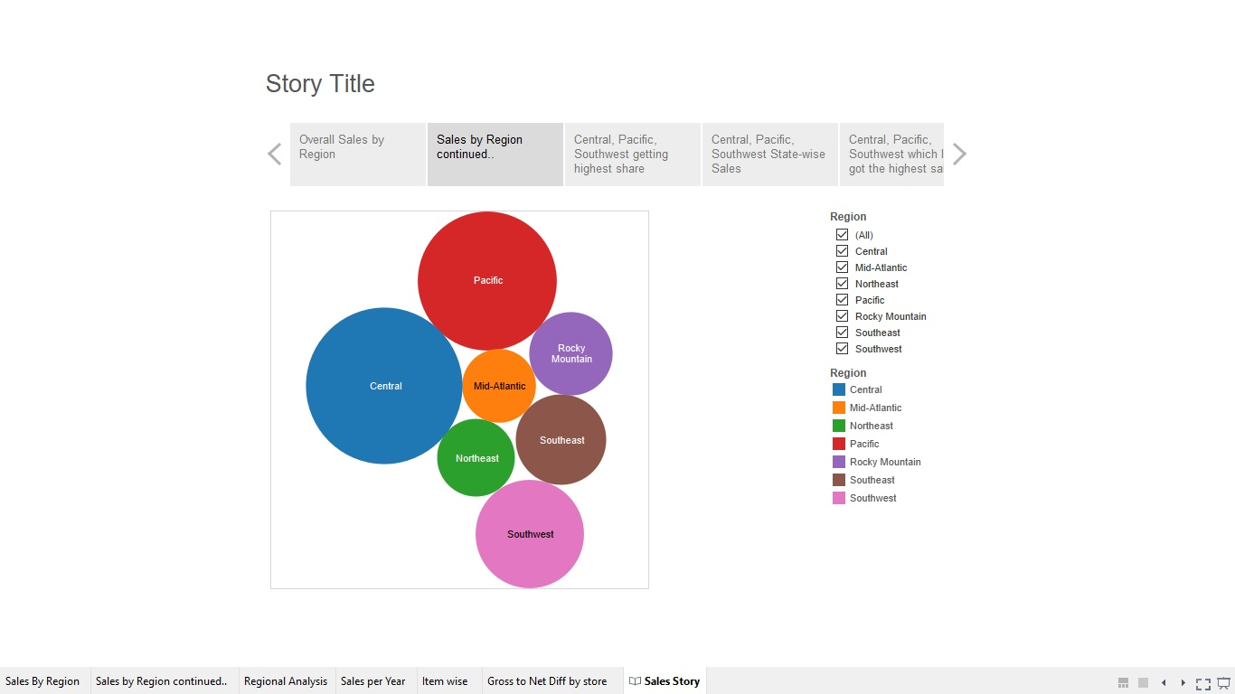
  - Sales share by region and year
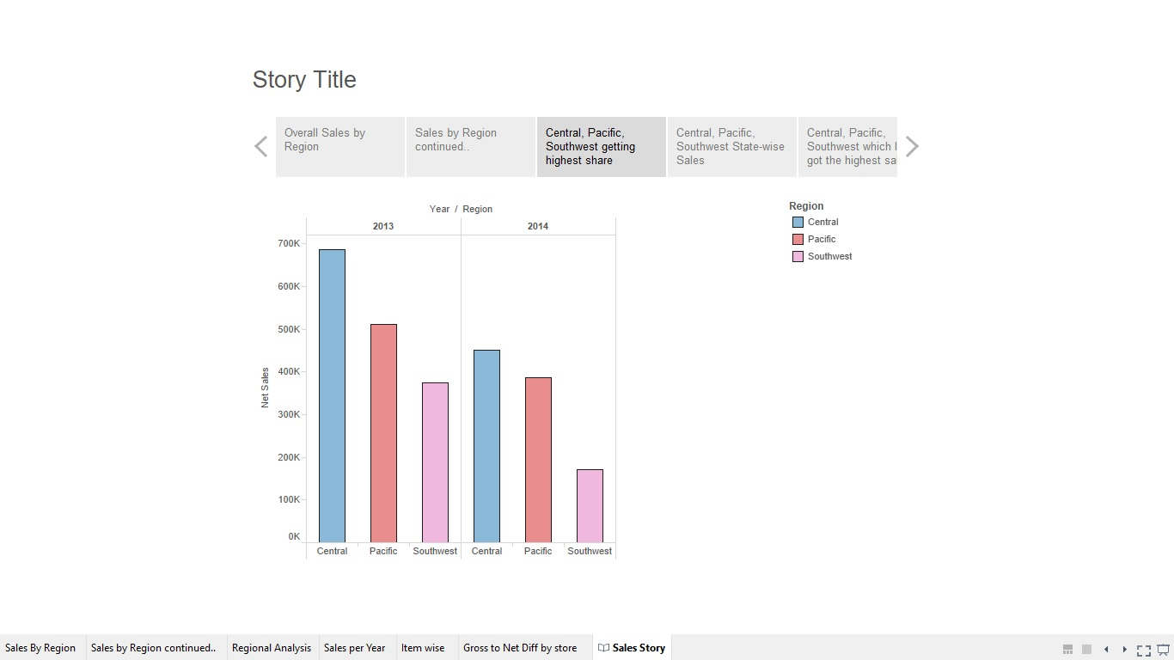

  - State-wise Sales
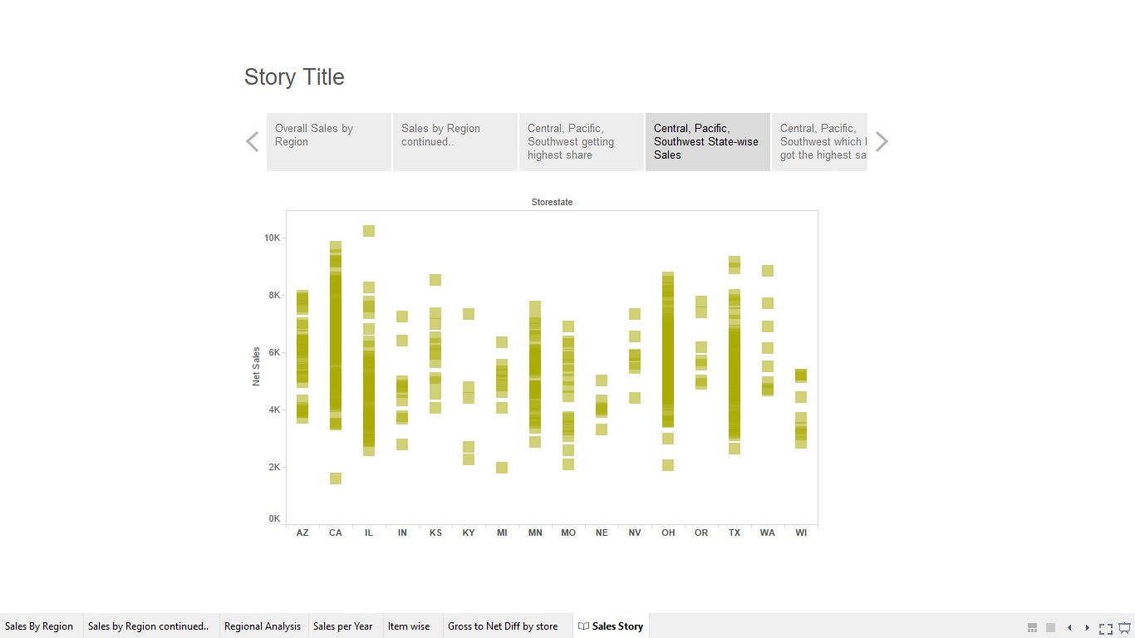
  - Product-wise sales
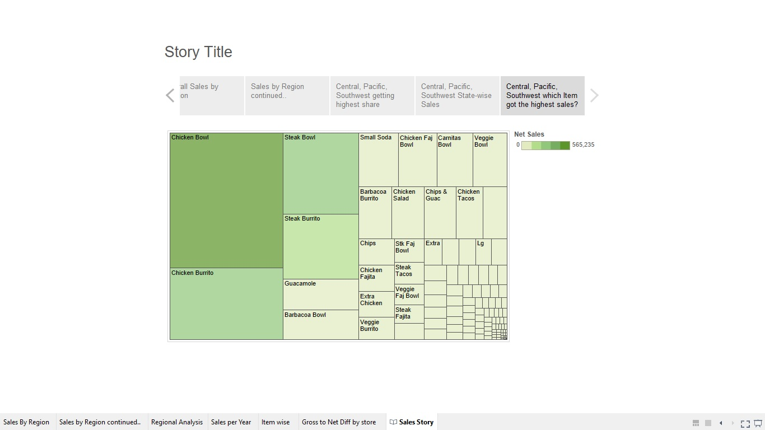

- Health Care Project Story; Excel Connection, Price Analysis by Hospital
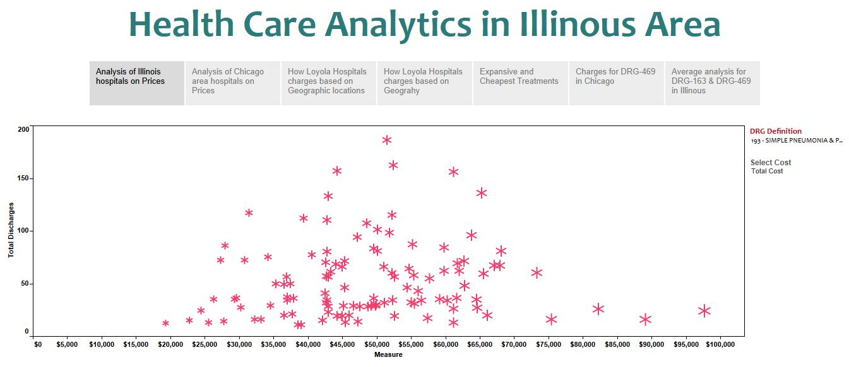
  - Price Analysis by Area
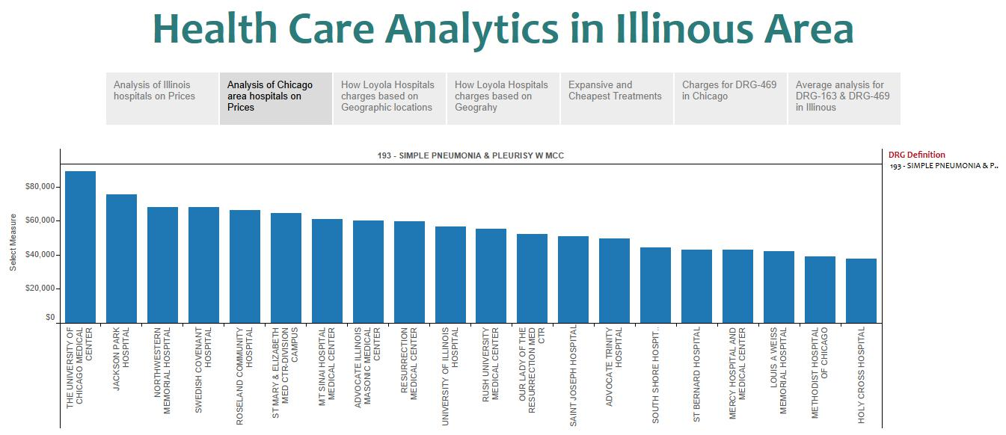
  - Hospital Price Comparison
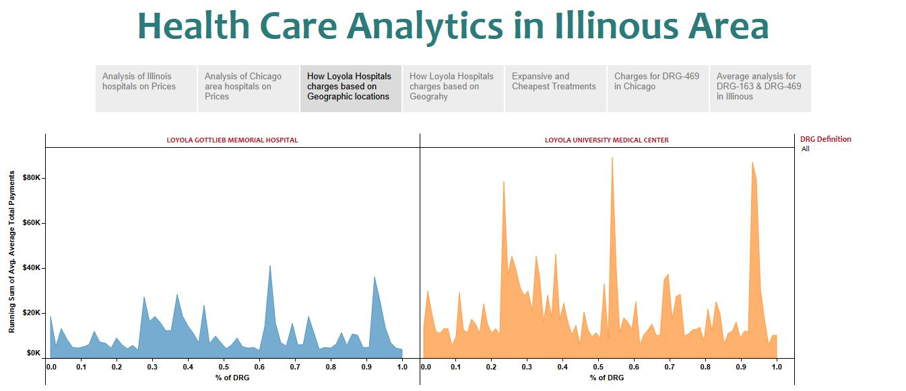

  - Charges based on geography
  - Treatment Cost
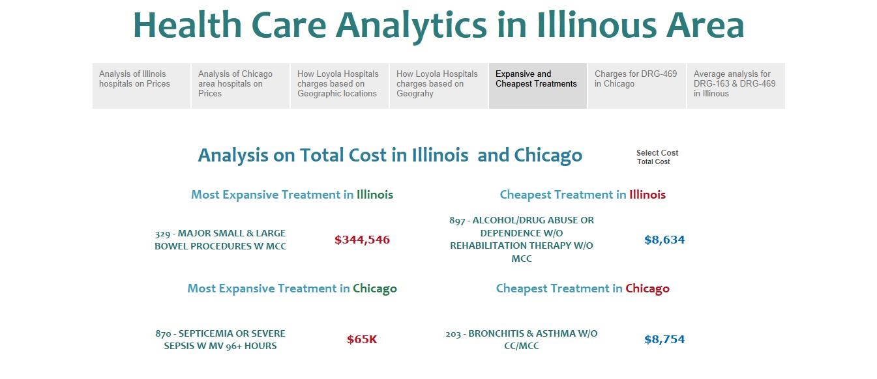
  - Drug-wise Charges
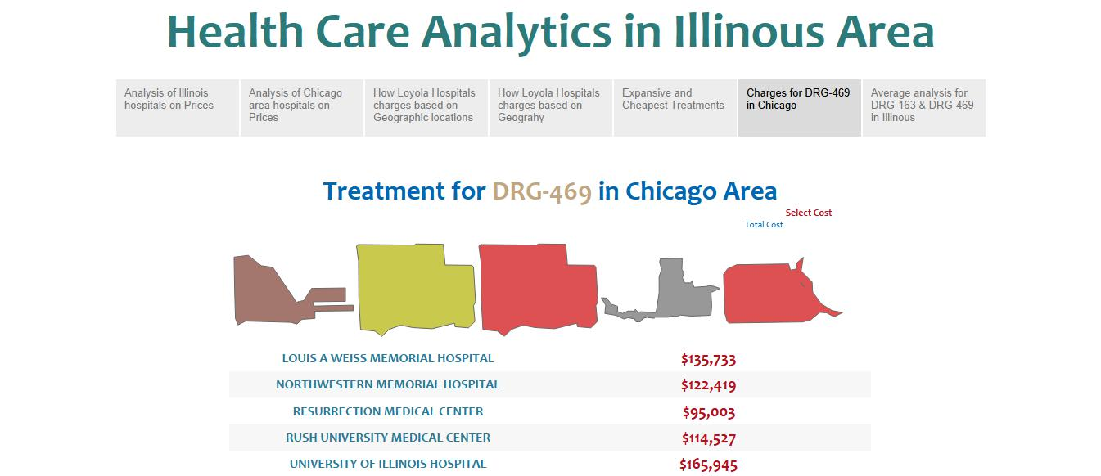

  - Drug Analysis
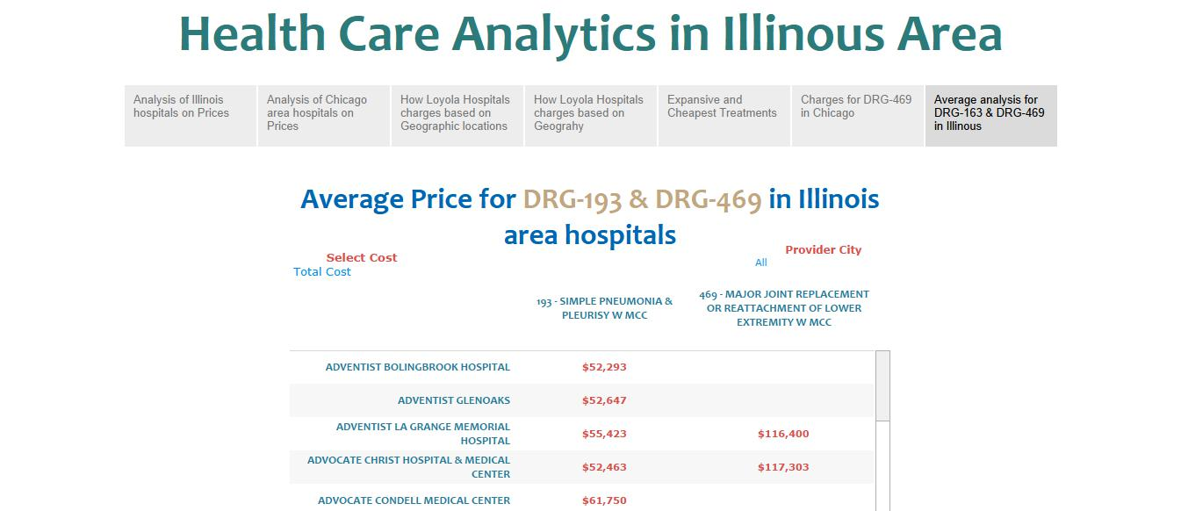
  - Health Care Individuals
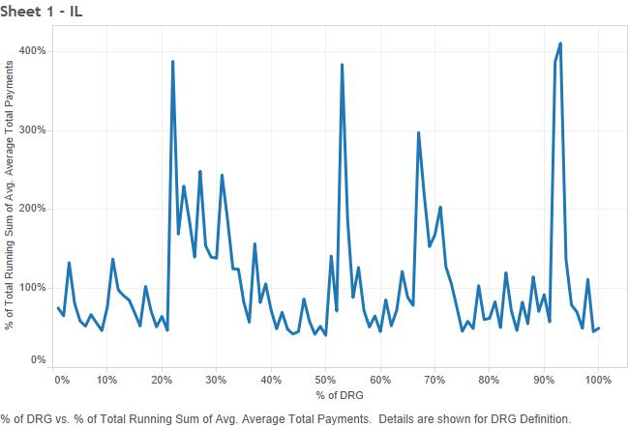
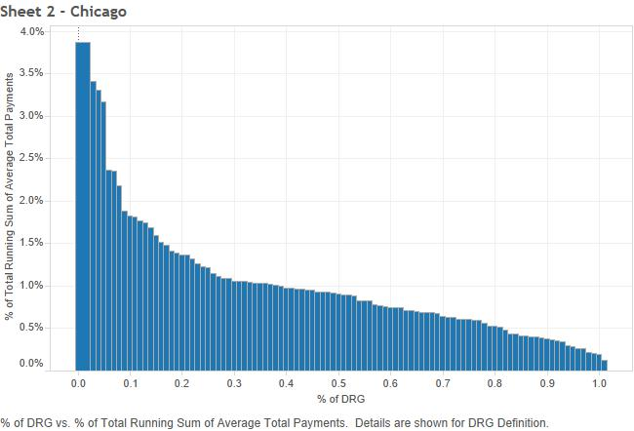
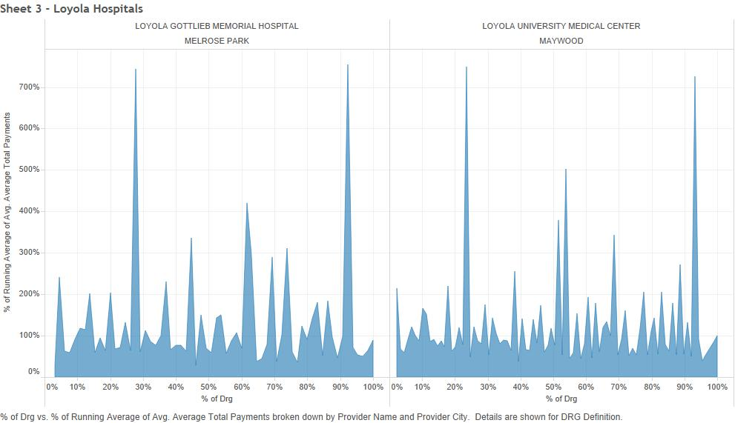
- Oracle Tableau Project; Oracle Data Source, Order Amount per HourSales by weekday
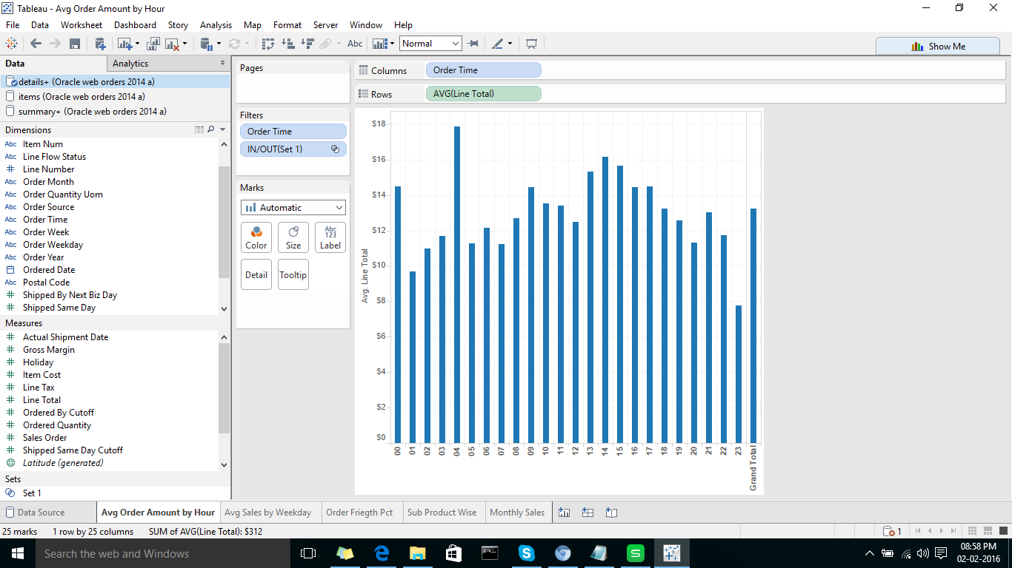
  - Sales by Weekday
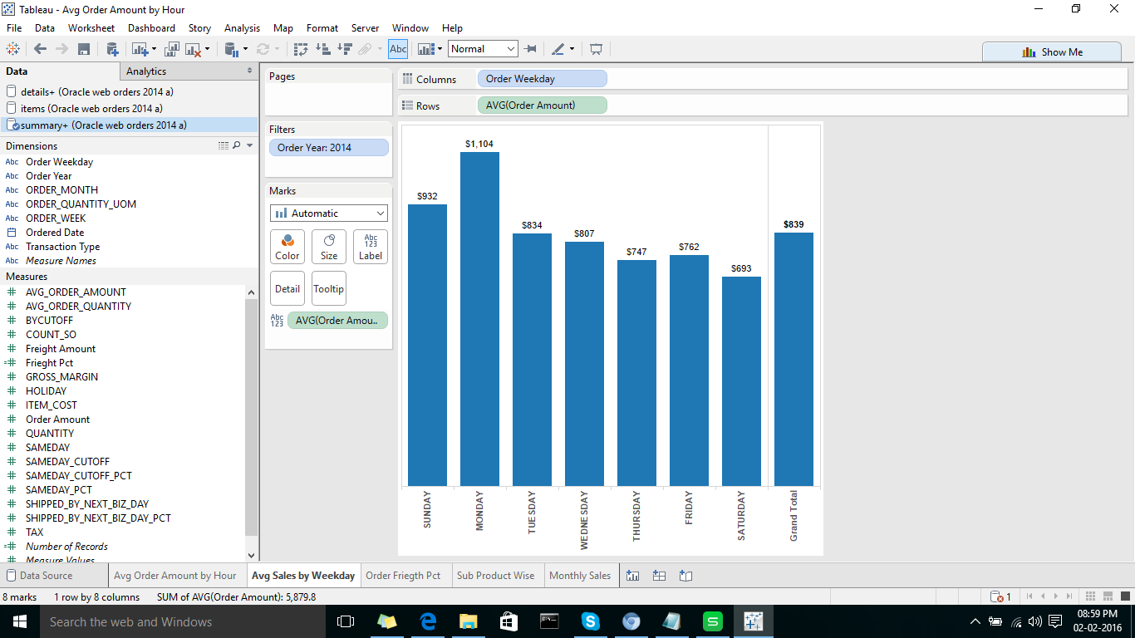

  - Monthly Sales
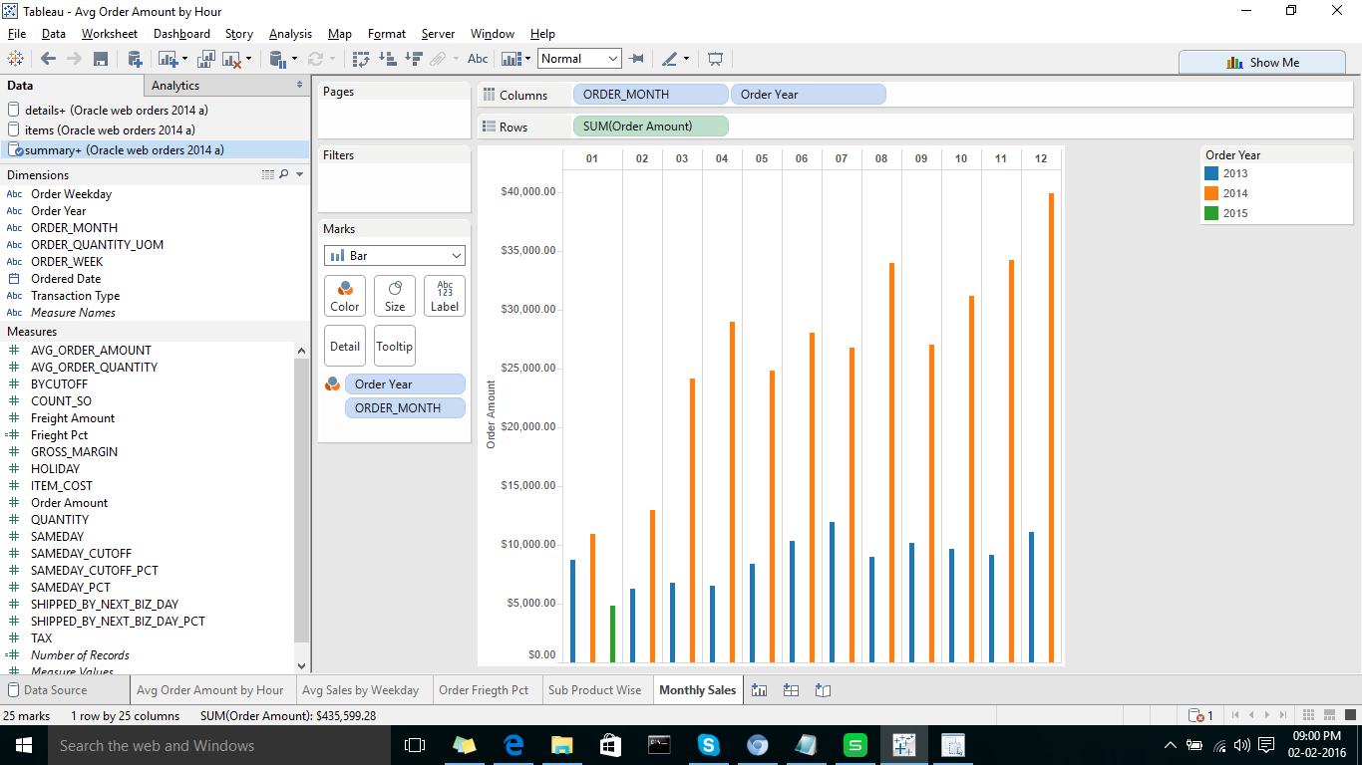
  - Order Freight Percent
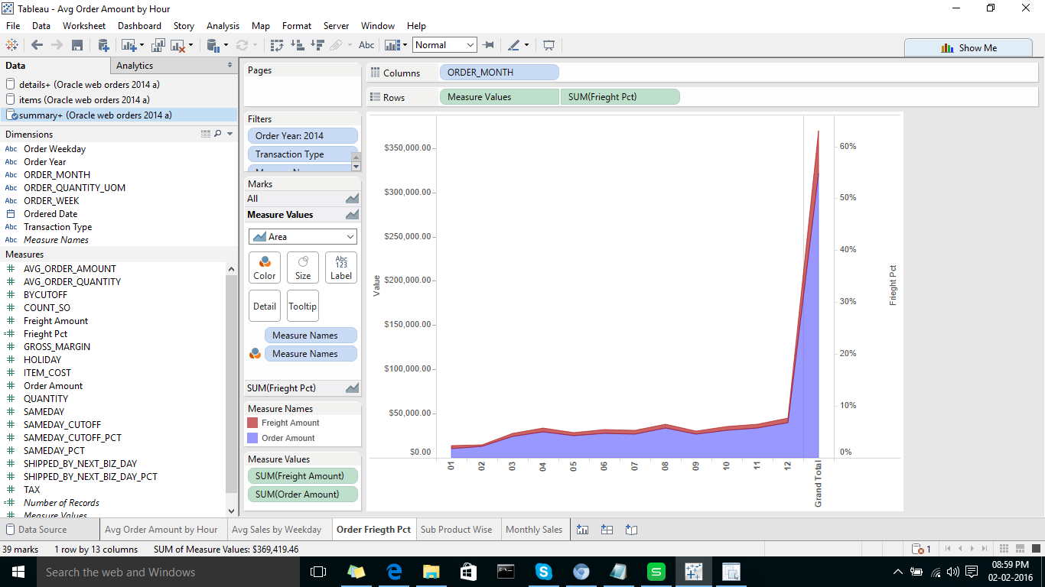
  - Sub-product Wise
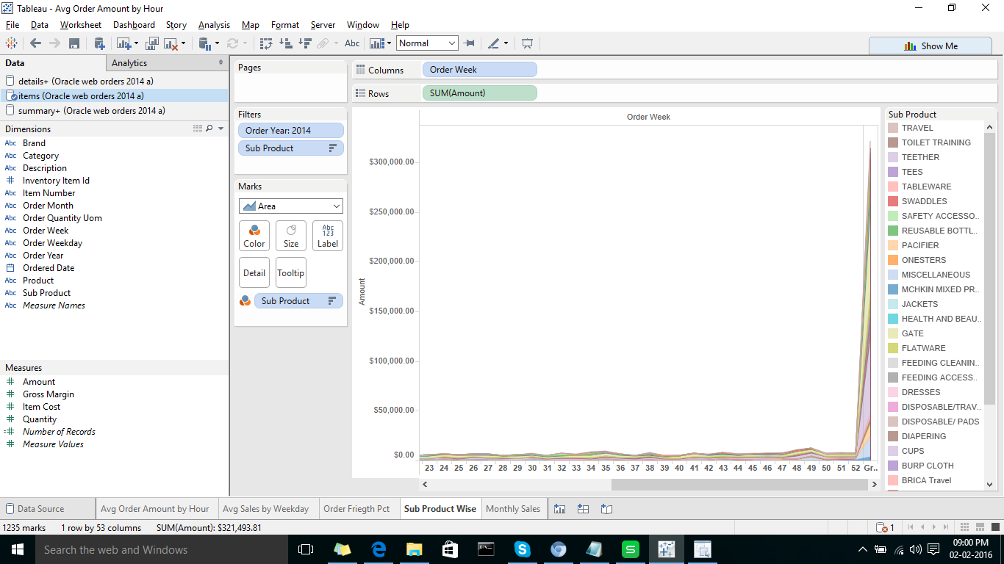

  - ORT Project; Sensor Line
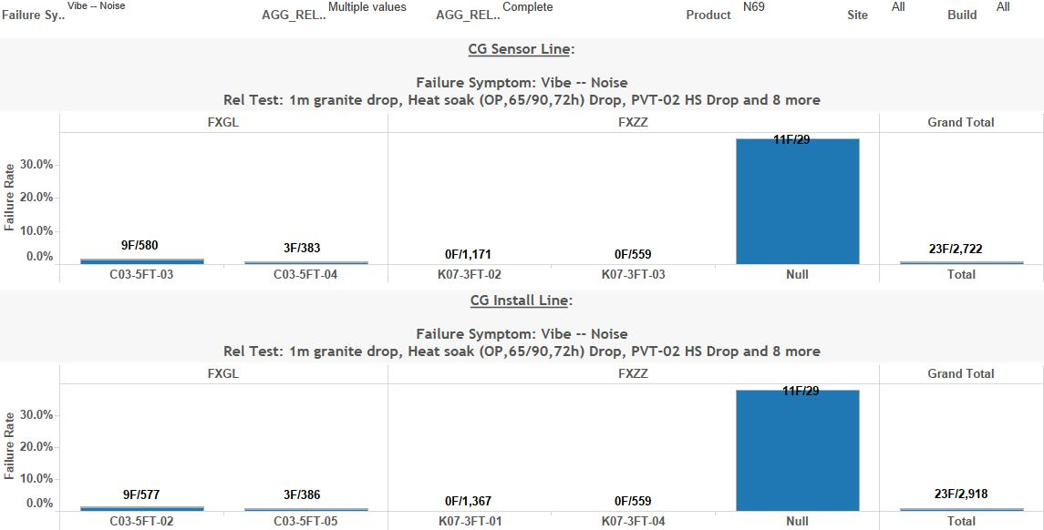
  - Line breakdown
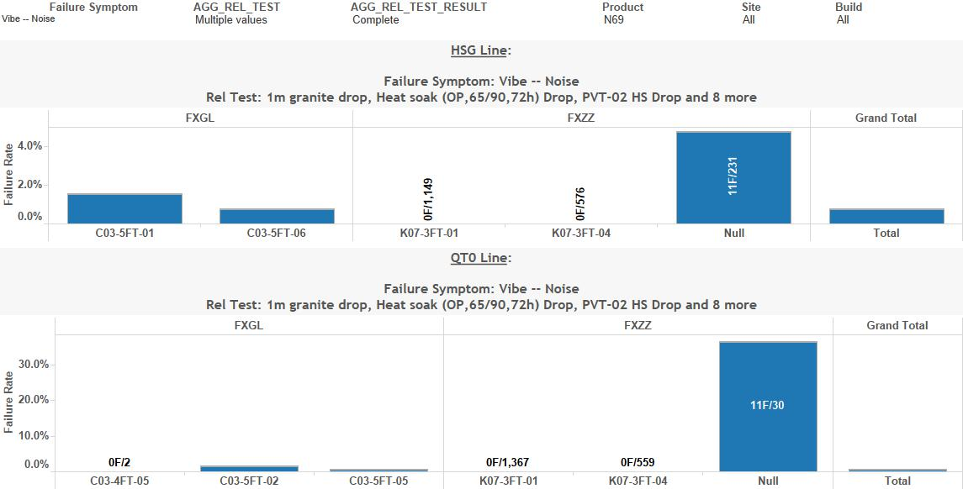
  - Reltest Combination, Pareto Chart
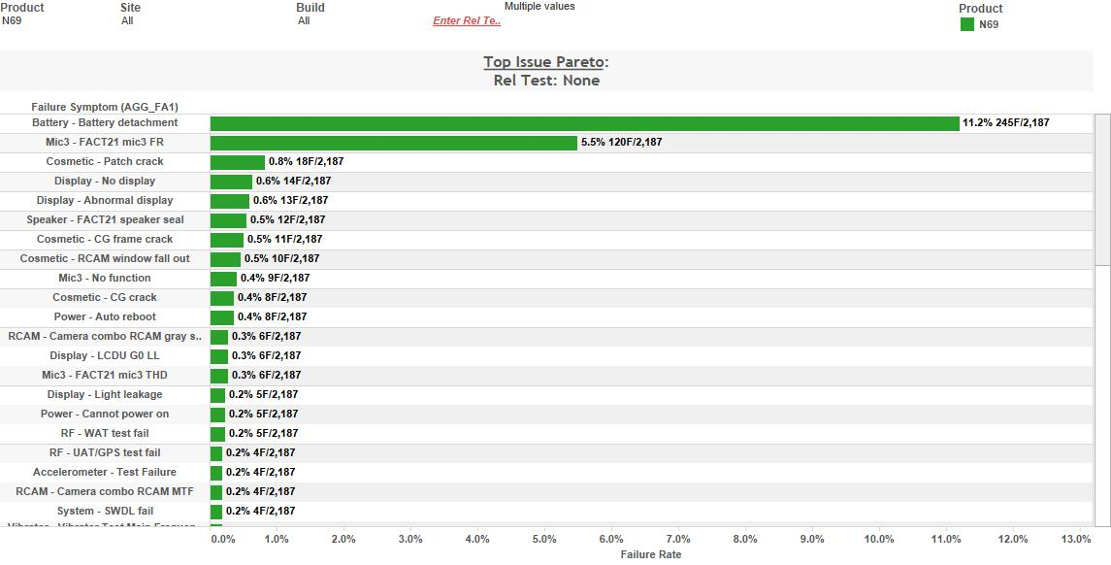

  - Shipset Line Breakdown
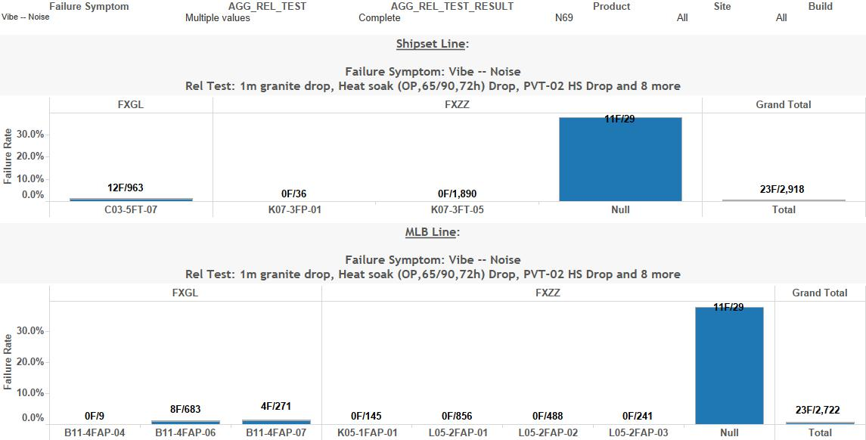
  - Top Issue
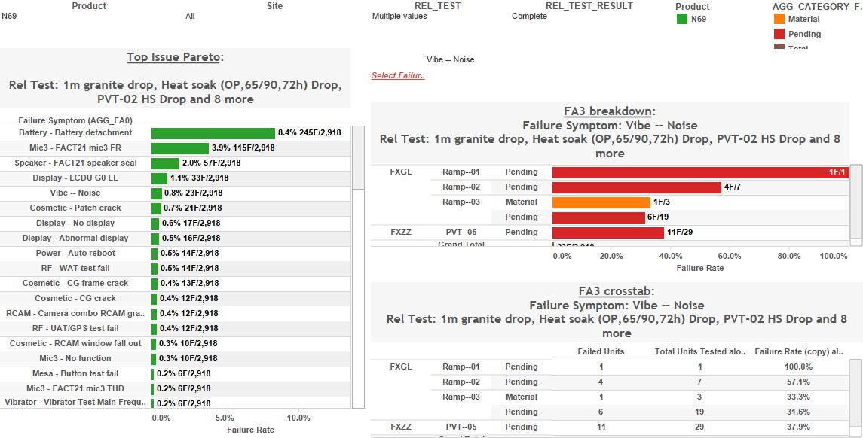
  - Top issue Summary
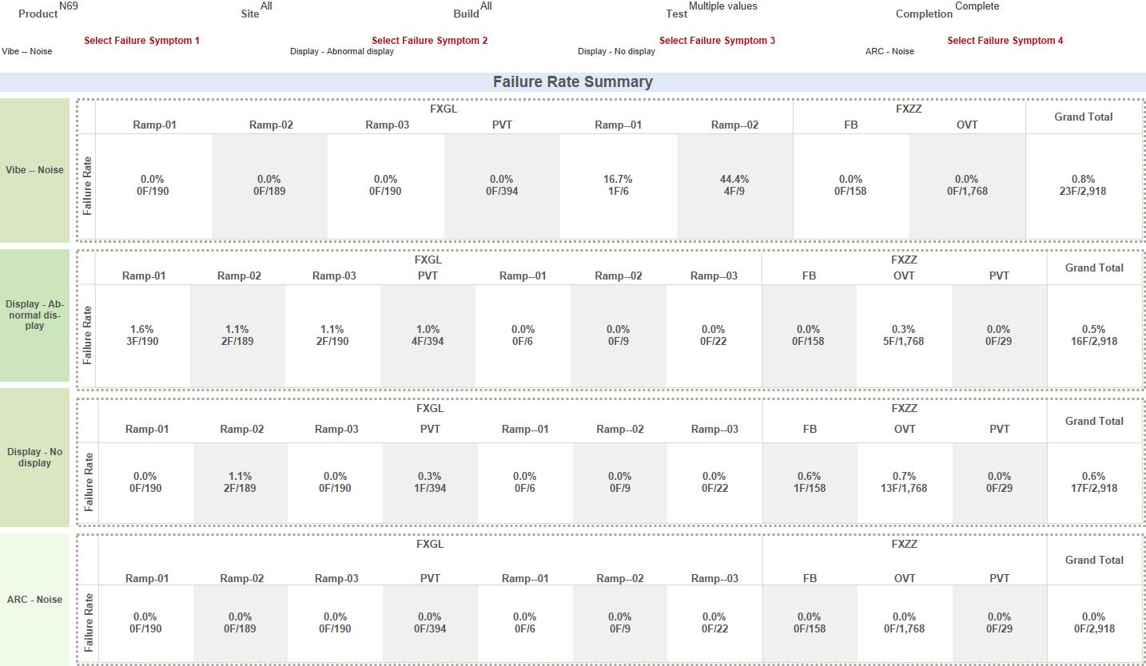

  - Top issue –Vendor
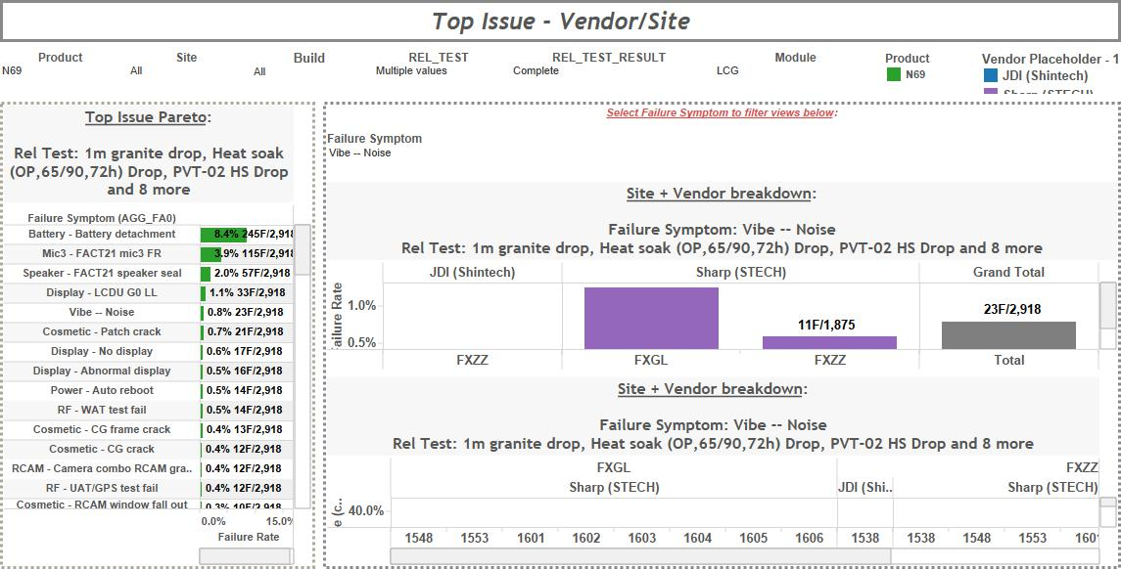
  - Total input breakdown
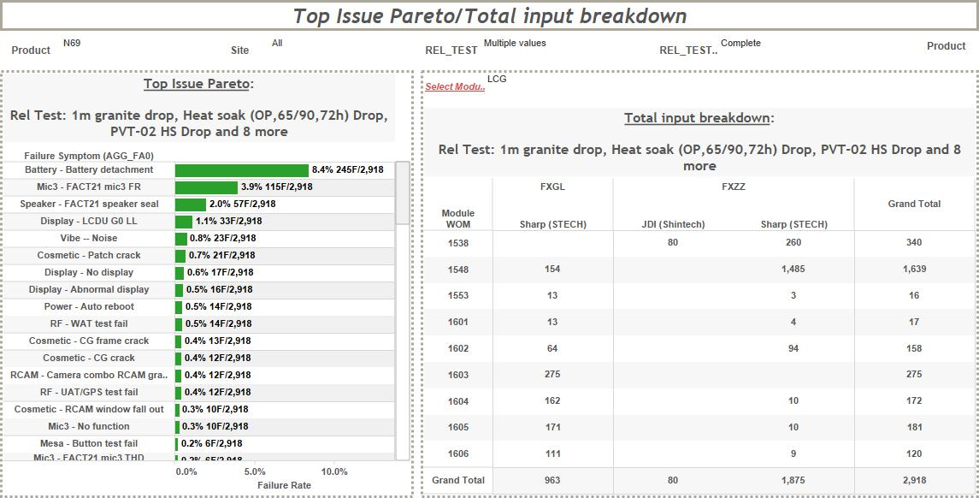

- Holiday Project; Filter Holidays in report
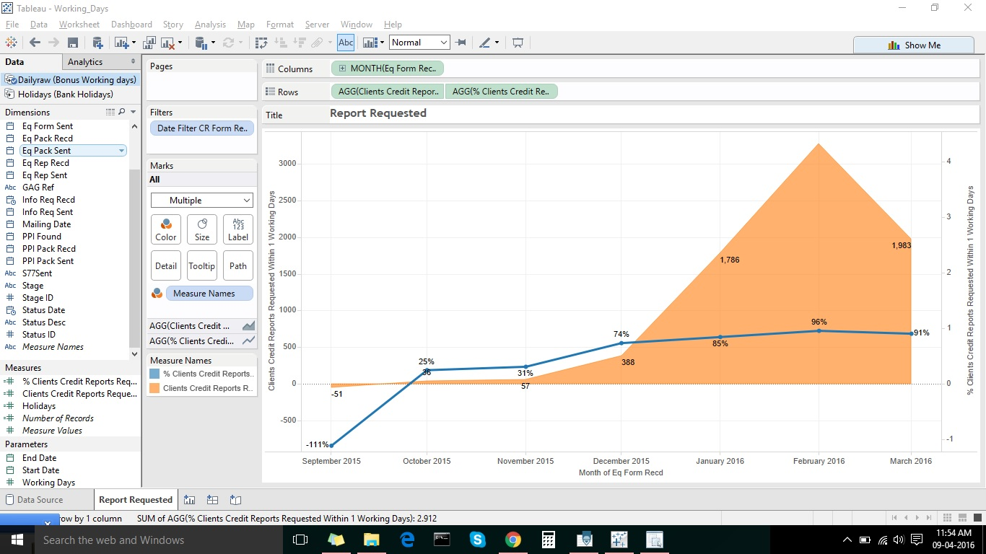
- Echo Nest WDC Project; WDC, Python Web Server, API Call, JSON
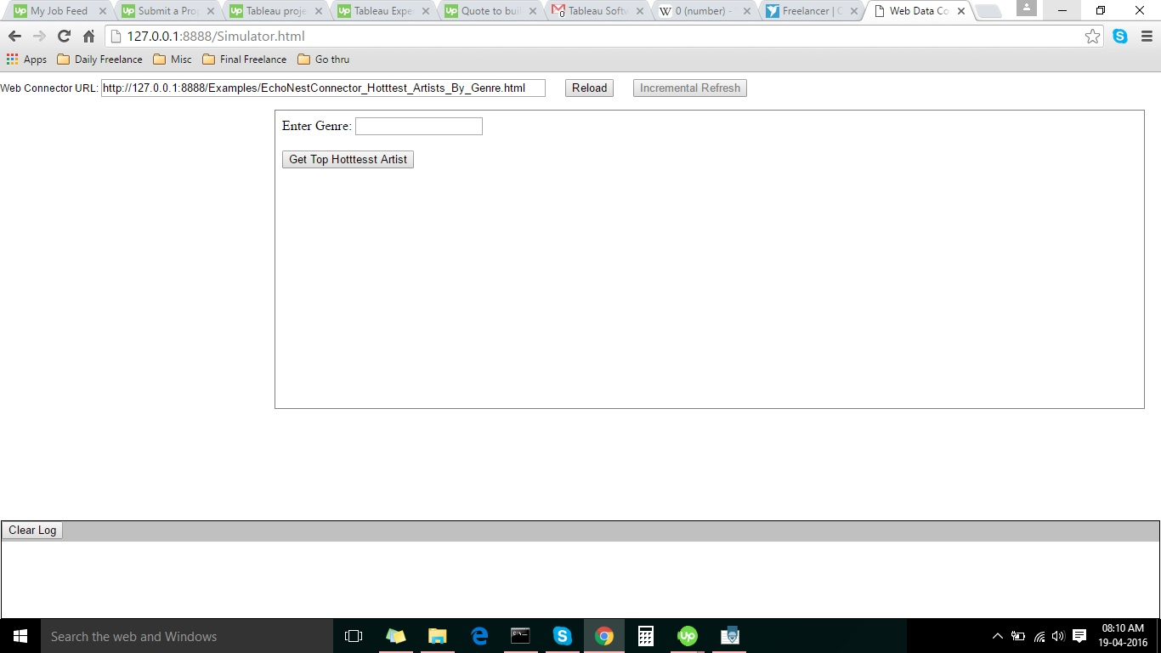
  - Connection at Tableau
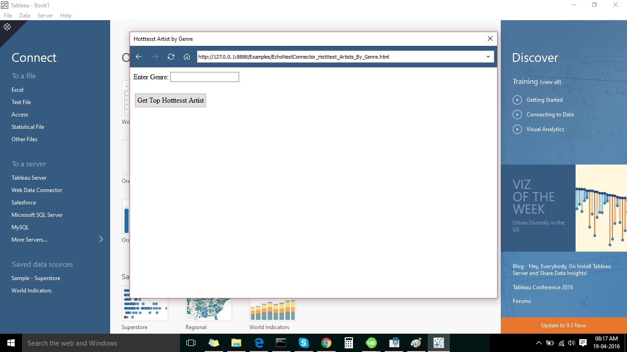

  - Tableau Report
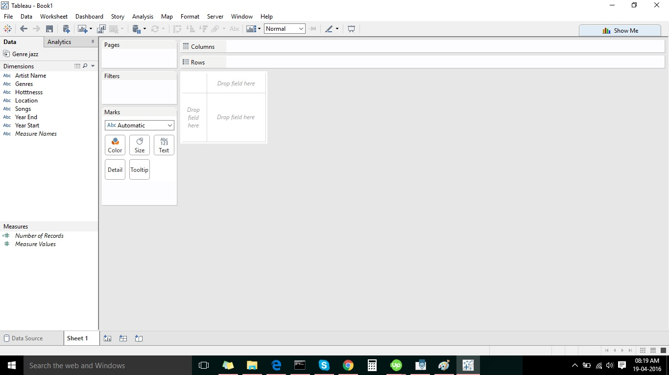
- Twitter WDC Project; WDC, Python Web Server, API Call, JSON, Twitter Public & Private API
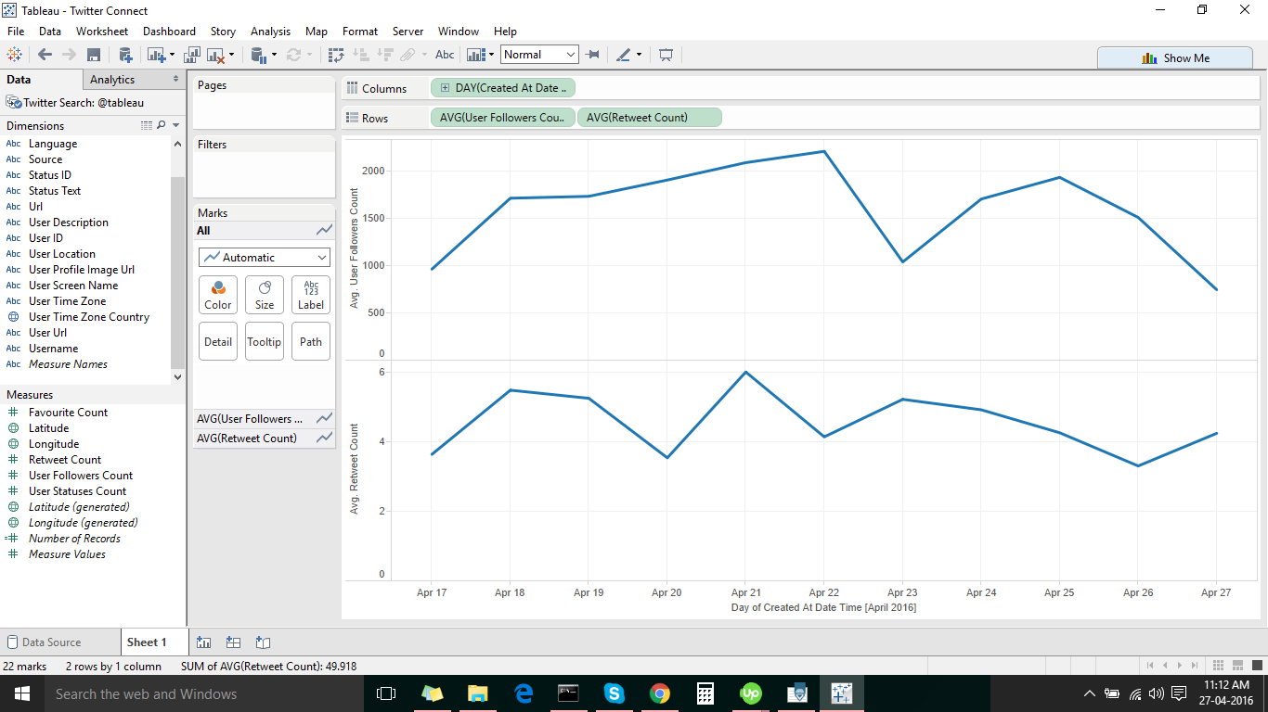

- Salesforce Data Connect(SFDC) Project; Heroku, Sparkle, Tableau Online, Salesforce Canvas
