Powerup CF7

Enable Webhook option in Contact Form 7 to post CF7 data anywhere you want to.

Description

Powerup CF7 plugin is created by Socket to enable Webhook option in Contact Form 7. This plugin can be easily configured to Post data from CF7 to any Third party application, like Google Sheet, CRM, Slack, Trello etc.

Since CF7 posts data only to emails, Powerup CF7 adds unlimited possibilities to forward your form data wherever you wish to. This saves a lot of development efforts that goes on writing custom codes to get form data.

Powerup CF7 just needs a webhook URL to activate it, which can be your own hosted URL or you can get it from Socket https://viasocket.com

Installation Instructions:
Pre-condition- Powerup CF7 works only when you have activated Contact Form 7.
Steps:
- Go to Wordpress admin panel and visit “plugins’-> ‘Add New’
- Search for Powerup CF7

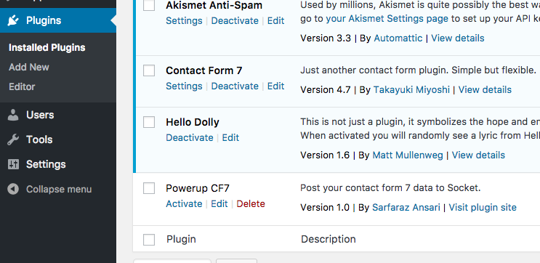

- Activate Powerup CF7, this will add a new menu named ‘Powerup CF7’ in your Wordpress admin menus

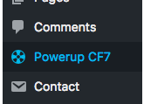

- Go to Powerup CF7 configuration page to configure URL

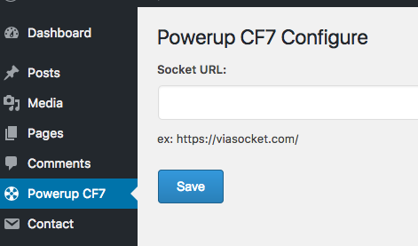

- Add your URL where you want to forward CF7 data
URL can be your own hosted URL or you can get it from Socket https://viasocket.com

Support:

This add-on is built by team SOCKET, viasocket.com. Get in contact via Socket’s Chat option or search for any question at socket.canny.io. If you can’t locate any topics that pertain to your particular issue, post a new topic for it.

Twitter https://twitter.com/viasocket
Contact hello@viasocket.com

Further Reading
https://learn.viasocket.com/powerup-cf7-a-wordpress-plugin-967a4ae34b54

