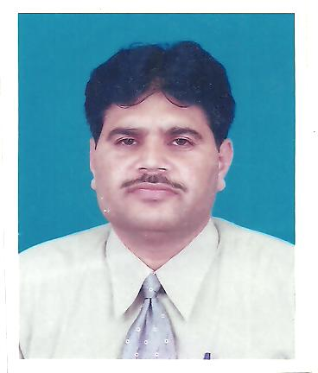

RESUME
MUHAMMAD AKRAM
I am confident and enthusiastic person. Have strong analytical and quantitative skills coupled with a fast learning aptitude. Have the ability to adapt quickly to new challenges and to handle difficult situation under pressure. Have excellent communication and leadership skills and technical background to carry out a profession with an organization proposed exigent.
Personal Details of MUHAMMAD AKRAM.

Name | : Muhammad Akram
Father’s Name | : Ashiq Ali ( Ex- Army Personnel )
Gender | : Male (Married )
Religion | : Islam
Nationality | : Pakistani
Date Of birth | : 26-12-68
NIC No. | : 17301-3408467-3
Current Address | : House No.22F/320 POF Wah Cantt.
Permanent Address | :Chak No. ML Tehsil Piplan Distt: Mianwali
Phone No. | : +92-0306-5126673-0334-5334610
Email | : rana.makram9999@gmail.com

OBJECTIVE
Looking for a Permanent Nature job in a growing organization to utilize and enhance my professional skills.
EDUCATIONAL DETAILS

University / College / School | Degree | DURATION | COMPLETION YEAR
A.I.O.U Islamabad. | M.B.A (B&F) | 02 year | 2008
Institute of Cost & Management Islamabad. | ACMA | 02 year | 1998
Government College of Commerce Rawalpindi. | B.Com | 02 year | 1993
Government College of Commerce Rawalpindi. | D.com | 02 year | 1990
Federal Government School No. 7 Wah Cantt. | Matric ( Science ) | 02 year | 1987

COMPUTER SKILLS

BASIC Computer programming language.( Quick Book , Ms Word, Ms Excel ,ERP )
`
EXPERIENCE

Duration | Company Name / Location | Designation | Internship Profile
April 04, 1998 to Feb 28, 2004). | SOS VILLAGES OF PAKISTAN (Project: Sos afghan relief Programme Peshawar & Afghanistan). | Accounts Officer cum project Coordinator | Responsible for maintenance of books of Accounts, Preparation of final Accounts, preparation of periodic expenditure.   Preparation of staff salaries and detail of daily routine and miscellaneous site expenditure.   Responsible for keeping the grant files updated with budgets, grant contracts and agreements.   Conduct internal audits of the sub grantees / sub recipients regularly, to ensure that all financial procedures are carried out in line.
March 01, 2004 to Dec 31, 2010. | ( PMC-JV ISB ) | Accounts & Procurement Manager | - Able to track the financial aspects of projects.  - Responsible for preparation of projection reports, analysis.  - To help the restructure the financial infrastructure of the company.  - Responsible to maintain inventory details & provide weekly, daily in-out reports of store items.  - Responsible for preparation of various periodic expenditure reports.  - Responsible for the accuracy of various financial reports.  - To give the management various ideas about how we minimize project cost.
January 02, 2011 to December 31, 2015. | Mohd Amin Brothers (Pvt) Ltd.(Mineral Division). | General Manager Operation | - To look after overall operation of the mines area and offices.  - To check all the offices working of manager operations in mines area.  - To give the CEO and whole management various ideas about how we minimize project cost.
January 03, 2016 to till date. | TIP Factory Haripur. | Senior Accounts & Finance Manager Acting DGM. | - To look after overall factory affairs related to production &finance & budget.

ACHIEVEMENTS.

IELTS: 7.5 BAND from British Council
LANGUAGES
- Pashto (Fair in & Listening. )
- English ( Excellent in speaking and writing )
- Urdu ( Vernacular )
- Hindko ( Excellent in speaking and writing )
- Saraik) Excellent in speaking and writing.
References

- Arshad Abass
Section Officer
Ministry of I.T & Telecommunication
Islamabad. 051-9206277

