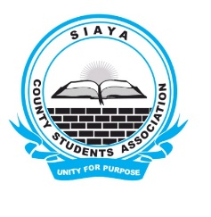
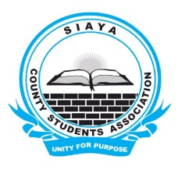
EMAIL:info.sicosa@gmail.com
Siaya County Students Association (SICOSA)
Phone: 0711305915

Ref No: Sicosa/01/12/2019 DATE: 13/12/2019
To: CEC Youth, Education, Gender and Youth affairs
Cc to: The governor
CO Education
CO Youth and Social affairs

IVITATION & REQUEST FOR FINANCIAL SUPPORT
The Executive office of Siaya County Students Association (SICOSA) wishes to notify your office of their planned Special General Meeting that shall be held on 28th December, 2019 at Siaya Scouts Centre. We shall be discussing serious matters affecting students, mentorship program and the future of Education in Siaya among other agenda. As students we believe in dialogue and positive engagement with the county government for this will make us benefit mutually. In this line, we would like to formally invite you to the meeting since your speeches will be of importance to the students.
In order to enable us make this event a success, we have done a budget that we humbly request your office to kindly assist in financially. We are targeting 200 students for the meeting.

NO | ITEM | QTY | COST
1. | Chairs | 200 | 2,000.00
2. | Tents | 2 @ Ksh 5,000 each | 10,000.00
3. | Soda | 200 @ Ksh 50 each | 10,000.00
4. | Water | 50 @ Ksh 30 each | 1,500.00
5. | 1 day Public Address | 1 | 5,000.00
6. | Ushers | 5 @ 500 each | 2,500.00
7. | Transport | 1 | 5,000.00
8. | Venue | 1 | 5,000.00
9. | Miscellaneous |  | 4,000.00
 | TOTAL |  | 45,000.00

We appeal for any material support too including donations.

For more information and Assistance Kindly reach us via the following Contacts
1. Mr Evans Oyatoh (chairperson) 0711305915
2. Mr Ronald Kasanga (Sec Gen ) 0741478756

