Portfolio

Clickvalley is an IT company which is known for its services. Clickvalley assists companies around the world to design, develop, and maintain quality software, websites, and mobile applications.
Our team has great experience in website creation, CMS, Mobile application development, to develop a scintillating experience for the end-users.
Our Team is proficient in numerous Technology Stack such as Angular, Vuejs, React, Bootstrap, HTML, CSS, SCSS, and Asp.net Core. Phonegap, C# and .NET.

Mentions below are some of the projects we delivered successfully.

WEB APPLICATIONS

Looped Housing
Looped Housing (https://loopedhousing.co.uk/) is a platform to help buyers and renters to find a perfect home. We are involved in developing their front-end. The project is in progress.
The app is built using the web pack template of Vuejs and using Vuex for store management. App is built using mock data which helped speed up things by not waiting for back-end team if real APIs. Swagger specs were used to refer to the API structure which helped in API integration at a later stage.

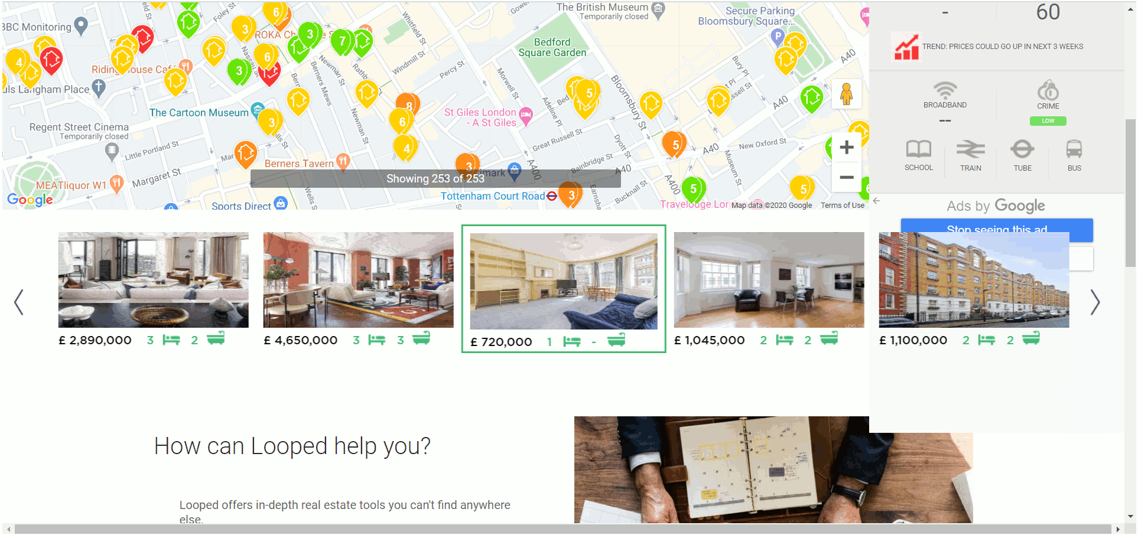
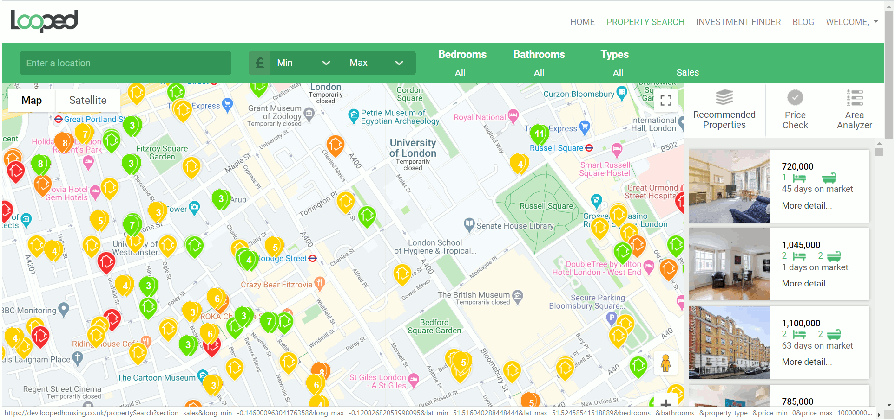
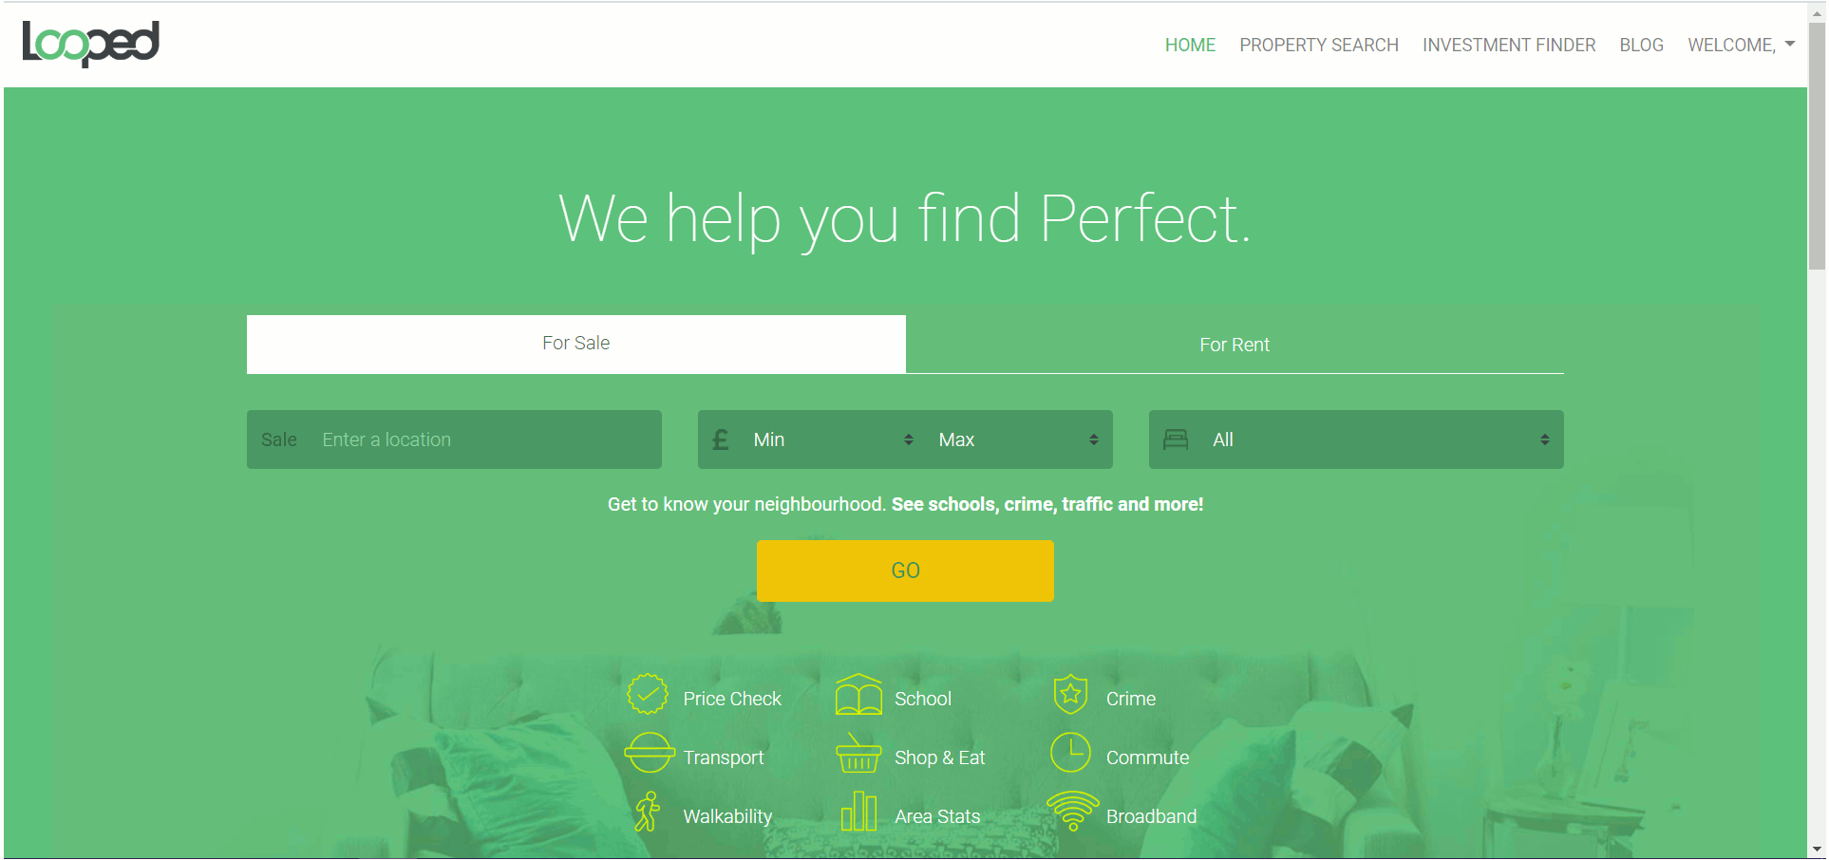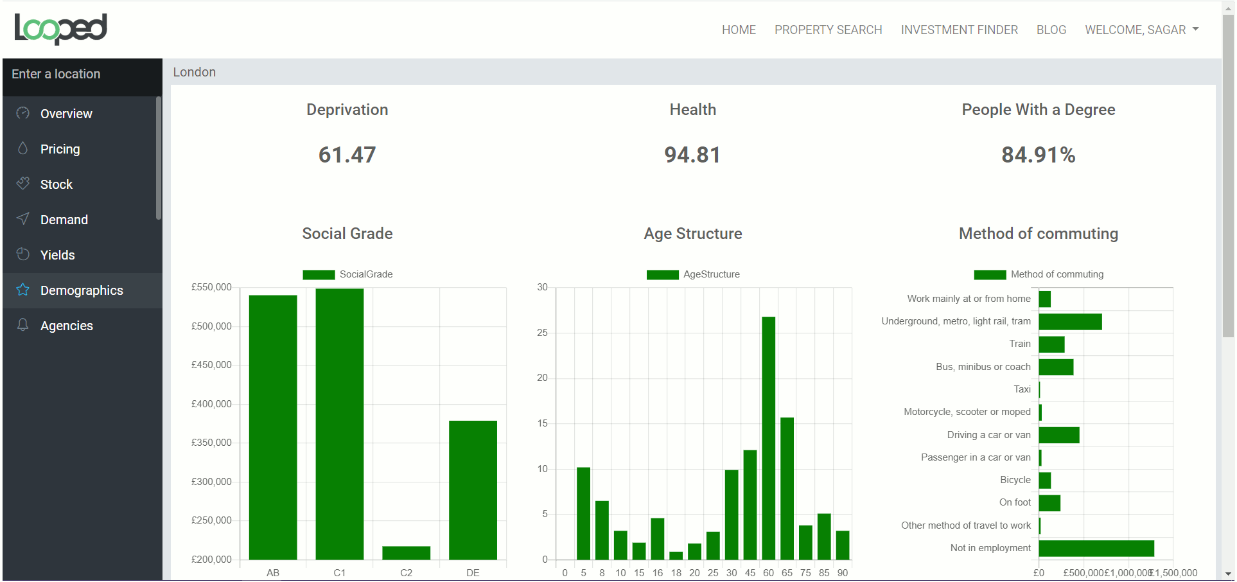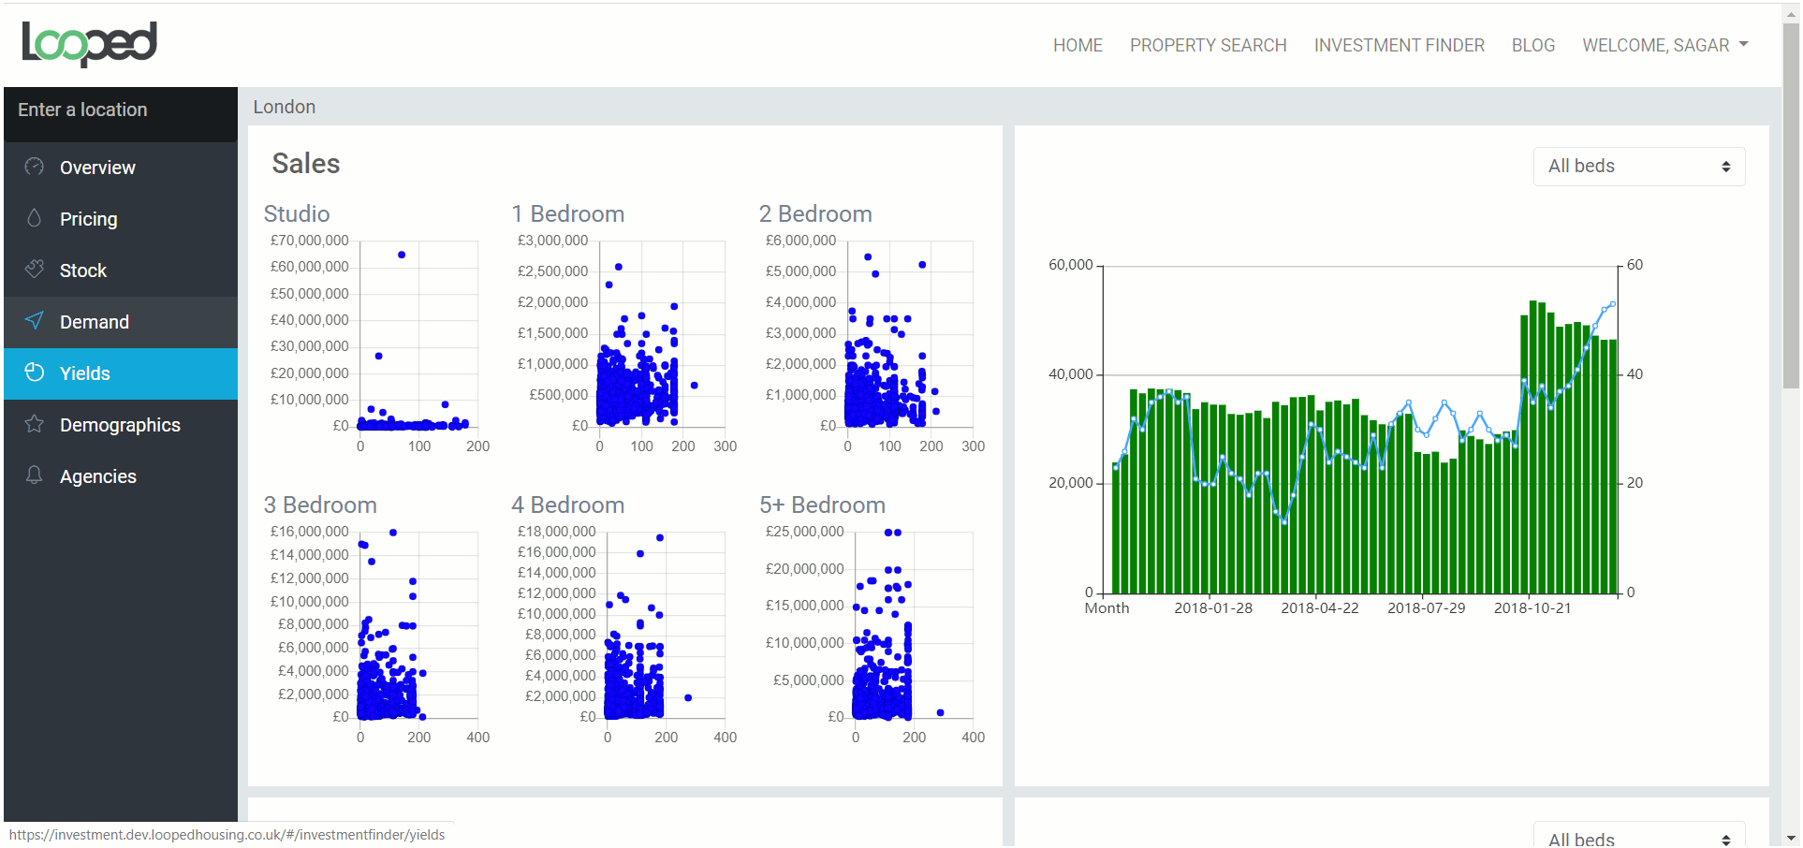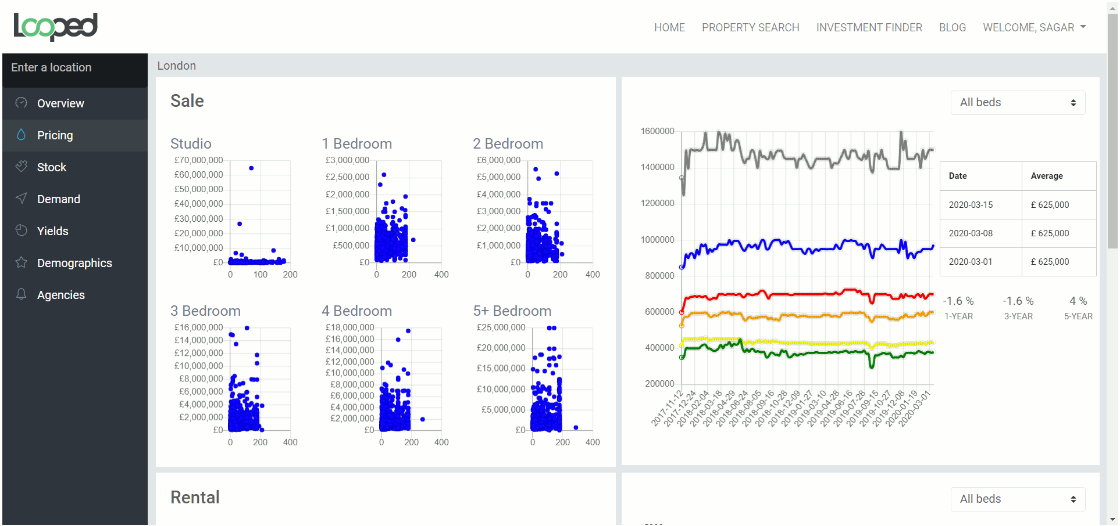

ScriptSender
ScriptSender is a platform used by referring providers to integrate clinical information. The project was to modernize their existing PHP Laravel application using SPA framework. Vuejs was chosen as a framework. Designs were available in Invision app. Our role was to convert InvisionApp mockups in html/css and then build the front-end in Vuejs. The project is 80% complete and api integration is in progress. The app is built using webpack template of Vuejs and using Vuex for store management. Entire app was built using mock data which helped speed up things by not waiting for back-end team for real apis. Swagger specs were used to refer to the api structure which helped in api integration at a later stage.
http://ivdev.scriptsender.com:8080/
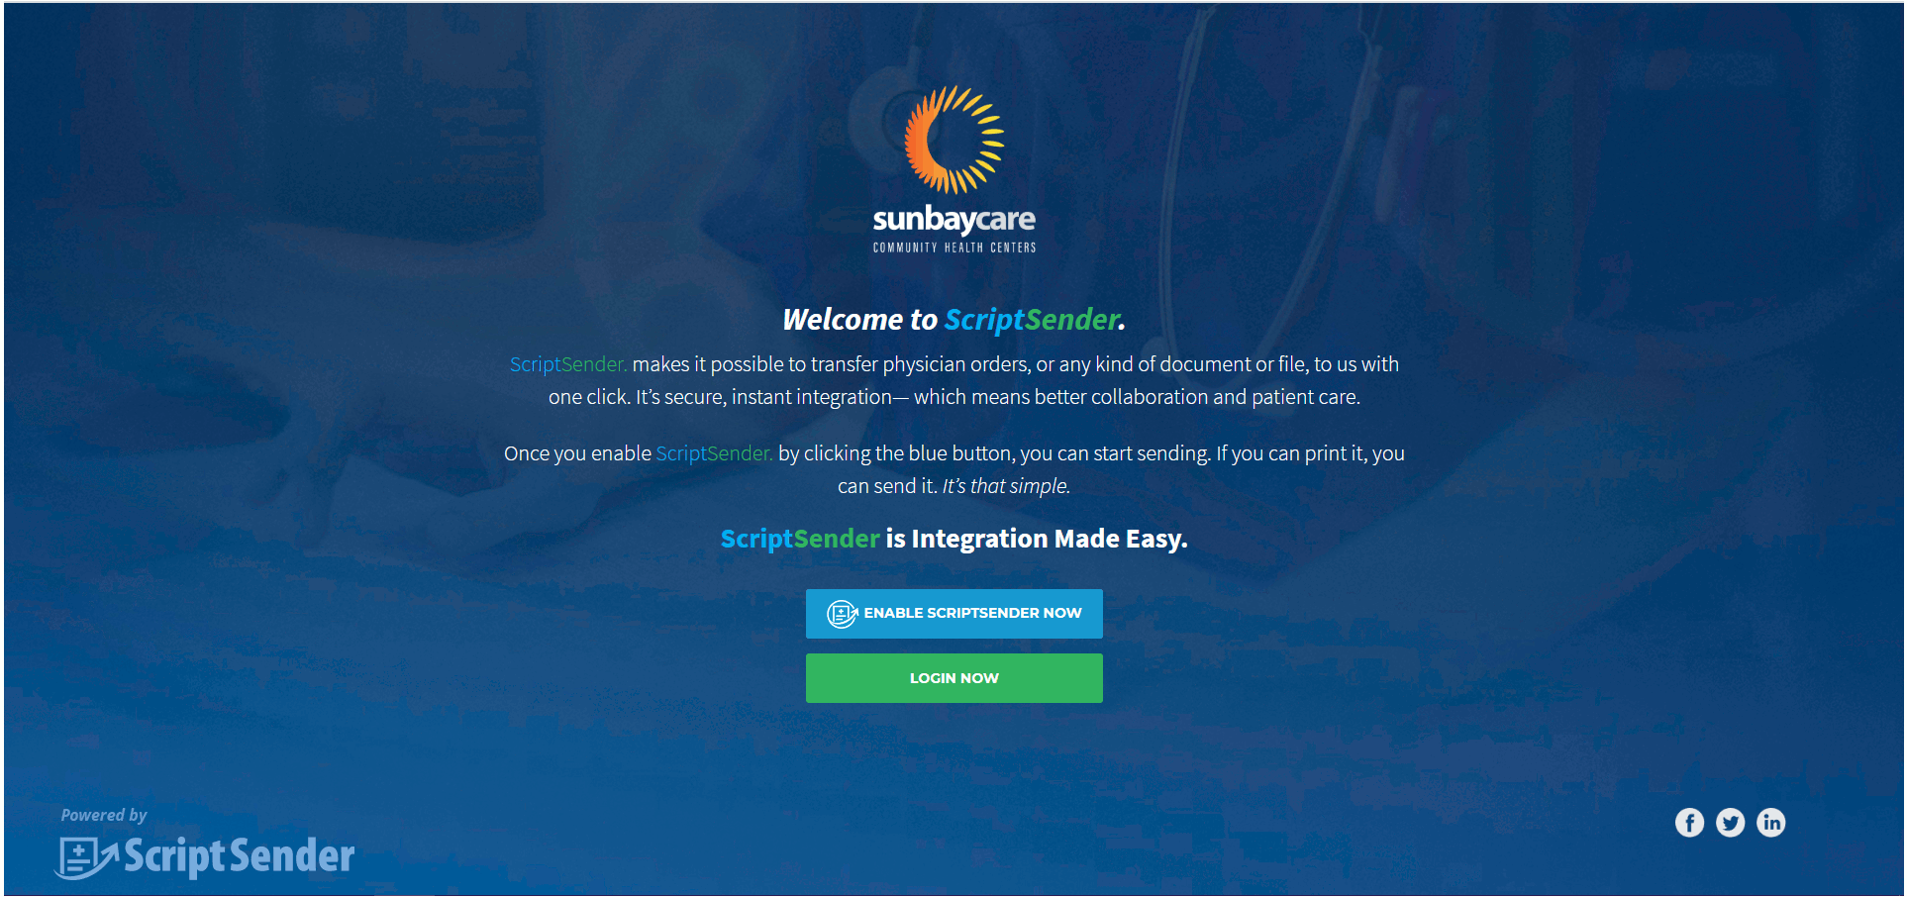

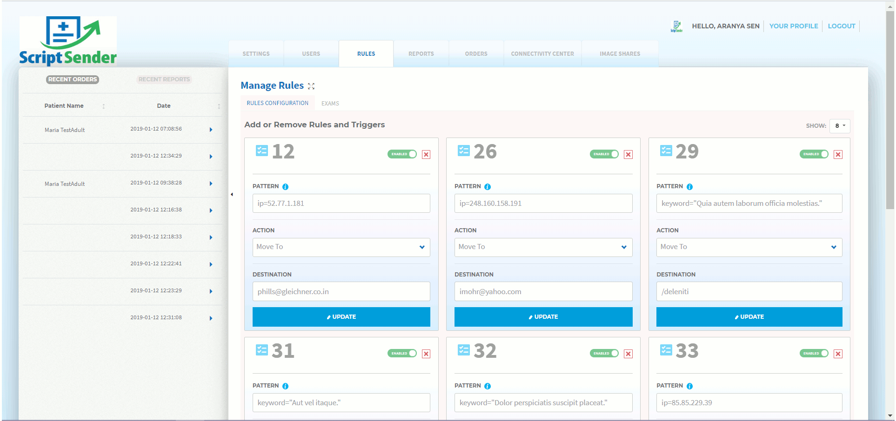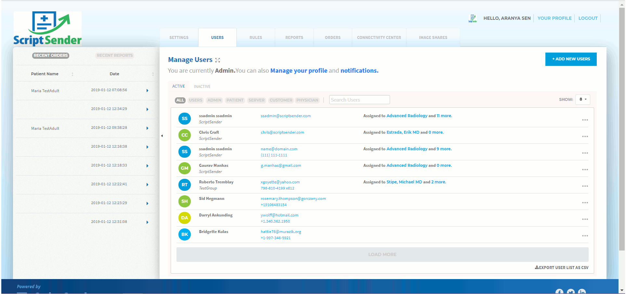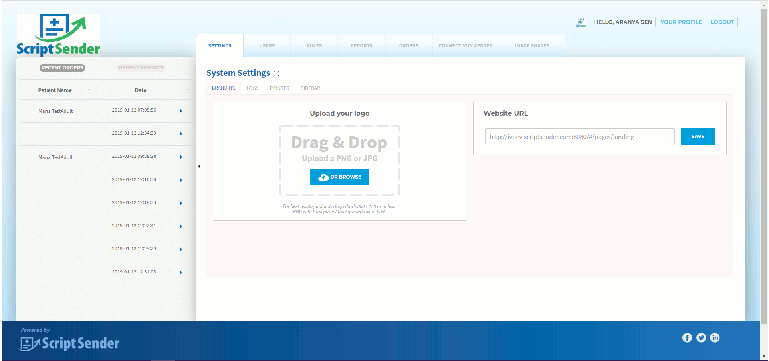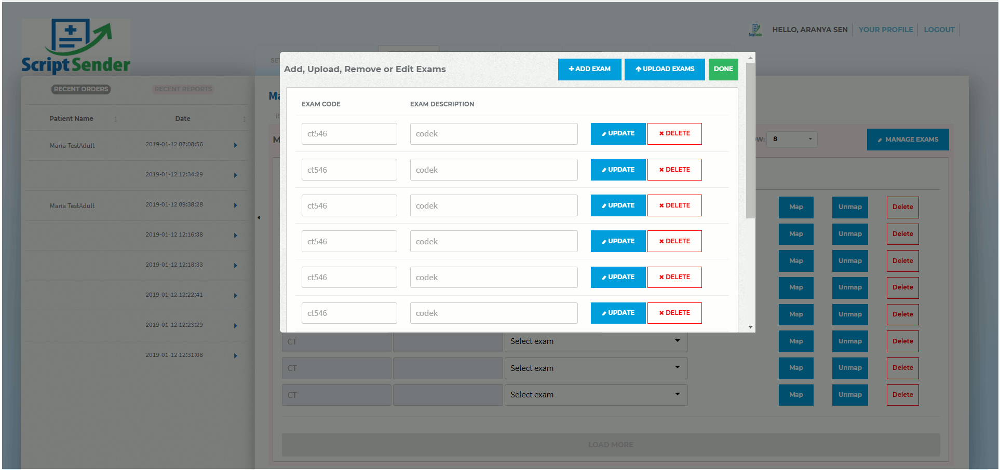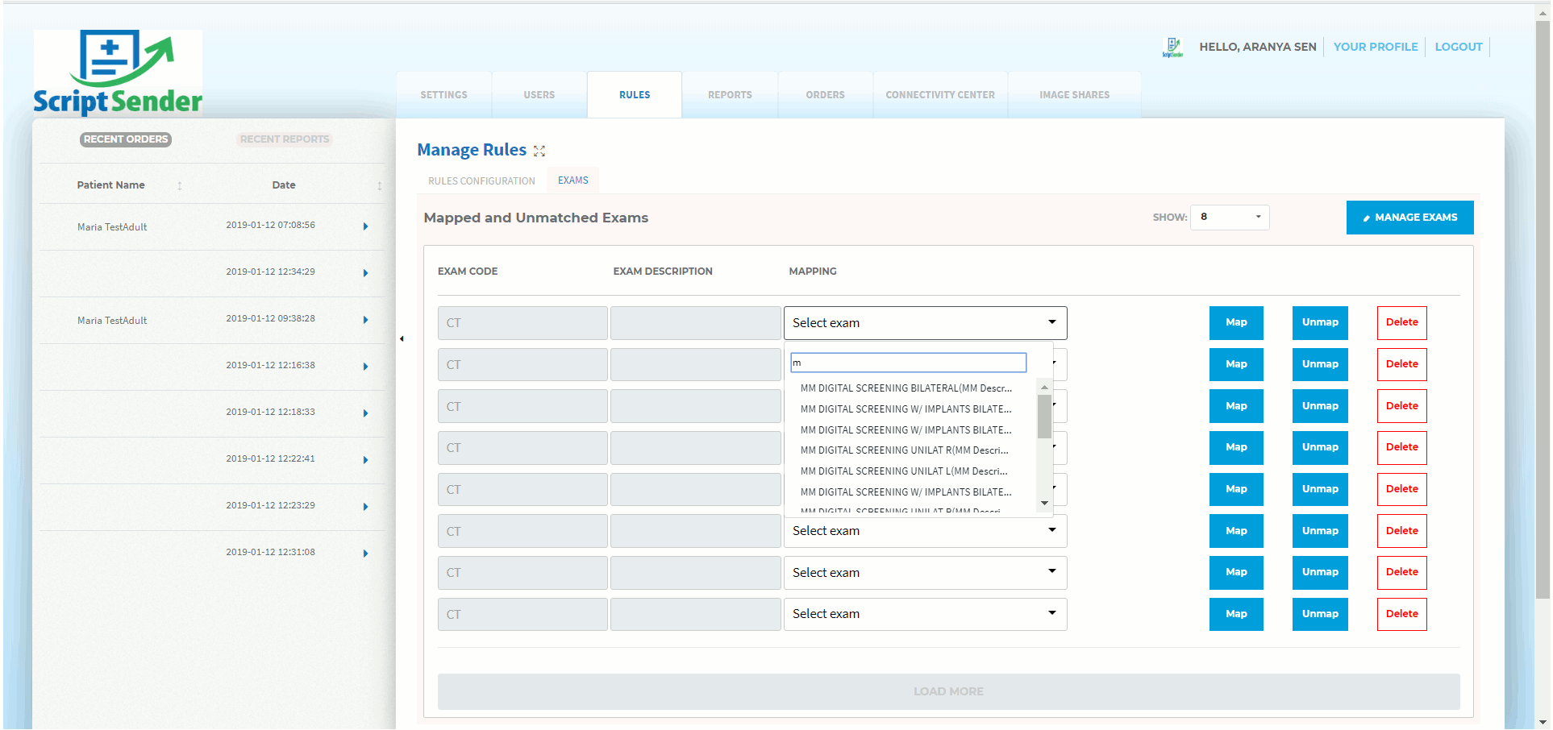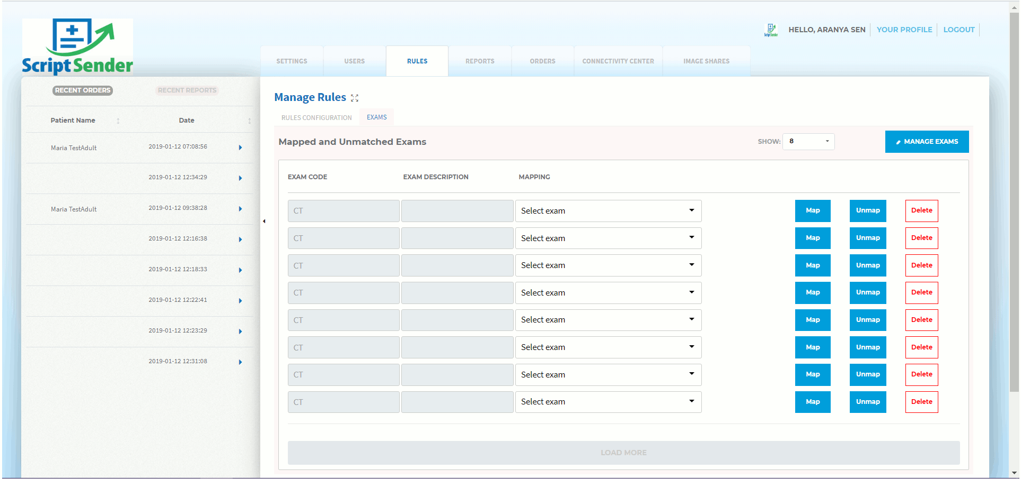

Travel Analytics
This project is for a travel company in Australia (https://www.travelanalytics.com.au/). They had an existing reporting dashboard which they wanted to modernize using SPA framework and visualization libraries. The project lasted for eight months and we were responsible for developing the front-end using SPA framework called VueJS.
The project is delivered successfully and the new project snapshots can be seen in their website on their home page. The app is built using web pack template of Vuejs and using Vuex for store management. Charjs is used for visualization - bar charts, pie charts, world map. Entire app was built using mock data which helped speed up things by not waiting for back-end team for real APIs. Swagger specs were used to refer to the API structure which helped in API integration at a later stage.
Proper unit tests were created using Mocha, Chai which helped in reducing risk of introducing breaking changes. Overall the application was a pleasant experience for client as well as for us as a development partner.
Demo of the app with mock data can be seen at -
http://ta.clickvalley.in/#/accommodation
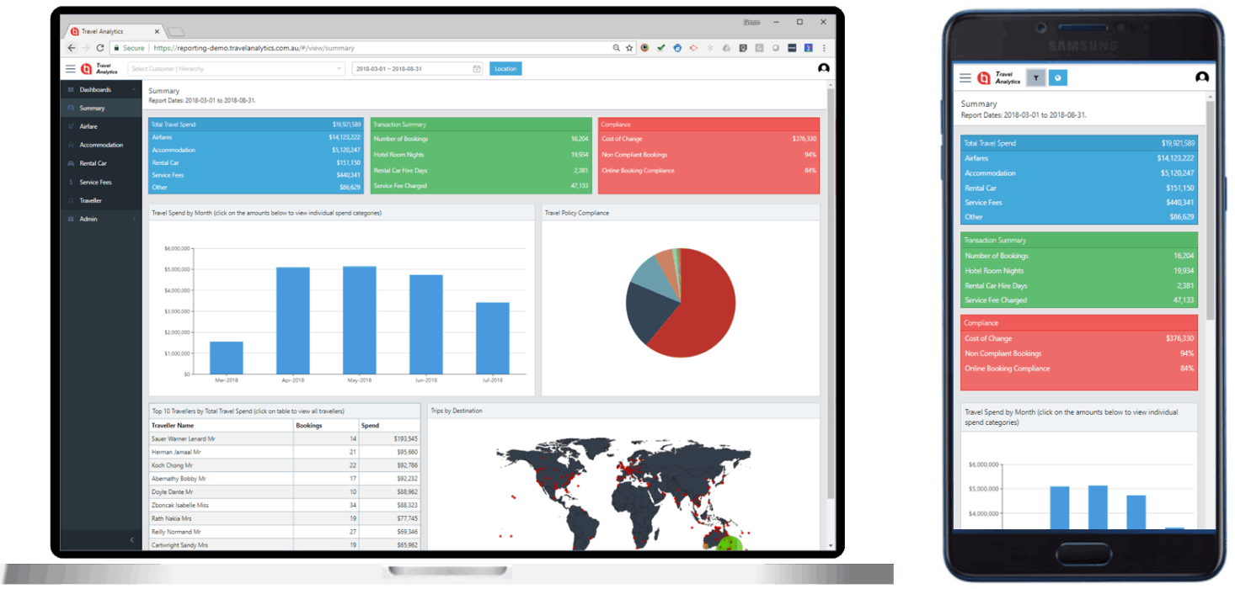

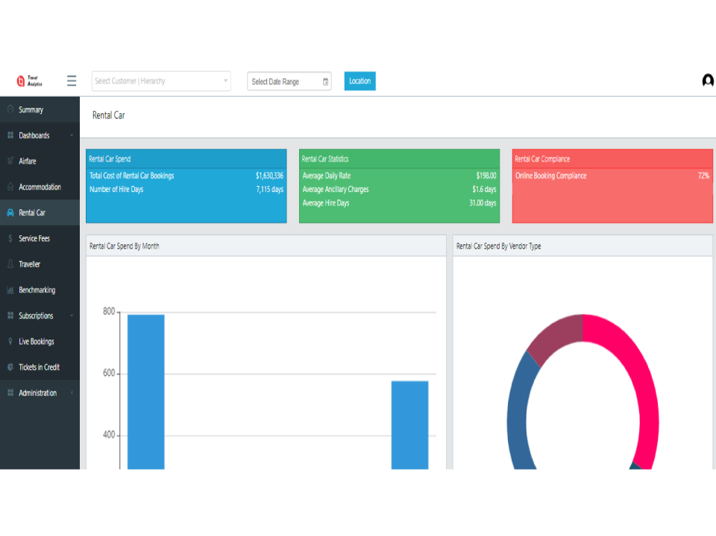
UMBRACO PROJECTS

Axitrader Website Content Management
Axitrader is a Forex trading platform headquartered in Australia and is active in 50+ countries. I was involved in managing their main website (axitrader.com) which was developed in ASP.NET Core, Umbraco and had multi-lingual support.
Main job responsibility was to enhance the CMS and add features and address bugs. I was also involved in address SEO related technical issues which could be handled from Umbraco backend by document types, templates and by overriding the asp.net code.
The project was based on Umbraco 7.11. The website can be accessed from -
https://www.axitrader.com
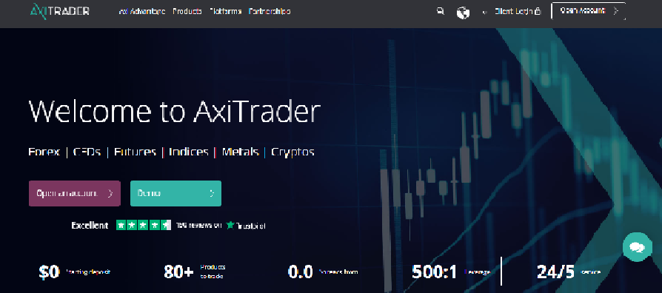
Quick Proposal
Quick Proposal is our agency's product that was developed for a personal use and later was deployed on Google Play store for public use. The motivation behind this product was to be able to generate effective content on mobile for proposals. It can be used to generate proposals of any kind. With few swipes, a beautiful proposal is ready to be used in any kind of application. The product was originally a mobile app built in Xamarin but we are extending and developing its web version in nodejs and angular.
The technologies used are - MEAN stack, MySQL, Xamarin. The product can be seen on play store -
https://play.google.com/store/apps/details?id=com.quickproposal.launcher
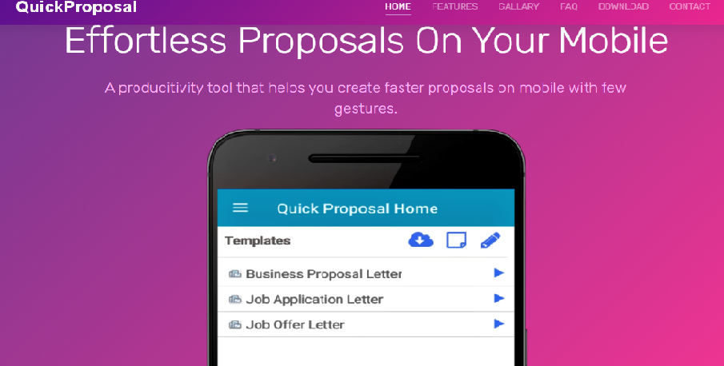

ClickValley:

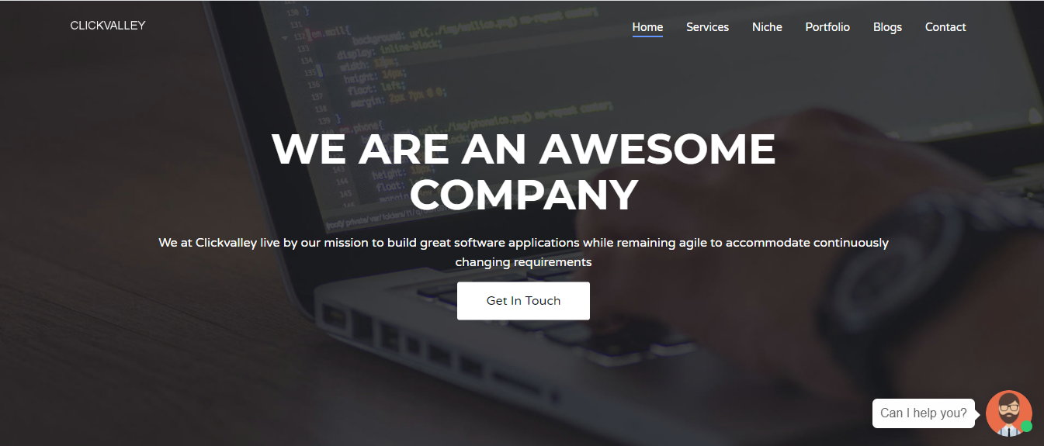

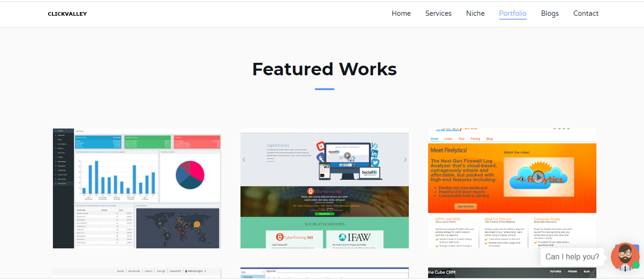
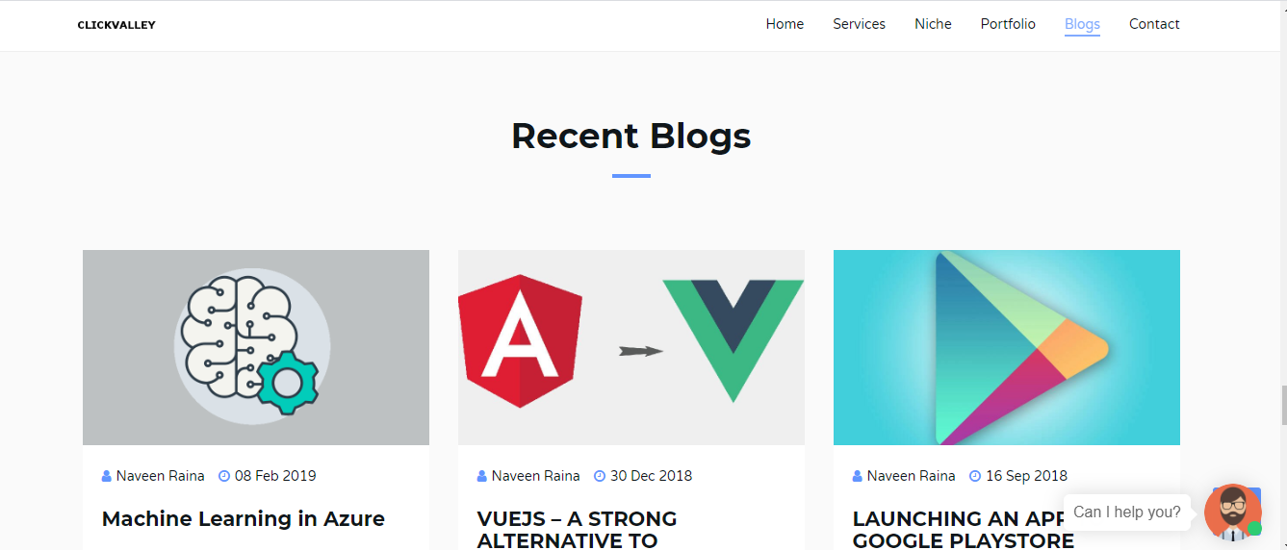

DESKTOP APPLICATIONS

We offer platform-specific and cross-platform desktop app development services to help you turn a solid software idea into a market sensation, as well as couple your manufactured devices and equipment with complementary software to gain customer loyalty and outdo competitors.

Office Automation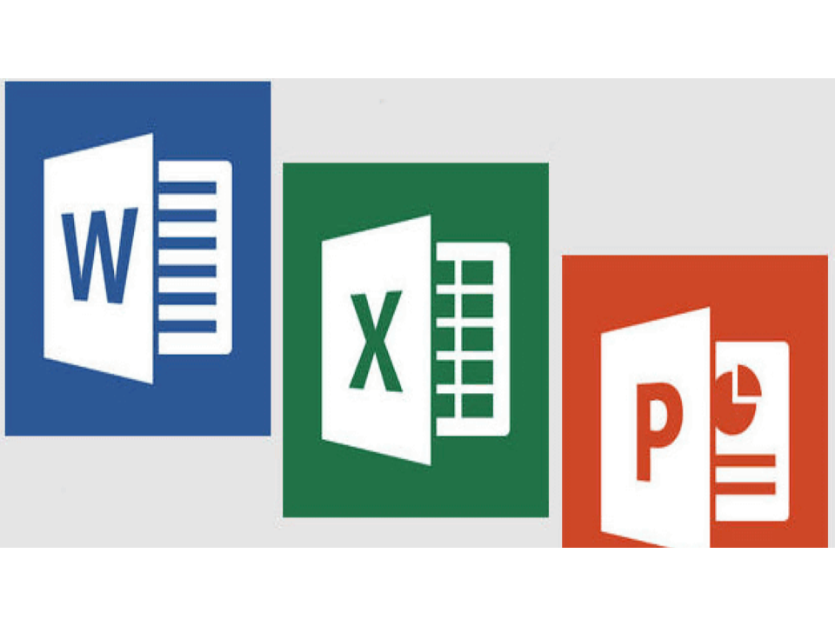
ASP.NET Web API, ASP.NET, C#
Office Suite Automation (C#, Web API) This project is to support the back-end processing of Office documents like Word, Excel, PowerPoint, and Project. The project involved processing all Office App operations in backend on an Azure Virtual Machine where this app is deployed. This app had two components - Web API - This is a secure API that accepts Office commands in the form of JSON and saves them in a Message Queue for the Automation Core component to process the commands. Automation Core - This is a windows service that performs Office operations on a given document (passed as FileBase64 in Open command) and then returns the updated document (as FileBase64) as a response to Message Queue (from where Web API returns it back to caller). Microsoft documentation for Interop is followed to implement all commands (like a copy, paste, replace text, and many more commands).

MOBLIE APPLICATIONS
Mobile development using Xamarin, Ionic and React Native.

QuickProposal

QuickProposal is a productivity tool that helps you create faster proposals on mobile with few gestures. It helps you tailor each cover letter to reflect the duties of the job you’re applying for and hence you’ll have a better chance of making it through and standing out to recruiters. It saves you time spent typing the same text over and over again. With a few gestures, you will be ready with an attractive proposal ready for disposal. You can use it for creating job application cover letters, recruiters offer letters, business proposals and more.

