School/ Department Name: Diploma in Management/Diploma in Marketing

Course Name: International Business

Course Code: 16SMGB222

Instructor Name: Lorena Abuin-Lorenzo

Assessment 1 – Country Profile – PESTEL Analysis: Social and Economic
Due Date: Week 5

Student's Name:
Student ID No:
Section:

INSTRUCTIONS
This research corresponds to the social and economic pillar of the PESTEL analysis for investment in foreign countries. Your research will be focused on a country assigned by the instructor. The objective is to research the country to evaluate the feasibility of expansion into this market. Only selected and reputable sources (WEForum, World Bank, IMF) are accepted on this assignment, and you must include the source link on your response. You are required to do the following for each item listed in the report:
- Research the item
- Specify the fact(s) from your research and reference all your sources
- Explain why the indicator is relevant for an international business

Assignments submitted after the due date have a penalty of 10% per day.

DO NOT WRITE IN THE AREA BELOW:

Mark ________/14

Feedback: ________________________________________________________________
________________________________________________________________
Instructor’s signature: __________________________
Student’s Signature: ___________________________

TASK DETAILS:

Complete the tables below with required information, and present back to class as per your instructor's schedule.

BASIC COUNTRY DATA | PROVIDE THE INFORMATION, CITE YOUR SOURCE AND PROVIDE EXPLANATION  - INCLUDE THE REQUESTED INFORMATION WITH THE RELEVANT SOURCE LINK  - EXPLAIN WHAT DOES THIS INFORMATION MEAN  - EXPLAIN WHY IS IT RELEVANT FOR THE COUNTRY YOU ARE ANALYZING
COUNTRY NAME, CAPITAL AND CONTINENT IT BELONGS TO | United Arab Emirates  Abu Dhabi  Asia
An economic system (Command, market, mixed) | - The UAE has an open economy, making it a strategic hub and a business-friendly environment (UAE Economy ).  - Due to this reason, there is significant growth in the GDP of the country.  - An open economy leads to business partnerships that help in raising the economy of the country.
Interest rate (Prime Lending Rate) | - The UAE's interest rate has reached a record low of roughly 0.43% in the year 2020 and an all-time high of 2.92% in 2019 (ceicdata.com 2020).  - The organization's cash policy rate was placed at 1.25% annually in the last quarter of 2020.  - Interest rates help in determining how the country can offer loans to its people.
Inflation rate | - The United Arab Emirates' inflation rate in 2019 was recorded at -1.93%, which is a decline from the initial 3.07% recorded in 2018.  - A decline in the inflation in an economy helps improve the country's economy by improving the business.
Exchange rate (to USD) | - The exchange rate of the AED against the USD is at one US dollar exchange for 3.2663 AED.  - The exchange rate is significant as it helps in determining the country's economic health.  - Through the exchange rate, it is clear that the relative level of the AED is relatively high.  - This means that it is a high valued currency making its imports cheaper and the exports relatively high.
GDP per capita (US$ per annum) (World Bank) | - The GDP per capita is at $43,004.95 as of 2018.  - It shows that each citizen of the country can be attributed to the amount of their economic production.
CRA (Coface) | n/a
Global Competitiveness Index (WE Forum) | - According to the global competitiveness report, the UAE is ranked the 25th globally and first in the Arab region.  - The report assesses 141 economies the country is involved in.
Population size and growth rate | - The population of the country is approximately 9.9 million people (Worldometer 2020).  - The population growth rises at a steady growth of 0.13% with a population density of 118 per km2.
Life expectancy at birth rates (2018) | - The life expectancy at birth rate is 77.65 years as of 2017.  - The life expectancy at the birth rate for the women falls at 79.16 years.
Population pyramid (image) | 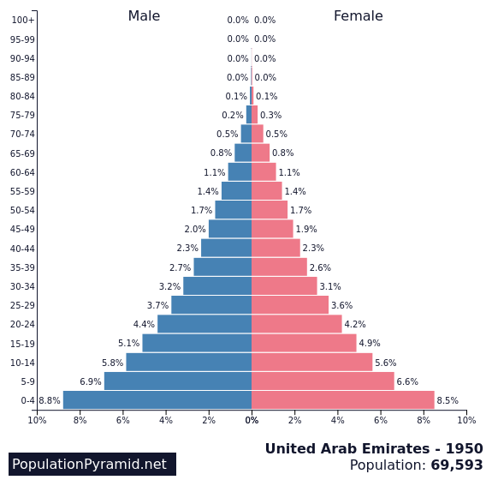 (populationpyramid)
Adult literacy rate | - The adult literacy rate is 93.2%, which indicates that most Emiratis are well educated.
Cultural norms and values: relate the social norms and values to the Masculinity/Femininity Index by Hofstede (include score) | - Most cultural and norms of the Emiratis are based on the Islamic values where etiquette and customs are derived from.
Religion and beliefs | - Most UAE Emiratis being to the Sunni Muslim religion, and the beliefs are mainly focused on the Islamic law.  - Other religions are given the freedom to worship as the freedom to expatriate is provided to the population. This is an essential quality as it speaks of a diverse country.
Crime levels (Intentional homicides) | - The UAE's crime rate was at 0.50 in 2017, which is a 28.57% decline from the 2016 rate.  - This shows that the crime levels in the country have significantly reduced.

Task No. | Student is able to do | Assessment Task Maximum Marks: | Assessment Task Assigned Marks to Student:
1 | Economic system | 1
2 | Interest rate | 1
3 | Inflation rate | 1
4 | Exchange rate (to USD) | 1
5 | GDP per capita | 1
6 | CRA (Coface) | 1
7 | Ease of doing business | 1
8 | Population size and growth rate | 1
9 | Life expectancy rates | 1
10 | Population pyramid | 1
11 | Adult literacy rate | 1
12 | Cultural norms and values (Hofstede) | 1
13 | Religion and beliefs | 1
14 | Crime levels | 1
 | Assessment Weight | Assessment Total Marks Achievable: | Assessment Total Marks achieved by Student:
 |  | 14

References
Population pyramids of the world from 1950 to 2100. (n.d.). PopulationPyramid.net. https://www.populationpyramid.net/united-arab-emirates/1950/
UAE economy. (n.d.). Welcome | UAE Embassy in Washington, DC. https://www.uae-embassy.org/about-uae/uae-economy
United Arab Emirates population (2020). (n.d.). Worldometer - real time world statistics. https://www.worldometers.info/world-population/united-arab-emirates-population/
United Arab Emirates short term interest rate. (2018, June 1). Global Economic Data, Indicators, Charts & Forecasts | CEIC. Retrieved December 2020, from https://www.ceicdata.com/en/indicator/united-arab-emirates/short-term-interest-rate#:~:text=The%20data%20reached%20an%20all,1.25%20%25%20pa%20in%20Oct%202020

