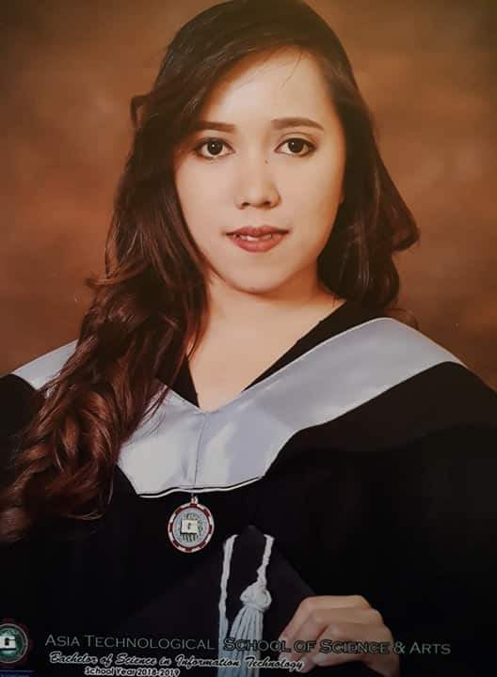
MARY JANE R. DIMAS
Purok Yakal, Diaz Compound Poblacion II
Basud Camarines Norte
Contact Number: 09383538796
Email Address: charmolypimj@gmail.com

EDUCATIONAL BACKGROUND:

Tertiary Bachelor of Science in Information Technology
Asia Technological School of Science and Arts
Golden City Subd. Brgy. Dila Sta. Rosa Laguna
( A.Y 2015 – 2019 )

Vocational Computer Science (Short Term Course)
Xavier Technical Training Center
August 2013 – October 2013

Secondary Accelerated
Alternative Learning System
Central 1 Sta. Rosa, Laguna
( A.Y 2011 - 2012 )

SKILLS:

- Oriented In Microsoft Applicaton Such as:
- Microsoft Office Word
- Microsoft Office Powerpoint
- Microsoft Office Excel
- Basic Arduino Programming
- Programming Experiene (HTML, PHP , SQL)

WORKING EXPERIENCE:

I.T Staff Intern Netsite Biz et al
Waltermart Balibago Sta. Rosa, Laguna
(O.J.T) Encoder Yumemirai Language Learning Center
Pala-Pala Dasmarinas City, Cavite
SEMINARS ATTENDED :

“Adobe Photoshop Tips and Tricks”
Gardenside Resort Pink Villa Roseville Subd.
February 14, 2018

“Trends In Industrial Automation Using PLC”
Gardenside Resort Pink Villa Roseville Subd.
February 14, 2018

“Game Development”
Gardenside Resort Pink Villa Roseville Subd.
February 14, 2018

“Technopreneurship”
Gardenside Resort Pink Villa Roseville Subd.
February 14, 2018

“Web Application with Database System”
Gardenside Resort Pink Villa Roseville Subd.
February 14, 2018

“IT Securityt”
Gardenside Resort Pink Villa Roseville Subd.
February 14, 2018

Personal Information:
- Age : 25 years old
- Gender : Male
- Status : Single
- Languages : Filipino & English
- Citizenship : Filipino
- Religion : Born Again Christian
- Height : 4’11
- Weight : 45 kg.

Character Reference:
Judy Ann Calapit
Office Staff
Hyundai Sta. Rosa 0926 320 7009
Mary Anne Manuel
Business Administrator
LightHouse Club Manila
09338628835
Zyrix Ryan U. Fagela MIT
ICT Professor
ASIATECH College
09157802737

I hereby certify that the above information is true and correct to the base of my knowledge and belief.

_______________________
Mary Jane R. Dimas

