6 Simple Ways to Lose Belly Fat, Based on Science

Overview

Having belly fat is not only a problem that can affect your health, but it is also an issue that can make your body appearance look very bad. Too much belly fat in the abdominal area is closely associated with health complications such as heart diseases and type 2 diabetes that can make your life difficult. It is therefore important for a person to lose belly fat as it has great benefits for your health and makes you have a longer life span.

Estimation of belly fat can be easily done from the comfort of your house using a simple tape measure that you can buy. With this tape measure, you can use your own ways to measure the circumference around the waist and come up with a rough estimate. Any measurement that exceeds 40 inches (102 cm) in men and 35 inches (88 cm) in women is considered an abdominal obesity.

How to lose belly fat

For a person that has a lot of excess fat along their waistline it is highly recommended that you take the necessary steps to get rid of it regardless of whether you have a heavy body weight or not.

Fortunately, it is possible to get rid of belly fat when you use your own ways that target the belly fat leaving alone other parts of the body. Some of these include:
- Do not eat sugar and avoid sugar-sweetened drinks
Using sugar is very unhealthy as it causes health complications especially if it is added sugar. From the studies that have been carried out, it is proven that sugar has adverse effects on one’s metabolic health.

Sugar is made up of Glucose and Fructose in equal amounts. Metabolism of Fructose is entirely done by the liver in significant amounts and thus too much intake of added sugar overloads the liver with Fructose. This forces the liver to turn the excess Fructose into fat that ends up accumulating in the liver and belly.

Studies suggest that this action is the primary mechanism behind the harmful health effects that sugar has on a person’s health. This is because added sugar increases liver fat and belly fat leading to insulin resistance and other metabolic problems.

For people that like taking liquid sugar, the effects that it has on the body is worse than that posed by added sugar. This is because when you take beverages that are sweetened with sugar, you end up taking more calories since liquid calories are ‘registered’ in the brain in a hasty manner when compared with solid calories.

From the studies that have been conducted, sugar-sweetened beverages are closely linked with a 60% increase in the chances of obesity in children when taken on a daily basis.

Make the choice of reducing the amount of sugar you take in your diet and consider taking other beverages rather than using sugary drinks like fruit juices and sugary sodas. You should note that this does not apply to whole fruits, which are very healthy as they counter the negative effects that Fructose has on the body.

Reading labels is the best way a person can start with when you want to cut down the intake of refined sugar. Try this option as it makes you use your own ways in losing belly fat.
2. Start eating more protein.

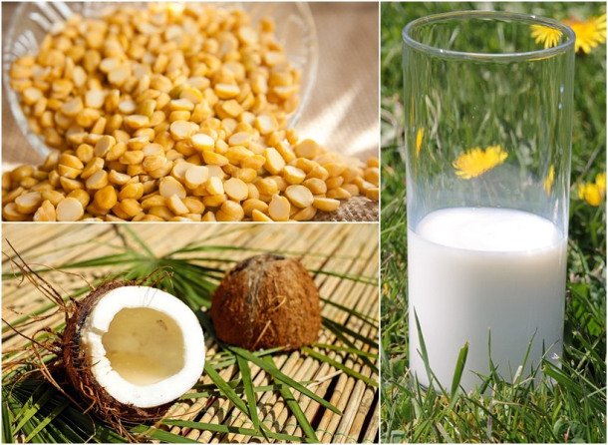
https://indianexpress.com/photos/lifestyle-gallery/10-high-protein-foods-to-help-you-lose-weight-2999069/

From studies conducted, proteins improve metabolism rate by 80-100% in a single day while also reducing any craving by 60%. They are also beneficial as they assist you in reducing the amount of calories consumed in any given day.

If you want to lose your belly fat in no time, adding the amount of protein in your diet is highly recommended. This is one of easiest methods as it requires you to use your own ways instead of using artificial methods.

Studies carried out have proven how proteins work against belly fat in your body. For people that have a regular intake of proteins, the level of belly fat tends to be less compared to those with less intake.

It is important to ensure that you are having the correct intake of proteins approximately 25-30% in a day to reduce your belly fat. Foodstuffs with high-protein include:
- Fish
- Seafood
- Dairy products
- Meat
- Nuts
- Eggs
You can also use your own ways to get a protein supplement as it plays a key role in boosting your protein levels. An example of a good supplement is the Whey protein.

3. Use your own ways to reduce carbs in your diet

When a person cuts down the intake of carbs, they tend to lose their appetite resulting in weight loss. This can be supported by the over 20 studies that have been carried out proving the role of carbs in reducing your weight.

Other studies have also shown how a reduced curbs intake influences positively in the loss of belly fat. The curbs assist in reducing the dangerous abdominal fat that if not destroyed will lead to health complications.

Use your own ways to reduce the intake of refined carbs such as white bread and candy while at the same time increasing your protein intake. This will be of great help in reducing your weight and containing other health complications like type 2 diabetes.

4. Add fibre rich food to your diet

http://www.besthealthmag.ca/best-eats/nutrition/vegetables-high-fibre/view-all/

Inclusion of fibre in your diet is beneficial to your health. This is because fibre does not undergo digestion easily. Increase in fibre intake especially viscous and soluble fibre is believed to play a part in weight loss.

This is made possible as the viscous and soluble fibre combine with water forming a thick stiffen that is deposited in the gut. The effect of this deposition is a slowed rate of digestion and absorption of nutrients into the bloodstream. This leaves you full for quite some time and thus resulting in weight loss by the use of your own ways. On the other hand, additional soluble fibre intake of about 5 grams a day will decrease abdominal fat by about 3.7%.

The most valuable food products that contain a high intake of soluble fibre include:
- Vegetables like broccoli
- Fruits like mango and avocado.
- Cereals like whole oats.
- Nuts.

You can also spend some money on fibre supplements like Glucomanan as it is one of the best product containing fibre.

5. Exercise on a regular basis

Use your own ways to reduce belly fat by exercising on a regular basis. A person who constantly exercises has the benefit of living a longer life, avoid unnecessary illnesses and maintain a healthy lifestyle. Exercising will also help you in losing your belly fat within a short period without using a drug as it is your own ways and efforts that matter.

These exercises do not include abdominal exercises that work on the abs as they will not reduce the fat in your belly, you should try other types of exercises such as swimming, running and walking as they work on all muscles of the body

It is also important to exercise as it will reduce your chances of gaining body weight once you are done with the weight loss process. An improvement in metabolic activities that are essential in belly fat lose is another advantage that you will get after doing aerobic exercises.

6. Determine how much and what you are eating by keeping track of your foods

Keeping track of all the food that you are eating is important since you can know whether you are having all the nutrients that the body requires. If you do this on a regularly, it will be easier for you to monitor and realize the changes that you should make on your diet.

Use your own ways of monitoring the foods that you take as it is the only method that will effectively give you the expected results. You can even note down all the meals that you have had in a given week or a month and make changes based on the results you have received.

Checking online magazines and blogs that talk about the diet can also assist you in coming up with the required meal. Ensure that you take the required amount of proteins and soluble fibre while at the same time reducing the intake of sugar and carbs.

The bottom line

Making the necessary changes that help you lose belly fat is very important especially if you use your own ways. Consult your diet advisor if you are having issues in balancing the exact amount of nutrients that are helpful in the loss of belly fat.

You should also have an exercise trainer who will make your belly fat loss process easier since they will offer guidance on the training you should do. If you use your own ways to lose belly fat, the chances of regaining the fat is minimal since you will take great care when it comes to things that increase belly fat.

Knowledge of the types of food to avoid will also play a part in your efforts of maintaining a low belly fat once you are done with losing it.

