10 Black Musicians Who Changed Music Forever
Music is undeniably 'food for the soul', and when it comes in diverse genres, music lovers around the world are spoilt for choices. If we take a quick look at the history of music, we can see that the music industry has witnessed some brilliant Black musicians who have revolutionized music, especially genres like Jazz, Soul, Gospel and R & B. Here's our pick of the top 10 talented black singers of all times:
1. Bob Marley - Soulful Reggae
Bob Marley is a name synonymous with Reggae - popular music that originated in Jamaica which can be differentiated by its strongly accented subsidiary beat. A member of the Rastafarian movement, Bob Marley won the hearts of music lovers around the world with a unique brand of reggae that skillfully blends the spiritual essence of his religion with unbeatable lyricism and inspirational messages.
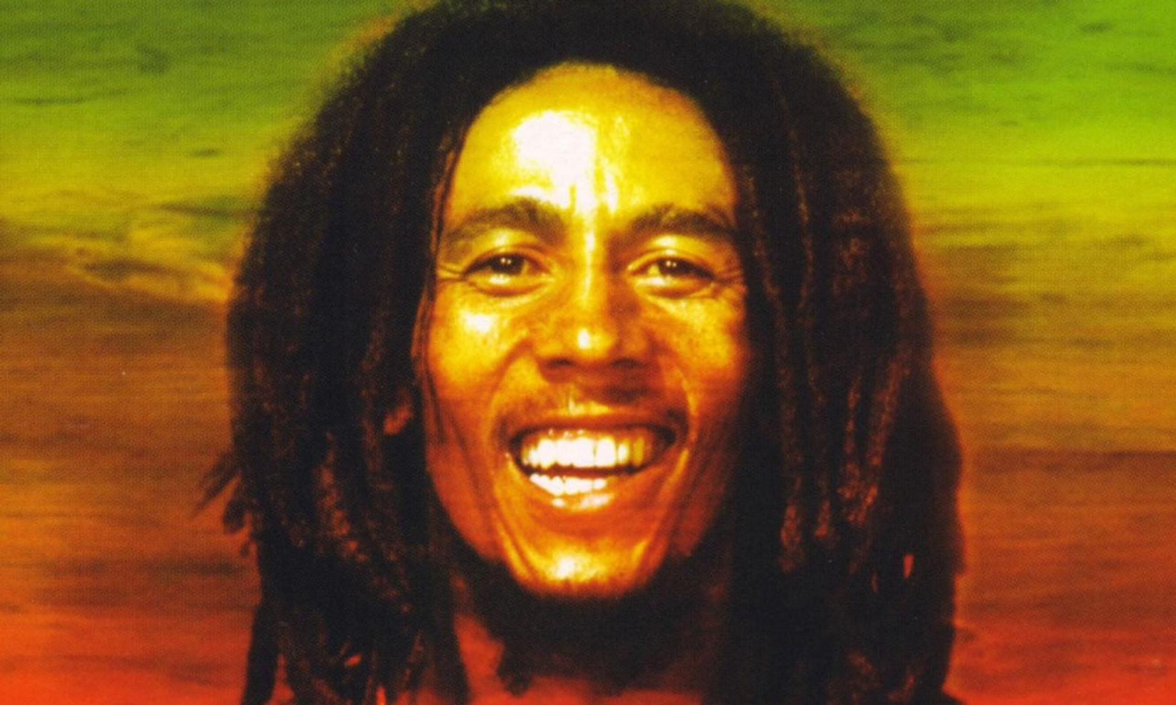
http://www.relix.com/images/uploads/about/bob-marley-5.jpg
2. Michael Jackson - King of Pop
Ubiquitously known as the King of Pop, Michael Jackson was a singer, songwriter, choreographer, producer, entertainer and humanitarian all rolled into one. No wonder he is considered a legend in the music industry who revolutionized music forever.
Besides being a great artist, a charismatic entertainer, and a phenomenal composer, Michael Jackson was gifted with a brilliant business sense too.
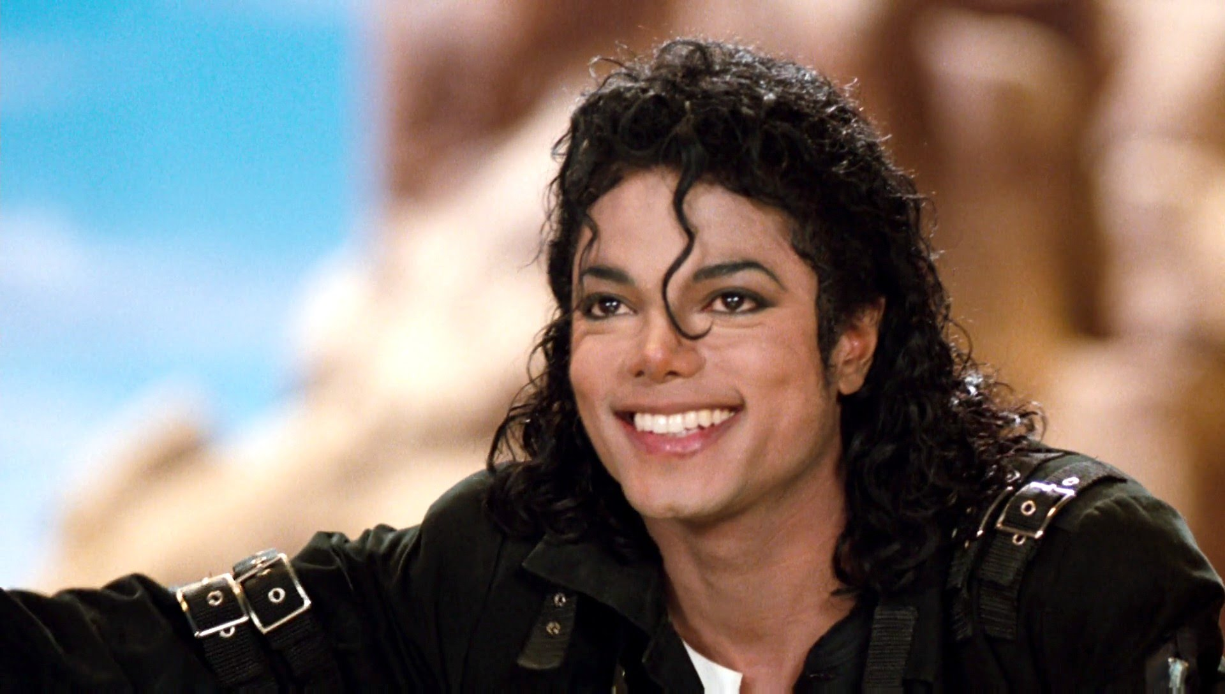
https://i.ytimg.com/vi/ubc3zwCi1Zo/maxresdefault.jpg
3. Prince - Legendary superstar
American singer-songwriter Prince captured the hearts of millions of fans across the world with his phenomenal music, his trademark look and riveting stage presence. Prince's music was a fusion of the Rock, Blues, and Jazz. Having released several albums in the 1980s, Prince is best known for songs such as "Little Red Corvette", "Purple Rain", "When Doves Cry" and "1999".
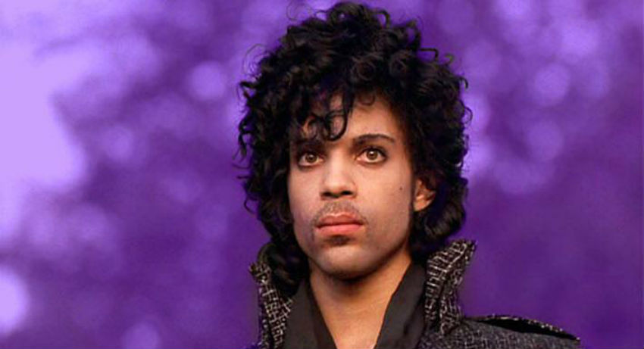
http://queerty-prodweb.s3.amazonaws.com/content/docs//2016/06/prince.jpg
4. Marvin Gaye - The Prince of Motown
Internationally acclaimed American singer-songwriter Marvin Gaye is remembered for revolutionizing the soul genre with his highly inspirational and powerful music. Marvin Gaye was one of the key contributors to America's first black-owned record company Motown. His powerful influence on R&B and soul genres won him a place in the Rock and Roll Hall of Fame in 1987.
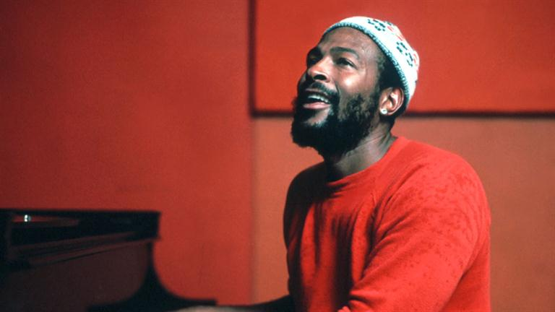
http://cp91279.biography.com/BIO_Mini-Bios_0_Marvin-Gaye_150549_SF_HD_768x432-16x9.jpg
5. Stevie Wonder - From child prodigy to music sensation
A former child prodigy, Stevie Wonder is considered to be one of God's greatest gifts to music lovers. One of the pioneers of Detroit based record label Motown, Stevie Wonder delivered multi-generational hit numbers like "Superstition", "You Are the Sunshine of My Life", "My Cherie Amour", "Living in the City," and "Boogie on Reggae Woman", among others. Stevie also won awards for his contributions to civil rights besides the UN Messengers of Peace prize.
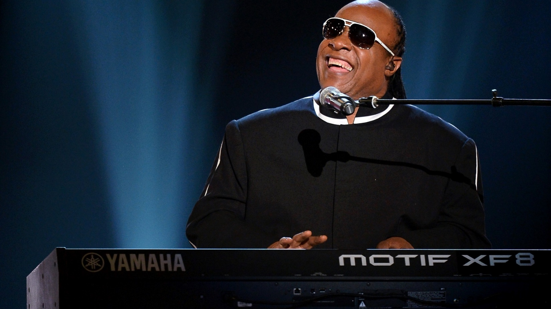
http://www.hdwallpaper.nu/wp-content/uploads/2015/08/stevie_wonder_rhythm_and_blues_soul_funk_jazz_blues_98401_1920x1080.jpg
6. Ray Charles - Father of the Soul
Vision impaired, but phenomenally talented Ray Charles (named as 'The Genius' and 'Father of the Soul') is known for pioneering Soul music in the 1950s by a skillful fusion of R&B, Gospel and Country music. As one of the most influential artists to have graced this planet, he is most famous for his hit numbers ‘Baby Let Me Hold Your Hand’, 'Mess Around’, and ‘Kissa Me Baby’.
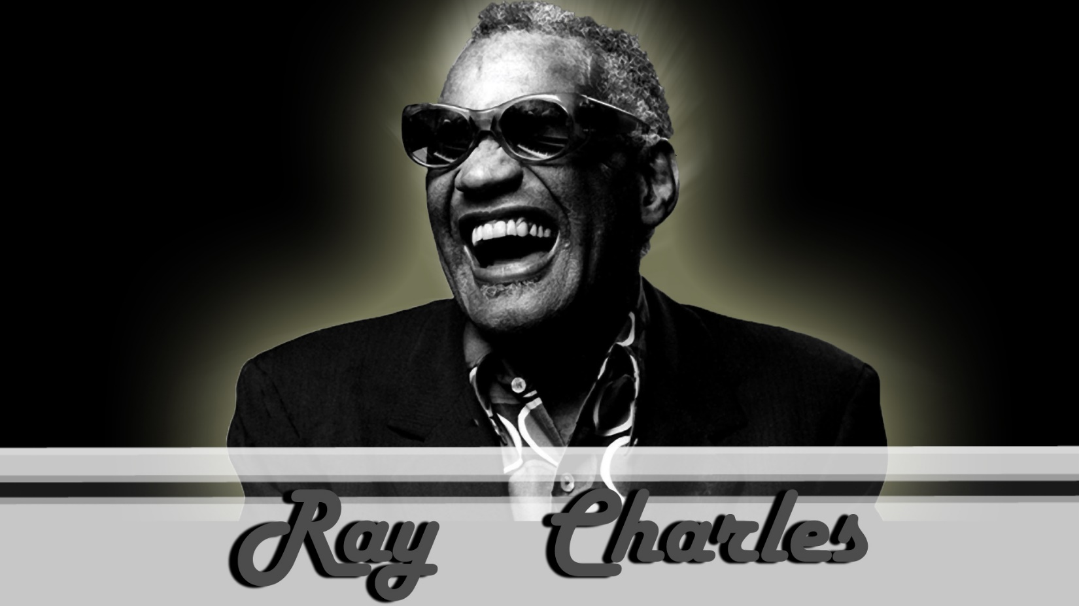
http://img0.ndsstatic.com/wallpapers/8cbd9a76b1a21702b9c6483f1deb84a4_large.jpeg
7. Louis Armstrong - The Jazz maestro
A trumpeter, singer, soloist, bandleader, film star and comedian, multi-talented Louis Armstrong is an iconic figure in jazz history.
Associated with bands like 'The All Stars', ‘His Hot Five’ and ‘His Hot Seven’, he was best known for his world renowned single ‘What a Wonderful World’.
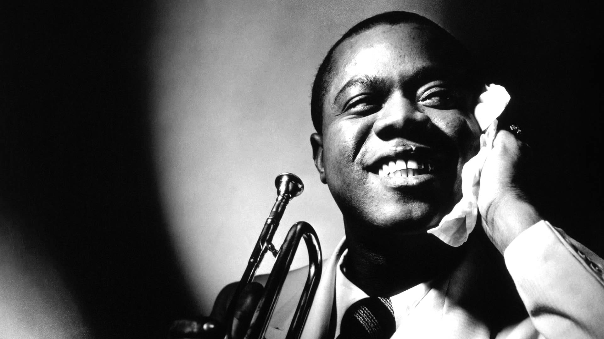
https://i.ytimg.com/vi/nJAuYiIzCLg/maxresdefault.jpg
8. James Brown - Godfather of Soul
Known as the "Godfather of Soul," James Brown was an extremely talented singer, songwriter and bandleader. He was one of the most influential artists of soul and funk music during the second half of the 20th century. With an arresting stage presence, Brown popularized the era's much celebrated dance moves. He is best known for churning out hit singles like ‘Get Up Offa That Thing’ and 'Sex Machine'.
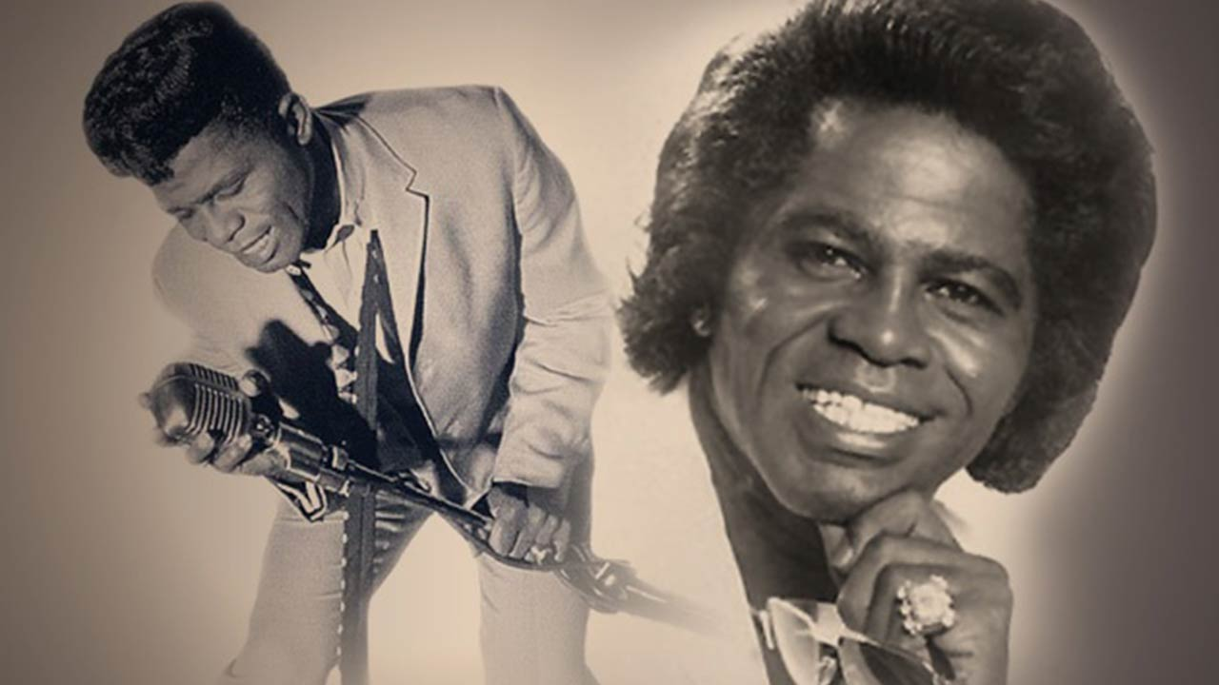
http://wciv.images.worldnow.com/images/4260129_G.jpg
9. Whitney Houston - An iconic voice
An extremely popular figure in the music scene of the 1980's, American singer and actress Whitney Houston was loved for her unique voice and style. Her first four albums, released between 1985 and 1992, were sold in excess of a whopping 86 million copies globally. Talk about talent!
Having delivered single hits like ‘Saving All My Love For You’, she collaborated with Mariah Carey for another of her renowned hits ‘When You Believe’.
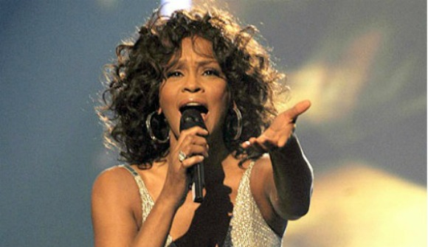
https://pmcdeadline2.files.wordpress.com/2012/09/whitneyhouston__120927161425.jpg
10. Aretha Franklin - Queen of Soul
Called the "Queen of Soul", Aretha Franklin was a multiple Grammy Award winner best known for hits such as "I Say A Little Prayer", "Respect," and "Freeway of Love". A phenomenal singer and pianist, Franklin's popular singles are now considered to be absolute classics. She became the first female artist to be inducted into the Rock and Roll Hall of Fame in 1987. She won her 18th Grammy Award in 2008, emerging as one of the most celebrated artists in Grammy history.
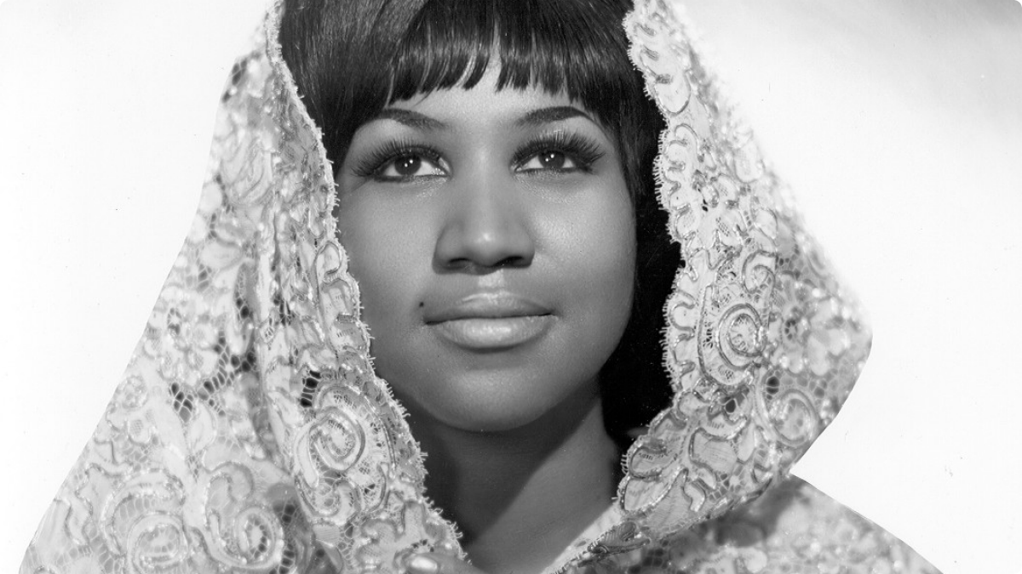
http://blavity.blavity.netdna-cdn.com/wp-content/uploads/2015/06/082411-music-protest-aretha-franklin.png?e11daf
So, the next time you crave for some soul food, don't forget to check out some of the masterpieces of these musical geniuses.

