TEA TREE OIL USES AND BENEFITS
META DESCRIPTION: TEA TREE IS ALSO KNOWN AS MELALEUCA OIL. IT IS KNOWN FOR CURING BACTERIAL AND FUNGAL INFECTIONS. IT HAS MANY OTHER BENEFITS AS DISCUSSED BELOW.

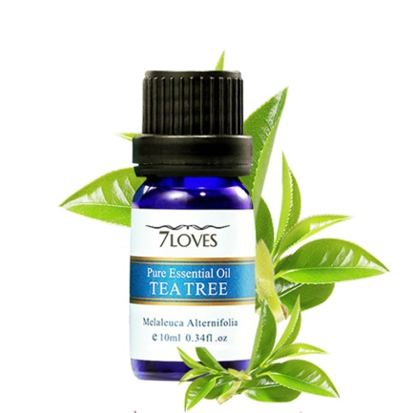Image from Google
Tea tree oil has a good smell and has various colors. It can be clear, pale yellow or colorless. It is also known as melaleuca oil.
You get the oil from myrtle tree leaves. In ancient days the trees were found in southern Wales and Queensland. It is not to be taken orally because it is poisonous. You can only apply it on the skin.
It has many benefits like treating fungal diseases, dandruff and bacterial infections. It soothes insect bites.
In the ancient days it was used to treat Candida infection in women. It was used to message the feet of athletes.
Do not use it on children to avoid rashes that come as a result of irritation.
You can mix it with some little water and spray it on places where mold can grow. This includes the walls of the bathroom and the curtain in humid rooms. Spray it on your washing machine and drawers.
You can use it to clean your face, hair, laundry and for massaging.
Today I will concentrate on the benefits of using it.
1. IT CAN BE USED TO CLEAN YOUR HAIR
When you use this oil on your scalp it removes dandruffs and moisturizes the scalp and hair. For people who suffer from lice this is a good remedy. They will die instantly.
To make a shampoo mix it with a few drops of lavender oil, Aloe Vera oil and coconut oil. It will give you a shinny silky texture.
2. IT HELPS IN TREATING FUNGUS
It has a compound that helps in killing fungus and parasites. People who run for long distances have fungal problems.
Use a small piece of cotton wool to apply undiluted oil on the affected area. You can add a few drops of oregano oil to eliminate wart and resistant fungus.
Do not go for an expensive medication that you are not sure if it will work. Buy this oil because it is very effective and has no side effects.
3. IT CAN BE USED AS A DEODORANT
This oil has antimicrobial components, they destroy bacteria that make you to have bad odor. You can prepare your own deodorant by mixing a few ingredients.
Take a few spoonfuls of baking powder, lemon oil and mix with this oil. Add coconut oil on this paste. Apply a small amount on your toes and in your shoes.
For athletes they can apply it on their sports shoes,
4. IT HELPS IN PREVENTING CANCER
When you notice a bruise you can apply this oil on it. Mix it with raspberry seed oil and frankincense oil.
Stir well until all of them mix completely. Apply on the affected area three times a day. Repeat this consistently to get quick results.
If you doubt the cause of the growth, consult the doctor.
5. IT IS USED TO PROTECT THE SKIN
The oil is effective in protecting your skin from dehydration, rash and acne. It does not have any side effect unlike the chemical remedies.
Mix a few drops of this oil with two tablespoonful of honey. Use the mixture to wash your face.
The irritation stops immediately and the skin start regaining smooth and shinny texture. Do not go for cosmetics. Most of them have not been medically proven to be fit for your skin. You may end up having a major problem than you had initially.
6. IT CAN BE USED TO GET A FRESH BREATH
A smelly mouth makes people to have a low self esteem. They do not have the confidence to talk in the presence of people.
Tea tree oil is able to destroy harmful bacteria that inhabits in your mouth. They can cause a bad smell and contribute to gum bleeding.
Mix this oil with baking powder and coconut oil. Use it to gurgle three times a day. This will give you a fresh breath and stops tooth decay.
7. IT IS USED IN ELIMINATING MOLD
The oil has the ability to destroy mold that grows in your home. It grows in the areas that are humid like bath room and on you washing machine.
The curtain on your bathroom door can also get the mold. Ensure that you spray this oil on the sensitive areas.
8. IT IS A REMEDY FOR INFECTIONS
This oil works well in dealing with infections. Clean the cut with hydrogen peroxide and water using a clean cloth. Apply this oil on the wound to kills the bacteria.
Cover the wound with sterilized gauze. This will help in speeding up the healing process. Repeat this thrice or twice a day until you recover.
9. IT IS USED IN CLEANING CLOTHES
A fresh smell makes you to have confidence when you are with other people. Using tea tree oil in cleaning your clothes may be a beginning of your joy.
It kills the bacteria on your clothes because it has the compounds of antimicrobial. It gives your clothes a fresh smell.
It maintains the texture of your clothes and they do not fade quickly.
You can use the oil in cleaning the floor of your house. This will make the insects to disappear. The entire house will have a fresh breath. It will stop the mold from growing.
10. IT STOP SKIN IRRITATION AND ITCHNESS
Sometimes your skin may experience irritation and itchiness. As a result you may get a red rash, psoriasis and it may be dehydrated.
Using this oil will help you in getting your soft texture back. Mix it with five drops of lavender and one table spoonful of coconut oil.
Use the mixture to clean your body or to apply after bathing.
CONCLUSION
Tea tree oil is very versatile. You can use it on countless functions. It has no side effects and it is very effective.

