Stirling Residences
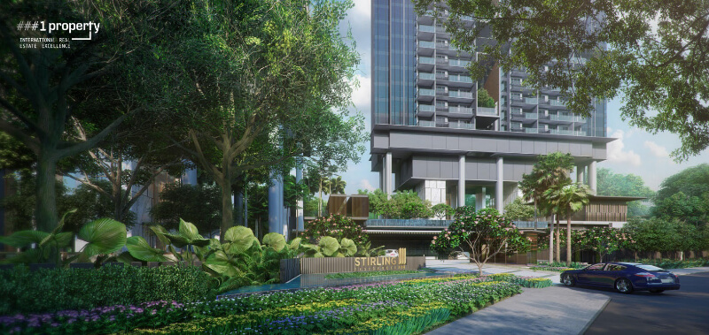
Entrance to the Stirling residence has breath-taking view of the property, covered with flush green landscaping and a beautiful gateway.
Introduction
The latest news on the brand-new residential development in Queenstown has been the brimming with excitement from the industry and as well as the buyer community. Stirling Residences will be the future of residential living experience and will reform the community based living style by bringing in vibrant energy in to the forgotten entity. Stirling Residences is expected to be completed by 30th April 2022.
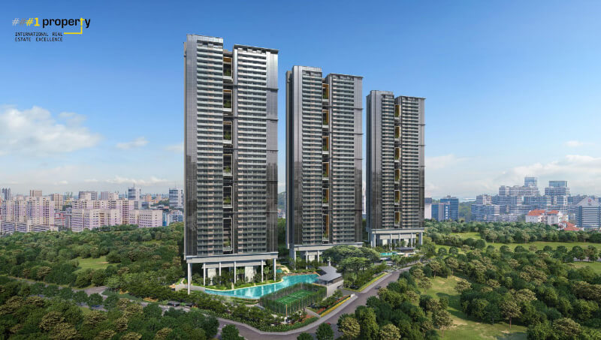
Aerial view of The Stirling residence property.
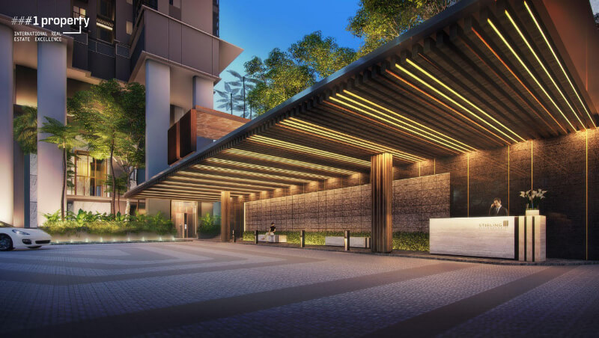
Waiting Lounge at The Stirling residence with modern facilities to provide you and your guests with the best hospitability.

About the Developers
Stirling residences developed by the Hong-Kong listed developer Logan property Holdings and Chinese developer NanShan Group have combined forces and submitted a top bid of $1.002 billion. In all 13 bidders were in the tender for the Stirling Road residential site. It is the First time that a residential site in the Government Land Sales (GLS) programme has surpassed the billion-dollar mark.

Logo of the Logan Property Holdings Company Limited

Logan Property Holding Company is operating since 1996 and has worked on some really big projects. With its target audience primarily being the first-time buyers and upgraders, they have concentrated on the residential property development in the PRC mainly the Guangdong-Hong-Kong-Macao Greater Bay area. While on other hand, NanShan Group is also an enterprise which has developed into a large-scale private joint –Stock enterprise, which has done some remarkable jobs in the past.
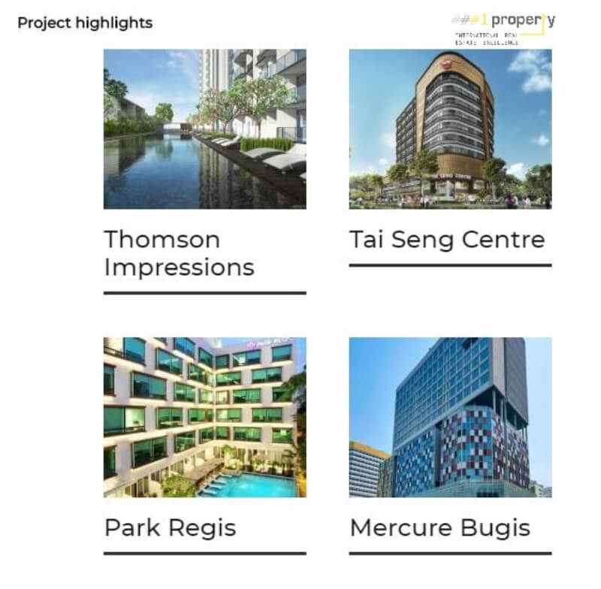
List of Highlight buildings by the Logan Nanshan group.

Location of Stirling Residences
- Stirling Residences is an upcoming residential development that is located along Stirling Road, Central region of Singapore. Stirling Residences is a part of the Queenstown planning area, a mature housing estate in Singapore.

- This city fringe residential project is situated in the junction of Stirling Road and Angora Close. Stirling Residences is just beside Queens and also next to the Anchorage.

- Other developments that are within Stirling Residence’s vicinity include Commonwealth Towers, Highline Residences, Alexis, Alex Residences, The Crest and also Principle Gardens.
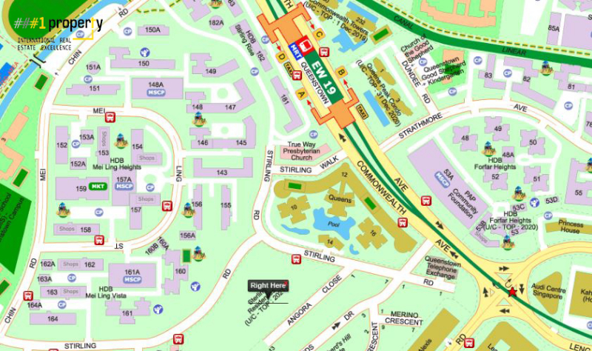
The stirling residence located at the central region of the singapore with best transit facilities around it.
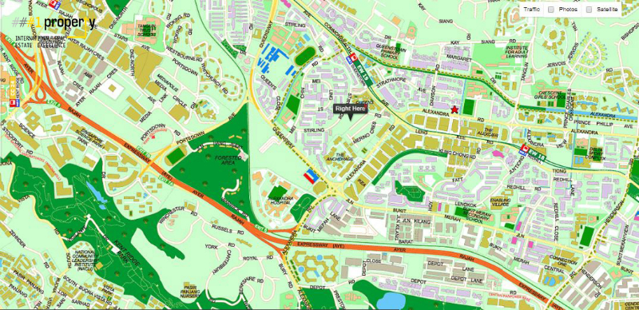
The Stirling residence is located at the best proximity from all the aminities, transport hub and major expressways.

Project Area and Built up
The total site area for this development is approximately 21,109 square metres and with a plot ratio of 4.2. Upon its completion, Stirling Residences will yield an estimation of 1,259 residential units.

Reasons to buy
MRT Station
The MRT station nearby in walking distance is a major reason to consider buying a condo in the Sterling Residences. Stirling Residences is conveniently located approximately 300 m away from Queenstown MRT Station which operates the East West Line.
- Future residents of Stirling Residences just need to travel 2 stations toward the West to arrive at Buona Vista MRT Interchange to transit to the Circle Line.
- By commuting 3 stations towards the East, future residents will arrive at Outram MRT Interchange which they could easily access to the North East Line and Downtown Line services which are readily available at the station.
- Stirling Residences is just 5 train stations away from Raffles Place MRT Station. For drivers, Stirling Residences is 8 minutes away from the Central Business District (CBD).
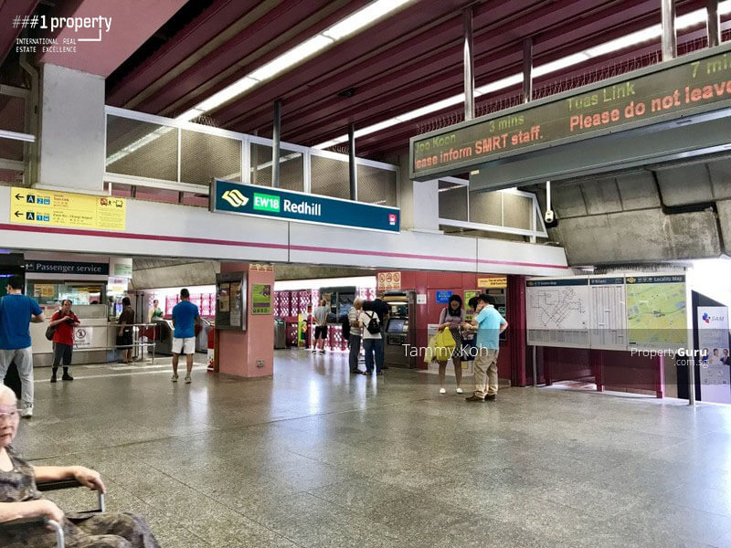
The Stirling residence is located closest to the Queenstown EW18 MRT connecting the East west line, best way to reach the world above the ground.
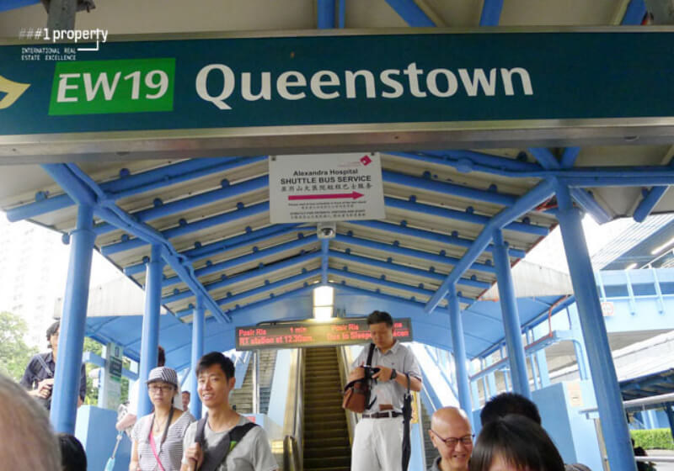
The Stirling residence is located closest to the Queenstown EW19 MRT connecting the East west line, best way to reach the world in the traffic island. 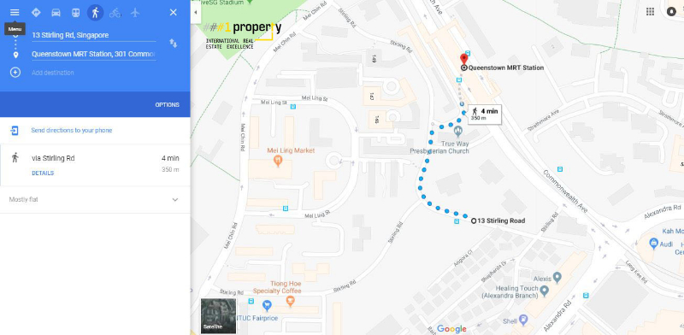
Reach Queenstown MRT Station within a 4min walk from The Stirling residence

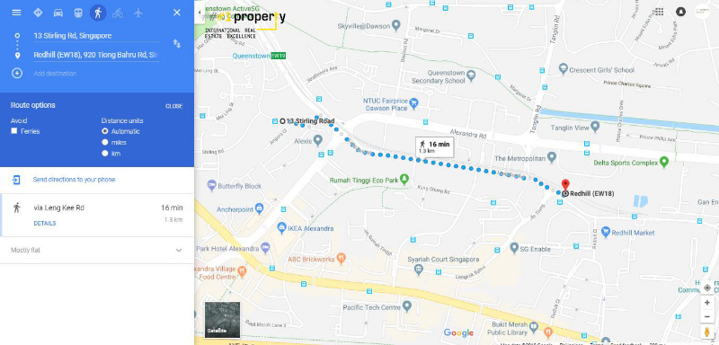
Reach Redhill MRT Station within a 16min walk from The Stirling residence

Transport Network
Stirling Residences is also just 6 minutes’ away from Orchard Shopping Area. The nearby main arterial road, Queensway, easily connects future residents of Stirling Residences to the Ayer Rajah Expressway (AYE) which links them to the Central Expressway (CTE).

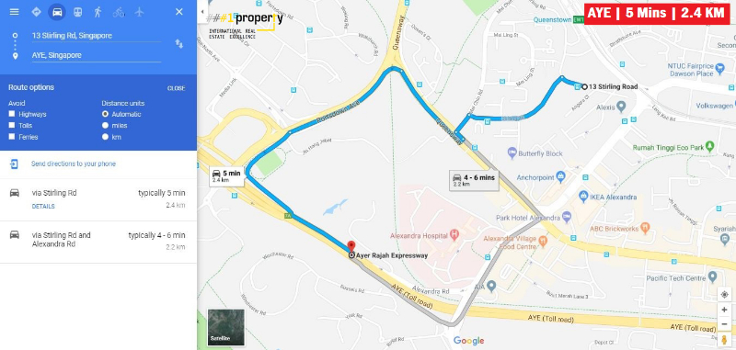
The Stirling residence is located just 2.4km away from the AYE Rajah Expressway which connects the western end of the Marina to the south of Singapore, with such a close proximity it can be reached within a 5 minute drive.

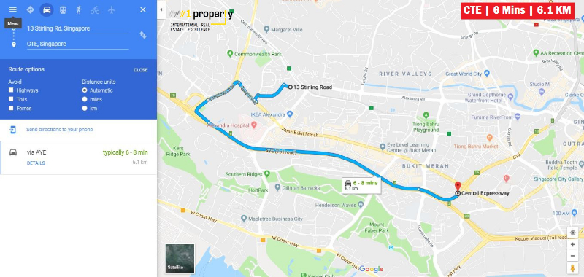
The Stirling residence is located just 6.1km away from the Central Expressway which connects the city centre to the Northern residential parts and can be reached within a 6 minute drive.
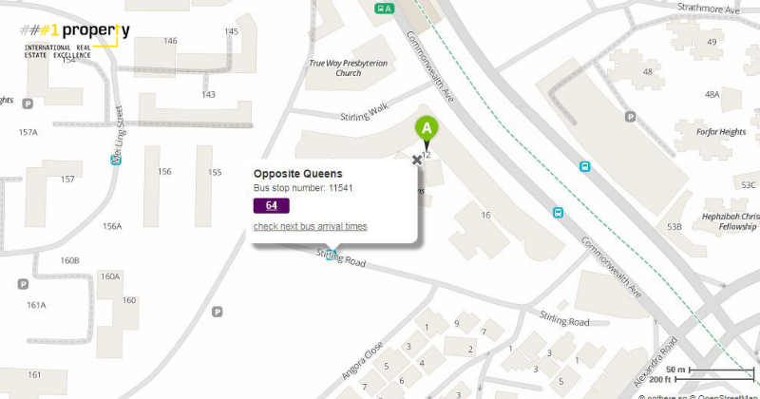
Proximity to the Best Transit – Bus stop located across the property for the residents to reach anywhere anytime without any delay.

Other Amenities Available Nearby
National Trades Union Congress fairprice Xtra sole national trade union centre is just within your reach from The Stirling residence.

- Stirling Residences is just approximately 300 m away from Anchorpoint Shopping Centre which is situated right beside Anchorage.

- The future residents are 5 min walk away from many retail shops, F&B outlets and also a supermarket right in the mall providing with their daily necessities.

- Stirling Residences is also just walking distances away from IKEA Alexandra (0.4 km), Alexandra Central (0.5 km) and Queensway Shopping Centre (0.5 km).

- Apart from the supermarkets the inhabitants of Stirling Residences can also get fresh market produce and cheap and delicious local foods easily as it is close to many wet markets and food centre.

- The residential site is in close proximity to the supermarkets such as Fairprice shop 170 Stirling Road (0.3 km), Cold storage at the Anchorpoint (0.3 km), Sheng Siong at the 88 Tanglin Halt (1.3 km) and Giant at86 Redhill (1.6 km).
- The Mei Chin Road Block 159 Market is a 5 min walk from the Stirling residences, ABC Brickworks Food Centre and the Alexandra Village Food Centre area 0.6 km from the site.

- The other well-known dining outlets near the Stirling Residences are Commonwealth Avenue Block 40A Food Centre, Redhill Food Centre, Tanglin Halt Food Centre, Tanglin Halt Road Block 48A Market and Food Centre, Redhill Lane Block 85 Food Centre, Bukit Merah Central Block 163 Food Centre, Commonwealth Crescent Market, Ayer Rajah Food Centre 3 and Bukit Merah View Block 115 Market And Food Centre are all just within the 2 km radius.

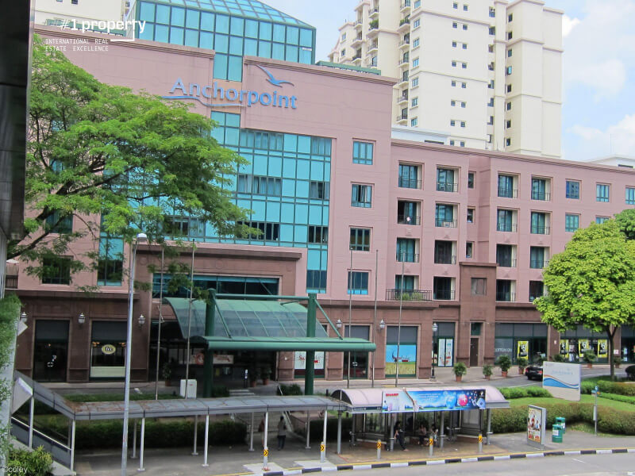
Right across the Stirling residence is the Anchorpoint Mall , a shopping mall, filled with branded options for shopping at the best price in the city.
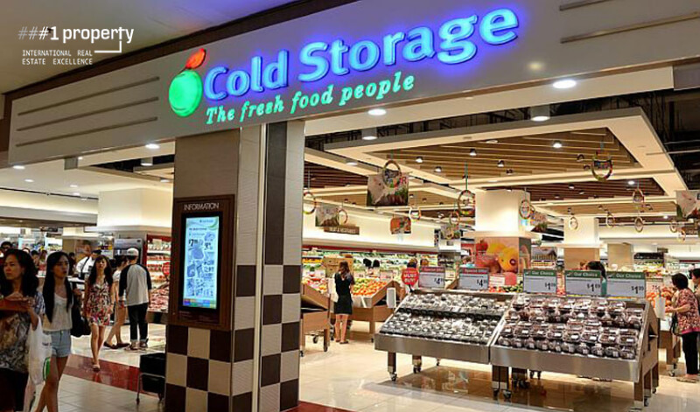
The Stirling residence is located at a close proximity to the Cold storage one north, one shop for all the fresh and healthy food.
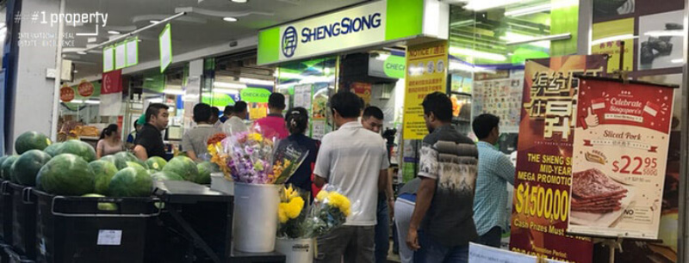
The Stirling residence is situated close to the sheng siong clementi ave 1 , fresh farm fruits and vegetable, electronics, home needs and everything under one roof.

Best snack in the town from the Fish and Chicks store is just few steps away from The Stirling residence.
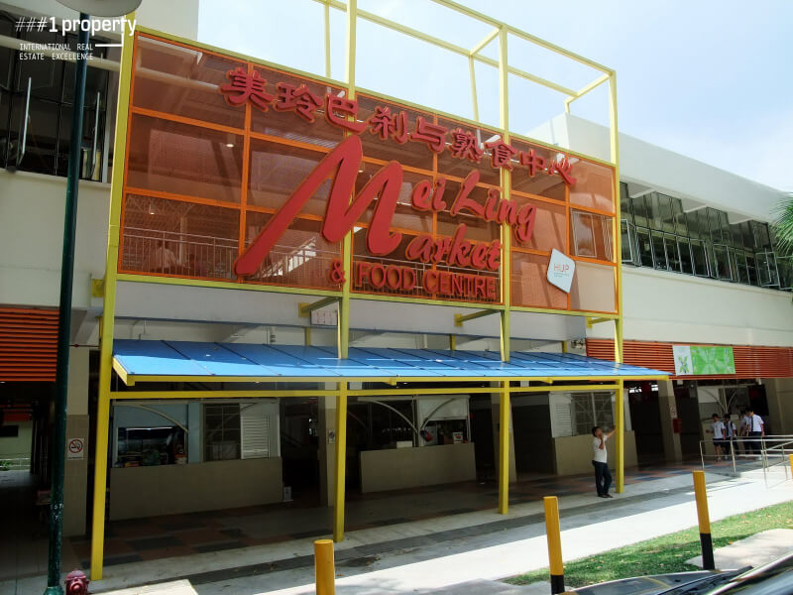
Mouth-watering and delicious food and snacks from the Mei Ling Market and Food centre is just located at the doorstep of The Stirling residence.
One spot for the best buffet and food under 10$ at Natsu, is located right across your street from The Stirling residence.
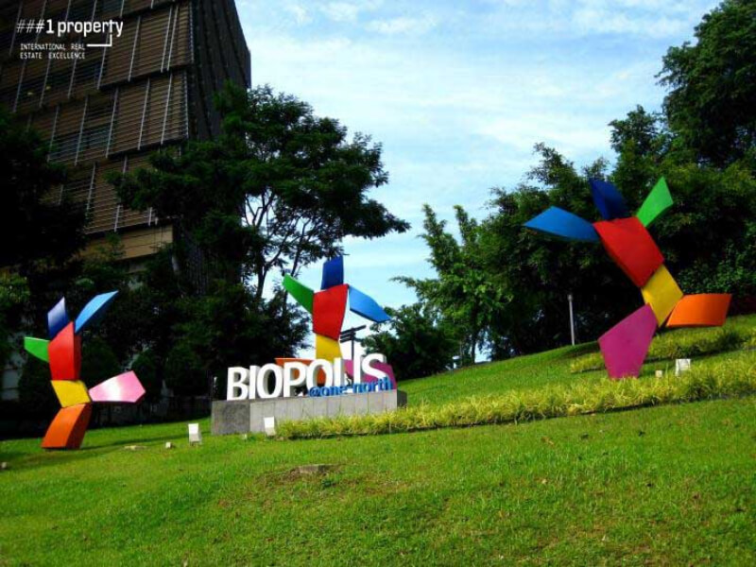
The Stirling residence is just one stop away from the BIOPOLIS One North park which is a home to the best trees and shrubs in the world
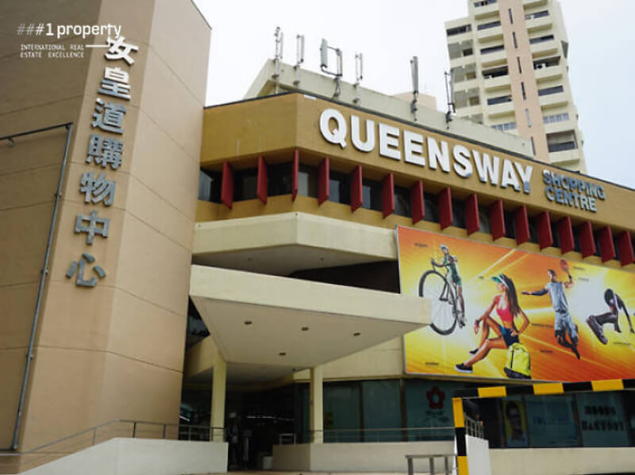
Queensway shopping centre is the first multi-purpose shopping complex located right next to The Stirling residence.

Education
Education is a major factor when it comes to a residential project and a Stirling Residence is present in the central region of Singapore is surrounded by various schools and junior colleges.
For families with school going children, there are various schools that are within Stirling Residence’s vicinity such as Queenstown Primary School, New Town Primary School, Gan Eng Seng Primary School, Blangah Rise Primary School, Queenstown Secondary School, Queensway Secondary School, Bukit Merah Secondary School, Crescent Girls’ School and Henderson Secondary School.
Stirling Residences is also near international schools such as Global Indian International School (Queenstown Campus), ISS International School (Preston Campus) and Tanglin Trust School.
How about young families?
There’s a childcare centre within Stirling Residences thus saving time in sending your child before heading for work.
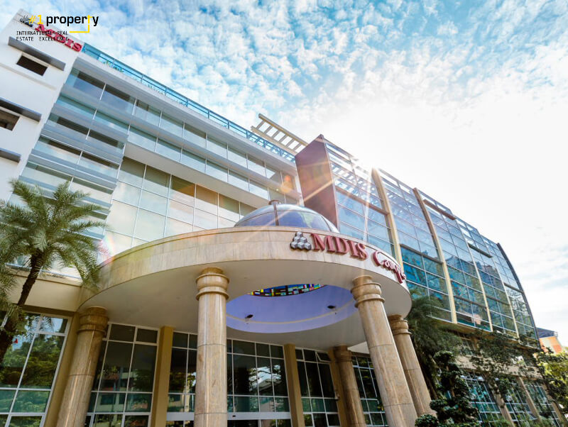
Management Development Institute of Singapore, one of the best institute for your child’s education, present in the 1.5 km radius from The Stirling residence.
The Stirling residence is located closest to the Queenstown secondary school, best government co-educational neighbourhood secondary school since 1956.
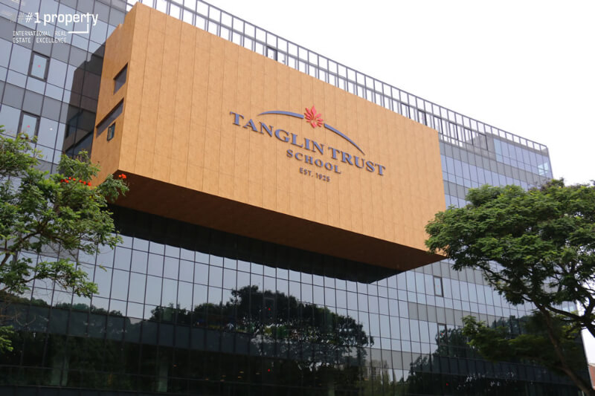
The Tanglin Trust school one of the Secondary schools which can be one of the option for child’s education located just near The Stirling residence.

Stunning View

The apartment is oriented in a specific orientation to provide proper ventilation across the project, along with it the designing is in such a way that the project provides un-hindering view of the island and the sea.
Southern View captures a view all the way to the Sentosa waters from higher levels.
Abundant sun light and natural ventilation can be expected for all the residents, as Southern View apartments open up towards the landed houses.
Residences oriented along the Northern direction, opens up to the Swimming pool and are exposed to proper sunlight and natural ventilation. Northern View faces city skyline towards Holland Village.
Landscaping incorporates conservation trees providing apartments on lower levels a lush view of greeneries. Tranquillity and serenity are key elements considered while designing the project. After a hard day’s work, there are three thematic zones with pavilions, garden lawns and pools, to unwind.
Designing and Planning

The proposed residential development is 3 high storey buildings within the complex along with a childcare centre, basement car park and other recreational facilities. The project has 1259 units and 1259 car parks. The split up of the units goes as follows:
  - 112 Units of 1- Bedroom apartment of area 441 Sq ft
  - 115 Units of 1- Bedroom + Study of area 506-710 sq ft
  - 306 Units of 2- Bedroom apartment of area 624-872 sq ft
  - 230 Units of 2- Bedroom premium apartment of area 678-904 sq ft
  - 151 Units of 2- Bedroom + study apartment of area 764-980 sq ft
  - 73 Units of 3- Bedroom apartment of area 883-1130 sq ft
  - 78 Units of 3- Bedroom + utility apartment of area 980-1281 sq ft
  - 112 Units of 3- Bedroom premium apartment of area 1055 sq ft
  - 76 Units of 4- Bedroom apartment of area 1346 sq ft
  - 6 Units of 4- Bedroom penthouse of area 1959-1970 sq ft
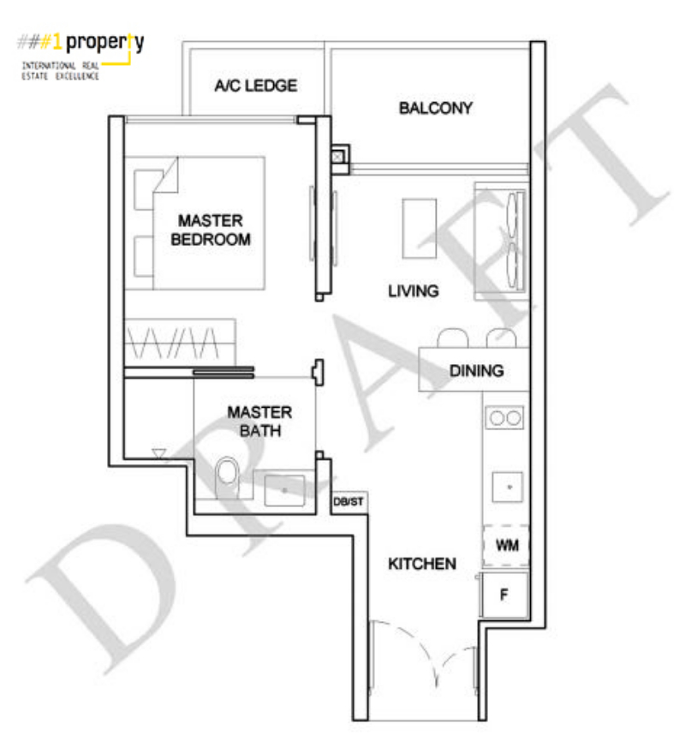
The floor plan consist of a single master bedroom with an attached two way master bathroom provided with high end sanitary fittings and proper fenestrations for ventilation, the outdoor balcony has an irresisitable view planned with living area just adjacent to it.The dining and the kitchen extends the living area towards the entrance of the layout.
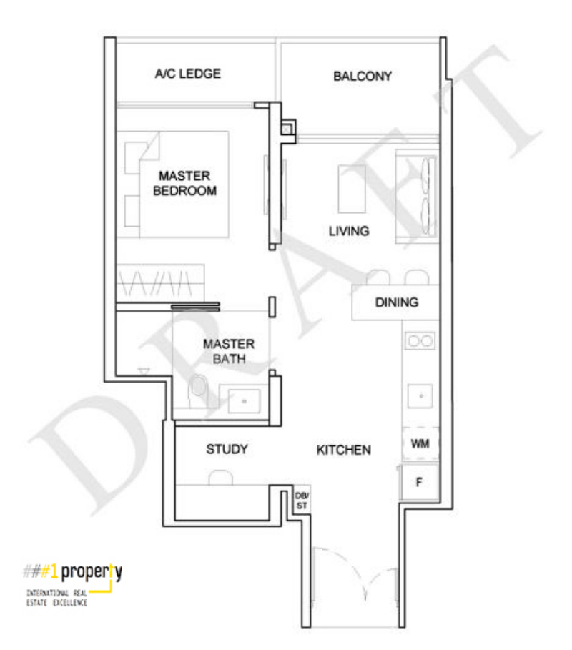
The foyer leads into an informal study area and a kitchen, the counter top is flushed on a side wall createing a passage way connecting it to the dining and a living room. It is further connected to the outdoor balcony, extending the living area and providing better ventilation. The layout consist of a master bedroom with an attached two way master bathroom and service oriented AC ledge.
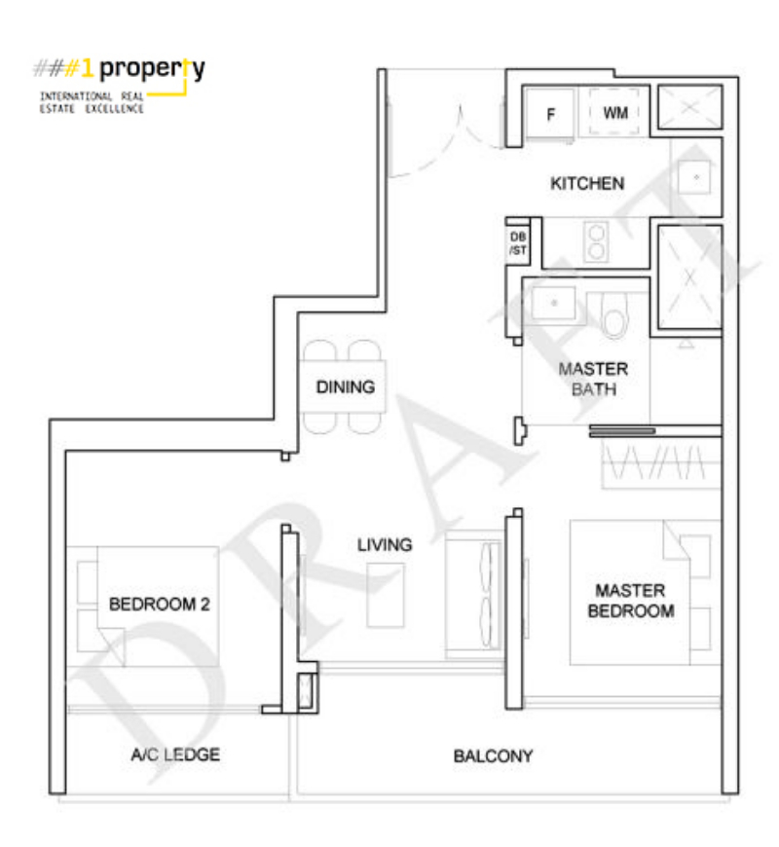
The planned layout connects the kitchen with dinning and the living room, thus seprating all the informal spaces from private spaces. The living room has an access to the bedroom 2 and the master bedroom with an attached two way master bathroom. The long elongated balcony is shared by the living area and the master bedroom, capturing maximum sunlight and providing better ventilation to all the living spaces.
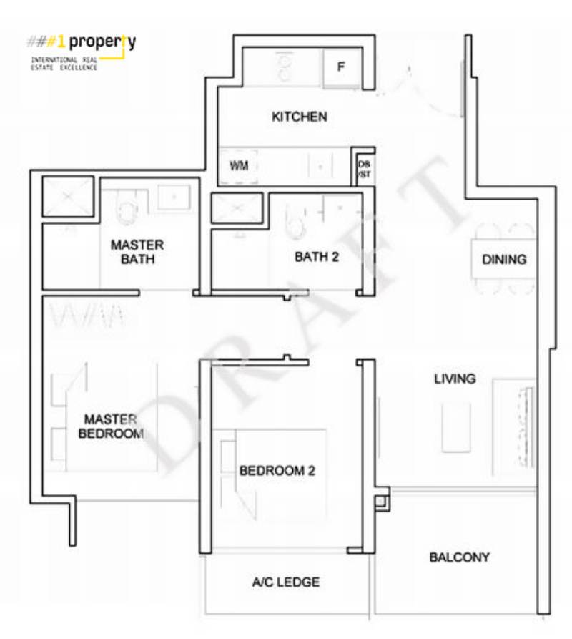
The floor plan consist of a two bedrooms; Single bedroom with an Ac ledge and one master bedroom with an attached master bathroom provided with high end sanitary fittings. A common bathroom is provided opposite to the bedroom 2 for shared usage purpose. Proper fenestrations are planned for both the bedrooms to achieve maximum ventilation and lighting.The outdoor balcony has magnificient views, planned with living area just adjacent to it.The dining and the kitchen extends th e living area towards the entrance of the layout.
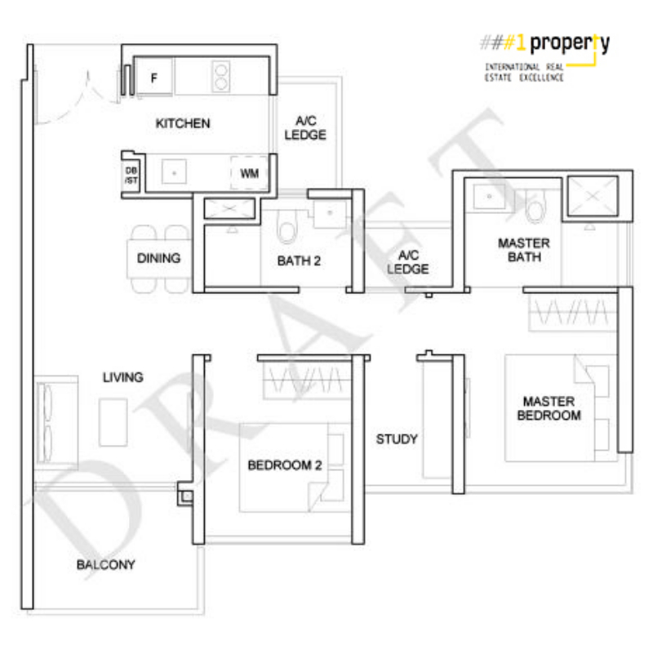
The planned layout connects the kitchen with dinning and the living room, thus seprating all the informal spaces from private spaces. A passage from the living room connects the bedroom 2, common study room and the master bedroom with an attached two way master bathroom. A common bathroom is also provided along the passage planned just opposite to the bedroom 2 for shared usage purpose.The balcony is zoned just adjacent to the living room inorder to provide amzing star gazing view. Windows are provided in all the bedrooms in order to achieve good ventilation and natural lighting. AC ledges are provided for service purposes.

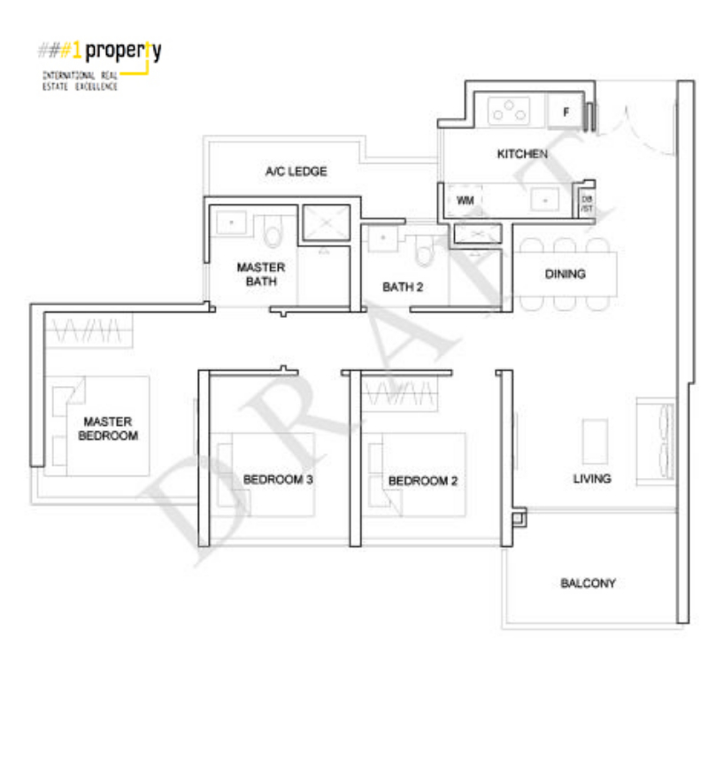
The floor plan consist of a three bedrooms; Two single bedrooms and one master bedroom with an attached master bathroom provided with high end sanitary fittings. A common bathroom is provided opposite to the bedroom 2 for shared usage purpose. Proper fenestrations are planned for all the three bedrooms to achieve maximum ventilation and lighting.The outdoor balcony has magnificient views, planned with living area just adjacent to it. A passage from the living room lead towards all the bedrooms and the common bathroom .The dining and the kitchen extends the living area towards the entrance of the layout.

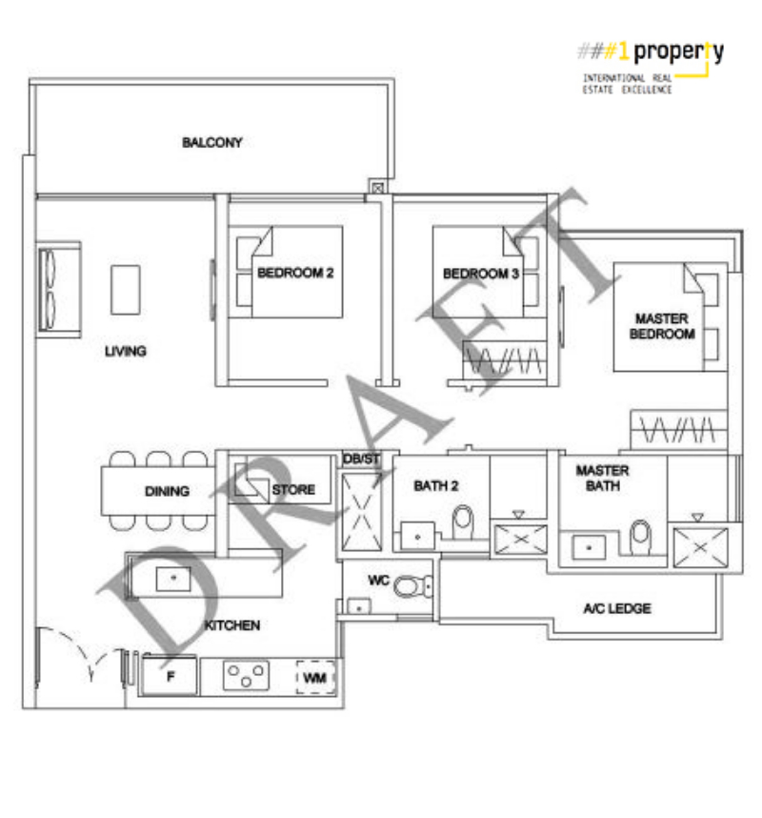The three bedroom layout consist of a linear passage from the entrance towards the living area, with kitchen and dining zoned near the foyer.The kitchen is provided with an in-built storage facility for easy stocking of food.The living area has an attached elongated balcony connecting with the bedroom 2. A passage way from the living connects both the single bedrooms , common bathroom 2 and the master bedroom with attached master bathroom. All the bedrooms and bathrooms are well ventilated and naturally lit.
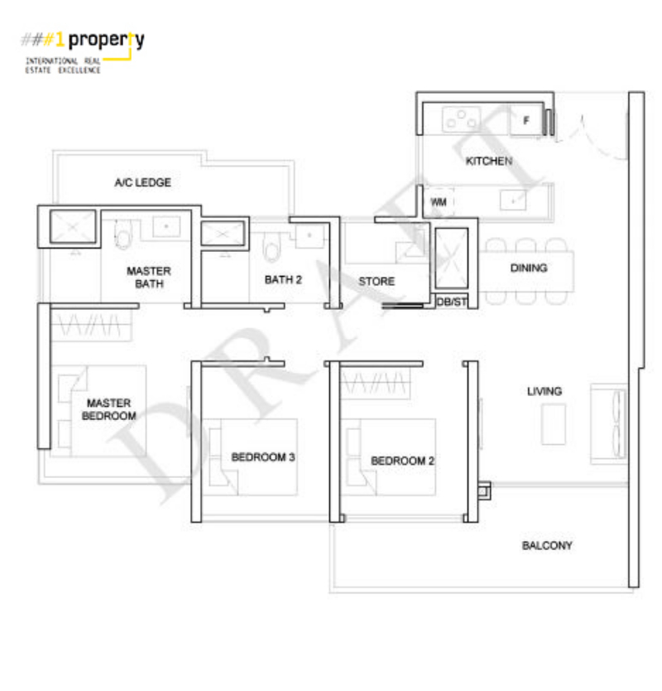
The layout consist of a three bedrooms; Two single bedrooms and one master bedroom with an attached master bathroom provided with high end sanitary fittings. A common bathroom is provided opposite to the bedroom 3 for shared usage purpose and a storage room is also provided for general stocking purposes. Proper fenestrations are planned for all the three bedrooms to achieve maximum ventilation and lighting.The outdoor balcony has magnificient views, planned with living area just adjacent to it. A passage from the living room lead towards all the bedrooms , store room and the common bathroom .The dining and the kitchen extends the living area towards the entrance of the layout.

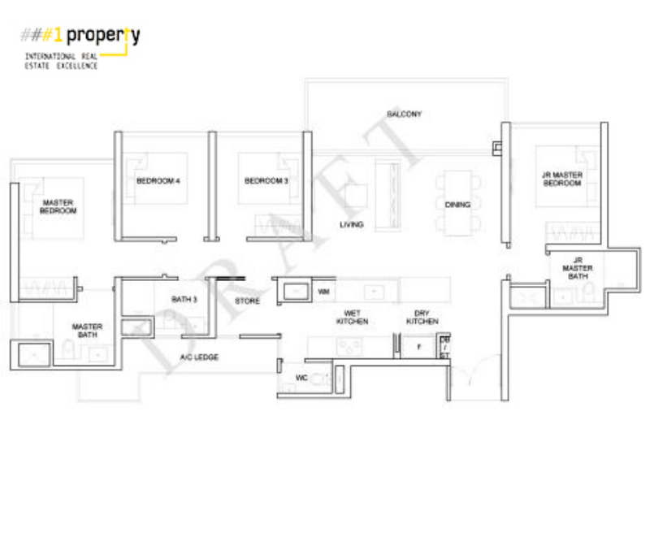
The layout is planned with four bedrooms, A common passageway is provided from the living room connecting the Master bedroom with an attached Master bathroom, two single bedrooms and common bathroom zoned near them and a two way multipurpose storage room, connecting from the kitchen. Jr Master bedroom is zoned islotaed from the other bedrooms and planned near the living room. High-end kitchen zoned along the passageway provided from the foyer to the living and the dining area, it is provided with segregation of a dry kitchen and wet kitchen spaces for ease of work.

3 Elevated skyscrapers sit on sprawling landscapes with 80 facilities, featuring a 500m Forest Trail, 18 Sky Terraces & 7 Pools.
Other Notable Facilities include:
- Stargazing lawn
- Aroma Garden
- Fern Grove
- Hammock Lawn
- Taichi Lawn
- Trekking Hill
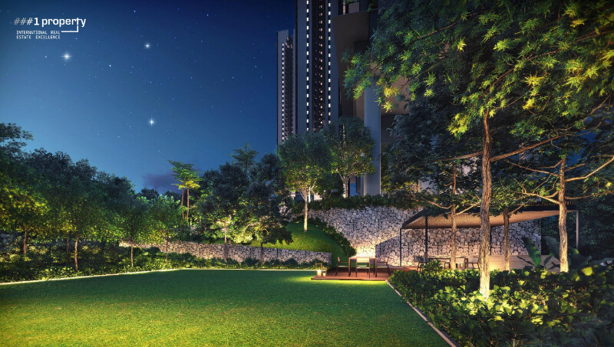
The Aroma garden in the Stirling residence have been planned to enhance the experience of the residents by providing outdoor sit-outs, star gazing view points and refreshing outlooks.
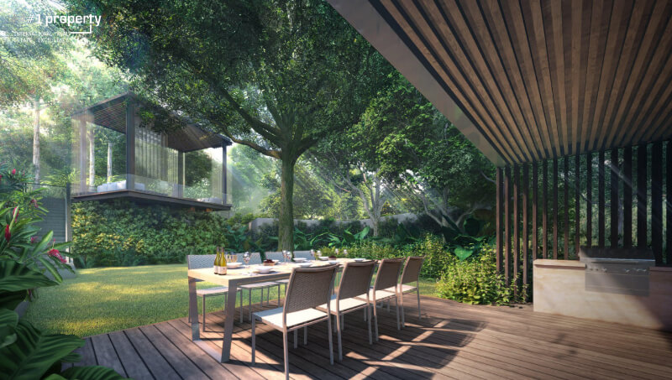
Grill pavillion at the stirling residence coverved with wooden louvers and flooring with a beautiful scenic view for outdoor dining.
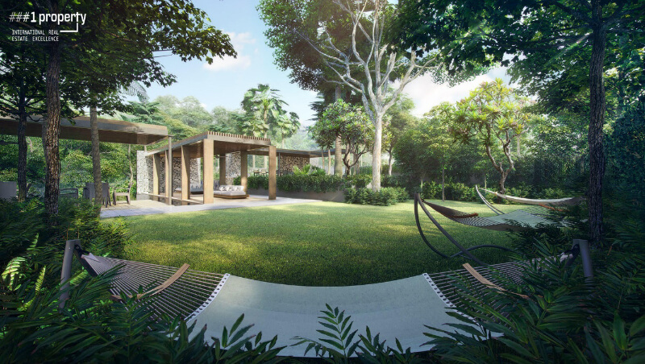
Hammock lawn at the stirling residence is planned and covered with a green belt of landscaping, a best spot to picnic within the compound
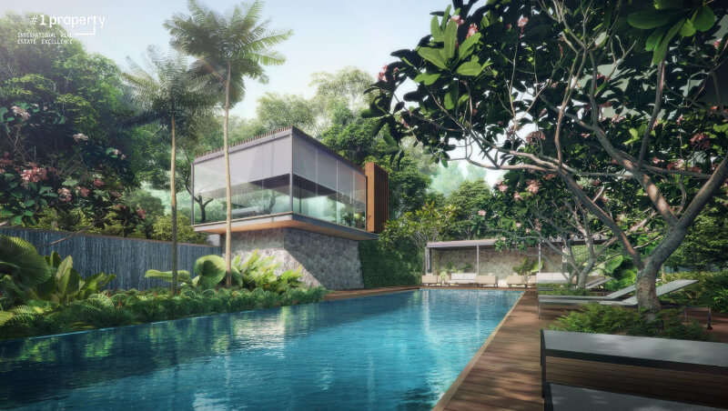
Massage Pavillion at the stirling residence with a world class swimming pool , a place for rejuvenation,relaxation and to rejoice.
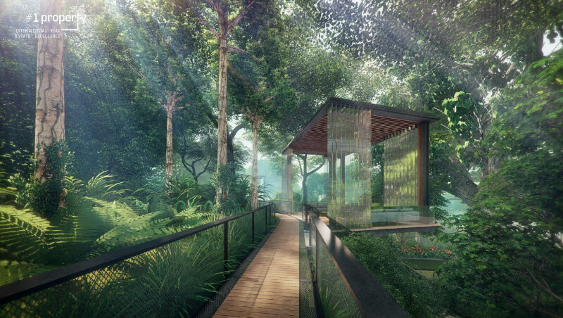
Rainforest trail at The Stirling residence has been planned to give the residents a thrilling experience of a forest withing their own compound.
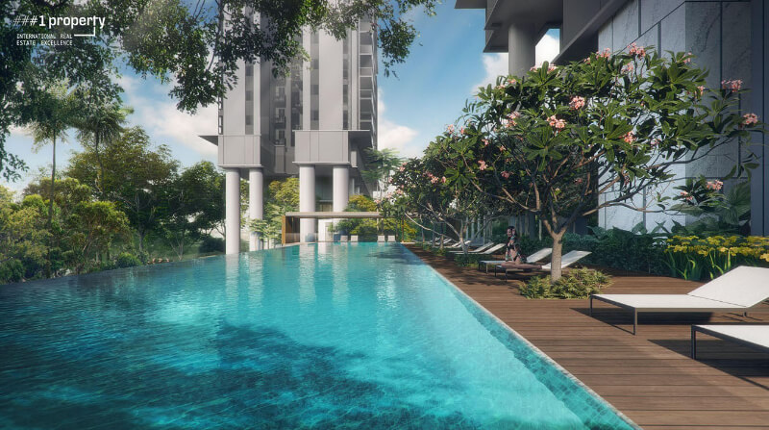
World class swimming pool available at The Stirling residence, just for the residents to beat the heat during the summer.

Projects Estimation and Comparison
The project providing a competitive design and a prime location the project demands its worth in the market. In comparison to the neighbouring projects the namely the Commonwealth Towers built last year has an Average psf of $ 1774, The Crest which was also completed last year has psf of $1963 and the under construction project Queens Peak as of May’18 has psf of around $1916 the pricing of Stirling residences is profitable. 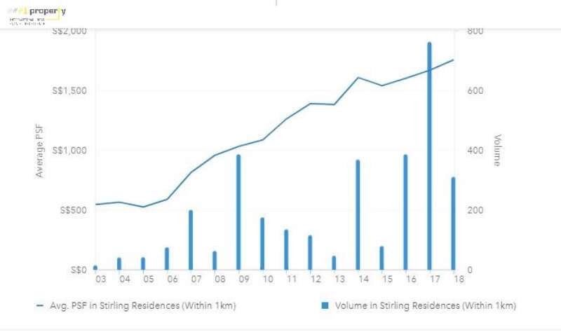
Graph representing statistics on Average PSF of Condo within 1km radius from The Stirling residence
Based on the above market analysis and the proximity advantage the Stirling Residence provides the rental income is always expected to be growing on exponential rate and the demand for the residential space increases as time goes. The resale value is also expected to grow exponentially with time.
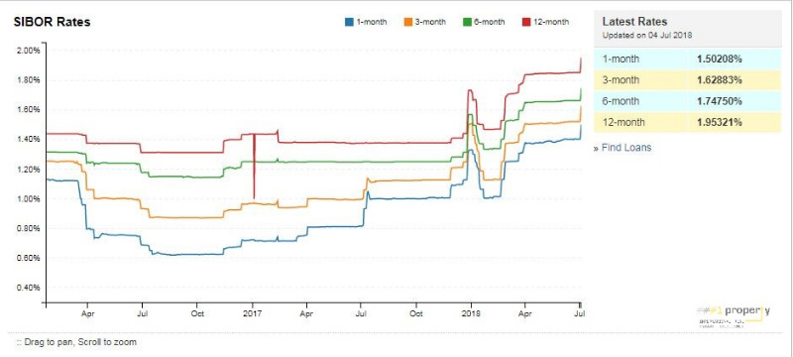
The Graph depicting Sibor rate as of august 2018.
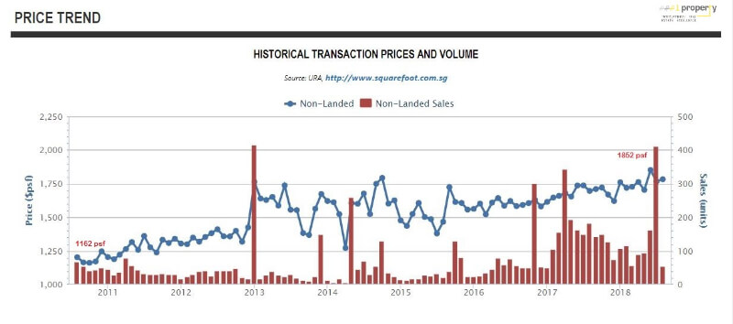
Graph representing statistics on District 3 historical transaction Price and Volume

Estimated pricing of the project based on above analysis are as follows:
- 1 Br from $800K
- 2 Br from $1.10mil
- 3 Br from $1.40mil
- 4 Br from $2.20mil
In conclusion investing in the Stirling Residence is an investment for the future generations to live in a comfortable community.

