Jeremiah Odhiambo
PHONE: +254 [0] 704789385
mihjere68@gmail.com https://www.linkedin.com/in/jeremihza/

Summary
I specialize in APIs, Web, mobile apps. Im familiar with DevOps tools such as docker, kubernetes in AWS and VPS environments. Am comfortable coding in PHP, Javascript(Node) and Python (Flask). I have experience building mobile apps on React Native and Android. I’m equally comfortable working with a team or flying solo.

Education

Skills
Technical Skills Skills
Front-End
- HTML5, JavaScript,CSS3,Ajax,Sass and Jquery
- JavaScript frameworks like React Js
- Front-end (CSS) frameworks such as Bootstrap Back-End
- PHP Frameworks: CodeIgniter, Laravel and Slim PHP
- Python (Flask)
- JS Frameworks: Node
- Building and documenting APIs on REST architecture
- Securing API endpoints in JWT and Oauth2
- Database technologies like MySQL and MongoDB. Mobile Apps
- React Native Linux
- Deployment on VPS and AWS servers
- Domain and DNS Management
- Working with the command line and with files.
- Bash scripting.
Other Skills
- Implementing message queues with RabbitMQ
- Using Docker & Kubernetes
- Deployment on AWS
- Mobile money API integration in Kenya and Ghana

Work Experience
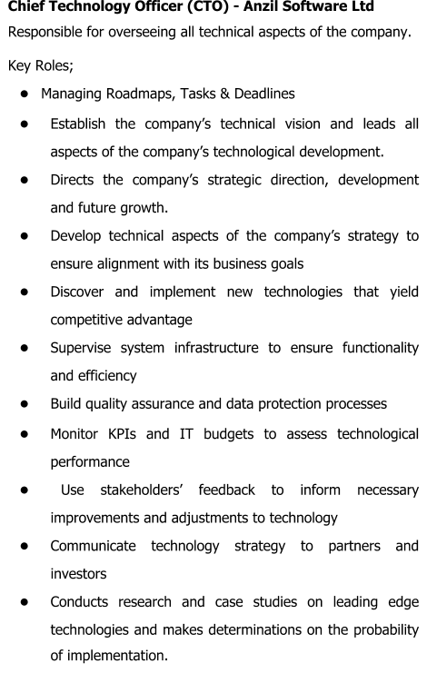
Jan 2019 to date

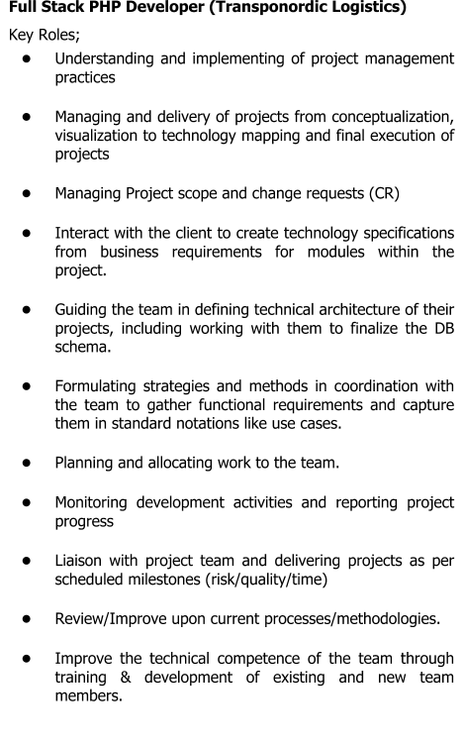
Jan 2018 to Dec 2018

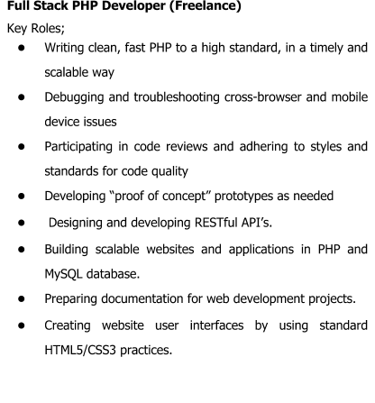
Jan 2015 to Date

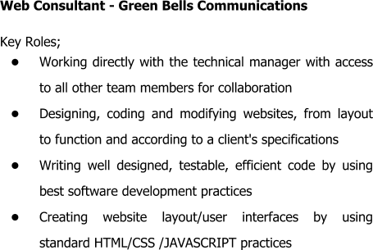
Nov 2017- April 2018

Major Projects
Sept 2019 to Date Beba APIs (Beba is Swahili Word meaning Carry)

BebaAPI is an elaborate API to allow developers, shipping companies, an e-commerce stores integrate pickup and delivery functionality into their applications.
Official API Documentation https://pikieglobal.com/docs/
Beba API Node SDK available NPM repository https://www.npmjs.com/package/beba-node-sdk Beba Laravel SDK available on Github Repository https://github.com/anzilsystems/beba-laravel-sdk

June 2019 - Sept 2019 Fleverr Food App

Developed Fleverr app on react native currently deployed on Google Playstore. The app allows customers to make food orders to restaurants via an android app and get it delivered to through a network of drivers registered on the platform. See link https://play.google.com/store/apps/details?id=com.tamufoods.pikieglobal
June 2019 - Sept 2019 Pikie Driver App

Developed Pikie app on react native currently deployed on Google Playstore. This app allows drivers to pickup and deliver orders from selected online businesses to customers. See link https://play.google.com/store/apps/details?id=com.pikiedriver.fleverr
Feb 2019 to May 2019 Multi Hospital Management System(Online)

Medyafrica is an integrated Health Management Information System. Link https://www.medyafrica.com/
June 2018 to Aug 2018 Web Application for Transponordic Logistics, a shipping company based in Denmark. http://www.transponordic.dk/
Dec 2017-Mar 2018 East African Business Council Website Redesign http://eabc-online.com/

Referees
- Steven njenga
CEO, Sapama Technologies Phone: +254 780967784

- Japheth odiwuor
Senior API Developer, sysem automation tester Safaricom PLC Phone: +254 707627362

