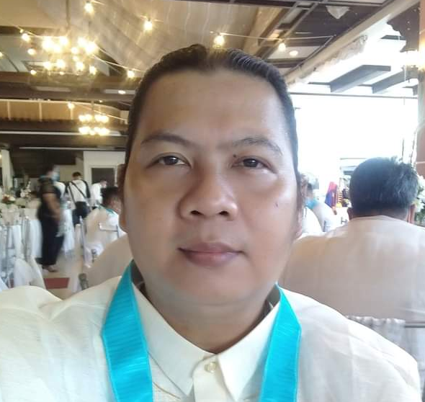
Benjamin G. Bandelaria III
Block,3 Brgy. 1, Taft Ilaod, Daet
Camarines Norte Philippines 4600

Cell No. +63-0998-395-3708/ +63-0936-884-9074
E-mail Add: designflow7@gmail.com / benjtoinks@yahoo.com

Objective:
To obtain a challenging position with a growing company that will provide opportunity to utilize my knowledge of all the skills I have stated bellow, continuing my personal and professional growth where my positive attitude, integrity and strong desire to succeed will contribute to the company’s success.

My Key Skills:
- Auto CADD
- Google SketchUp
- Lumion / 3D animation
- Adobe Photoshop
- Adobe In-Design
- Adobe Lightroom
- Microsoft Word
- Microsoft Excel
- Video Editor
- Casting/ Sculpture
- Powerpoint
- Drone Piloting
- Corel Movie Maker

Job Experiences:

Owner/ Proprietor of Green Tech Construction and General Merchandise September 17, 2018 to Present

Government Employee Department of
Public Works and Highways (DPWH-CNDEO)
Philippines (Engineering Aide/Field Researcher/ Architectural Designer/ Graphic Artist) January 2010 – September 17, 2018

Government Employee Camarines Norte
Municipal Engineering Office
(Job Oder) Philippines (Draftsman) January 2008 – 2009

Catanduanes Circumferential Road Project
under DPWH /PJHL Joint funding project
(Supplied Personnel to China Roads and Bridges)
Materials Laboratory Technician August 2006 – August 2007

Educational Background:

Bicol University College of Engineering
Department of Architecture 1998-2006 BS Architecture
Legazpi City, Philippines

Bicol University College of
Industrial and Technology 1994-1998 Secondary /Major Legazpi City, Philippines in Building
Construction

St. Agnes Academy
Legazpi City, Philippines 1988-1994 Elementary

Examination Taken:
Philippine Regulatory Board Passer in Master Plumber October 2015
Trainings Taken:
COSH (Construction Occupation Safety and Health) Training
Organization:
Philippine Society of Plumbing Engineers – Chapter President
The Fraternal Order of Eagles Philippine Eagles Club Treasurer
JCI Kabihug, Daet, Camarines Norte Chapter, Philippines- Member
Camarines Norte Provincial Land Use and Zoning Committee- Member
United Architects of the Philippines Graduate Auxiliary- Member
Mayon Albay Football Association -Member

Voluntary Works:
Soccer Coach Camarines Norte State College, Daet, Camarines Norte, Philippines
Soccer Coach Camarines Norte Our Lady of Lourdes College, Daet, Camarines Norte, Philippines
Soccer Coach Universal Peace Federation, Daet, Camarines Norte Philippines

Reference Persons:
Arc. Elmer Cezar A. Zaleta Architect II DPWH- CNDEO Planning and
Design Section

Arc. Donna Jean T. Lacson Architect I / Special Agent DPWH- CNDEO
Planning and Design Section

Arc. Siegfrey Pante
Draftsman DPWH-Cam. Norte Dist. Engineering Office

