Article on - cell phone spy Apps
Are you looking for the best cell phone spy apps? Well, if yes, then, stay tuned because in this article we will discuss the best cell phone spy apps that will really help you.
The first one is mSpy. mSpy is a leading mobile application in its industry and is one of the highly recommended spy apps. It is also prominent as an ultimate monitoring application for parental control.
One thing to note down before using mSpy is that some of its features may require a rooted Android device or iOS device jailbreaking. For iOS, it is available in both jailbreak and no-jailbreak versions.
Given below are the supported devices:
Android devices: It is compatible with all the devices above Android4+
iOS devices: mSpy is compatible with iOS 7 - 8.4 and 9.0 - 9.1
Following are the key features of the mSpy:
1) SMS tracking:
With mSpy you can easily check all the messages on your child's phone. Even you can see the deleted messages. Today's children hardly make phone calls so it is highly advisable to check their messages and confirms whether they are in contact with the right people.
2) Geofencing: It is the most amazing feature of the mSpy. With the help of this feature, you can set the virtual boundaries for your child. If your child breaks these boundaries you will be notified by an alarm or even a message. Geofencing helps parents to check the whereabouts of their child and as well as employees at a workplace.
3) Check browsing history:
mSpy helps to monitor the browsing history of the targeted device. It also comes up with an option with the help of which you can block certain websites.
4) Track GPS location:
mSpy uses the latest GPS tracker that tells you the exact position of your child. Your child's location will be seen in your control panel. So, simply monitor the location of your child at your fingertips.
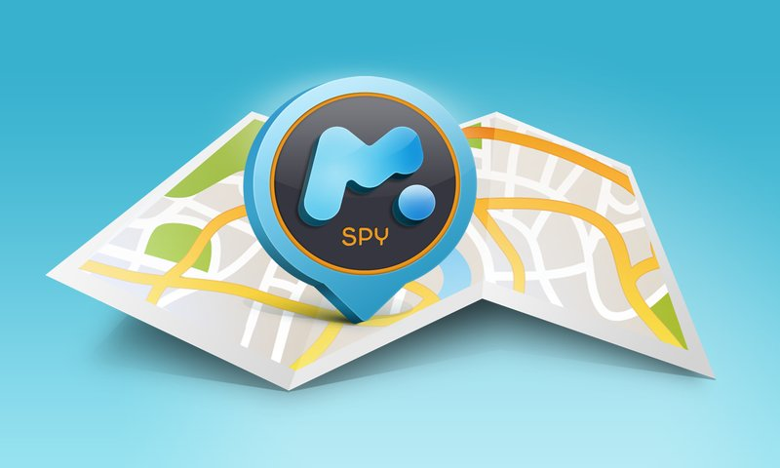

5) Monitor all social media platforms:
A recent study has revealed that 56% of the people communicate with strangers via social media platforms. So, keep a record of the social media platforms like Whatsapp, iMessage, Snapchat, Skype, Kik, Viber, Tinder, and Facebook which are available on a targeted cell phone.
6) 24/7 customer support:
If you face any problem while using mSpy simply connect them as they provide you a 24/7 customer support in various languages. You will also get an option of Live Chat support.

It is time to have a brief glance at the pricing of this world-class spy app:
Basic: You will get some basic features in this package. It is available for $29.99.
Premium: Its one-month subscription is for $69.9. For two months you have to pay $119.99 and for 12 months $199.99
No-jailbreak: It is especially for iOS devices and for one month its price is $69.99
Overall, mSpy is the perfect cell phone spy app. It is convenient and easy to use.

Now, let's have a close look at another spy app. Spyera is the award-winning app and regarded as “Best Overall Spyphone”. It is compatible with Android, iPhone and BlackBerry devices.
Following are the features of the Spyera that you must know:
1) Phone call tracker:
With this feature, you can listen to the incoming and outgoing calls of the target device without knowing him/her. This feature is quite awesome. Along with tracking, you can also record these calls and thus, can monitor with whom your child, family members or employees are talking. Such features will help you in determining the efficiency of your employees at their workplace.
2) File manager tracker:
You can check the audio and video files received by your child or any other person who has a device in which Spyera is installed. Nowadays children love to watch films, play video games on their cell phone. But overusing the cell phone can destroy their future so it is better for parents to see what their child is watching, sharing.
3) Now use Spyera in the secret mode:
You can hide the Spyera icon as well as many files related with it easily. Selecting a Spyera hidden mode will help you.
4) Money-back guarantee:
Spyera offers the money-back guarantee to its users. There are many cell phone spy apps available in the market but very few of them offer such money-back guarantee. If you are unsatisfied while using the features of this app you can request for the money-back guarantee. But you have to raise your request only in the initial 10 days.
5) Find the correct GPS location:
You can get the exact location of your child or employees at any time. So, there is no need to worry. Whether your child is attending school or not can be easily found by this location tracker.
6) Monitor text messages:
In this digital world, people prefer messaging over calling. So, check the contact list of the targeted device and have a close look at their contact list. This will help you in deciding whether your child is in contact with right people or not.
7) Simple and convenient:
Spyera is really very easy to operate and the control panel has an elegant design. It takes a maximum of four minutes to install this app.

Pricing:
There are basically four packages of the Spyera.
1) Smartphone: For the Spyera smartphone app you have to pay $189 for 3 months. Also, other packages are $289 per 6 months and $389 per 12 months
2) Tablet: For the tablet version, 3 months package is of $149, $189 dollar per six months and $249 per 12 months.
3) Computer: Whether you have a PC or MAC device, 3 months subscription is for $59, $79 per six months and $99 per 12 months.
4) All in one: It is a combo pack where you can use a smartphone, tablet, and PC for $489 per year, $689 per 2 years.
In short, Spyera is quite higher in price but in turn, it is providing many extra features to users. Due to a wide range of features and its simplicity, it is the best cell phone spy app.

