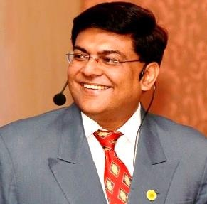
Amitabh Pant
amitabh.pant@outlook.com
+91 9823724398

Key Skills Domain  Brand Development  Marketing & Communication  Digital Marketing  Channel Branding & Management  Sales Management  Pricing & Profitability Management  Strategic Planning  Planning and Budgeting Change Management  CRM Management  Cross Functional Team Leadership | Marketing, Branding & Business Development Expert  Highly Innovative and Creative and been an active voice for change management, thoroughly enjoyed and contributed by being a pivotal person in driving change at all levels in the organization.
- Profile Summary

- Marketing & Business Development: - 14 years of All India hands on experience in creating and executing overall Marketing and Branding Plans, Business Plans, and Being Responsible for Pricing & Profitability, Business Intelligence, Training, CRM & Channel Sales.

- Sales: -10 years of extensive experience in sales and key account management for direct customers and through distributors

- Production: - 4 years of Shop Floor & Industrial engineering

- Industry Experience: Manufacturing, Metal cutting, & Digital Manufacturing
- Social Contribution & Skill Development

- Association with NGO’s for People with Special needs Since 1998
- Sandvik Academy Group Leadership Program – 2014
- Tooling Leadership and Development Program (TLDP), Sweden & Poland, 2008
- Finance Management Basics – 2007
- Finance Management for Non-Finance – Dr. Lamba – 2006
- Dale Carnegie – Effective Self Development – 2004
- Various Sandvik Coromant Academy Programs on Value Selling, Value Negotiations, Sales Management, Marketing Communication & Effective Presentation Skills – Professional Selling Skills and Negotiation Skill by Achieve Global - Self- Development, Presentation Skills and Business Ethics by Minochar Patel

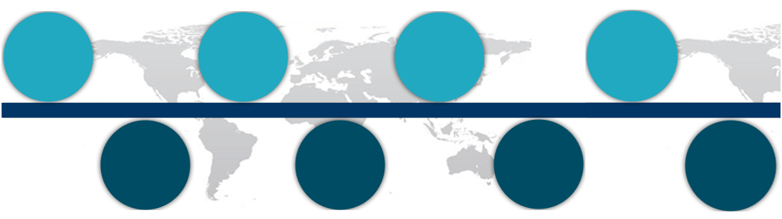
Growth Path at Klockner and Sandvik Coromant
Sr. Engineer Marketing

Shop Floor & Industrial Engineer
Sr. Sales
Engineer

Sr. Manager

1994 - 1996

1996 - 1998

1998 - 2004

2004 - 2007

2007 - 2010

2010 - 2012

Since 2012

1990 - 1994

General Manager

Manager

Sales Engineer

Key Account Management

Key Achievements  Executed channel plans in 2008, 2014 and 2017, delivered min 3% Market Share growth YoY  Strategized and prepared Sandvik Coromant India annual Sales & Marketing plans since 2010  Lead Digital Marketing Strategy to make India as the No. 1 Market Globally  Personal Details  Education  Top achiever for highest selling the new 4000 series inserts, rewarded by Europe trip hosted by Global President  Recognized as the Highest Selling Sales Person in 2002  Successfully managed direct customers and distributors price contracts over last 8 years  Administered pricing and profitability; delivered Net Price Change of Min 2% YoY since 2008  Successfully delivered minimum 8% new product sales YoY  Delivered “Beyond Imtex” tradeshow concept, first ever in cutting tool Industry  Best Boot Award 3 consecutive times at IMTEX Bangalore | Sandvik Coromant Key Result Areas and Experience  - Marketing & Branding  - Designing and preparing Sandvik Coromant India Marketing, Branding & Sales plans since 2010  - Been a regional and global contributor for creative and engaging go to market strategies for new product launches directed towards brand building and lead generation  - Developed the marketing formula – Right Target | Right Message | Right Media | Right Time  - Designing and executing targeted plans on - AD | PR | Media | Printed Matter | Events management Trade Shows | Web | Social Media | Magazine | Employee & Channel Branding | Giveaways| Marketing Automation and Digital Marketing Strategies  - Designing and executing innovative sales and marketing campaigns and mobilize & motivate teams, internal and channel.  - Developing Creative Virtual Training Events and live machining demonstrations  - Developed the first of its kind B2B Loyalty Program  - Executed 360 Degree, Brand Development and Management Plans in the Organization  - Executed “You are the Brand” Strategy for internal sales and channel partners over many years  - Pricing  - Successfully executed Sandvik Coromant India pricing strategy.  - Developed & implemented tools for efficient discount management. Consistently delivered desired net price change and profitability.  - Responsible for End Customer Pricing and contracts  - Provided price/discount training to all for value selling and gaining market shares – Internal as well as distributors  - Channel Management  - Developed and executed All India Distributor sales and marketing plans, growth, resources, employee development, motivation, performance and profitability  - Fully Responsible for Driving Sales and Motivating and Engaging 80 Distributors and 150 distributor sales engineers across 16 Cities with 8 Regional Sales Managers  - Responsible for discount management, target setting, performance evaluation and classification of all distributors  - Sales:  - Excellent customer relationship, still remembered,  - 100% market share at 3 key customers for continuous 5 years  - Top Achiever, year on year growth and market share gains  - Business Operations and Development  - CRM, Business Operations, Intelligence and Analysis  - Contributed actively towards a common CRM for APAC from 10 localised modules, including hosting the data base in India, training of IT developer teams, and rolling out of new CRM in whole of ASIA  - Gained valuable knowledge of ERP and CRM management & drove the utilization of CRM throughout ASIA  - Contributed with Regular Business Analysis for Sales and Product Business Action Plans  - Contributed and worked with global and regional teams and various agencies to provide business intelligence data on competitor business and activities and M/S  B.E. Mechanical  Bila Vishwakarma Mahavidhyalaya, Vallabh Vidhyanagar, Sardar Paterl University, Gujarat  Hobbies: Cooking & Travelling  Languages Known: English, Hindi and Gujarati  Address : B201, Runwal Daffodils, NIBM to Undri Road, Pune – 411060, Maharashtra

