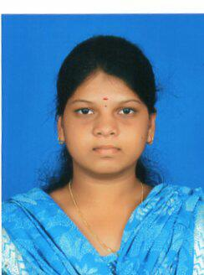
Venkatalakshmi Ravi
Soft skill Trainer

Bachelor's Degree in Civil Engineering( 2012- 2016)

JOB EXPERIENCE
- Communication and life skill trainer @ Next Generation Academy (2017)
- Customer Executive Officer @ Hinduja Global Solution (2016)
KEY SKILLS PERSONAL SUMMARY
Optimistic A courteous, polite and ambitious trainer who is highly
efficient and has organizational skills. Possessing a good
Calm, efficient & organised team-spirit and having a passion for providing a good
standard of training for the trainees. A quick learner who
Friendly disposition sportive & can absorb new ideas, communicate clearly and
adaptable Effectively.
Keen to find a suitable position within an ambitious
Institute where I will be able to start to increase my work
Experience and develop my abilities and skills.

PERSONAL DETAILS DUTIES

Venkatalakshmi To create a student friendly classroom which will be
D/O Ravi helpful for the effective communication with the
114/147 Radio park east street, trainees.
Sanjeevirayanpet, Introducing innovative ideas and methods to improve
Salem-6. he creativity of the students.
D.O.B: 16/12/1993 Conducting classroom activities to grasp trainees
Nationality: Indian attention throughout the session.
Assessing the students on monthly basis to notice their
M: 9543215628 improvement in communication and behaviour.
E: venkatalakshmiraviresh@gmail.com

TRACK RECORD

- Effectively worked as an organiser of NGEN’s BLOOM. (2017)
- Participated in the Guinness Record Event of “ Largest and Easiest Math Training Class. (2015)
- Won second place in the State Level Basketball tournament. (2012 &2009)

