Note
- References to follow: CMS 15th ed, Merriam Webster’s, and AMA 10th ed for references.
- US spellings and punctuations. Use serial comma, e.g., A, B, and/or C.
- Abbreviate references to chapter, figure, and appendix unless they occur at the start of sentences. Abbreviate units if used with numbers.
- Spell ranges in text and use en-dash in tables and parentheses.
- Set variables in italics.
Chapter 1
Introduction and Cost Comparison of
Trenchless Technology Methods

Trenchless Technologies (TT) are alternatives or methods of choice for construction and renewal of buried pipelines, such as oil and gas pipelines, water distribution systems, and sewer collection systems, as well as drainage structures and culverts. Specifically, TT is used when other traditional methods, such as open-cut, are not physically possible. Other reasons for trenchless technology methods to be increasingly adopted by owners, engineers, and contractors, are their low environmental impacts, based on project and site conditions, and lower costs per foot of installed pipe, making this technology much more efficient and versatile with final results within a shorter time span.
Cost is the bottom line! Throughout a project’s programming, planning, designing, and construction phases, important decisions are made based on the anticipated costs. The total cost of a construction project includes not only the direct and indirect costs but also the social costs. For this reason, an accurate estimate of life cycle costs of the project is necessary to select the appropriate construction methods. Using the literature review and statistical analysis of the collected data, this chapter presents how TT can be more cost-effective than open-cut methods when used for new construction and/or renewal and replacement of existing pipelines. While the open-cut method requires a higher cost of operation for continuous excavation and safety measures along with the pipeline alignment, trenchless methods require excavation only at the entry and exit shafts and pits; therefore, reducing costs of unnecessary work.

Horizontal Directional Drilling (HDD) Method
The horizontal directional drilling (HDD) method is a steerable system mainly used for the installation of pressure pipelines and cable conduits. This method involves a two-stage process. The first stage consists of drilling a small diameter pilot hole along with the desired centerline of the proposed profile. The second stage consists of enlarging the pilot hole to the desired diameter to accommodate the utility pipe. As the name suggests, this method has the unique capability to track the cutter head and steer it during the drilling process. The directional drilling method can be classified into three broad categories as presented in Table 1.1 (Najafi, 2010).

Table 1.1 Main Characteristics of HDD Methods (Najafi, 2010)
Method | Diameter range (in) | Maximum installation (ft) | Depth (ft) | Typical application | Accuracy
Small-HDD | 2–12 | ≤600 | ≤15 | Telecom, power cables, ducts and gas lines | Varies
Medium-HDD | 12–24 | ≤900 | 25–75 | Pressure pipelines | Varies
Large-HDD | 24–60 | ≤10,000 | ≤200 | Pressure pipelines | Varies

Data Collection
As mentioned above, the data collected for all the trenchless methods analyzed here were obtained using CUIRE database and literature search.
Once all project costs were adjusted to 2012 costs, said average costs ($/ft) were classified by diameter ranges as shown in Figure 1.1. Since diameter ranges are 2″–12″, 12″–24″, and 24″–60″ for small, medium, and large sizes, respectively, for the HDD method, there is no cost information given for diameters above 60 in.

Data Analysis
Once the data were gathered, they were analyzed using regression methods. As mentioned in Chap. 1, in this chapter there is one response parameter, also called dependable variable, which is price per foot, and two main independent variables or predictors, diameter and length of the pipe.
Since diameter and length are factors that affect the price of the trenchless method, Figure 1.28(a) shows the cost ($/ft) depending on the size, in inches, of the pipe, while Figure 1.28(b) shows the cost ($/ft) depending on the length, in feet, of the same pipe.
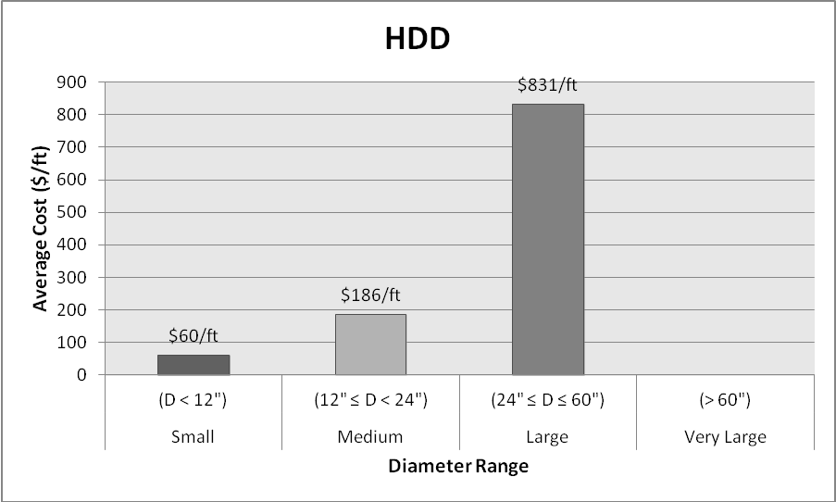
Figure 1.1 Average cost of HDD trenchless method classified by diameter ranges.

 | 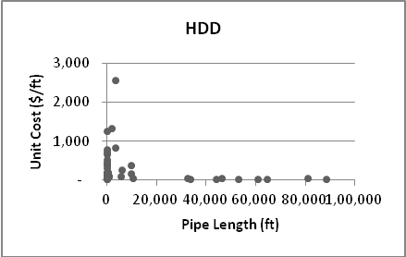
(a) | (b)
Figure 1.2 Scatter plots of cost data: (a) versus pipe diameter (b) versus pipe length.

Once the scatter plots were set up, a significant fitted curve needs to be found based on the relationship between each variable and the pipe cost. Therefore, a regression equation based on statistical methods is the best option. As there are four different types of regression methods, i.e., linear, logarithmic, power, and exponential; it is important to decide which curve is the best-fitted trend line within the scatter plots. The assumed criterion for the relationship between both parameters is R-squared (R²), the higher the R² value is, the more accurate trend line will be obtained.
Figure 1.3 shows the best-fitted regression trend line of the four different regression types on the cost–diameter size graph. Appendix D2 shows the comparison among the four trend lines, finding the higher R² value will give us the higher relationship between cost and variables.
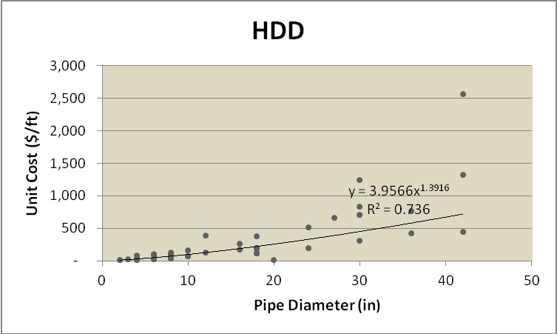
Figure 1.3 Best-fitted trend on HDD cost and diameter data.

The equations and the related R² of each regression type are presented in Table 1.2. Due to the highest ratio in the power regression type, the equation that best fits in the scatter plot is Y = 3.9566x^{1.3916} and R² of 0.74, where “Y” is the cost of the pipe and “X” is the diameter of the pipe. Graph using the obtained equation is shown in Appx. G.
Table 1.2 Cost vs. Diameter Trend Line Comparison
Regression type | Equation | R-squared (R²)
Linear | y = 29.456x – 185.1 | 0.56
Logarithmic | y = 336.98ln(x) – 554.25 | 0.38
Power | y = 3.9566x^{1.3916} | 0.74
Exponential | y = 26.533e^{0.0978x} | 0.71

The same process is carried out to obtain the relationship between cost variable and length predictor from the collected data. Similarly, Figure 1.4 shows the best-fitted regression trend line of the possible four types of trends on the cost–length data graph. The complete graph comparison is shown in Appx. E2.
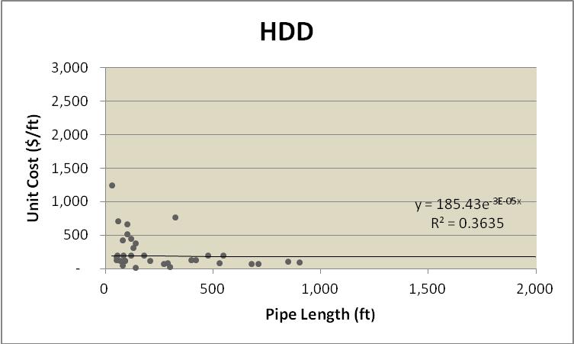
Figure 1.4 Best-fitted trend on HDD cost and length data.

Table 1.3 presents the equations and the related R² of those trend lines. In this case, the highest relationship ratio is found using the exponential regression type with an R² of 0.36 and equation Y = 185.43e^{–3E–05x}. Graph using the obtained equation is shown in Appx. H.
Table 1.3 Cost vs. Length Trend Line Comparison
Regression type | Equation | R-squared (R²)
Linear | y = –0.0049x + 338.04 | 0.06
Logarithmic | y = –25.91ln(x) + 457.24 | 0.02
Power | y = 780.52x^{–0.271} | 0.26
Exponential | y = 185.43e^{–3E–05x} | 0.36

In order to find out the mathematical relationship between predictor variables, diameter and length, and the response variable cost, statistical software called Minitab 15 was used. The way Minitab works is similar to the way any spreadsheet software works. For our purpose, three data columns are input, i.e., diameter, length, and price. Once the data is inserted, the statistic regression option is run, considering price as the response variable, and diameter and length as the predictor variables. The complete regression output for HDD method is demonstrated in Appx. F.
The regression equation obtained from Minitab 15 that best fits for HDD trenchless data is:
Eq. 0.1

PTMT Method
Diameter ranges are between 6 and 30 in for the PTMT method. Figure 5.11 shows the cost ($/ft) depending on the size, in inches, of the pipe, while Figure shows the cost ($/ft) depending on the length, in feet, of the same pipe. Each figure shows its best-fitted curve using regression equation based on statistical methods.
The assumed criterion for the relationship between both parameters is R-squared (R²), the higher the R² value is, the more accurate trend line will be obtained.
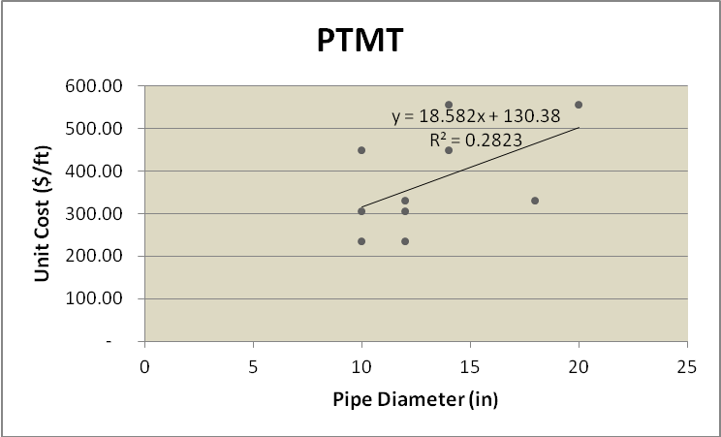
Figure 5.11 Best fitting trend on PTMT's cost and diameter data.

The same process is carried out to obtain the relationship between cost variable and length predictor from the collected data. Similarly, Figure shows the best fitting regression trend line on the cost–length data graph.
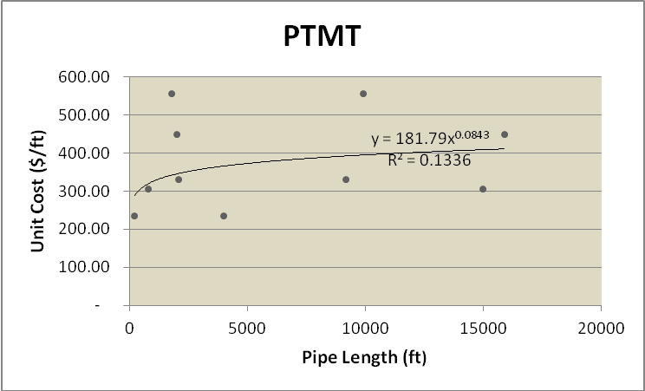
Figure 1.12 Best fitting trend for PTMT's cost and length data.

In order to find the mathematical relationship between predictor variables, diameter and length, and the response variable cost, statistical software called Minitab 15 was used. The way Minitab works is similar to the way any spreadsheet software works. For our purpose, three data columns are input, i.e., diameter, length, and price. Once the data is inserted the statistic regression option is run, considering price as the response variable, and diameter and length as the predictor variables.
The regression equation obtained from Minitab 15 that best fits for PTMT trenchless data is:

References
- Gates PC, Barnett HJ, Vinters HV, et al. Primary intraventricular hemorrhage in adults. Stroke. 1986;17:872–877.
- Mayfrank L, Hutter BO, Kohorst Y, et al. Influence of intraventricular hemorrhage on outcome after rupture of intracranial aneurysm. Neurosurg Rev. 2001;24:185–191.
- Lisk DR, Pasteur W, Rhoades H, et al. Early presentation of hemispheric intracerebral hemorrhage: Prediction of outcome and guidelines for treatment allocation. Neurology. 1994;44:133–139.
- Adams RE, Diringer MN. Response to external ventricular drainage in spontaneous intracerebral hemorrhage with hydrocephalus. Neurology. 1998;50:519–523.
- McIver JI, Friedman JA, Wijdicks EF, et al. Preoperative ventriculostomy and rebleeding after aneurysmal subarachnoid hemorrhage. J Neurosurg. 2002;97(5):1042–1044.
- Hellingman CA, van den Bergh WM, Beijer IS, et al. Risk of rebleeding after treatment of acute hydrocephalus in patients with aneurysmal subarachnoid hemorrhage. Stroke. 2007;38(1):96–99.
- ter Laan M, Mooij JJA. Improvement after treatment of hydrocephalus in aneurismal subarachnoid haemorrhage: Implications for grading and prognosis. Acta Neurochir (Wien). 2006;148:325–328.

- Seyed H. Construction Cost of Underground Infrastructure Renewal: A Comparison of Traditional Open-Cut and Piep Bursting Technology [M.S. thesis]. Arlington, TX: The University of Texas at Arlington; 2008.

- Lee H, Najafi M, Matthys J. Cost comparison of pipeline asset replacement: open-cut and pipe-bursting. In: Proceedings of ASCE International Pipeline 2007 Conference. Boston, MA; 2007.

- Najafi M, Gokhale S. Trenchless Technology: Pipeline and Utility Design, Construction and Renewal. New York: McGraw-Hill; 2005.

- Najafi M. Trenchless Technology Piping: Installation and Inspection. Chapter 1. McGraw-Hill; 2010.
- Means RS. Building Construction Cost Data. Kingston, MA: Reed Construction Data, Inc; 2012, 712 pp.

- Water Online. $53 Trillion in Infrastructure Needed by 2030 – OECD/Oliver Wyman; 2012. Available at: http://www.wateronline.com/doc.mvc/53-trillion-in-infrastructure-needed-by-oecd-oliver-wyman-0001?sectionCode=TOC&templateCode=SponsorHeader&user=1943423&source=nl:33781. Accessed May 08, 2012.

- Zhao JQ, Rajani B. Construction and Rehabilitation Costs for Buried Pipe With a Focus on Trenchless Technologies. Ottawa, Canada: Institute for Research in Construction National Research Council Canada; 2002.

