NAME: SYED SHAHARYAR AHMED
AGE: 21
CITY: LAHORE, PAKISTAN
EDUCATION: LLB (HONS), USIP CERTIFIED IN CONFLICT MANAGEMENT, PEACEKEEPING AND PEACEBUILDING
CONTACT NUMBER: 0320-8033803
EMAIL: shaharyargcu@gmail.com

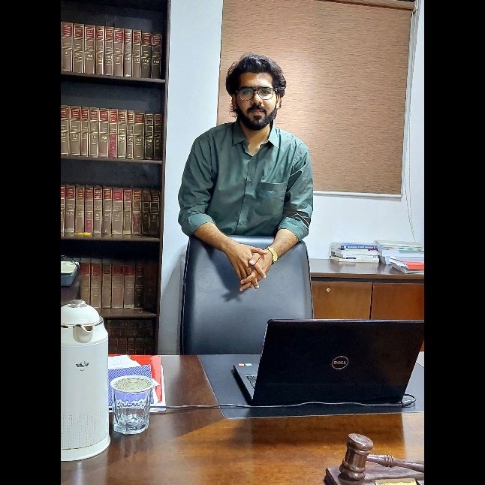

Emerging Non-Traditional Security Challenges in the 21st Century
In the previous centuries, the greatest security challenges a country faced were generally the militaries of other governments. However, it is no longer true in the twenty-first century. The rise of non-state entities, including such terrorist networks, drug lords, and maritime pirate networks, as well as intra-state disputes (e.g. civil wars), have taken significance as modern challenges to the global defense of contemporary governments. In addition to these non-state and transnational entities, the influence of environmental deterioration on the future of nation-states, particularly the consequences of anthropogenic climate change, has arisen as a realistic and grave danger to the future survival of contemporary nation-states. Future global power politics may be influenced by just one social factor: demographic shifts, such as an ageing and/or declining population, which are particularly pronounced in Western industrialized nations. Lastly, technical improvements in the 21st century, namely the Information and Communication Technology (ICT) breakthrough, has encouraged the creation of cyber-warfare and cyber-espionage, causing a gradual transfer of the battlefield from land, air, and sea to cyberspace.
In the age after the end of the Cold War, the phrase "National Security" has gained broader implications. In the 21st century, 'National Security' encompasses more than the use of raw power alone. In order to provide complete national security, it involves non-traditional security concerns. Pakistan has been confronting a number of non-traditional security issues for quite some time, which have had a significant influence on its development, prosperity, economic advancement, and political stability. These non-traditional security issues, which include environmental deterioration, food and water shortages, and an unprecedented population expansion, require immediate response before problems spiral out of control and endanger Pakistan's life and prosperity.
In Pakistan, the frequency of low-probability, high-impact catastrophes including such earthquakes, floods, droughts, storms, and cyclones has increased, causing catastrophic human and monetary losses. The 2005 earthquake caused roughly 0.1 million lives, rendered 3.5 million people homeless, and resulted in $5.2 billion in financial damages; while the 2010 floods affected 20 million people and wreaked devastation. Climate change and fluctuations in rainfall pattern also have a negative impact on agricultural productivity, which exacerbates food shortages. Food shortage is anticipated to be among the most significant concerns that the United States will confront in the future. Many academics believe that interstate "water-wars" are imminent due to diminishing fresh water resources.
The vast population and fast growth rate of Pakistan have a negative impact on many facets of society, the economy, and the environment. Idealistically, non-traditional concerns necessitate transnational regional cooperation techniques; nonetheless, our hostile neighbourhood exacerbates our difficulties. In the near future, the security, stability, and peaceful growth of the nation may be severely compromised by these non-traditional concerns. Clearly, Pakistan's population boom and resulting unrestrained, unregulated, and unplanned urbanisation is a big problem. Pakistan bears the highest urbanisation rate in South Asia, and the urbanisation process is marked by strong sociocultural and geophysical diversity. As in many other developing nations, the majority of population increase occurs in areas below the poverty line and in disaster-prone, subsistence-based economies.
Two resource-devouring global wars, the establishment of a bipolar international order, multiple proxy conflicts, the conclusion of the Cold War, and the rise of the United States as the world's only superpower characterised the 20th century. The creation of the United Nations as in wake of World War II and its subsequent declaration that the military assets of member countries could be utilised only for self-defense, or security interests, as identified and legitimised by passage of a United Nations resolution, has effectively "outlawed" the use of aggressive military force by UN member states. The incidence of interstate and civil conflicts in the twenty-first century has decreased in comparison to the twentieth century. When the United Nations was founded, it was primarily designed to deal with countries. However, modern warfare is no longer limited to battles between the armed forces of sovereign nations. The growth of organised criminal networks (e.g., drug cartels) and terrorist organisations in the 21st century has created a situation in which these non-state actors constitute a bigger danger to the national security of a state than the armed forces of other governments.
Multiple factors make transnational organised crime networks an extremely strong danger to a nation's national security. The World Bank describes an organised crime network as one which employs force and coercion to pursue financial gain through illegal methods. According to this description, worldwide drug cartels, weapons smuggling gangs, and maritime pirate networks are some of the most significant organised criminal networks. In the previous several decades, drug cartels have gained prominence due to their improved access to resources (financial and organisational) and use of advanced technology innovations to strengthen their risk management tactics and elude arrest by state security forces. Typically, organised crime networks flourish and proliferate in "weak" or "failed" states (mostly undeveloped and developing nations), which are characterised by ineffective government influence, poor law and order control, a weak set of regulations for protecting business activities, and a corrupt judiciary. Since these networks are quasi actors, they do not comply with the international rules and conventions that govern the use of force by states. Non-state actors are not constrained by geographical boundaries and do not acknowledge the idea of sovereignty. Consequently, transnational drug cartels and illicit weaponry distribution networks disregard all international regulations during their activities. In addition, they utilise bribery as a successful tool to recruit and/or persuade those employed by the government to oppose them. Since state intelligence services and police agencies in emerging and underdeveloped nations are more vulnerable to the temptation of bribery, these networks of organised crime flourish in these locations. However, this does not imply that organised criminal activities are solely prevalent in these locations. The United States and the European Union are the two largest drug markets, and drug cartels may benefit by focusing only on these markets.
Terrorism and insurrection have evolved as the most generally recognized and visible dangers to national security, particularly in the aftermath of the September 11 attacks. Terrorism is defined by Hoffman as the "deliberate production and use of fear via violence or the threat of terrorism in order to effect political change." Even though terrorist as well as insurgency groups are comparable to organised crime networks with their use (or threat) of way to accomplish their stated goals, the most significant and fundamental distinction is in their goals. In addition, insurgent organisations vary from terrorist groups by their desire for self-determination and territorial control; they often oppose the existing local government and foreign authority, whom they view as illegitimate occupying troops. In addition, organised criminal networks utilize governmental machinery to secure the success of their companies, while terrorist organisations attack civilians to bring awareness to their political objectives. The fact that both transnational organised crime channels and terrorist groups are non-state actors, and that terrorist groups, like transnational organized crime networks, do not recognise state boundaries, sovereignty, or international conventions and regulations governing the use of force, is the greatest security risk to a state that harbors such groups.
The enhanced organisational effectiveness of terrorist groups (e.g., leaderless networks) and the inefficient use of raw force and targeted assassinations by the state have impeded efforts to combat terrorism (in Chechnya and Palestine). Notably, the last interstate conflict between Israel as well as an Arab state was almost 30 years ago, and Israel's most recent battles were fought against non-state entities (i.e. Hezbollah and Hamas). Counter-terrorist operators are troubled with doubts as to whether terrorism can be entirely eradicated, which hinders the state's response to this worldwide danger to security and peace. Thus, the danger of terrorism continues to play a significant role in shaping a state's concept of national security.
One of the downsides of the organisation of the United Nations is that it only allows use of force in response to clear proof of aggression. Identifying the aggressor in civil conflicts is not always straightforward. When UN action is deemed ineffective, foreign intervention may occur, typically when a crisis escalates out of hand, as occurred in Libya. However, civil conflicts are intrinsically cyclical. Approximately forty percent of governments that had a civil war as well as a regime transition enforced by a foreign force relapsed within a decade. Typically, regime transition is ineffective due to the quick reversal of fortune of a specific group participating in the fight, to which the group may respond with violence. Thus, it is difficult to terminate civil wars by U.N. or foreign involvement; typically, these battles finish only when one party achieves a decisive and overwhelming victory over others, that might take generations. In the interim, there is a breakdown in law and order, with an increase in crimes or murders. This results in "failed states," in which the state government has lost power and control over the security leadership or the state due to a mix of intrastate conflict and foreign involvement. There are several instances of civil conflicts leading to failed governments, including Iraq, Afghanistan, and Rwanda. There is also the danger of "spillover," in which a military conflict in one nation impacts the security and peace of surrounding states owing to the influx or egress of refugees, rebel soldiers, guns and ammunition. Consequently, civil conflicts always result in instability in the region and a deteriorating security environment.
In the twenty-first century, non-state actors, intra-state warfare, ecological degradation, demographical shifts, and cyber-conflict offer a larger security danger to nation-states than armies of other nations. International rules and institutions, such as the United Nations, are two crucial tools of managing and preventing conflict and fostering greater collaboration. However, these laws & institutions are solely designed to deal with governments; they have no mechanisms for dealing with organised criminal networks or terrorist organisations. The "tragedy of the commons" has led to the overexploitation of environmental assets without regard for their replenishment, because "moderation is considerably more difficult to achieve than deterrence." Developed nations are averse to intentionally stifling their economic progress by complying to the Kyoto Protocol, while emerging nations are unwilling to sacrifice their recent economic triumphs. This has led to an impasse in addressing the effects of climate change. Future power dynamics of a state may hinge on demographic shifts, making them a crucial flashpoint. Cyberwarfare may be in its infancy, yet its effectiveness has been demonstrated when employed (e.g. the Stuxnet attacks which were allegedly carried out by US and Israel to take down the Iranian nuclear infrastructure). It is also very attractive to government and non-actors as an efficient addition to traditional combat strategies because to its low cost and lack of direct human casualties during operations. All of these new dangers to a nation's national security exist outside the scope of conventional battles. According to Nye and Welch, the international stage is getting crowded, and nations are no longer the sole actors in a vibrant international system not because the laws of the game has altered, but also there are no rules to commence with, nations find it extremely difficult and complicated to address these contemporary disputes.

https://reliefweb.int/report/pakistan/kashmir-earthquake-october-8-2005-impacts-pakistan
The World Bank. 2013. “Shape of Violence Today.” In International Politics: Enduring Concepts and Contemporary Issues, 11th Edition, edited by Robert Art and Robert Jervis, New York: Pearson.
Williams, Phil. 2014. “Transnational Organized Crime and the State.” In The Emergence of Private Authority in Global Governance. 1st edition, edited by Rodney Bruce Hall and Thomas J Biersteker. Cambridge: Cambridge University Press
Hoffman, Bruce. 2013. “What is Terrorism?” In International Politics: Enduring Concepts and Contemporary Issues, 11th Edition, edited by Robert Art and Robert Jervis, New York: Pearson
Nye, Joseph S Jr and David A Welch. 2013. “Managing Conflict.” In Understanding Global Conflict and Cooperation: An Introduction to Theory and History. New York: Pearson
Downes, B. Alexander. 2011. “To the Shores of Tripoli? Regime Change and Its Consequences.” Boston Review 36:5 (September/October)

