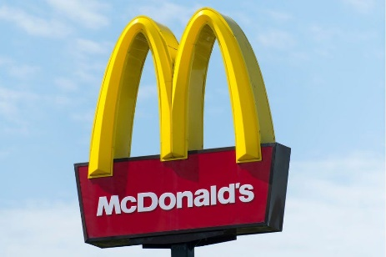
Introduction
McDonald's is one of the world's most popular labels. This article illustrates how McDonald's strives to develop the reputation continually by listening to its consumers. It also describes the various steps in the process of marketing. Branding generates a corporate, commodity or service identity. The brand identity reflects how customers see the product. Branding succeeds only because an entity is regularly behaving and introducing itself. Communication techniques for advertisement, such as ads and advertisements, are used to create colors, patterns and photographs that make the brand identifiable. At McDonald's, the Golden Arches is the famous emblem. McDonald's differ with other firms in all of its markets. Furthermore, the achievements of McDonald on the market was influenced by cultural, regulatory and technical developments, social trends, the business climate and much others. Marketing involves recognizing and better fulfilling consumer expectations and demands than rivals. A business thereby produces trustworthy clients.

What is marketing?
Marketing is the process, collection of institutions and processes for the creation of services for suppliers, suppliers, partners, and the business as a whole. (Approved 2017)
Marketing involves a company's efforts to facilitate the acquisition or distribution of a good or service. Marketing includes advertisement, distribution and merchandise supply to customers or other businesses. Such commercialization is performed on behalf of a client by distributors (Twin, 2020).

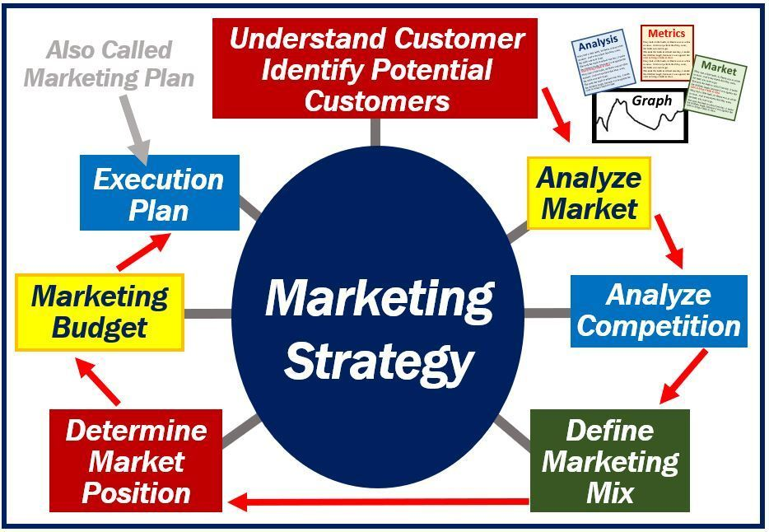

Stages in Marketing Process
Mission Statement and Objective of McDonalds

McDonald's goal is "to be the perfect spot and way of eating and drinking for our customer." This mission statement emphasizes the value of consumers for companies and holds the brand as a big influence on their buying choices on products and drinks.

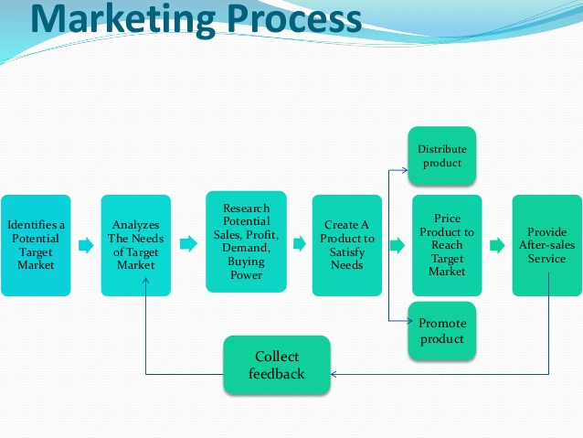

Situational Analysis
- Market Analysis and Market Share Model
McDonald is a well-recognized pioneer in the fast-food industry or also referred to as the "Burger" business. A famous company image has been successful for the organization. Since the alliance, the extensions of fast food were called 'McDonaldization.' Advertising involves knowing what consumers desire and seeking to satisfy their demands. Promoting the audit involves analyzing various points of view of the company and evaluating the promotional strategy of the company. It includes the drawing of declines in the implementation of partnerships. McDonald's is the largest fast food business stop company. This has over 30,000 grocery shops feeding millions of customers globally in over 100 countries. As a result of the agreement they took in, the company became known as the Q.S.C. & V (Sheikh, et al., 2016).
According to market analysis of McDonalds Corporation in 2015, the group obtains the three legged stool, who are the proprietors, vendors and staff of the Company, adopting a specific action plan. The three legged stool. It is a connection that makes, operates, businesses and partnerships a general coffee shop's game plan that gathers, packs and provides an expected collection of automatically organized, ignored survival options. Market Strategy
A marketing strategy lays out and explains the aims or strategies that will meet customers' desires in a specific market. For example: Marketing teams, executives, executives and so on coordination between various divisions of the company includes.

MARKETING STRATEGIES OF MCDONALD’S

- DEVELOPMENT OF FRENCHISE
The business holds just 15% of the overall number of restaurants. The remaining 85% is owned by franchisors. The organization provides a rigorous preparation and testing system with its franchises to conform to its customers' Price, Operation, Cleanliness and Value deals.
- CONSISTANCE PRODUCT
The company was able to create a clear product experience and price in all geographies by creating a complex networked management and delivery infrastructure for the manufacturer.
- ACT LIKE A RETAILER AND THINK LIKE A BRAND
It not only concentrates on producing instant profits, but also on maintaining its value for a long-term brand.
- HIGHLY SUGGEST THE MENU
McDonalds believe in the food, belief values, culture, vocabulary and experience of the consumer. McDonalds became famed internationally for its hamburgers made from beef and pork burgers. Yet McDonald's came up with chicken and fish burgers to satisfy these consumers for religious purposes and in order to fulfill their needs and desires.
- THE VEGETARIAN CLIENTS
In the UK, there are numerous vegetarians. McDonald's has created an entirely new range of vegetarian items such as McVeggie burger, Spicy Veggie wrap, to meet the demand of these consumers.

Implementation and Control
McDonalds will reflect on their final performance to consider what kind of stuff would be good if they wish to hang onto their position to preserve their credibility.
Implement Marketing Plan
When McDonalds needs to develop a appropriate strategy plan so that all client divisions can operate on their superior structure and have exact direction.
Achieving goals
If McDonalds aims to accomplish its targets rather than relying on its overall financial performance including market share, income, revenue, strategy, and review in all McDonalds divisions and departments, so all strategies, and strategic plans will definitely be successful and McDonalds will follow suit.
Contingency Plan
When items do not align and work, principles are not attached to a publicity scheme because we have to find a backup strategy for the second alternative. McDonalds's must then put certain goods in their pipeline; they must analyze all of their products, places and facilities. After that both McDonalds would surely have their other option for their rough time.

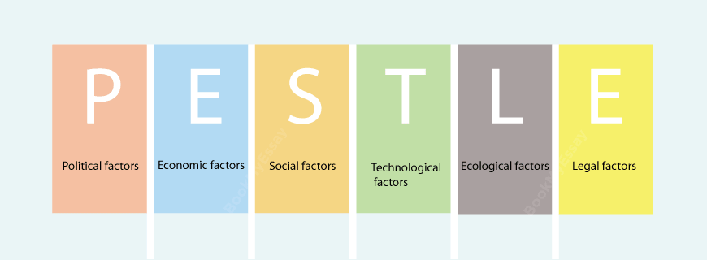

PESTEL Analysis of McDonalds
We shall take a look at the numerous environmental macro factors in our PESTLE review of McDonald's Corporation that influence the achievement of this global restaurant chain.
We will carry out the McDonald's PESTLE review here.
- McDonald’s Political Factors

In McDonald's success, political factors play a critical role. As a food chain, it is continually exposed to the various safety and hygiene laws imposed by its governments. McDonald's also must take into account the health needs of its consumers, as it primarily sells fast food, linked with a range of health risks such as obesity and heart disease. Governments' taxes on fast food purchases may have a negative effect on supermarket chain profitability.

McDonald’s Economic Factors

For any company, economic conditions play a critical role, and McDonald's certainly does. But the situation is actively difficult in this multinational empire, because not only the U.S. local economy, but the economic and welfare condition of all areas in which it exists must be taken into account.

McDonald’s Social Factors

A weekly tradition for many families was a night out at McDonald's. That's not the case today. When obesity issues grow around the globe, consumers are moving toward 'junk food' to low-calorie to low-salt diets more and more. As the environment is cleaner, McDonald's will now refurbish the menu to satisfy the demands of a worldwide client.

McDonald’s Technological Factors

For McDonald's performance, innovations will make a big difference. McDonald's will build a devoted follower with sophisticated technologies like digital ads and social media that can definitely turn into more sales. In turn, the restaurant chain will be able to incorporate new orders and payments that improve consumer satisfaction and boost revenue leveraging emerging technologies.

McDonald’s Legal Factors

Legal regulations will also be the concern of major companies. McDonald's policies on food safety and sanitation are very significant. It will also deal with the rules and laws of different countries, as it works around the globe. Developing countries also have flexible regulations that may make extending McDonald's to these markets enticing. Yet strengthened legislation and bureaucracy can be major barriers in the direction of growth.

McDonald’s Environmental Factors

McDonald's has a shot of establishing itself as a company that better fulfills his corporate obligation as the planet gets more environmentally aware. The company will reach a broad client base that can certainly associate with sustainable practices by growing the supply chain, the distribution and activities ecologically friendly.

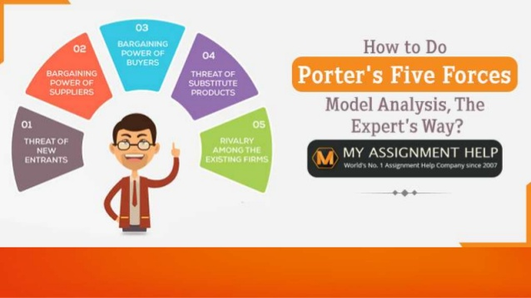

PORTERS FIVE FORCES MODEL

Based on shifts in markets around the world, McDonald's experiences the impact of external factors with different intensities. Of example, the US market is distinct from the European market in its economic environment. The company wants approaches to counter these external factors to mitigate their negative effects. This Five Forces Study of Porter's McDonald's determines the intensities of all five forces, despite the variation of the business conditions:

Competition with McDonald’s (Strong Force)

The restaurant is in a fast food industry crowded with McDonald's facing stiff competition. The impact of competitive companies on the business landscape are discussed by this aspect of Porter's 5 Forces analysis model. McDonald's situation is based on the following external factors: The strength of economic rivalry:

Multiple firms – Strong Force.

High business aggression – Strong Force.

Low prices for switching – Strong Force.

McDonald's customers / buyers' market strength

McDonald's will tackle consumers' control over company results. This dimension of the Five Forces study deals with market interest and expectations and how companies affect their decisions. In the case of McDonald, the external factors leading to the buyers' high bargaining capacity are:

Low prices for switching – Strong Force.

Wide selection of suppliers – Strong Force.

Strong replacement choice – Strong Force.

McDonald's suppliers’ market strength

According to the quality of raw material the manufacturers affect McDonalds' production efficiency. The effect of the suppliers in the business and fast food industry ecosystem is shown by this dimension of the Five Forces research model. The poor bargaining power of suppliers in McDonald's case is focused upon these external factors:

Large number of suppliers – Weak Force.

Small vertical product alignment – Weak Force.

Low production total – Weak Force.

Threat of substitution (Strong Force)

The McDonald's Company has major alternatives. The future influence of alternatives on business development is addressed in this section of Porter's Five Forces research model. In McDonald's case, the possibility of replacement is a important external factor:

Strong availability of substitute – Strong Force.

Low prices for switching – Strong Force.

Strong cost-effectiveness of substitutes – Strong Force.

New Entrants' Threat (Moderate Force)

The market share and financial results of McDonald will affect new entrants. The impact of emerging entrants on the current firms are alluded to in this Five Powers review. The mild threat of new entry in McDonald's case is based on the following external factors:

Small prices for switching – Strong Force.

Work costs extremely variable – Moderate Force.

Large production costs – Weak Force.

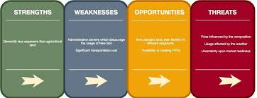

SWOT Analysis

SWOT Analysis assists with the following strategic planning:

Develops the strengths of the organization.

Check the weaknesses.

Enhance your response to opportunities.

It helps set strategic planning goals.

It helps to understand past, present and future so that future strategies can be developed by the use of historical and existing evidence.

SWOT analysis of McDonalds

Strengths

Global Brand

McDonald's has a large global name, which is appealing for any age and type of customers.

STRONG OPERATIONAL CAPACITIES

McDonald’s is able to offer high-quality food and customer satisfaction in its restaurants with good organizational skills.

Successful Products

Any of the products, including Big Mac, are variants of Chicken McNuggets. Strong brand attracts buyers into the restaurants of the company and gives it a well-known name in emerging markets.

PRODUCT QUALITY

McDonald's is the premium icon for the variety of products.

Weakness

Low productivity of Revenue

Small sales growth suggested that, due to the maturing and consolidation of its core markets, the organization has been unable to increase consumer demand in existing restaurants.

Weak Development of Product

Strong competition is hitting McDonald's and his slow product production is a concern.

Opportunities

Development

McDonald's also have a wide audience to reach. It also has few stores in the towns it is operating in, and McDonald's is still willing to spread within the cities.

Franchisee

McDonald's plans to employ franchisees of business stores. The franchisor's profit income – managed restaurants is higher than that of operated restaurants – operated.

OUT Demand – GROWING DIVING

If food preference habits shift, the restaurant industry rises, which will give McDonalds a shot.

Threats

COMPETITION

Restaurants in McDonald's face extreme completion by worldwide, global, regional and local food retailers. The company is competitive on the basis of food products' costs, convenience, operation and efficiency. Restaurants, fast-service dining places, pizza salons, coffee shops, street stalls, convenience grocery stores, delicatessen and supermarkets are included in the rivalry of the business.

Health Consciousness Increasing

With the rates of education growing, the awareness of wellbeing has also increased. McDonald's may decrease an increasing awareness of health issues.

Increment in Sales Tax

Sales tax has grown, leading to higher rates for customers and a smaller volume of sales.

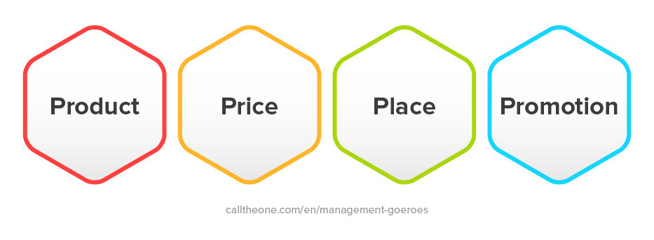

4P’s Marketing Mix

Products

The most important thing when you show the customer a menu is to give them the alternative. It is because consumers have many options to spend their money according to their desires at different locations. Thus, you are literally satisfying their desires by giving them a preference. McDonalds often strive to build a menu that is always wanted or needed by consumers.

The research and development of McDonalds also strongly tracks customer tastes. By launching new products and often through elimination of old goods or items that are not working with them, they tackle these changes (Malik, 2011).

Price

The development of a consumer interest preposition is a significant price determinant. The customer needs to make the visual picture more valuably. It may often be considered that a good is greater than the real expense due to its psychological meaning (Khosoet al., 2014).

Place

Here McDonalds Pakistan has taken the leading position to sell its goods for its customers. The item thus suggested that it would be possible to sell firm goods. So the virtual and non-existent areas of McDonald Pakistan are able to market their products.

Promotion

This component of the marketing mix includes all aspects of consumer interaction and describes the methods to be used during contact with the client. It depends on either field on what resources you have to support or on the commodity you sell. In McDonald's case, they are simply encouraging the appeal of their goods to consumers, but in some cases McDonald's has always distinguished consumers with its services.

Conclusion

Once the campaign policy is in motion, various individuals are responsible for executing the program. Systems for customer reviews evaluating performance in relation to short-term goals are introduced. McDonald's must ensure that this takes place within a narrowly regulated, final campaign budget.McDonalds' ability to meet its own targets according to the demand and research. McDonalds's willingness to introduce and sell new goods and services to the public will increase its share when looking at its valuation.

We are likely to claim that a stable economy and technical innovation will fuel McDonald's trajectory to sustain number one spot in the fast-food market, irrespective of rapid-food developments and global political turmoil.

McDonald's expects to rise rapidly in 2019, according to industry forecasts. You should expect that this pattern will persist almost and further in the future with the right approach.

References

Twin, 2020. Marketing. https://www.investopedia.com/terms/m/marketing.asp

Greenspan, 2018. McDonalds PESTEL Analysis & Recommendations. http://panmore.com/mcdonalds-pestel-pestle-analysis-recommendations

Farooq, 2019. PESTLE Analysis of McDonald’s. https://www.marketingtutor.net/pestle-analysis-of-mcdonalds/

Howard, 2015. Marketing Strategies at McDonald's. https://www.researchgate.net/publication/301621368_Report_on_Marketing_Strategies_at_McDonald's

Gregory, 2018. McDonald’s Five Forces Analysis (Porter’s Model) & Recommendations. http://panmore.com/mcdonalds-five-forces-analysis-porters-model

Ahmed, 2016. Strategic Marketing Plan for McDonald’s 2016. https://www.researchgate.net/publication/301553341_Strategic_Marketing_Plan_for_McDonald's_2016

Meyer, 2019. McDonald’s Mission Statement & Vision Statement (An Analysis). http://panmore.com/mcdonalds-vision-statement-mission-statement-analysis

Malik, 2011. Mcdonaldsmarketingproject. http://vustudents.ning.com/

Khoso I, AhmedRR, Ahmed J, (2014), “Pricing Strategies in Pharmaceutical Marketing”.

