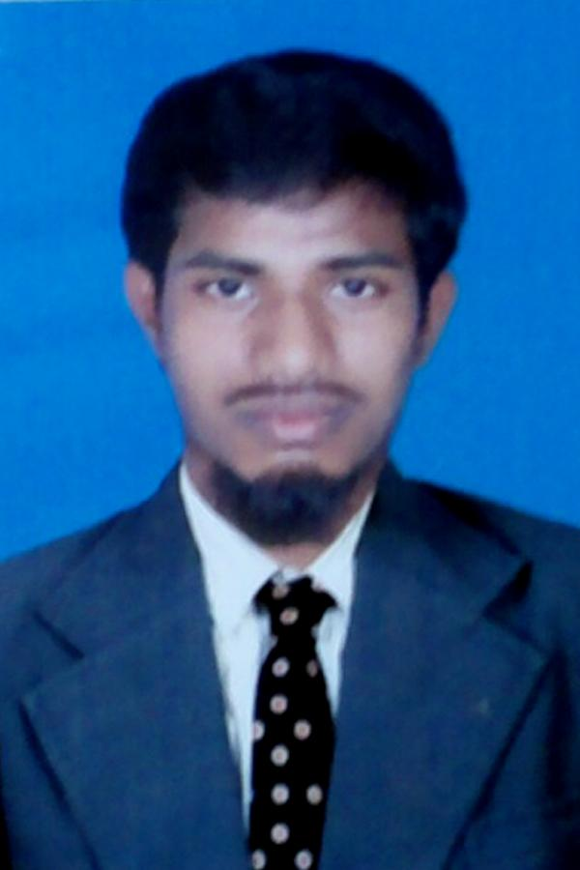
CURRICULUM VITAE

Mohamed Ismail
Mob: +91-9698704108
E-mail: liamsi001@gmail.com
…………………………………………………………………………………………………………………

JOB OBJECTIVE:

Aim to build a strong career as a bilingual translator in a challenging and progressive environment, where my skills and experience can be utilized effectively.

ACADAMIC DETAILS

Degree | Course Name | Duration From | Duration To | University/  Institute | Course Type | Specialization
Graduate | Bachelor of Arts  (English) | 01/06/2016 | Perusing | Alagappa University  Karaikudi | Distance | English
Post Graduate | Master in Arabic | 03/06/2013 | 10/06/2015 | University of Madras | Distance | Modern Arabic
Graduate | Bachelor of Arts  (Arabic) | 01/09/2008 | 01/06/2012 | Bharathidasan University, Tamilnadu | Full Time | Modern Arabic
Fazilat  (equivalent to Graduation) | Arabic Research | 01/07/2012 | 01/06/2013 | Darul Uloom Deoband-Nw Delhi | Full Time | Modern Arabic
Linguistic (Arabic) | Maulvi | 01/06/2008 | 31/04/2012 | Irshadul  Uloom ,  Perambalur | Part Time | Modern Arabic
HSC | - | - | 2016 | Private | - | Arabic
SSLC | - | 01/06/2006 | 31/05/2007 | J.F Oriental Higher Secondary School | Full Time | Tamil

WORK EXPERIENCE DETAILS:

Name of Employer | Address of  Employer | Duration | Designation | Nature of Duties | Salary(INR)
J.F Oriental Higher Secondary School | Trichy Main Road, Pulivalam | 2013-2014 | Teacher | Teaching Modern Arabic Language, Accountant | 15,000/-
Al-Munawara Islamic School –(CBSE) | Pudukkottai | 2014-2015 | Teacher | Accountant & Teaching Modern Arabic Language, | 20,000/-
Qalam International School | Tiruvallur | 2016-2017 | Teacher | Teaching Modern Arabic Language&  Arabic Translator | 22,000/-
D&B Technologies and Data Services Pvt Ltd. | 9th Floor, Phase I, Prince Infocity, Rajiv Gandi Salai,  Old Mahabalipuram Road, Kandanchavadi,  Chennai - 600 096. | 27-Feb-2017 | 24-Feb-2020 | Senior Process Associate (Level 2)  &Arabic Translator | 4.5 lakh per Annum
Paypal India Pvt Ltd | Futura IT Park, 334, Elcot Sez, Rajiv Gandhi Salai, Chennai, Tamil Nadu 600119, India | 09-Mar-2020 | Till Now | Customer Identity Advisor 2 | 5.5 lakh per Annum

LANGUAGES KNOWN:

Language | Read | Write | Speak
Tamil (mother tongue) | Yes | Yes | Yes
English | Yes | Yes | Yes
Arabic | Yes | Yes | Yes
Hindi | Yes | No | Yes
Urdu | Yes | Yes | Yes

Computer Skills:
- Packages: Ms-office xp, Tally, Photoshop, Window 7 & 8.
Others: In page & Internet Surfing, DCA
- Special: Typing of English, Arabic, Tamil (30 words per minute)

Skills & Expert Area:

- Teaching Modern Arabic Literature.
- Having strong skill of Arabic Financial documents.
- Proven Experience in bilingual Translation, Proof Reading, editing like visa, passport and all type of cards.
- Operating System data base and Updating Campus Software.
- Having e a Research in Islamic Banking and Arabian Technical Field
- Data handling.

Strengths:

  - Can finish work in dead line with Confidence & Time Management
  - Cultural awareness and sensitivity.
  - Exceptionally Professional demeanor.
  - Ability to Work in a fast paced environment and multitask
  - Good Communication Skills.
  - Ready to face challenges cheerfully and Self-motivated.
  - Hardworking, Obedient to Management
  - Positive with never say-die attitude.

PERSONAL PROFILE:

- Father’s Name: Abdul Jabbar. M
- Date of Birth: 27/06/1992
- Place of Birth: Pulivalam
- Nationality: Indian
- Religion: Islam
- Marital Status: Unmarried
- Permanent Address: 2/21A, Gounder Street,Pulivalam,Trichy-621 006

I, Mohamed Ismail hereby declare that the contents of the Bio- Data are true to the best of my knowledge. I can assure you for the best service, if I am given a chance.

Mohamed Ismail

