Differences between Geriatric Care on Home Nursing and in Retirement Homes

David, Justine Rodinah S.

Pangilinan, Rachelle

Subido, Kerstin Marie Lois C.

Tamega, Christine

February 28, 2019

Author’s Note:

Justine Rodinah David, Rachelle Pangilinan, Kerstin Marie Lois Subido & Christine Tamega, Angeles City Science High School.

Should there be any correspondence concern regarding this paper be addressed to either any of the authors, Justine Rodinah David, Rachelle Pangilinan, Kerstin Marie Lois Subido & Christine Tamega, Angeles City Science High School, Dona Aurora St., Lourdes Sur East, Angeles City, Pampanga.

+63 975 208 1125

.E-mail: justinerodinah.sd@gmail.com

**Abstract**

Many people are unaware about geriatric care, and this gave the researchers an idea to conduct a study on the Differences between Geriatric Care on Home Nursing and in Retirement Homes. The researchers aim to know the different protocols used by the geriatricians and home nurses. The descriptive type of qualitative research was conducted on the health facilities and home for the aged around Angeles City, Mabalacat City and City of San Fernando. Data were gathered by interviewing the participants using semi-strucured interview with open ended questions. The researchers found out that there is a significant difference between geriatric care in home nursing and in retirement homes. The researchers suggest to the future researchers to conduct their study in a larger area in order to gather more respondents and informants.

*Keywords*: private nurses, caregivers

**Introduction**

Filipino families are under pressure to maintain “ownership” of taking care of their respective elderly as globalization and the international migration put pressure on the family as traditional caregivers. Family members opt to leave the country or seek opportunities elsewhere in the country. The Philippines is a diverse country that will experience an increase in its aging population in the near future.

Since the year 2012, the Primary Health Care Committee, Subcommittee on Gerontology and Geriatrics of the PAFP or the Philippine Academy of Family Physicians developed a partnership with the United Bayanihan Foundation in distribution and promotion of Healthy Lifestyle modules for senior citizens. The Senior Citizens Summit gathers 250-300 senior citizens to educate them on the impact of aging and to emphasize healthy lifestyle as they age. Family physicians from PAFP were trained to give the lecture in barangays all over the Philippines and for the mean time has its campaign focused in NCR and Luzon. In the year 2016, the committee has started training barangay health workers and caregivers of Homes for the Aged and other nursing homes on care for the elderly. In the same year, more than 12,000 seniors were reached, 5,000 barangay health workers and 350 caregivers were trained (PAFP, 2016).

Geriatrics is defined as caring for older adults (Leff, Kao, & Ritchie, 2015). Geriatricians are physicians that are well trained in managing the health care needed by older people. Other health care professionals such as nurses, social worker and physical therapists have advanced training in geriatrics as well. Since older adults have a more complex medical care due to their special health care needs, older people need well-trained professionals to care for them (“What is Geriatrics”, 2018). People aged 65 years and older have up to 45% increased functional dependence and 10% mortality rate within the first three months of being discharged from the hospital. Nurses with specialized training in geriatric care helped improve the patient’s health (Roethler, Adelman, & Parsons, 2011). Yet, despite the need of having a good health care system for older people, geriatric care is not given much attention of. Nursing facilities for old people tend to be understaffed and the care complexity of residents increases while expertise of staff does not keep pace (Spector, Cohen, & Pesis-Katz 2014). Although most care organizations want to innovate and improve their quality of care, many lacks the expertise or financial resources to do so (Moran et al., 2013). Nursing homes, specifically in the Philippines have little or not enough facilities to accommodate the needs of the old people. Some methods of geriatric care in nursing homes must also be studied and modified to cater the needs of the patients better. Centralized health care service coordination among hospitals and nursing homes have made improvements in geriatric care and this has also reduced the excess costs of providing health care services on the patients (Martin-Khan et al., 2015).

An average of 17 million patients enter the emergency department in the year 2006. Elder patients have a higher percentage of going to the emergency department of hospitals than other age groups. 35% to 60% of the patients in the emergency department are from the older age groups. Yet, most physicians tend to fail in providing consistent high-quality health care among their elderly patients (Malaguarnera et al., 2013). Good health care in nursing homes are able to reduce hospital admissions rate from the elderly patients (Graverholt, Forsetlund, & Jamtvedt, 2014). Hospitalizations also have detrimental impact to the health of elderly people, including infections, functional and cognitive decline (Wilson et al., 2012). Positive approach to the elderly patients also results to positive cognitive feedback. Thus, justifies the need for the staff members to be equipped in caring for the patients and to be engaged personally to them as well (Anderson, et al., 2014).

The percentage of older persons have increased over the years. People aged 60 years and above was estimated at 600 million in year 2000, which is 30% of the world’s population. Projected numbers of older people will reach around 1.2 billion in 2025 and 2 billion in the year 2050 (UNFPA, 2002; WHO, 2002). As generations pass by, people possess higher background, thus, having greater financial situations. People expect and demand greater standards for their health care in the future as they retire (Roach, 2001). Older people have to acquire special health care due to their health conditions contributed by their aging process (Gendron, Inker, & Welleford, 2017). Some geriatric problems that older people experience are inactivity and deconditioning, falls, dementia, meditation complications. These problems interfere with the health care that nursing homes are able to provide (“Care of the Older Adult”, 2012).

Research has proven that the majority of older people would prefer to live independently in their own home. Unfortunately, there are many times when this does not happen and loved ones end up moved from familiar surroundings to be placed in residential care homes. This is often due to a lack of knowledge about the options that are available when it comes to care for the elderly. For those who need support and assistance with their day to day lives, live-in home care is a solution that enables them to remain safely in familiar surroundings. In home care can encompass a broad range of services. Domiciliary care consists of a carer visiting at a predetermined time each day and carrying out certain tasks, such as assisting with personal care or administering medication (Bernabei, Onder & Landi, 2010).

This research study aims to assess the service provided by the geriatric health care professionals and compare it to the standard protocol of geriatricians.

Specifically, this research seeks to find answers to the following questions:

• What is the performance of the health care professionals in the field of geriatric care?

• Do the health care professionals in nursing homes strictly abide with the universal health care protocol for geriatrics?

• What is the health situation of elderly patients in nursing homes?

• What is the difference between geriatricians and home care nurses?

It is important to study about geriatric care because it can inform and alert people on the problems and processes that they may experience as they grow older. The results of this study will not only serve as a guide for caregivers alone, but it can also educate everyone on the proper ways of taking good care of the elderly. Doing this research, will also help people determine whether the ways they are doing are correct and proper.

**Conceptual Framework**

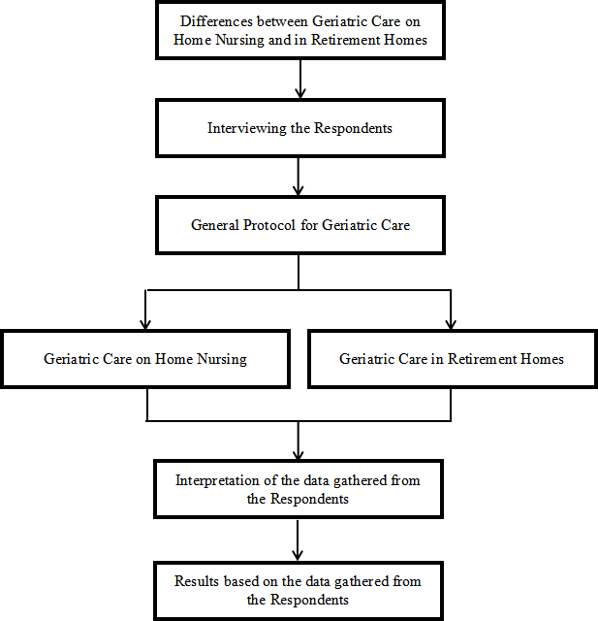

The researchers determined the differences between geriatric care in home nursing and in retirement homes by interviewing respondents who are geriatric care providers, such as nurses, caregivers and social workers. The data gathered were compared to the general protocol of geriatric care to find out the differences between geriatric care being provided in home nursing and in retirement homes.

The beneficiaries of this study are the geriatricians, geriatric patients and their families, and other geriatric health care professionals.

**Methodology**

This chapter shows the methods used by the researchers in order to gather the data needed for the study. This includes the questionnaires used by the researchers in conducting the survey as well as the chosen sampling method for the research.

**Subjects**

The participants of this research are the medical professionals involved in providing health care services for the elderly – geriatric care professionals. The chosen geriatric care providers were the private nurses and those who are from retirement homes. The participants were geriatric health care providers from the province of Pampanga, specifically in Angeles City, City of San Fernando and Mabalacat City.

**Research Design**

The research design used in this research is descriptive, which pursues to show the participants in an accurate manner. In other words, descriptive research describes the characteristics of the topic that is being studied.

**Measures**

The survey interview was conducted with respect to research ethics which protects the identity of the participants through confidentiality. The participants were not forced to answer questions that are not for disclosure or anything that they are not comfortable with. The participants were interviewed using semi-structured method which uses a guided questionnaire but also allows the researchers to ask follow up questions regarding the topic that could help in the further enhancement of the research work.

**Methods and Procedure**

The researchers conducted a survey interview among geriatric health care providers on the services that they provide to their patients. The questionnaire focused on the care services and standard protocol. The researchers used a semi-structured procedure that helped them strengthen the research. A semi-structured interview is a meeting in which the interviewer does not strictly follow a formalized list of questions. They will ask more open-ended questions, allowing for a discussion with the interviewee rather than a straightforward question and answer format. The sampling technique used in this research is purposive sampling. It is a non-probability sampling technique which is selected based on the characteristics of a population and the objective of the study. This sampling method let the researchers choose the participants that suit the research based on a set of standards that was made by the researchers to make sure that the participants were people that are of use with the research work.

The researchers followed a set of questions that served as a guide during the interview with the respondents, which were adapted from ncbi.gov:

* Do you think that the medical study of aging is necessary?
* What predictors are available to evaluate geriatricians/home nurses attitudes to “medicine of older people”?
* What knowledge on aging and older people do geriatricians/home nurses have?
* What attitudes do geriatricians/home nurses have towards aging?
* What attitudes do geriatrician's/home nurses have towards older people?

**Results and Discussion**

This chapter aims to determine and summarize the results of the interview on the differences between the care provided by geriatric health care professionals on home nursing and in retirement homes. The data gathered from the study aims to address the problems and concerns of the professionals in the geriatric care community.

The research conducted proved that the medical study on geriatric care, specifically on the development of the treatments for the elderly, is important, however the study also showed that it is unnecessary for the nurses or caregivers to be a graduate of a medical course, such as nursing, physical therapy, and caregiving, to become a geriatric health care provider. The study on aging and older people is needed in order to address the needs of the patients. This helps the nurses and caregivers aid the needs of the elderly patients. Yet, it is unnecessary for a carer of an elderly patient to become a geriatric health care professional. Either way, the care provider can address and tend to the needs of the elderly patient needing help.

As for the care provided by the nurses and caregivers to their elderly patients, the nurses and caregivers follow certain protocols and procedures. Nurses focus more on the medical needs of the patients, the medication that the patients should take and the food that the patients should eat. On the other hand, the caregivers aid the elderly patients in performing their daily activities such as walking, eating, bathing, and putting on their own clothes.

The health care providers for the elderly need to evaluate and assess the needs of the elderly patients to ensure their welfare. This includes, family caregiving activities include assistance with day-to-day activities, illness-related care, care management, and invisible aspects of care. Day-to-day activities include personal-care activities (bathing, eating, dressing, mobility, transferring from bed to chair, and using the toilet) and IADL (meal preparation, grocery shopping, making telephone calls, and money management). Illness-related activities include managing symptoms, coping with illness behaviors, carrying out treatments, and performing medical or nursing procedures that include an array of medical technologies. Care-management activities include accessing resources, communicating with and navigating the health care and social services systems, and acting as an advocate. Invisible aspects of care are protective actions caregivers take to ensure the older adults' safety and well-being without their knowledge.

The nurses and caregivers should determine and respond to the medical needs of the patients, monitor their health status, their blood pressure and blood sugar. It is the job of the caregivers and nurses to attend to the needs of the patients and assist them on doing their daily activities. Though some of the carers of the elderly patients are not a graduate of any care giving or medical related course, all of them have at least the basic knowledge on how to care for the elderly patients. They follow protocols on cleanliness to ensure the safety of the environment of the patients, lessening the health hazards around them.

The care providers for the elderly also need to understand and respond to the needs of their patients. A geriatric health care provider is expected to provide services for the elderly to feel comfortable or at ease. It is also better to develop a sense of empathy towards the patients in order to understand them and their situation better. As for the private home nurses and caregivers, they establish a closer relationship to their patient given that they have to focus on that patient alone. While the nurses and caregivers in retirement homes have to familiarize themselves with all of the patients in their retirement home rather than focusing on one patient alone.

The care provided by private nurses and caregivers and nurses and caregivers in retirement homes are very much alike and are almost the same. The difference between the privately hired caregivers and the caregivers in retirement homes are only on a slight margin, based on the research conducted, the marginal difference between the two is the relationship between the caregiver or nurse and the elderly patient. A hired nurse is only focused on a single patient, whereas a caregiver or nurse in a retirement home is subject to checking up on all of the elderly patients.

Based from the interview, the results showed that geriatric health care providers in nursing homes and retirement homes have more patients to be responsible of and to take care of than the hired private nurses at home. The private nurses at home tend to only focus on a single patient while the nurses and caregivers in retirement and nursing homes have to look out for quite a number of patients.

**Recommendations**

The researchers suggest that the future researchers use a wider range of area where the research is to be conducted in order to gather more respondents for the study. Find more geriatric care professionals and providers to become respondents and informants to contribute in this study in order to obtain more data and a wider range of topic coverage. Put additional questions such as determining the budget allocated for each facility or each patient, finding the ratio of the workers to the patients. It is recommended by the researchers to determine if the patient handled by the nurse or caregiver is suffering from any kind of disease and indicate if the patient is bedridden, in a normal physical condition or in a comatose status.

**References**

Anderson, N. D., Damianakis, T., Kröger, E., Wagner, L. M., Dawson, D. R., Binns, M. A., ... & Cook, S. L. (2014). The benefits associated with volunteering among seniors: a critical review and recommendations for future research. Psychological ubulletin, 140(6), 1505.

Bernabei, R., Onder, G., & Landi, F. (2010). Comprehensive care for older adults: Case management approach. *Journal of the American Geriatrics Society*, *58*(6), 1202.

Care of the Older Adult. (2012). Retrieved from: https://www.amsn.org/practice-resources/position-statements/archive/care-older-a dult

Drickamer, M.A., Levy, B., Irwin K.S., & Rohrbaugh, R.M. (2006). Retrieved from: https://www.ncbi.nlm.nih.gov/pmc/articles/PMC1924752/

Gendron, T. L., Inker, J., & Welleford, E. A. (2017). A theory of relational ageism: A discourse analysis of the 2015 White House Conference on Aging. The Gerontologist, 58(2), 242-250.

Global Age-Friendly Cities Project. (2002). Retrieved from: https://www.who.int/ageing/projects/age_friendly_cities/en/

Graverholt, B., Forsetlund, L., & Jamtvedt, G. (2014). Reducing hospital admissions from nursing homes: a systematic review. BMC health services research, 14(1), 36.

Hofman, C., Lutomski, J., Boter, H., Buurman, B., De Craen, T., OldeRikkert, M., & Melis, R. (2014). The feasibility and validity of a preference-weighted composite endpoint to establish value in geriatric care. BMC health services research, 14(S2), P55.

Leff, B., Kao, H., & Ritchie, C. (2015). How the Principles of Geriatric Care Can Be Used to Improve Care for Medicare Patients. Retrieved from: https://www.asaging.org/blog/how-principles-geriatric-care-can-be-used-improve -care-medicare-patients

Malaguarnera, M., Vacante, M., Frazzetto, P. M., & Motta, M. (2013). What is the frailty in elderly? Value and significance of the multidimensional assessments. Archives of gerontology and geriatrics, 56(1), 23-26.

Martin-Khan M., et al. (2015).Establishing a centralised telehealth service increases telehealth activity at a tertiary hospital.

Moran, N., Glendinning, C., Wilberforce, M., Stevens, M., Netten, A., Jones, K., ... & Jacobs, S. (2013). Older people's experiences of cash-for-care schemes: evidence from the English Individual Budget pilot projects. Ageing & Society, 33(5), 826-851.

Nerve Aging and Bone health in Navotas. (2016). Retrieved from: https://thepafp.org/geriatric-care/

Population ageing and development-social, health and gender issues. (2002). Retrieved from: https://www.unfpa.org/publications/population-ageing-and-development-0

Roach, M.S. (2001). Caring, the Human Mode of Being. Retrieved from: https://nursing.fau.edu/uploads/images/Caring%20the%20human%20mode%20of %20being_smallsize-PW.pdf

Roethler, C., Adelman, T., & Parsons, V. (2011). Assessing emergency nurses' geriatric knowledge and perceptions of their geriatric care. *Journal of Emergency Nursing*, *37*(2), 132-137.

Spector, W. D., Cohen, J. W., & Pesis-Katz, I. (2014). Home care before and after the Balanced Budget Act of 1997: shifts in financing and services. *The Gerontologist*, *44*(1), 39-47.

What is Geriatrics? (2018). Retrieved from: http://www.healthinaging.org

Wilson, R. S., Hebert, L. E., Scherr, P. A., Dong, X., Leurgens, S. E., & Evans, D. A. (2012). Cognitive decline after hospitalization in a community population of older persons. Neurology, 78(13), 950-956.

**Appendices**

**APPENDIX A**

**Letter to the Facilities**



**APPENDIX B**

**Research Questionnaire**

* **Do you think that the medical study of ageing is necessary?** *Ang pagaaral ba ng medisina tungkol sa kalusugan ng mga matatanda ay kailangan? Bakit?*
* **What predictors are available to evaluate geriatricians/home nurses attitudes to “medicine of older people”?** *Anong mga sukat ang inoobserbahan para sa ebalwasyon ng mga manggagawa at manggagamot ng mga matatanda?*
* **What knowledge on ageing and older people do geriatricians/home nurses have?** *Ano at gaano kalawak ang iyong kaalaman tungkol sa pagaalaga sa mga matatanda?*
* **What attitudes do geriatricians/home nurses have towards ageing? What attitudes do geriatrician's/home nurses have towards older people?** *Paano ang ginagawang pakikitungo ng mga tagapagalaga ng matanda sa kanilang pasyente?*
* **What is the significant difference between a private nurse/caregiver and a nurse/caregiver in a retirement home or nursing home?** *Ano ang pinagkaiba ng nag-aalaga ng matanda sa bahay sa mga nag-aalaga ng matanda sa mga nursing home?*

**APPENDIX C**

**Raw Data**

***Interviewee #1- Social Worker in Retirement Home/Nursing Home***

* **Do you think that the medical study of ageing is necessary?** *Ang pagaaral ba ng medisina tungkol sa kalusugan ng mga matatanda ay kailangan? Bakit?*
* Dito sa bahay pag ibig? Sinong mag aaral? Yung mga staff? Or? Not necessarily kasi ang bahay pag ibig ay home for the elderly. So yung facility, yung shelter they ahh ang importante dito sa bahay pag ibig is uhm.. naitayo ang bahay pag ibig purposely a home for the abandoned, neglected elderly. So, hindi naman nangangahulugan na ibig sabihin kailangan may natapos na medisina para i manage ang isang ano.. ang isang institusyon or isang elderly. Hindi, not necessarily. Oo yes. Yes of course.
* **What predictors are available to evaluate geriatricians/home nurses attitudes to “medicine of older people”?** *Anong mga sukat ang inoobserbahan para sa ebalwasyon ng mga manggagawa at manggagamot ng mga matatanda?*
* Sa evaluation? Ano ba yung basis? Saan halimbawa basis ng mga ano? What aspect? (question) meron, May evaluations sakanila kasi in the first place ang requirements for admission is social case, study report na ginagawa ng social worker from the community at sila yung magre-recommend for placement sa bahay pag ibig. (question) Oo, wala na talaga silang no one no relatives no family to care for them outside in the community. Totally.
* **What knowledge on ageing and older people do geriatricians/home nurses have?** *Ano at gaano kalawak ang iyong kaalaman tungkol sa pagaalaga sa mga matatanda?*
* Well, ako ang social worker. In the first place ako ang social worker ang trabaho ng social worker is yung uhm.. kasi bawat elderly na na-admit dito is kailangan ng intervention ng social worker. They are the elderly na victims of abuse and circumstances so kailangan ng social worker tapos ang tanong mo is ano ba yon anak? (repeats question) gaano kalawak ang kaalaman ofcourse ang social worker kasi at the moment you ask me and interviewing me as a social worker. Ang social worker kasi is ano jack of all trades master of none ibig sabihin ang social worker is have to evaluate every need of an elderly okay hindi man siya social wor- ay psychologist, hindi man siya doctor, hindi man siya professional doctor.
* **What attitudes do geriatricians/home nurses have towards ageing? What attitudes do geriatrician's/home nurses have towards older people?** *Paano ang ginagawang pakikitungo ng mga tagapagalaga ng matanda sa kanilang pasyente?*
* Okay. Pakikitungo. Ang pakikitungo nila is magsstart sa in doing their duty ng caregiver is to enhance, uh to enhance comfort, maibigay sa kanila yung mga pangagailangan ng mga lolo’t lola okay. And the first thing in the morning yung pakikiano sa kanila, first yung mga caregiver paliliguan ang mga lola, pangalawa pakakainin, pangatlo yung morning care nila so papasok na doon yung ano papasok na dun yung nurse. Yes meron kaming nurse dito, sa yung nurse kasi kukunin na niya yung araw-araw kukunin na niya yung BP, okay. Tapos sila kasi yung nagmemaintain. Bawat, it is expected na at their age 60 above, 60 years old to 95 years old yan yung age, age range ng mga lolo dito so lahat yan nagmemaintain. Nagmemaintain sila ng hypertensive, diabetic, uh, ano bang tawag dito, yung mataas yung cholesterol, ano ba yon, then they maintain yung prophylaxis yung vitamins. So all of them are taking medicines, so ang nagpapainom dun is yung nurse. Yung pagdating sa health. Merong nurse ngayon nakaduty. Oo siya ang responsible sa health, kasi ang programs and services ng Bahay Pag-Ibig, number one is health. Syempre matatanda na yan, so ibig sabihin mauplift ang health status ng mga lolo lola, while they are here. So nurse talaga ang magiintervene doon. Tapos doon sa personal hygiene naman, sa basic needs naman, sa food, shelter, caregivers naman.
* Huli na nagstart dito ang professional, basta dito lang doon lang nila nilagay yung mga mahihirap, mga ganyan neglected, yung mga napulot pulot, then later on habang nagseserve sila sa tao, sa elderly, nakita nila yung need ng professional. So kailangan ng nurse, kailangan ng caregiver, at para malegalize, marecognize ng government, kailangan nila ng social worker. So para maregister as a working agency ang Bahay Pag-Ibig, that’s the reason why may social worker.
* **What is the significant difference between a private nurse/caregiver and a nurse/caregiver in a retirement home or nursing home?** *Ano ang pinagkaiba ng nag-aalaga ng matanda sa bahay sa mga nag-aalaga ng matanda sa mga nursing home?*

Yung difference siguro namin is yung mga ano… mga private nurse o caregiver, mas napagtutuunan nila ng pansin yung pasyente nila dahil, yung mga hinahire na ganyan kadalasang iisa lang ang pasyente na inaasikaso niyan kaya natututukan talaga. Hindi gaya dito sa amin sa home for the aged, yung isang nurse para na sa lahat ng mga pasyente, e madami tayong mga lolo at lola na nakatira dito na nangangailangan din naman ng medical attention, lahat sila kailangan iyon ano. Tapos yung the rest ng mga bagay gaya ng pag-aasikaso sa ibang pangangailangan ng ating mga lola at lolo ay kami na na mga volunteer ang tumutugon.

* **Yung mga matatanda po, ilan po sila dito ngayon?**

At the moment nasa 50 sila.

* **Ilan po yung babae?**

Uh, mas madami yung babae.

* **Paano nabuhay ng 30 years ang Bahay Pag-Ibig?**

Wala namang pondo na nanggagaling sa gobyerno, it’s a miracle mga anak, alam niyo kung ano ang bumubuhay sa Bahay Pag-Ibig? Yung mga tao, mga volunteers, na may puso, naaawa sila, nagdodonate sila.

***Interviewee #2- Caregiver in Retirement Home/Nursing Home***

* **Do you think that the medical study of ageing is necessary?** *Ang pagaaral ba ng medisina tungkol sa kalusugan ng mga matatanda ay kailangan? Bakit?*

Sa tingin ko mahalaga talaga ang pag-aaral tungkol sa kalusugan ng mga matanda. Syempre, sabihin na nating kahit di talaga masyadong pinag-aaralan ito, pero kahit kaunti lang hindi ba may kaalaman na tayo, at yung kaalaman natin na yun ang tumutulong sa atin sa pag-aalaga ng matatanda.

* **What predictors are available to evaluate geriatricians/home nurses attitudes to “medicine of older people”?** *Anong mga sukat ang inoobserbahan para sa ebalwasyon ng mga manggagawa at manggagamot ng mga matatanda?*

Siguro, yung pagsunod nalang nila sa protocol or yung mga kalakaran sa home for the aged or nursing home na pinagtatrabahuan nila.

Pero para sa akin, mahalaga talaga na nandoon lang yung puso mo sa kanila. Yung kagustuhan sa kalooban mo na matulungan sila. Kasi kapag ganoon ang pananaw mo, kaya mong gawin yung mga mahihirap na bagay para sa kanila.

* **What knowledge on ageing and older people do geriatricians/home nurses have?** *Ano at gaano kalawak ang iyong kaalaman tungkol sa pagaalaga sa mga matatanda?*

Tungkol sa pag-aalaga sa matanda? Yung basics siguro ng caregiving, kagaya nung pagpapalit ng diapers nila, yung pagpapaligo sa kanila at yung mga pinapakain sa kanila, iba yung mga pinapakain natin sa kanila dahil syempre matatanda na sila at madaming bawal para maiwasan yung further complications na pwede silang magkaroon. Kasama na din yung mga gamot na pinapainom natin sa kanila, kailangan mas maingat tayo doon.

* **What attitudes do geriatricians/home nurses have towards ageing? What attitudes do geriatrician's/home nurses have towards older people?** *Paano ang ginagawang pakikitungo ng mga tagapagalaga ng matanda sa kanilang pasyente?*

Isa siguro sa dahilan kung bakit mas naging madali yung pakikitungo ko sa mga matandang naalagaan ko eh dahil alam ko sa sarili ko na aabot din ako sa puntong iyon na tatanda din ako. Gusto ko din namang may mag-aalaga sa akin kapag ako yung tumanda.

Pinagkaiba ng geriatrician sa home nurses? Ang alam ko lang naman bilang home nurse, yung mga geriatrician parang mas malawak yung sakop ng pag-aaral nila sa matatanda. Kami kasing mga nurse, mga caregiver, more on sa pagaalaga at pagaasikaso lang sa mga matatanda., yung pagtulong lang sa kanila sa paggawa nung mga araw araw na gawain na nahihirapan sila dulot ng katandaan.

* **What is the significant difference between a private nurse/caregiver and a nurse/caregiver in a retirement home or nursing home?** *Ano ang pinagkaiba ng nag-aalaga ng matanda sa bahay sa mga nag-aalaga ng matanda sa mga nursing home?*

Kaming mga caregiver sa retirement home na sinasabi niyo ay halos wala namang pinagkaiba sa mga binabayaran na private nurse o yung personal na caregiver. Pareho lang naman na trabaho naming alagaan yung mga pasyente naming may mga edad na. Yung pinagkaiba siguro namin, sa retirement home, hindi naman kakayanin ng budget na may kanya kanyang personal na tagapangalaga lahat ng matandang inaccommodate dito, mas madami kaming pasyente na kailangan pagtuonan ng pansin.

***Interviewee #3- Caregiver (Private/At Home)***

* **Do you think that the medical study of ageing is necessary?** *Ang pagaaral ba ng medisina tungkol sa kalusugan ng mga matatanda ay kailangan? Bakit?*

Oo naman, paano natin sila matutulungan kung wala tayong solusyon sa mga pangangailangan nila, kaya kalilangan ding pag-aralan yung sitwasyon nila.

* **What predictors are available to evaluate geriatricians/home nurses attitudes to “medicine of older people”?** *Anong mga sukat ang inoobserbahan para sa ebalwasyon ng mga manggagawa at manggagamot ng mga matatanda?*

Para sa akin, mahalagang matugunan man lang yung pangangailangan ng mga matatanda. Iba iba din kasi yung approach naming mga nag-aalaga sa kanila, depende sa kailangan nila. Kaya wala din siguro akong masabing protocol na kailangan sundan kasi magkakaiba yung aruga na kailangan ng bawat matandang inaalagaan naming mga caregiver.

* **What knowledge on ageing and older people do geriatricians/home nurses have?** *Ano at gaano kalawak ang iyong kaalaman tungkol sa pagaalaga sa mga matatanda?*

Bilang caregiver, yung alam ko lang naman sa pagaalaga sa mga matatanda ay yung mga natutunan ko sa TESDA. Yung caregiving course kasi doon tinuruan kami magpalit ng bedsheet ng mga inaalagaan naming bed ridden na. Yung pagpapaligo sa kanila at pagpapalit sa damit nila.

* **What attitudes do geriatricians/home nurses have towards ageing? What attitudes do geriatrician's/home nurses have towards older people?** *Paano ang ginagawang pakikitungo ng mga tagapagalaga ng matanda sa kanilang pasyente?*

Yung approach naming mga caregiver sa mga pasyente naming matatanda eh syempre gentle lang kami. Mahinahon yung pakikipagusap namin sa kanila kahit na hindi nila kami gaanong naririnig dahil mahina na nga yung pandinig nila. Tapos lagi lang kaming nakaalalay sa kanila, pag naglalakad sila, pag gusto nilang umupo o humiga, kapag kumakain sila. Yung point kasi ng buhay nila na ito, para silang mga sanggol na nasa matanda at mahina ng katawan, kaya kailangan talaga nila ng gabay at alalay naming mga caregiver.

* **What is the significant difference between a private nurse/caregiver and a nurse/caregiver in a retirement home or nursing home?** *Ano ang pinagkaiba ng nag-aalaga ng matanda sa bahay sa mga nag-aalaga ng matanda sa mga nursing home?*

Ang caregiver kasi na private, kailangan all around yan. Siya lahat, parang yaya na nurse pa ganoon. Kailangan niya i-monitor yung bp ng pasyente bago ang lahat sa umaga. Tapos papakainin niya yan, papaliguan niya at bibihisan pa.

***Interviewee #4- Nurse (Private/At Home)***

* **Do you think that the medical study of ageing is necessary?** *Ang pagaaral ba ng medisina tungkol sa kalusugan ng mga matatanda ay kailangan? Bakit?*

Oo, because as we all know, lahat tayo aabot sa punto na tatanda tayo. Di lang tayo, pero pati mga mahal natin sa buhay. Syempre para mas maalagaan natin sila and lalo humaba buhay nila, kailangan natin alamin at pag-aralan yung ageing.

* **What predictors are available to evaluate geriatricians/home nurses attitudes to “medicine of older people”?** *Anong mga sukat ang inoobserbahan para sa ebalwasyon ng mga manggagawa at manggagamot ng mga matatanda?*

May mga sinusundan din tayong mga protocol dahil hindi biro ang pagaalaga ng mga matatanda, dahil mas kailangan nila ng tama o special na atensyon at paraan ng pagaalaga.

* **What knowledge on ageing and older people do geriatricians/home nurses have?** *Ano at gaano kalawak ang iyong kaalaman tungkol sa pagaalaga sa mga matatanda?*

Mayroon naman, dahil may mga seminar naman kaming inaattendan at ang mga ibang geriatricians ay nagsasagawa ng mga pa-seminar sa tulad naming mga nurse.

* **What attitudes do geriatricians/home nurses have towards ageing? What attitudes do geriatrician's/home nurses have towards older people?** *Paano ang ginagawang pakikitungo ng mga tagapagalaga ng matanda sa kanilang pasyente?*

Kailangan maingat at kailangan ding sundin ang mga protocol naming mga home nurses, dahil tulad nga ng sabi ko kanina iba ang pagaalaga ng matatnda dahil mas sensitibo ang mga ito at maraming pangangailangang kailangang maibigay.

Ipakita na mahaba ang iyong pasensya at willing kang bigyan sila ng sapat na atensyon at maramdaman nila ang pagaaruga na hindi maibigay ng mga mahal nila sa buhay, dahil ang mga matatanda ay mas naghahanap ng pagmamahal. Alam niyo naman mas sensitive ang mga matatanda.

* **What is the significant difference between a private nurse/caregiver and a nurse/caregiver in a retirement home or nursing home?** *Ano ang pinagkaiba ng nag-aalaga ng matanda sa bahay sa mga nag-aalaga ng matanda sa mga nursing home?*

Kapag private nurse kasi, nakatutok ka nga sa iisang pasyente, pero ikaw naman ang gagawa ng lahat. Ikaw yung magpapainom ng gamot, ikaw yung maglilinis sa kanila, magpapaligo. Kadalasan pa man din sa mga pasyente, sa experience ko ha, ay bedridden na, so ikaw yung maglilinis ng lahat ng dumi nila, yung ihi at tatae nila, pagpalit ng catheter yung pagpalit din sa diaper. Mahirap, lalo na kung mag-isa mo gagawin.

***Interviewee #5- Caregiver (Private/ At Home)***

* **Do you think that the medical study of ageing is necessary?** *Ang pagaaral ba ng medisina tungkol sa kalusugan ng mga matatanda ay kailangan? Bakit?*

Ay syempre, oo naman, kailangan pa din nating bigyan ng pansin ang pag-aaral tungkol sa matatanda dahil kailangan na matugunan yung ano.. mga pangangailangan nila.

* **What predictors are available to evaluate geriatricians/home nurses attitudes to “medicine of older people”?** *Anong mga sukat ang inoobserbahan para sa ebalwasyon ng mga manggagawa at manggagamot ng mga matatanda?*

Sinusundan namin dapat yung mga guidelines ganon, mga protocol ng pag-aalaga sa kanila. Kapag naman kumuha ka ng caregiving course or nursing course matututunan mo din yung mga iyon. Yung tamang mga ano, uh.. procedures kung paano sila asikasuhin.

* **What knowledge on ageing and older people do geriatricians/home nurses have?** *Ano at gaano kalawak ang iyong kaalaman tungkol sa pagaalaga sa mga matatanda?*

Ayun nga, yung mga uh.. basic na procedure kung paano sila inaasikaso tsaka yung mga ano, pag pinapaliguan sila, pag pinapakain sila at pinapainom ng mga gamot. Yung simpleng pag-aalaga lang, pero syempre yung iba sa mga matandang naaalagaan namin e may mga health conditions dahil na nga sa katandaan nila, so yung mga ganon e kinokunsulta muna sa mga doctor pagkatapos ay doon pinagsasabihan, uhm ano bang tamang term dito, inoorient, yun, inoorient yung mga nangangalaga kung ano yung extra na care na kailangan ng ating mga matatanda.

* **What attitudes do geriatricians/home nurses have towards ageing? What attitudes do geriatrician's/home nurses have towards older people?** *Paano ang ginagawang pakikitungo ng mga tagapagalaga ng matanda sa kanilang pasyente?*

Sa pag-aalaga naman ng mga pasyente, kailangan nating maging pasensyoso sa kanila, sa kadahilanan na din na madami na silang iniindang sakit kung kaya sila nahihirapan na sa paggawa ng mga bagay, minsan o madalas masama yung mga pakiramdam nila kaya nagiging masungit sila. Pero iniintindi natin yung nagiging sitwasyon nila dapat sa lahat ng pagkakataon. Tsaka respeto pa din sa kanila, kasi nga nakakatanda pa din sila sa amin.

* **What is the significant difference between a private nurse/caregiver and a nurse/caregiver in a retirement home or nursing home?** *Ano ang pinagkaiba ng nag-aalaga ng matanda sa bahay sa mga nag-aalaga ng matanda sa mga nursing home?*

Sa experience ko bilang caregiver, noong nasa ibang bansa ako, sa US, sa retirement home ako nagwork. Pero nung una ko talagang trabaho sa Hong Kong noon, personal na caregiver ako doon. Yung pinagkaiba nung dalawa, nung nasa Hong Kong ako, kapag caregiver ka na personal, ako yung nagaasikaso sa lahat ng pangangailangan ng matandang inaalagaan ko. Mula umaga pagkagising niya hanggang matulog siya, ako yung nakaantabay sa kaniya. Kahit kapag may pupuntahan silang pamilya, ako kasama ako palagi para asikasuhin yung matanda, ako yung magsusubo ng pagkain, magtutulak ng wheelchair, kapag nagdumi, ako yung magpapalit ng diaper, lahat lahat. Pero sa retirement home sa US, may mga kasama nama, nakakahingi ako ng assistance sa mga kasama kong workers doon.

***Interviewee #6- Nurse in Retirement Home/Nursing Home***

* **Do you think that the medical study of ageing is necessary?** *Ang pagaaral ba ng medisina tungkol sa kalusugan ng mga matatanda ay kailangan? Bakit?*

As for me, oo kailangan nga yung pag-aaral tungkol sa mga matatanda. Uh.. sa tingin ko kasi kailangan malaman yung pag-aaral para sa kanila dahil ganoon naman talaga sa field ng medicine hindi ba? Nagdedevelop yung katawan natin ng immunity sa mga bagay bagay, may mga bagong condition or sakit na nadidiscover as time goes by, kailangan ng innovation para ano… matugunan ng mga health professional yung mga pangangailangan ng mga matatanda lalo na yung nung mga may sakit. Kung hindi pag-aaralan ito, hindi natin matutugunan yung mga iniinda ng mga matatanda. So kung sa ganoon, anong gagawin, paano sila aalagaan diba, hindi naman nating pwedeng.. uh… hayaan na lamang na ganyan yung sitwasyon nila. Kaya ayun… kailangan talaga.

* **What predictors are available to evaluate geriatricians/home nurses attitudes to “medicine of older people”?** *Anong mga sukat ang inoobserbahan para sa ebalwasyon ng mga manggagawa at manggagamot ng mga matatanda?*

So paanong evaluate ba ito? Yung may supervisor na nagoobserve ganoon? Ah… para malaman lang, makita kung tama yung ginagawa nila ano? So.. if yung gusto niyo lang malaman is kung tama yung mga ginagawa nila… kailangan siguro na nasusunoed nila yung guidelines sa mga ginagawa nila. Yung ano bang tawag doon.. ah oo, mga protocol para sa gawain. Ako, nurse ako and so far, yung mga alam ko e kagaya nung kapag may bedridden patient, kung paano palitan yung beddings nila and yung paglilinis sa kanila. Yung mga ganoong procedure, if tama yung pagkakagawa sa mga iyon.

* **What knowledge on ageing and older people do geriatricians/home nurses have?** *Ano at gaano kalawak ang iyong kaalaman tungkol sa pagaalaga sa mga matatanda?*

Ako bilang nurse… na nagtrabaho sa ganitong home for the aged. Yung mga alam ko tungkol sa matatanda e yung mga napag-aralan ko bilang.. uh.. isang nurse. Mas nakafocus ako sa pagaadminister ng mga gamot na kailangan nilang inumin, kailangan hindi makaligtaan yun at palaging on time, yung tamang dosage, sa dami nila dapat hindi mo mapaghalo halo yung mga gamot na kailangan nila itake, at doon sa diet nila.. sa pagkain nila, kailangan na hindi masyadong mataba or matamis ganoon, yung hindi nakakapagpataas ng presyon nila or ng blood sugar nila cholesterol, mga ganon, kasi prone silang magkasakit dahil sa ganoon. Yung mga caregiver kasi, mas nakafocus sila sa pag-aalaga na pagpapaligo at pagaasikaso doon sa mga daily activities ng patients.

* **What attitudes do geriatricians/home nurses have towards ageing? What attitudes do geriatrician's/home nurses have towards older people?** *Paano ang ginagawang pakikitungo ng mga tagapagalaga ng matanda sa kanilang pasyente?*

So… pakikitungo sa mga matatandang pasyente. Doon sa pagtanda nila, inevitable yun syempre, lahat tayo dadating sa punto na yan. Kailangan lang natin intindihin or unawain, yun lang siguro yung magagawa naming nurses doon.

Doon naman sa mga pasyente namin, sa mga matatanda, pag-intindi sa kanila at sa sitwasyon nila. Syempre yung fact lang na mag-isa sila dito dahil iniwan sila ng mga kaniya kaniya nilang pamilya eh mabigat ng dalhin para sa kanila lalo na sa time na ito ng buhay nila, yung sinasabi nilang dapithapon. Tapos yung mga sakit pa na iniinda nila physically, masama talaga ang pakiramdam nila and mahina yung immune system nila kaya kadalasan na wala sila sa mood at medyo masungit nga sila. Kaya iniintindi nalang dapat sila at yung situation nila.

* **What is the significant difference between a private nurse/caregiver and a nurse/caregiver in a retirement home or nursing home?** *Ano ang pinagkaiba ng nag-aalaga ng matanda sa bahay sa mga nag-aalaga ng matanda sa mga nursing home?*

Sa mga nursing home kasi dito sa Pilipinas, kaunti, or wala talagang pondo at all para sa mga ganitong institution. Kadalasan sa aming mga nangangalaga ng mga matatanda ay naitatawid lang dahil sa mga donation nung mga tao. Hindi tulad nung mga private nurse ang nag-aalaga sa bahay, syempre may pambayad sila ng private nurse, kaya mas natututukan at natutugunan yung mga pangangailangan ng pasyente. Pero rest assured, na ginagawa naman ng lahat ng staff sa aming nurse home ang lahat ng makakaya namin para matugunan yung needs ng aming mga patients na nandito.

***Interviewee #7- Nurse (Private/At Home)***

* **Do you think that the medical study of ageing is necessary?** *Ang pagaaral ba ng medisina tungkol sa kalusugan ng mga matatanda ay kailangan? Bakit?*

Parang ano ba to, yung sa mismong medical field, or kailangan ng pag-aaral bago ka makapag-alaga ng matanda? Siguro sagutin ko nalang both ways ano. Hahahahaha oh sige. Sa experience ko bilang private nurse ng ilang taon ha, sa tingin ko yung pag-aaral sa matatanda ay hindi na kailangan para alagaan mo sila, kasi medyo basic knowledge na din yun ano. Parang yung kapag nagkababy ka medyo basic knowledge nalang yung pagaalaga diba, like yung mga natututunan mo sa iba, na hindi mo na kailangan ng formal schooling para maging tagapagalaga ng matanda. Pero kung regarding sa mismong health care nila, yung welfare nila syempre oo naman, parang ano yan, hindi naman sa sinasabi kong sakit yung tumanda eh no, pero diba yung mga medical conditions kailangan pinagaaralan, kahit nga yung mga bagay na walang cure pinagaaralan diba para may sagot man lang behind dun sa condition na yon. So same yan sa health condition ng mga matatanda, hindi natin maaaring i-neglect yung needs nila health wise, may mga maintenance medicine sila hindi ba. So kailangan yung mga ganoong bagay eh pinag-aaralan.

* **What predictors are available to evaluate geriatricians/home nurses attitudes to “medicine of older people”?** *Anong mga sukat ang inoobserbahan para sa ebalwasyon ng mga manggagawa at manggagamot ng mga matatanda?*

Predictors… If nagagawa ng workers yung trabaho nila ng maayos? Uh… siguro if naaachieve nila yung goal nila which is to care for and to somehow heal their patients. Above anything else, dapat matugunan ng isang nurse yung concerns ng patient niya, and if nagawa niya iyon, the it is a job well done na.

* **What knowledge on ageing and older people do geriatricians/home nurses have?** *Ano at gaano kalawak ang iyong kaalaman tungkol sa pagaalaga sa mga matatanda?*

As a nurse, mas gamay ko yung mga gamot na kailangan nila inumin, and yung monitoring ng status nila. Ang trabaho ko kasi, yung bantayan yung estado ng kalusugan nila, kung bumubuti ba yung kalagayan nila. So more on, medical lang talaga yung knowledge ko. Kasi wala naman akong special course na tinake para sa pag-aalaga ng matanda.

* **What attitudes do geriatricians/home nurses have towards ageing? What attitudes do geriatrician's/home nurses have towards older people?** *Paano ang ginagawang pakikitungo ng mga tagapagalaga ng matanda sa kanilang pasyente?*

Pakikitungo, nagiging pasensyoso lang naman kami sa kanila. Kailangan na maging extra patient tayo sa kanila dahil yun lang naman kasi yung kailangan talaga nila. Mga taong nagtitiyaga sa kanila, dahil nahihirapan na silang gawin yung mga simpleng pang araw araw na gawain kaya kailangan nila ng mga taong nakasuporta sa kanila para magawa iyon.

* **What is the significant difference between a private nurse/caregiver and a nurse/caregiver in a retirement home or nursing home?** *Ano ang pinagkaiba ng nag-aalaga ng matanda sa bahay sa mga nag-aalaga ng matanda sa mga nursing home?*

Sa akin bilang private nurse, nakikita ko na mas kumpleto yung naibibigay na serbisyo sa pasyente, kasi sa mga nursing home, karaniwan na sobrang dami ng mga matatanda doon at hindi naman pwedeng nasa iisang matanda lang yung atensyon ng nagaaalaga sa lahat ng oras. Ayun nga yun, yung focus sa isang pasyente lang, yun siguro yung pinagkaiba. Pero pareho lang naman na goal namin ay yung maglingkod sa kanila, pagsilbihan sila.

***Interviewee #8- Volunteer in Retirement Home/Nursing Home***

* **Do you think that the medical study of ageing is necessary?** *Ang pagaaral ba ng medisina tungkol sa kalusugan ng mga matatanda ay kailangan? Bakit?*

Para magalaga sa mga matanda? Hindi naman siguro. Kasi nga kagaya ko oh, volunteer lang naman ako dito at wala akong formal na pinagaralan para sa pagaalaga sa matanda pero napapangalagaan naman natin sila ng maayos dito. Yung medical? As in yung mga ginagamot ganoon, mahalaga din naman iyan kasi syempre may mga iniinom silang gamot tsaka may mga sakit yung karamihan sa kanila, oo importante nga yan.

* **What predictors are available to evaluate geriatricians/home nurses attitudes to “medicine of older people”?** *Anong mga sukat ang inoobserbahan para sa ebalwasyon ng mga manggagawa at manggagamot ng mga matatanda?*

Kami kasi dito meron kaming nurse, siya yung parang head naming mga volunteer na nagaalaga sa matatanda, sila yung nagbibigay ng mga protocol na kailangang gawin sa pasyente. Minsan naman kapag may kondisyon o may sakit yung pasyente, sinusunod namin yung abiso nung doktor na tumitingin sa kanila.

* **What knowledge on ageing and older people do geriatricians/home nurses have?** *Ano at gaano kalawak ang iyong kaalaman tungkol sa pagaalaga sa mga matatanda?*

Ako, sumusunod lang naman kasi ako doon sa mga sinasabi nilang procedure doon sa pagaasikaso ng mga matatanda. Kapag kailangan sila paliguan o pakainin, palitan ng damit, pagaalaga sa may sakit, lahat ng yan ginagawa lang naming mga volunteer ayon doon sa mga utos o sa mga sinasabi ng mga nurse at doktor sa amin dito.

* **What attitudes do geriatricians/home nurses have towards ageing? What attitudes do geriatrician's/home nurses have towards older people?** *Paano ang ginagawang pakikitungo ng mga tagapagalaga ng matanda sa kanilang pasyente?*

Naging normal na siguro sa akin na makita sa araw araw yung matatanda kaya naiintindihan na namin yung mga araw araw nilang iniinda. Nauunawaan namin yung mga sitwasyon nila, kasi bawat matanda na nandito may mga kuwento yang mga yan. May mga inabandona ng pamilya, nakakalungkot at nakakaawa yung mga sitwasyon nila. Kaya kahit na minsan ay paulit ulit ay pinapakinggan lang namin sila.

* **What is the significant difference between a private nurse/caregiver and a nurse/caregiver in a retirement home or nursing home?** *Ano ang pinagkaiba ng nag-aalaga ng matanda sa bahay sa mga nag-aalaga ng matanda sa mga nursing home?*

Sa amin dito, yung bilang lang siguro ng mga matatandang inaalagaan namin, madami sila, hindi kagaya pag private nurse ka, iisang pasyente lang yung inaalagaan mo.

**APPENDIX D**

**Documentation**

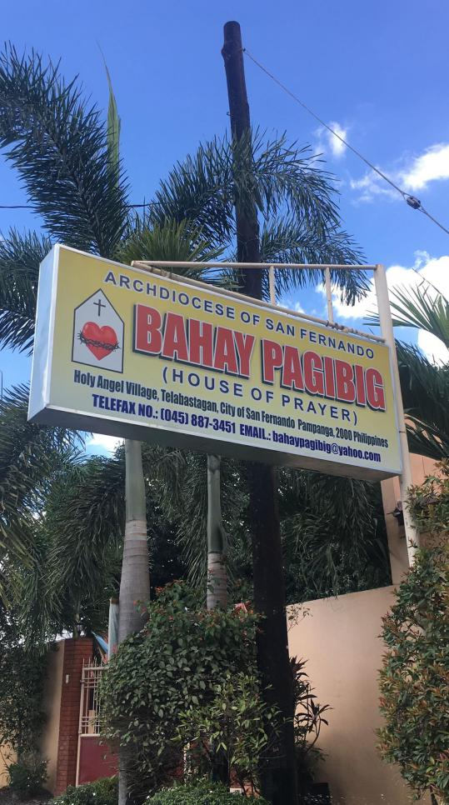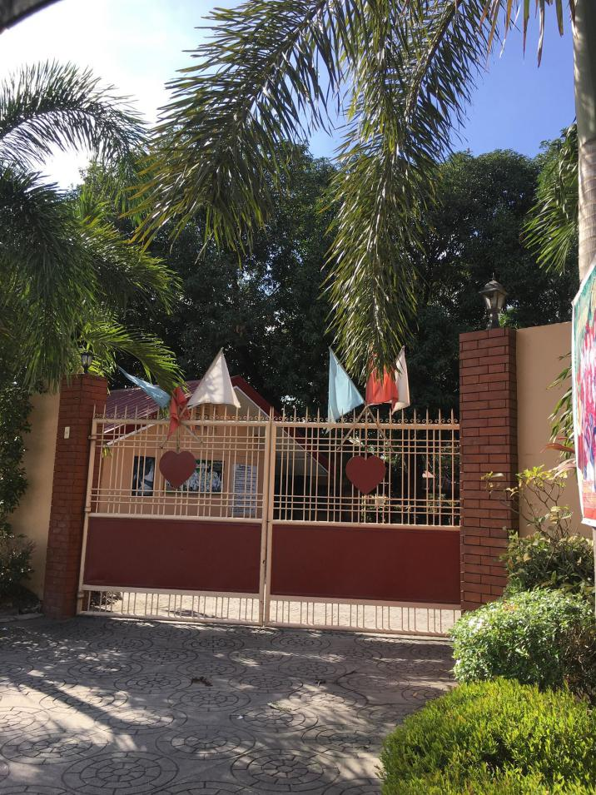

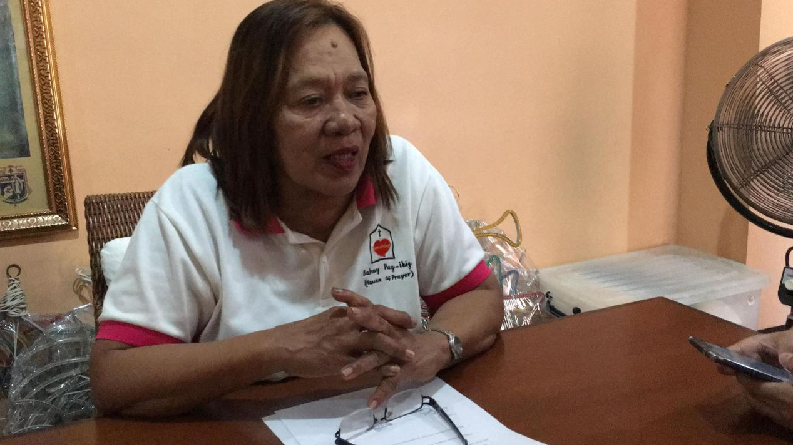**One of the Home for the Aged that was visited by the researchers.**

**One of the respondents, a social worker in Bahay Pag-Ibig.**

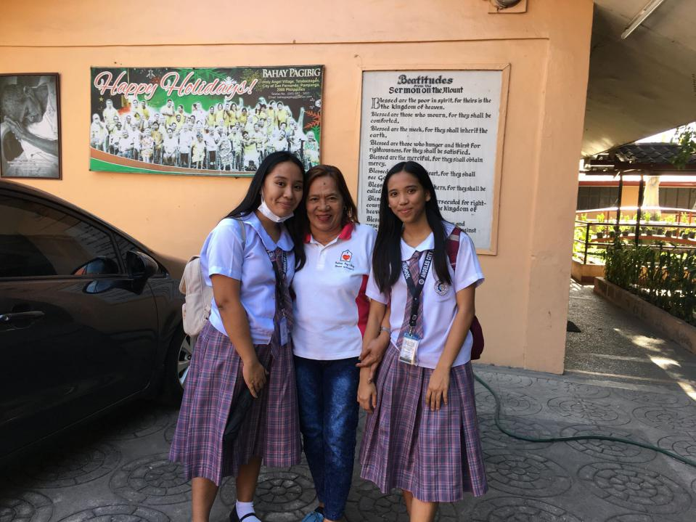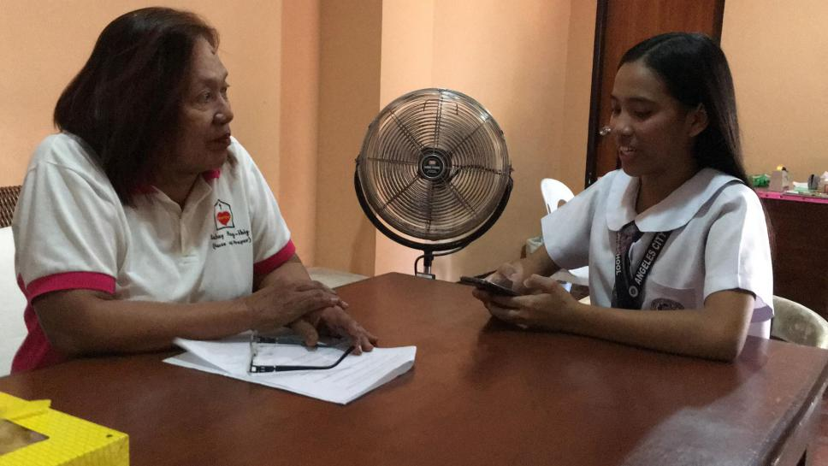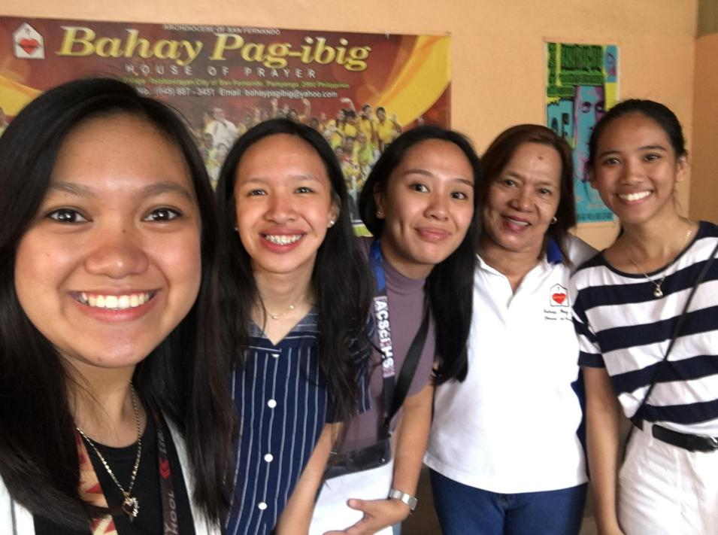**The researchers conducting the interview with one of the respondents.**