Republic of the Philippines
DEPARTMENT OF EDUCATION
Division of Angeles City
ANGELES CITY SCIENCE HIGH SCHOOL
Doňa Aurora Street, Lourdes Sur East, Angeles City
Telefax No. (045) 888-6193; E-mail: acshs_06@yahoo.com

NARRATIVE REPORT

I. TITLE OF ACTIVITY
Project I-Rite: Rigid Training on Enhancing the Technical Writing Skill of Grade 12 Students

II. PARTICIPANTS
Grade 12 Senior High School Students of Angeles City Science High School

II. DATE AND VENUE
November 23, 2018 at Angeles City Science High School- Senior High School Grounds

IV. NARRATIVE
To help in the further enhancement of the technical writing skills of the Grade 12 Senior High School Students of Angeles City Science High School, that could help them in the future on the field of their chosen jobs.

The seminar was held at Angeles City Science High School Senior High School Grounds on November 23, 2018 with Mrs. Princess Tiamzon Sangalang as the speaker. The speaker introduced us to the proper ways of writing the following business papers which are the following:

- Narrative Report
- Resume
- Application Letter
- Minutes of the Meeting

The speaker entertained some questions for further clarifications on the queries of the student participants before the seminar ended. Snacks and refreshments were given to the participants after the seminar.
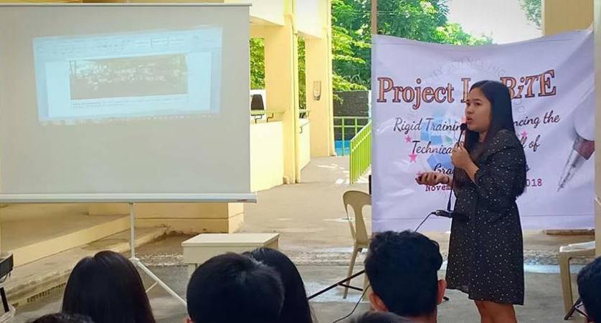
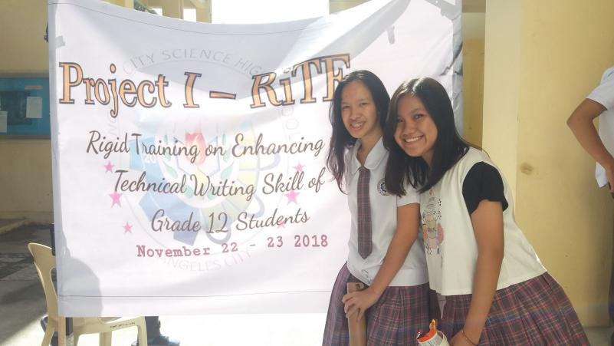

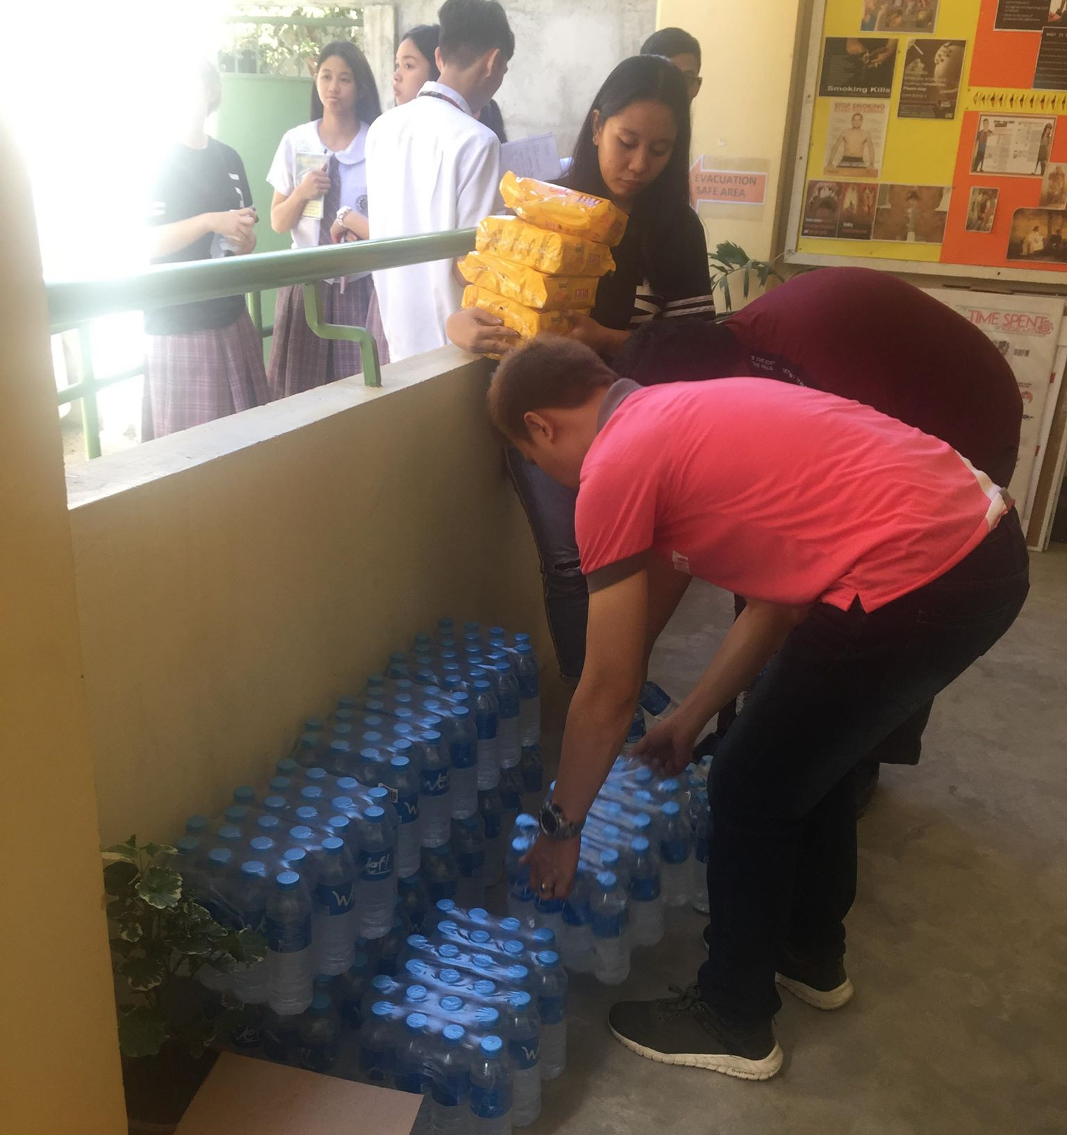
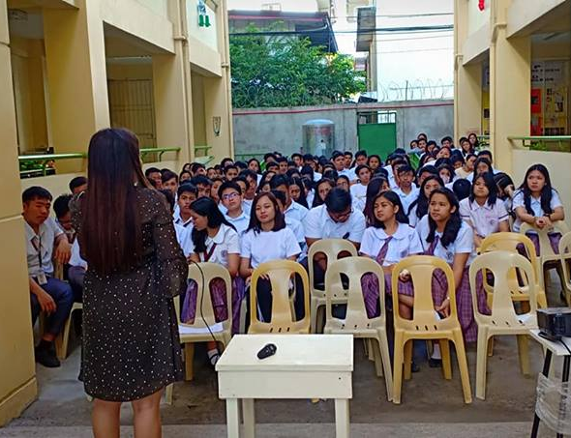
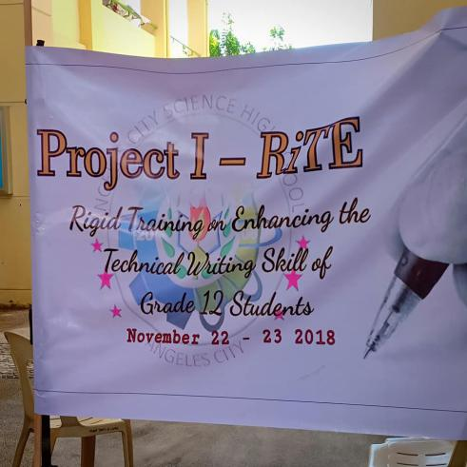

Prepared:

Justine Rodinah S. David
Student Immersant

Republic of the Philippines
DEPARTMENT OF EDUCATION
Division of Angeles City
ANGELES CITY SCIENCE HIGH SCHOOL
Doňa Aurora Street, Lourdes Sur East, Angeles City
Telefax No. (045) 888-6193; E-mail: acshs_06@yahoo.com

NARRATIVE REPORT

- TITLE OF ACTIVITY
Student’s Orientation on Work Immersion

- PARTICIPANTS
Grade 12 Student Immersants of Angeles City Science High School

- DATE AND VENUE
November 08, 2018 at Angeles City Science High School Covered Court

- NARRATIVE
The goal of the orientation was to enlighten the fututre student immersants in their upcoming work immersion deployment.
The orientation was done by Mr. Eric De Dios, the work immersion supervisor and Mrs. Amelita Pineda, the school principal who also happened to have done a research on work immersion.
The orientation tackled the different aspects of work immersion, which includes the following topics:
- Significance of Work Immersion
- Legal bases of Work Immersion
- Dos and donts in the Work Immersion
After the orientation, Mr. Eric De Dios, talked to the leaders of the student immersant groups from each batch and workplace.
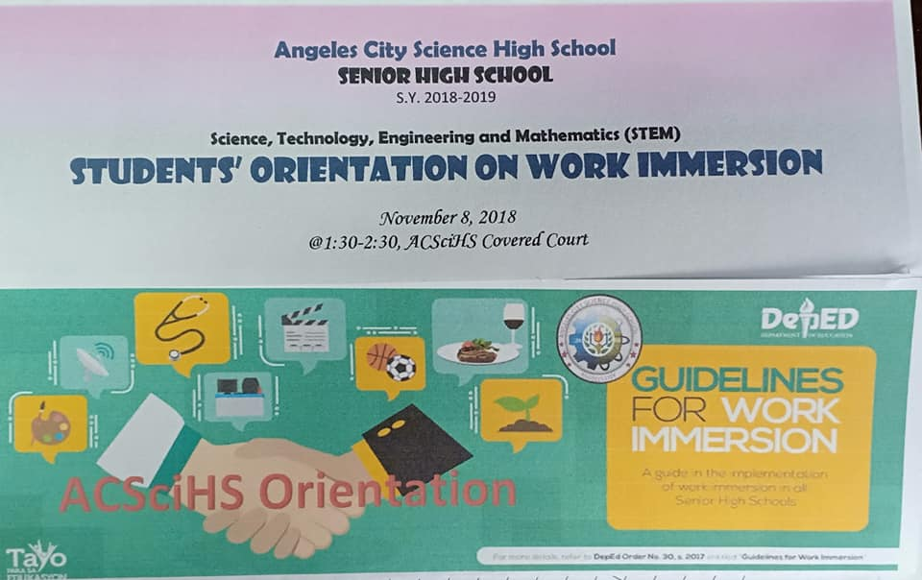
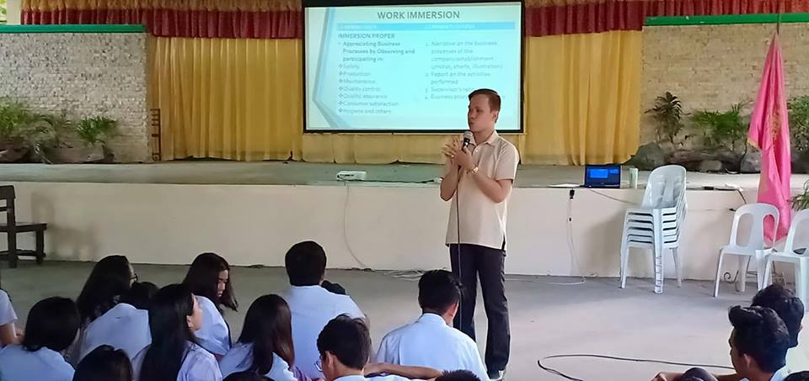
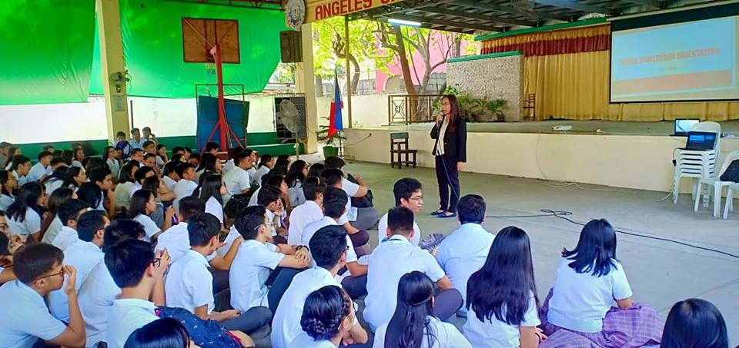
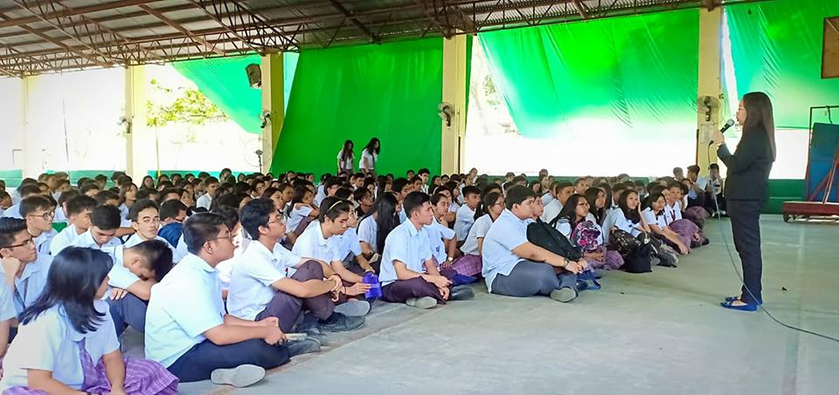
Prepared:

Justine Rodinah S. David
Student Immersant

