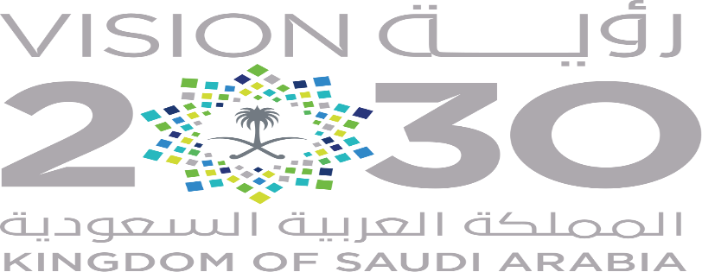
SAUDI ARABIA: Challenges ahead for VISION 2030

Apparently Saudi Arabia seems committed to its recently announced long term economic plan, Vision 2030, which aims reduce Kingdom’s dependence on oil exports within the coming decades on account of falling oil prices. Is the Kingdom going to achieve its goal despite financial woes? Let’s find out in our analysis.
Saudi Arabia saw significant economic growth from 2003-2014 during commodity super-cycle, nearly tripling its GDP, as oil prices were sky-rocketing. After the failure of agreement to reduce oil output by OPEC together with shale oil boom in US oil prices dropped to a record low. For the first time in its decades long oil history, Saudis were ready to slowly dissolve the 2 Trillion USD oil, black gold, industry after Saudi Arabia ran a $98 billion deficit in 2015; it has been since sending back expats as companies began to cut workers to cope with the downturn in prices, thus tight financial budget. Vision 2030 is a blueprint to end the country’s long dependence on oil and replace Saudi Aramco with an entirely new structure economy. Following the removal of Ali al-Naimi, Kingdom’s oil minister for last 25 years who was behind the oil production surge Saudi policy since November 2014, Saudi Government intentions to look for other options were clear.
The petroleum sector accounts for 87 percent of government revenue; with 90 % share in exports and almost 42 % share in GDP and oil industry is a major employer for the Saudi workforce, there has been much cynicism, with many doubting how Saudi Arabia could accomplish all that it has planned for itself. For instance claim of Saudi Crown Prince Muhammad bin Salman, also abbreviated ‘MBS’, to reduce its oil revenue share to ‘42 % by 2023’, is seen as ‘unrealistic’ looking at the current pace of progress.
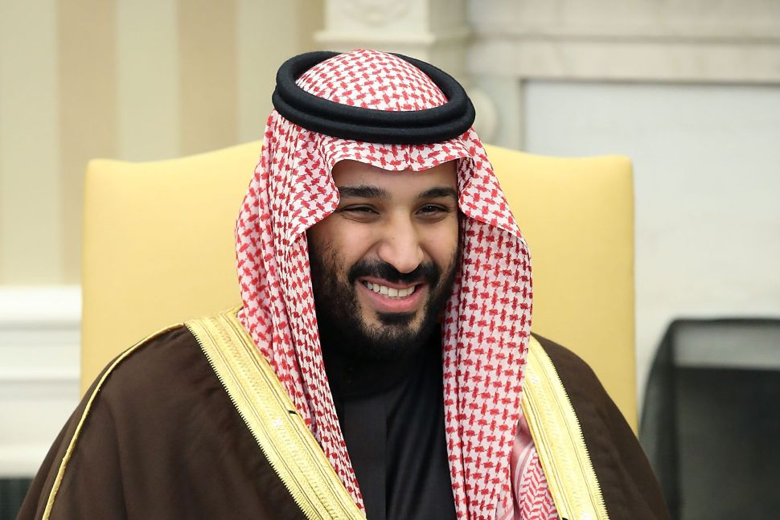
Young Crown Prince Muhammad bin Salman, who at 30 is considered a powerful member of the Saudi royal family and flag-bearer for the future generations of the Kingdom, dreams of an ‘oil-less’ Saudi Arabia. This will require the much needed capital to revolutionize the economy and investments in potential economic sectors. With the introduction of VAT and increment in fee together with cutting energy related subsidies Kingdom plans to reduce its budget deficit after a drastic drop in oil prices.
He emphasized in his announcement that Saudi Arabia would begin its transition to an “oil-less” economy through an IPO – International Public Offering of Saudi Aramco, the state-owned world largest oil company. A 5 percent IPO will take place was expected to take place in 2017, clearly, the nation most hooked up on oil wealth and extravagance, has realized amidst the current energy glut that oil revenues simply aren’t the basis for a stable economy.
In fact, oil is also known as a resource curse as, rather than offering a strong foundation for a sustainable economy, actually create longstanding systemic problems that can suppress practical growth; This leads autocratic governments as it feeds nepotism, patronage and corruption, and transform country into rentier states disassociated from the needs of the people. It has been apparent for some time that key oil producing states need to diversify their revenue sources in order to attain long-term viability, but that argument was hard to make when oil prices exceeded $100 a barrel reaching all time high of $140 a barrel.
In the midst of a crisis for oil-producers, especially Gulf States of UAE, KSA and Oman which suffers from record budget deficit, economic reform seems a desperate measure rather than just smart idea.
Bin Salman has some suggestions: tourism, investment in manufacturing, health care, education. Even more important will be the Public Investment Fund, into which the proceeds of the Saudi Aramco IPO will be funneled. Surprisingly, MBS announced during Future Investment Initiative conference in Riyadh, his plan of a $500 Billion city - Neom on Red Sea coast, funded by the Saudi Public Investment Fund. Further, he plans to increase the privately owned share of the economy from 40 percent to 65 percent. Even more important will be the Public Investment Fund, into which the proceeds of the Saudi Aramco IPO will be funneled. Kingdom plans to generate $100 billion IPO of Saudi Aramco, as MBS claims its worth of $2 Trillion USD. Economist contradicts his statement projecting true value to half of his claim.
Saudi need major overhaul education; they are as a matter of fact, determined as recent announcement that the Saudi government hopes for women to make up 30 % of the workforce by 2030 from present 22 %. In an economy where men and women are largely forbidden to work together in close quarters is a particularly pertinent question. The Saudi population is around 30 million; with two-thirds of that populace under 30, and of that number one-third are unemployed. In the next decade 2 million young Saudis will enter the workforce, government is still unable to figure the right solution. There are institutional and structural problems, such as a lackluster education system and over dependence on foreign labor in some major industries (9 million foreign expatriates continue to work in Saudi Arabia). The local Saudi market is relatively insignificant; industries created to feed domestic demand will not have much room for growth despite young population.
Decades of oil exports have afflicted Saudi Arabia with the “Dutch Disease,” where its currency has remained artificially high, making its goods more expensive in foreign markets. In some cases products with high pedigrees can be helpful locally, particularly among the urban elite. Unfortunately, Saudi Arabia has literally no major industry except, of course, oil.
Prince Salman has beguiled himself as a renowned ambitious Prince and a reformer. As foreign minister, he led Saudi intervention in Yemen despite international pressure from international communities including UN, and it was his intervention at the Doha conference that halted plans for an oil freeze. Prince Bin Salman is well-positioned to eventually become King, and his influence over foreign policy, defense policy, the oil industry and the country’s economic future solidifies his position as one of the most powerful people in the Saudi government. MBS Vision 2030 might come up with more strings attached. Jamal Khashoggi, Saudi journalist and critic of Kingdom’s monarchy, murder in Saudi Consulate in Istanbul, his tensions with Canada and his decision to continue war with Yemen despite financial woes among other policies has made Saudis doubt their loyalties. Oppression against Shia community in country’s oil-rich eastern provinces and control over press freedom continues when he is under spotlight for calling out women rights. The infamous 2017 purge of the Saudi political and business elite that generated $100 Billion was followed in 2018 by arrests of 17 women's rights activists, Perhaps, Muhammad Bin Salman tyrant in disguise in the only absolute monarchy other than Oman. His decisions to increase women workforce, ending female driving ban, opening cinemas and entertainment areas including an off shore beach without restrictions could have more to do with economic reforms rather than modernization of the conservative Kingdom.
Do you agree? Do let us know.

