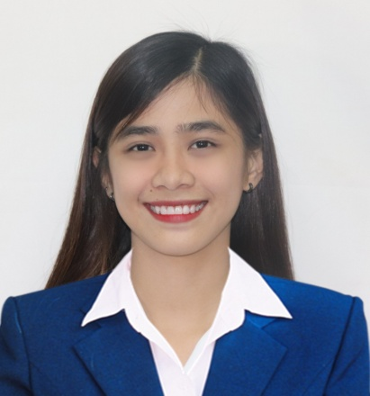
Career Objective
Seeking an entry-level position in the field of information technology (IT) with a focus on hardware and IT Office and IT equipment maintenance and monitoring. I am confident that my skills and experience in my studies could make a great contribution in your firm. I am also willing to do extra work that you will give to gain more experience.
Education

St. Paul University at San Miguel
Bachelor of Science in Computer Science June 2015 - March 2019

Skills

Computer Literate
Computer Coding Programming Languages:
Languages: Basic knowledge of Visual Basic.Net, Basic knowledge of PHP language, Basic knowledge of HTML, System Analyst

Database System: MS Access, Xampp SQL

Others: Photoshop, Microsoft Office Word, Microsoft Office PowerPoint, Microsoft Office Excel, Microsoft Office Publisher

Work Experience

Jollibee Corporation
Service Crew April 2016 – June 2016

Job Internship

Local Government Unit Municipality of San Miguel Bulacan
Assigned Position: Clerk Unit/Dept.: Admin Department April 2017 – May 2017
Awards & Acknowledgements

September 2016

UP SYSTEM INFORMATION TECHNOLOGY
The 14th Youth Congress on Information Technology

September 2017

UP SYSTEM INFORMATION TECHNOLOGY
Engineer a Better Future

Character Reference

Name: Mr. Raphael Montecalvo

Contact #: 09154863614

Relationship: College Adviser

