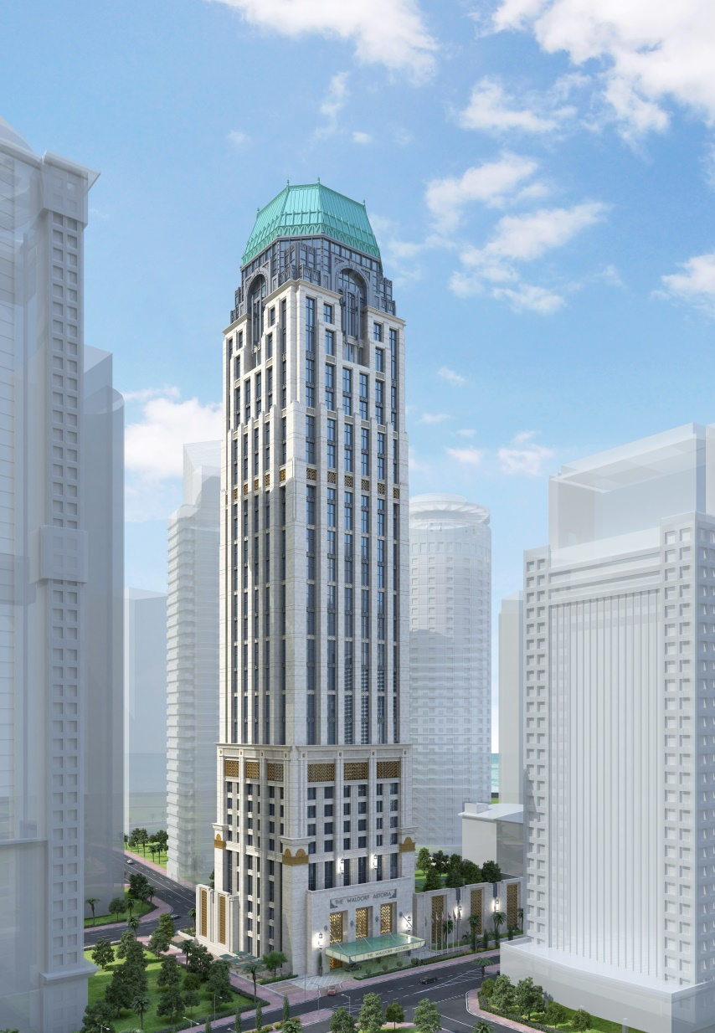

.

WALDORF ASTORIA
4B+LG+UG+M+43 STORY HOTEL
Baseline Program
(Program of Activities)

May 2019

PROJECT : WALDORF ASTORIA HOTEL (FIT-OUT)
CLIENT : MS. PENINSULA ENGINEERING
SUPERVISION CONSULTANT : LACASA -QATAR
DESIGN CONSULTANT : HBA
MAIN CONTRACTOR : HARINSA ECISA QATAR
FIT-OUT CONTRACTOR : ELM Contracting & Project Solutions W.L.L.

PROJECT NARRATIVE REPORT

Detailed Project Scope

The Scope of the Contract is The Fit-Out Works Construction of Waldorf Astoria – on the lot of land no. 61070167 & no. 61070168 Plot 14 with a total area of approximately 6.600 sq. The structure for the hotel will be four Basements, Lower Ground, Upper Ground, Mezzanine and Forty-Three stories tower, Upper Forty Three, Lower Roof, Roof and Upper Roof. Maximum built area is 104000.00 SQM.

- Preliminaries
The Works are mainly Setting Out of the Works, Use and Maintenance of the Site, Engineer’s and Main Contractor’s Site Facilities and Health & Safety.

The Work includes Temporary Facilities and Utilities for the Engineer and Main Contractor to execute the Engineering Submittals and Approvals categorized by the Disciplines, Systems and Specialization of Works including Procurement and Construction of the pre-defined Scope of Works of the Project.

- Pre-Construction
This includes the Preparation of relevant documents, Submissions and Securing Approval Permits, Mobilization, Investigation and Survey Works.

- Architectural Finishes Works – General Floor, Wall and Ceiling Finishes
These works are the general Architectural Finishes on Floors, Walls and Ceiling. The Works includes the bases and sub-bases preparation and interfaces making it ready to receive the Interior Design Finishes / Fit-Out works.

- Fit-Out Works, Interior Design – ID Package Works – Interior Designer’s Floor, Wall & Ceiling Finishes and FF&E
Mainly, this scope is covered by designated/appointed Interior Design Contractor with specialization in the interior finishes works and selection of specific and specified materials to be installed and applied in the process of making visual improvements, Decorations and beautification of the interiors of the Project. (i.e. Stones/Marbles, Ceramic/Porcelain, Special Paints, Wall Papers, Doors and Screens, Glass and Mirrors, Decorative Wood, Acrylics, Metals, Gypsum, GRC, Fibers, Cloth/Fabrics and the like etc.)

The Works also includes Installation of selected MEP Final Fix such as Sanitarywares, Fittings and the like supplied by Client.

Key Project Data (Number/detail of floors/units, key dates etc.)

The project is grouped into packages and mainly consisting of the following:

- FIT-OUT PACKAGE 1 - FRONT OF HOUSE (3rd basement to 4th floor & 6th floor)
- Dry Areas
- Wet Areas
- Corridors & Lift Lobby

- FIT OUT PACKAGE 2 & 3 - FRONT OF HOUSE 10th to 38th Floor
- Dry Areas
- Wet Areas
- Corridors & Lift Lobby

- FIT-OUT PACKAGE 4 - FRONT OF HOUSE (39th floor to 41st floor)
- Dry Areas
- Wet Areas
- Corridors & Lift Lobby
D. FIT-OUT PACKAGE 5 - FRONT OF HOUSE (43rd floor to 43rd upper floor)
- Dry Areas
- Wet Areas
- Corridors & Lift Lobby
E. FIT OUT PACKAGE 6 – INSTALLATION OF SANITARY FITTINGS AND ACCESSORIES
- Wet Areas
F. FIT OUT PACKAGE 7 - FRONT OF HOUSE/ BACK OF HOUSE (Thermal & Moisture Protection)
- Wet Areas & Exposed External Areas

Objectives

This Narrative is a compilation of data gathered from various Departments in order to establish the Project’s overall perspective. The intent of this report is to develop a clear understanding of the overall Scope of work and provide a realistic picture of the Planned Project Execution Programme and its Implementation.

As the execution of this Project will involve much coordination, interfacing and integrated efforts of different trades of personnel and resources, this report will enable the concerned parties to monitor the status, analyze and evaluate important factors that will result in the project being managed such that it is completed:

• Reasonably On-time,
• Within budget,
• With the highest degree of quality,
• In a safe manner for all,
• In a manner in which the Client’s trust, support, and confidence in the project will be maintained.

Basis of Baseline Program

The Baseline Program is basically developed as per Design Drawing Packages and Associated Documents (i.e. initial Bill of Quantities (BOQ), Design References and Compliance Documents with the Authorities as to be agreed upon before, during and after the Project Design Stages. The Program is to be based on the design as per Category/Disciplines and listed below:

- Commercial Documents

- Design Phase Period (By Others)

- Project Execution of the following:
- Civil and Structural – By Main Contractor
- Architectural – By Main Contractor
- MEP – By Main Contractor
- ELV System – By Main Contractor
- Interior Design – ID / Fit-Out Works by Fit-Out Contractor
- Kitchen and Laundry – By Main Contractor/Kitchen Specialist
- SPA & Gym - By Main Contractor / Spa & Gym Specialist
- Swimming Pool - By Main Contractor / Swimming Pool Specialist
Front End Management Information.
- Refer to Updated Organization Chart at the last Section
Program and Planning Methodology (Engineering phases, Awarding Subcontractor, MSTs, Procurement, Construction phases. Final Testing & Commissioning, Handing Over)

Engineering & Information
- Issued Design Drawings (from Main Contractor/Consultant),
- Request For Information (from Main Contractor/Consultant),
- Shop Drawing (Approved Related Fit-out Works Shop Drawings i.e. Mock-up)
- Material Submittal,
- Technical Submittal,
- Method Statement,
- Third Party Technical/Testing Assistance if required

Procurement – Fit-Out Scope
- RFQ/RFP,
- Receive of Quotation,
- Commercial Comparison,
- Recommendation for Award,
- Approval from Management,
- LOI - Letter of Intent,
- LOA - Letter of Award,
- Subcontract Agreement,
- Purchase Order,
- Delivery to Site
- QA/QC Inspection
Construction – Fit-Out Scope
- Confirmation of Verbal and Written Instructions to Commence Work
- Manpower Deployment and Allocation
- Machinery and Equipment and Tools Deployment and Allocation
- Trades Supply and Installation
- QA/QC Inspection of Completed Works
- Snagging and Touch-up/Repair Works
- Final QA/QC Inspection
- Handing Over
- Certificate of Completion
Resources
- It is planned to maintain a “Finish to Start” relationship between activities including MEP interfaces (by Main Contractor) as much as possible; however, in cases of simultaneous activities and parallel work scheduled in the Program, a separate or additional manpower crew will be allocated to similar tasks progressing on different areas during the same period of time during the execution of the fit-out works scope.

Calendars
Project Calendars assigned are the following:
ELM Friday Off (6 working day with Holidays) for Covenants & some of the Milestones.
Public Holidays are as per Qatar Holidays and Fridays off are considered in the above Calendars accordingly. Working days are from Saturday to Thursday from 7:00AM to 5:00 PM (one shift) with 1-hour break from 12:00 NN to 1:00 PM

Construction Phase Calendar Consideration
- ELM Friday Off (6 working day without Holidays)

Program Abbreviations and Coding

CODE | Description
MS | Milestone
SMS | Start Milestone
CMS | Completion Control Milestone
PRELIM | Peliminaries
PRO | Procuement
ENG | Engineering
PQ | Pre-Qulaification
MAR | Material Appoval
MS | Method Statement
CON | Construction
CONDA | Construction - Dry Aea
CONWA | Construction Wet Area
CONCOR | Construction Corridor
WP | Waterproofing
APSM | Acoustic Pad / Sound Mat
SCR | Screed
THRM | Thermal Insulation
CT | Ceramic Tiles / Floor / Wall / Mosaic CL
ST | Stones / Marbles - General
WDF | Wooden Flooring
FC | Fitted Carpetting
PNT | Wall Paint / Special Paint
WDC | Wood Cladding + Skirting + Architrave
MT | Metal Cladding / Metal Finish
CDW | Composite Decorative Wall
GLC | Glass Cladding / Glass Finish
WC | Wall Coverings + Moldings to Wall Cover
WSF | Wall Special Finishes
DDR | Decorative Doors + Ionmongery
SDR | Sliding Doors + Ionmongery
OP | Operable / Folding Partition+ Ionmongery
GLS | Glazed Screens & Doors (Shower) + Ironmongery
GCP | Gypsum Ceiling + Paint
CDC | Composite Decorative Ceiling
WCL | Wooden Ceiling
MCL | Mirror Ceiling
CFF | Composite Fixed Furnitures & Fittings
SNT | Sanitary Fittings (Install Only)
SHO | Snagging & Handing Over

Major Dates and Milestones
Target Completion Dates as per Main Contractor’s Key Milestones Amendment # 8

ACTIVITY ID | Activity Name | HCCQ to FIT-OUT  SUB-CON | FIT-OUT SUB-CON  to HCCQ
BASEMENT
BF1010 | B03 | 17-Aug-19 | 23-Nov-19
BF1000 | B02 | 1-Sep-19 | 16-Nov-19
PODIUM
PF1000 | LLG | 19-Oct-19 | 29-Feb-20
PF1010 | LMZ | 9-Oct-19 | 29-Feb-20
PF1020 | L01 | 29-Sep-19 | 25-Jan-20
PF1030 | L02 | 19-Sep-19 | 9-Jan-20
PF1040 | L03 | 9-Sep-19 | 15-Dec-19
PF1050 | L04 | 24-Aug-19 | 10-Nov-19
PF1060 | L06 | 12-Aug-19 | 25-Oct-19
TYPICAL FLOORS 10-27
F1000 | L10 - L13 | 30-Jun-19 | 5-Oct-19
F1010 | L14 - L17 | 16-Jul-19 | 28-Oct-19
F1020 | L18 - L21 | 1-Aug-19 | 20-Nov-19
F1030 | L22 - L25 | 17-Aug-19 | 14-Dec-19
F1040 | L26 - L27 | 1-Sep-19 | 28-Oct-19
APARTMENT & SUITE
F1050 | L29 - L32 | 8-Aug-19 | 20-Jan-20
F1060 | L33 - 36 | 24-Aug-19 | 12-Feb-20
F1070 | L37 - L38 | 8-Sep-19 | 24-Feb-20
POOL, SPA & ROOF (Floor 39-Roof)
F1080 | L39 | 3-Sep-19 | 27-Feb-20
F1090 | L40 | 3-Sep-19 | 29-Feb-20
F1100 | L41 | 13-Sep-19 | 29-Feb-20
F1110 | L43 | 13-Sep-19 | 29-Feb-20
F1120 | LU43 | 23-Sep-19 | 29-Feb-20

Receipt of Documents forming part of the Sub-Contract
The following are the list of Contract Documents received on 2nd May 2019 via letter LCQ/PQ-116/SD/671/2014/19.

Design Package:
- Approved Authorities:
- DC1 Approval
- Fire Life Safety Approval
- KM Water Supply (09.1.18)
- ASHGHAL Drainage (07.01.18)
- KM approved Protection SLD (6.3.18)
- KM approved Civil Drawings (26.3.18)
- QCDD Approved Fire Alarm System Drawings (19.4.18)
- QATAR COOL
- KM approved Electrical SLD (31.5.18)
- Ooredoo
- MOI-SSD _ CCTV Package
- CAA
- QCDD Approved Fire Fighting System Drawings (15.08.18)
- LPG Submission From Gasco R3 18-08-18
- QCDD Approved ACMV System Drawings (5.12.18)
- DC2 Submission

- CKP (Kitchens & Laundry):
- Tender addendum package 1
- Tender Addendum Package 2
- Tender Addendum Package 3
- 60. TA PCKG 3 EXL&RSP
- 2017-03-16 - CKP – HOODS
- CKP Construction Guides
- GZ Restaurant
    - 2018-11-20 - CKP - package to GZ for review
    - 2019-04-17 - CKP - GZ comments

- HBA (ID)
- Changes and clarifications by emails
- GZ Restaurant (6th Floor)
- H .B . A:
    - FF&E
    - Guest Rooms Package
    - HBA Specifications
    - Public Areas Package
    - Renders
    - Specifications
- Royal Suite Package

- HWW (Operator)
- 2014 Waldorf Astoria Guidelines
- 2017-04-17 - HWW - Waldorf Guidelines 2017

- LDA (Lighting)
- Drawings
- Luminaires

- MDG (IT, AV & Sec.)
- 2018-01-04 Updated IFC Drawings
- 2018-04-30 Revised BR, MR, OB
- 2018-06-11 Revised IFC Drawings
- 2018-07-09 Revised WA IFC Drawings
- 2018-08-23 Revised IFC Special Suites Drawings
- 2019-01-15 Revised Security Specs

- PMK (Acoustic):
- Acoustic Report
- Acoustic Typical Details

- WATER MASTER Spa & Pools
Engineering works:
- R.F.I (request for information)
- S.D: (shop drawings)
- Architectural
    - PBC
    - AGA
    - RCGA
- Interior design
    - Corridors and lobbies
    - Guest units
    - Mockup Rooms
- MEP coordination
Specifications
- LACASA Specifications
- QCS 2014

  - Room Numbering Matrix
  - Lift Matrix
  - Bills of Quantities & highlighted drawings issued on May 28, 2019
- Fit-out package 1 BOQ – 3rd to 2nd basement, lower ground floor to 4th floor & 6th floor
- Fit-out package 2&3 BOQ – 10th floor to 38th floor
- Fit-out package 4 BOQ – 39th floor to 41st floor
- Fit-out package 5 BOQ – 43rd floor to upper 43rd floor
- General preliminaries BOQ – for Fit-out package 1 to 5

Baseline Program Inclusive Dates
Site Access / Start Milestones

Fit-Out Site Access / Start Milestones |  | Start
Basement
WA-SMS-1000 | Basement 03 Fit-Out Clearance / Site Access Start | 17-Aug-19
WA-SMS-1010 | Basement 02 Fit-Out Clearance / Site Access Start | 1-Sep-19
Podium
WA-SMS-1020 | Podium L06 Fit-Out Clearance / Site Access Start | 12-Aug-19
WA-SMS-1030 | Podium L04 Fit-Out Clearance / Site Access Start | 24-Aug-19
WA-SMS-1040 | Podium L03 Fit-Out Clearance / Site Access Start | 9-Sep-19
WA-SMS-1050 | Podium L02 Fit-Out Clearance / Site Access Start | 19-Sep-19
WA-SMS-1060 | Podium L01 Fit-Out Clearance / Site Access Start | 29-Sep-19
WA-SMS-1070 | Podium LMZ Fit-Out Clearance / Site Access Start | 9-Oct-19
WA-SMS-1080 | Podium LLG Fit-Out Clearance / Site Access Start | 19-Oct-19
Typical Floors - Hotel Rooms
WA-SMS-1090 | Typical Floors L10-L13 Fit-Out Clearance / Site Access Start | 30-Jun-19
WA-SMS-1100 | Typical Floors L14-L17 Fit-Out Clearance / Site Access Start | 16-Jul-19
WA-SMS-1110 | Typical Floors L18-L21 Fit-Out Clearance / Site Access Start | 1-Aug-19
WA-SMS-1120 | Typical Floors L22-L25 Fit-Out Clearance / Site Access Start | 17-Aug-19
WA-SMS-1130 | Typical Floors L26-L27 Fit-Out Clearance / Site Access Start | 1-Sep-19
Apartment & Suites
WA-SMS-1140 | Apartment & Suite L29-L32 Fit-Out Clearance / Site Access Start | 8-Aug-19
WA-SMS-1150 | Apartment & Suite L33-L36 Fit-Out Clearance / Site Access Start | 24-Aug-19
WA-SMS-1160 | Apartment & Suite L37-L38 Fit-Out Clearance / Site Access Start | 8-Sep-19
Pool Spa & Roof
WA-SMS-1170 | Gym & Bar L39 Fit-Out Clearance / Site Access Start | 3-Sep-19
WA-SMS-1180 | HOH & Saloon L40 Fit-Out Clearance / Site Access Start | 3-Sep-19
WA-SMS-1190 | SPA L41 Fit-Out Clearance / Site Access Start | 14-Sep-19
WA-SMS-1200 | Swimming Pool L43 Fit-Out Clearance / Site Access Start | 14-Sep-19
WA-SMS-1210 | Kitchen & Restaurant LU43 Fit-Out Clearance / Site Access Start | 23-Sep-19

Subcontractor and Supplier Procurement, Appointment
Procurement | Start | Finish
 | 16-May-19 | 15-Jan-20
Waterproofing | 22-May-19 | 28-Jul-19
Acoustic Pad/ Sound Mat | 28-May-19 | 29-Jun-19
Thermal Insulation | 3-Oct-19 | 31-Dec-19
Ceramic Tiles Floor / Wall / Mosaic Ceiling | 2-Jul-19 | 5-Oct-19
Screed | 26-May-19 | 24-Aug-19
Wooden Flooring | 16-May-19 | 25-Sep-19
Fitted Carpeting | 28-May-19 | 7-Oct-19
Wall Paints / Special Paints | 16-May-19 | 1-Sep-19
Wall Coverings | 16-May-19 | 6-Nov-19
Moldings to Wall Coverings | 16-May-19 | 9-Sep-19
Gypsum Ceiling + Paint Finish | 4-Jun-19 | 9-Oct-19
Stones / Marble Floor / Wall / Skirting / Architrave | 21-May-19 | 18-Nov-19
Wood Cladding / Skirting / Architrave | 9-Jun-19 | 1-Oct-19
Metal Cladding / Metal Finish | 2-Jul-19 | 7-Nov-19
Composite Decorative Wall | 15-Jun-19 | 2-Nov-19
Glass Cladding / Glass Finish | 22-May-19 | 3-Oct-19
Wall Special Finishes | 9-Jun-19 | 2-Nov-19
Decorative Doors | 4-Jun-19 | 28-Oct-19
Sliding Doors | 6-Jun-19 | 30-Oct-19
Operable / Folding Partitions | 14-Jul-19 | 19-Nov-19
Glazed Screens + Doors (Shower Area) | 4-Jun-19 | 6-Oct-19
Composite Decorative Ceiling | 23-Jun-19 | 10-Oct-19
Wooden Ceiling | 20-Jul-19 | 7-Nov-19
Mirror Ceiling | 21-Oct-19 | 15-Jan-20
Composite Fixed Furnitures | 28-May-19 | 20-Oct-19
Engineering inclusive dates
Engineering | Start | Finish
Pre-Qualification
General Pre-Qualification | 16-May-19 | 9-Jun-19
Waterproofing | 30-May-19 | 15-Jun-19
Thermal Insulation | 15-Oct-19 | 7-Nov-19
Screed | 3-Jun-19 | 18-Jun-19
Ceramic Tiles Floor / Wall/ Mosaic Ceiling | 14-Jul-19 | 6-Aug-19
Wooden Flooring | 28-May-19 | 20-Jun-19
Fitted Carpeting | 9-Jun-19 | 2-Jul-19
Wall Paints / Special Paints | 23-May-19 | 16-Jun-19
Wall Coverings | 28-May-19 | 20-Jun-19
Gypsum Ceiling + Paint Finish | 16-Jun-19 | 9-Jul-19
Materials
Acoustic Pad/ Sound Mat | 5-Jun-19 | 20-Jun-19
Waterproofing | 16-Jun-19 | 29-Jun-19
Screed | 19-Jun-19 | 2-Jul-19
Thermal Insulation | 9-Nov-19 | 2-Dec-19
Gypsum Ceiling + Paint Finish | 2-Jul-19 | 25-Jul-19
Wooden Flooring | 22-Jun-19 | 15-Jul-19
Ceramic Tiles Floor / Wall/ Mosaic Ceiling | 7-Aug-19 | 31-Aug-19
Wall Paints / Special Paints | 17-Jun-19 | 10-Jul-19
Fitted Carpeting | 3-Jul-19 | 27-Jul-19
Wall Coverings | 22-Jun-19 | 15-Jul-19
Moldings to Wall Coverings | 22-Jun-19 | 15-Jul-19
Composite Decorative Ceiling | 4-Jul-19 | 28-Jul-19
Wooden Ceiling | 31-Jul-19 | 24-Aug-19
Mirror Ceiling | 2-Nov-19 | 25-Nov-19
Decorative Doors + Ironmongery | 16-Jun-19 | 9-Jul-19
Wood Cladding / Skirting / Architrave | 20-Jun-19 | 14-Jul-19
Sliding Doors + Ironmongery | 18-Jun-19 | 11-Jul-19
Operable / Folding Partitions + Ironmongery | 25-Jul-19 | 18-Aug-19
Composite Fixed Furnitures | 9-Jun-19 | 18-Jul-19
Stones / Marble Floor Wall / Skirting / Architrave | 2-Jun-19 | 25-Jun-19
Metal Cladding / Metal Finish | 14-Jul-19 | 6-Aug-19
Glazed Screens + Doors (Shower Area) + Ironmongery | 16-Jun-19 | 9-Jul-19
Composite Decorative Wall | 26-Jun-19 | 5-Aug-19
Glass Cladding / Glass Finish | 3-Jun-19 | 26-Jun-19
Wall Special Finishes | 20-Jun-19 | 30-Jul-19
Shop Drawings
Waterproofing | 16-Jun-19 | 29-Jun-19
Thermal Insulation | 9-Nov-19 | 2-Dec-19
Acoustic Pad/ Sound Mat | 5-Jun-19 | 20-Jun-19
Screed | 19-Jun-19 | 2-Jul-19
Ceramic Tiles Floor / Wall / Mosaic Ceiling | 7-Aug-19 | 31-Aug-19
Stones / Marble Floor Wall / Skirting / Architrave | 2-Jun-19 | 25-Jun-19
Wooden Flooring | 22-Jun-19 | 15-Jul-19
Fitted Carpeting | 3-Jul-19 | 27-Jul-19
Wall Coverings + Moldings | 22-Jun-19 | 15-Jul-19
Wood Cladding / SKirting / Architrave | 20-Jun-19 | 14-Jul-19
Metal Cladding / Metal Finish | 14-Jul-19 | 6-Aug-19
Composite Decorative Wall | 26-Jun-19 | 5-Aug-19
Glass Cladding / Glass Finish | 3-Jun-19 | 26-Jun-19
Wall Special Finishes | 20-Jun-19 | 30-Jul-19
Decorative Doors + Ironmongery | 16-Jun-19 | 9-Jul-19
Sliding Doors + Ironmongery | 18-Jun-19 | 11-Jul-19
Operable / Folding Partitions + Ironmongery | 25-Jul-19 | 18-Aug-19
Glazed Screens + Doors (Shower Area) + Ironmongery | 16-Jun-19 | 9-Jul-19
Gypsum Ceiling + Paint Finish | 2-Jul-19 | 25-Jul-19
Composite Decorative Ceiling | 4-Jul-19 | 28-Jul-19
Wooden Ceiling | 31-Jul-19 | 24-Aug-19
Mirror Ceiling | 2-Nov-19 | 25-Nov-19
Composite Fixed Furnitures | 9-Jun-19 | 18-Jul-19
Method Statement
General Method Statement | 15-Jun-19 | 6-Jul-19
Acoustic Pad/ Sound Mat | 5-Jun-19 | 20-Jun-19
Waterproofing | 16-Jun-19 | 29-Jun-19
Swimiing Pool & SPA, Roof Deck, Teraces Waterproofing | 16-Jun-19 | 29-Jun-19
Thermal Insulation | 9-Nov-19 | 2-Dec-19
Screed | 19-Jun-19 | 2-Jul-19
Ceramic Tiles Floor / Wall/ Mosaic Ceiling | 7-Aug-19 | 31-Aug-19
Wooden Flooring | 22-Jun-19 | 15-Jul-19
Fitted Carpeting | 3-Jul-19 | 27-Jul-19
Wall Paints / Special Paints | 17-Jun-19 | 10-Jul-19
Wall Coverings + Moldings | 22-Jun-19 | 15-Jul-19
Gypsum Ceiling + Paint Finish | 2-Jul-19 | 25-Jul-19
Stones / Marble Floor / Wall / Skirting / Architrave | 2-Jun-19 | 25-Jun-19
Wood Cladding / Skirting / Architrave | 20-Jun-19 | 14-Jul-19
Metal Cladding / Metal Finish | 14-Jul-19 | 6-Aug-19
Composite Decorative Wall | 26-Jun-19 | 5-Aug-19
Glass Cladding / Glass Finish | 3-Jun-19 | 26-Jun-19
Wall Special Finishes | 20-Jun-19 | 30-Jul-19
Decorative Doors + Ironmongery | 16-Jun-19 | 9-Jul-19
Sliding Doors + Ironmongery | 18-Jun-19 | 11-Jul-19
Operable / Folding Partitions + Ironmongery | 25-Jul-19 | 18-Aug-19
Glazed Screens + Doors (Shower Area) + Ironmongery | 16-Jun-19 | 9-Jul-19
Composite Decorative Ceiling | 4-Jul-19 | 28-Jul-19
Wooden Ceiling | 31-Jul-19 | 24-Aug-19
Mirror Ceiling | 2-Nov-19 | 25-Nov-19
Composite Fixed Furnitures | 9-Jun-19 | 18-Jul-19
Sanitary Fittings | 1-Aug-19 | 22-Aug-19

Construction Management
Construction (Fit-Out Works) | 30-Jun-19 | 29-Feb-20
Basement (FOH)
Basement - 3 | 17-Aug-19 | 23-Oct-19
Basement - 2 | 1-Sep-19 | 16-Nov-19
Podium (FOH)
6th Floor | 12-Aug-19 | 26-Oct-19
4th Floor | 24-Aug-19 | 10-Nov-19
3rd Floor | 9-Sep-19 | 15-Dec-19
2nd Floor | 19-Sep-19 | 9-Jan-20
1st Floor | 29-Sep-19 | 25-Jan-20
Mezzanine | 9-Oct-19 | 29-Feb-20
Lower Ground | 19-Oct-19 | 29-Feb-20
Typical Floors (10th -27th) Hotel Rooms -FOH
10th Floor - Hotel Rooms | 30-Jun-19 | 5-Oct-19
11th Floor - Hotel Rooms | 30-Jun-19 | 5-Oct-19
12th Floor - Hotel Rooms | 30-Jun-19 | 5-Oct-19
13th Floor - Hotel Rooms | 30-Jun-19 | 5-Oct-19
14th Floor - Hotel Rooms | 16-Jul-19 | 28-Oct-19
15th Floor - Hotel Rooms | 16-Jul-19 | 28-Oct-19
16th Floor - Hotel Rooms | 16-Jul-19 | 28-Oct-19
17th Floor - Hotel Rooms | 16-Jul-19 | 28-Oct-19
18th Floor - Hotel Rooms | 1-Aug-19 | 20-Nov-19
19th Floor - Hotel Rooms | 1-Aug-19 | 20-Nov-19
20th Floor - Hotel Rooms | 1-Aug-19 | 20-Nov-19
21st Floor - Hotel Rooms | 1-Aug-19 | 20-Nov-19
22nd Floor - Hotel Rooms | 17-Aug-19 | 14-Dec-19
23rd Floor - Hotel Rooms | 17-Aug-19 | 14-Dec-19
24th Floor - Hotel Rooms | 17-Aug-19 | 14-Dec-19
25th Floor - Hotel Rooms | 17-Aug-19 | 14-Dec-19
26th Floor - Hotel Rooms | 1-Sep-19 | 25-Dec-19
27th Floor - Hotel Rooms | 1-Sep-19 | 25-Dec-19
Apartments & Suites (29th -38th) - FOH
29th Floor - Apartments | 8-Aug-19 | 20-Jan-20
30th Floor - Apartments | 8-Aug-19 | 20-Jan-20
31st Floor - Apartments | 8-Aug-19 | 20-Jan-20
32nd Floor - Apartments | 8-Aug-19 | 20-Jan-20
33rd Floor - Apartments | 24-Aug-19 | 4-Feb-20
34th Floor - Ambassador Suite Level | 24-Aug-19 | 4-Feb-20
35th Floor - Ambassador Suite Level | 24-Aug-19 | 4-Feb-20
36th Floor - Executive Suite & Cigar Lounge Level | 24-Aug-19 | 4-Feb-20
37th Floor - Presidential Suite Level | 8-Sep-19 | 15-Feb-20
38th Floor - Royal Suite | 8-Sep-19 | 15-Feb-20
Pool, Gym & BAR, SPA and Roof Levels (39th - Roof) - FOH
39th Floor - Gym & Bar | 3-Sep-19 | 20-Feb-20
40th Floor - Heart of House and Beauty Saloon | 3-Sep-19 | 20-Feb-20
41st Floor - SPA & Gym | 14-Sep-19 | 20-Feb-20
43rd Floor - Swimming Pool Level | 14-Sep-19 | 20-Feb-20
43rd Upper Floor - Kitchen & Restaurant | 23-Sep-19 | 20-Feb-20
Back Of House
Wet Area | 30-Jun-19 | 27-Oct-19
Terraces and Roof Decks | 12-Sep-19 | 10-Feb-20
Project Snagging and Handing Over
Snagging/Punchlist
Basements
Basement - 3 | 24-Oct-19 | 29-Oct-19
Basement - 2 | 17-Nov-19 | 21-Nov-19
Podium
6th Floor | 27-Oct-19 | 31-Oct-19
4th Floor | 11-Nov-19 | 16-Nov-19
3rd Floor | 16-Dec-19 | 21-Dec-19
2nd Floor | 11-Jan-20 | 15-Jan-20
1st Floor | 26-Jan-20 | 30-Jan-20
Mezzanine | 29-Feb-20 | 4-Mar-20
Lower Gound | 1-Mar-20 | 5-Mar-20
Typical Floors (10th -27th) Hotel Rooms -FOH
10th - 13th Floor | 6-Oct-19 | 28-Oct-19
14th - 17th Floor | 29-Oct-19 | 20-Nov-19
18th - 21st Floor | 21-Nov-19 | 14-Dec-19
22nd - 25th Floor | 15-Dec-19 | 6-Jan-20
26th - 27th Floor | 26-Dec-19 | 6-Jan-20
Apartments & Suites (29th -38th) - FOH
29th - 32nd Floor | 21-Jan-20 | 12-Feb-20
33rd -36th Floor | 1-Feb-20 | 23-Feb-20
37th - 38th Floor | 16-Feb-20 | 26-Feb-20
Pool, Gym & BAR, SPA and Roof Levels (39th - Roof) - FOH
39th Floor | 22-Feb-20 | 26-Feb-20
40th Floor | 22-Feb-20 | 26-Feb-20
41st Floor | 22-Feb-20 | 26-Feb-20
43rd Floor | 22-Feb-20 | 26-Feb-20
Upper 43d Floor | 22-Feb-20 | 26-Feb-20
Handing Over Documentation | 27-Feb-20 | 22-Mar-20

Stages/Areas as per approved Construction Methodology should be mentioned, layouts explaining the stages should be attached.

The Project is to adhere and execute the works as per the approved Construction Methodology in conjunctions with the Construction Regulations of the QCS and Waldorf Astoria Project Specifications.

Areas and Sequence of Execution

  - FIT-OUT PACKAGE 1 - FRONT OF HOUSE (3rd basement to 4th floor & 6th floor)
- Dry Areas
  - Floor Screed (with & without acoustic)
  - Wall Finishes
  - Ceiling Finishes
  - Fixed Furniture / Joinery
  - Doors & Screens
- Wet Areas
  - Horizontal and Vertical Waterproofing
  - Floor Screed (with & without acoustic)
  - Wall Finishes
  - Ceiling Finishes
  - Fixed Furniture / Joinery
  - Doors & Screens

- Corridors & Lift Lobby
  - Floor Screed (with & without acoustic)
  - Wall Finishes
  - Ceiling Finishes
  - Fixed Furniture / Joinery
  - Doors & Screens

  - FIT OUT PACKAGE 2 & 3 - FRONT OF HOUSE 10th to 38th Floor
- Dry Areas
  - Floor Screed (with & without acoustic)
  - Wall Finishes
  - Ceiling Finishes
  - Fixed Furniture / Joinery
  - Doors & Screens
- Wet Areas
  - Horizontal and Vertical Waterproofing
  - Floor Screed (with & without acoustic)
  - Wall Finishes
  - Ceiling Finishes
  - Fixed Furniture / Joinery
  - Doors & Screens
- Corridors & Lift Lobby
  - Floor Screed (with & without acoustic)
  - Wall Finishes
  - Ceiling Finishes
  - Fixed Furniture / Joinery
  - Doors & Screens

  - FIT-OUT PACKAGE 4 - FRONT OF HOUSE (39th floor to 41st floor)
- Dry Areas
  - Floor Screed (with & without acoustic)
  - Wall Finishes
  - Ceiling Finishes
  - Fixed Furniture / Joinery
  - Doors & Screens
- Wet Areas
  - Horizontal and Vertical Waterproofing
  - Floor Screed (with & without acoustic)
  - Wall Finishes
  - Ceiling Finishes
  - Fixed Furniture / Joinery
  - Doors & Screens
- Corridors & Lift Lobby
  - Floor Screed (with & without acoustic)
  - Wall Finishes
  - Ceiling Finishes
  - Fixed Furniture / Joinery
  - Doors & Screens

  - FIT-OUT PACKAGE 5 - FRONT OF HOUSE (43rd floor to 43rd upper floor)
- Dry Areas
  - Floor Screed (with & without acoustic)
  - Wall Finishes
  - Ceiling Finishes
  - Fixed Furniture / Joinery
  - Doors & Screens
- Wet Areas
  - Horizontal and Vertical Waterproofing
  - Swimming Pool Waterproofing System
  - Floor Screed (with & without acoustic)
  - Wall Finishes
  - Ceiling Finishes
  - Fixed Furniture / Joinery
  - Doors & Screens
- Corridors & Lift Lobby
  - Floor Screed (with & without acoustic)
  - Wall Finishes
  - Ceiling Finishes
  - Fixed Furniture / Joinery
  - Doors & Screens

  - FIT OUT PACKAGE 6 – INSTALLATION OF SANITARY FITTINGS AND ACCESSORIES
  - FRONT OF HOUSE (3rd basement to 4th floor & 6th floor)
  - FRONT OF HOUSE 10th to 38th Floor Sanitary Fixation
  - FRONT OF HOUSE 39th floor to 41st floor Sanitary Fixation
  - FRONT OF HOUSE 43rd floor to 43rd Upper Floor Sanitary Fixation

  - FIT OUT PACKAGE 7 - FRONT OF HOUSE/ BACK OF HOUSE (Thermal & Moisture Protection)
- Wet Areas & Exposed External Areas
  - Horizontal and Vertical Waterproofing
  - Thermal Insulation

Key Location Plans (FOH)

3rd Basement
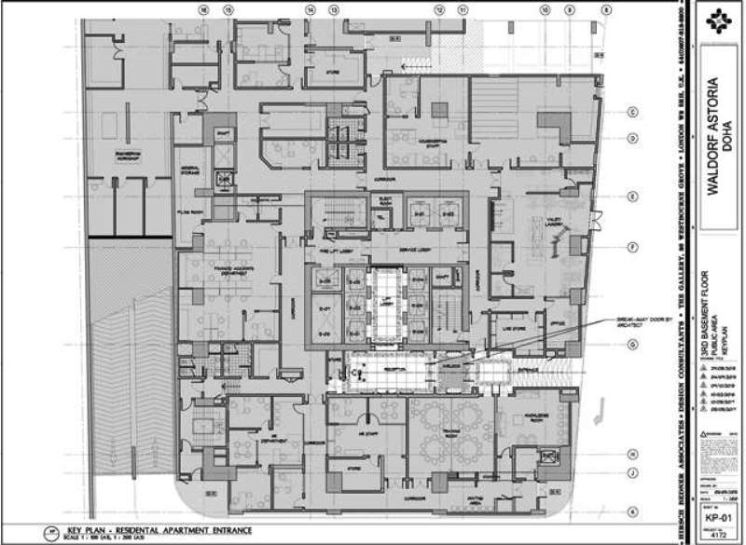

2nd Basement
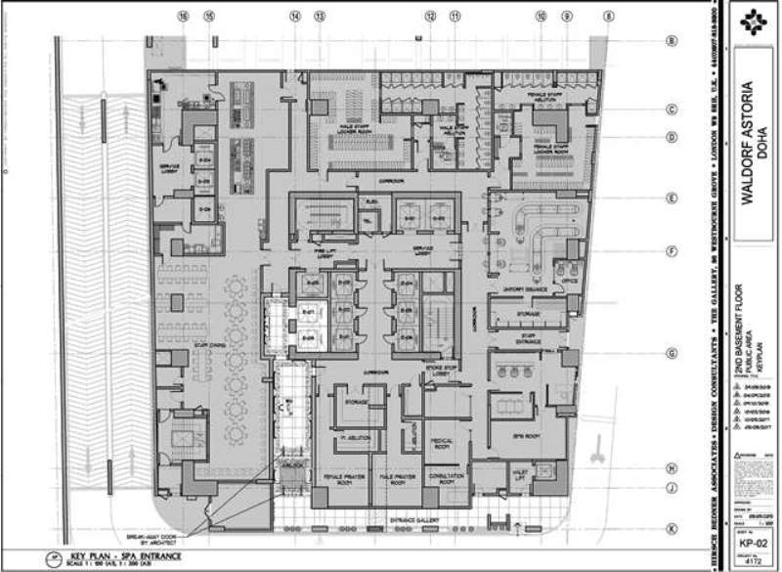

Lower Ground
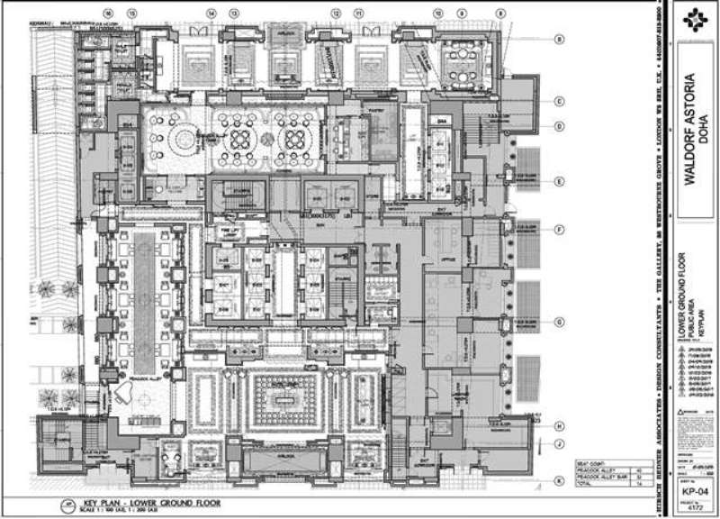

Mezzanine
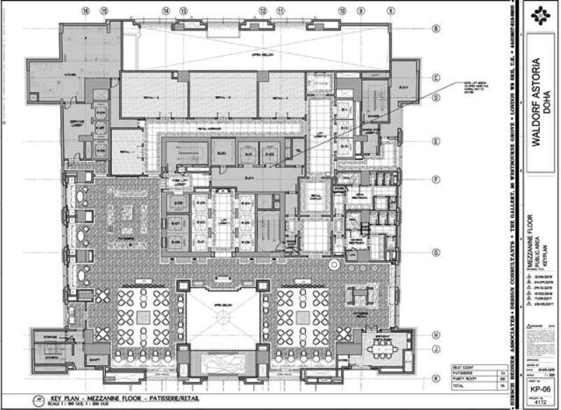

1st Floor
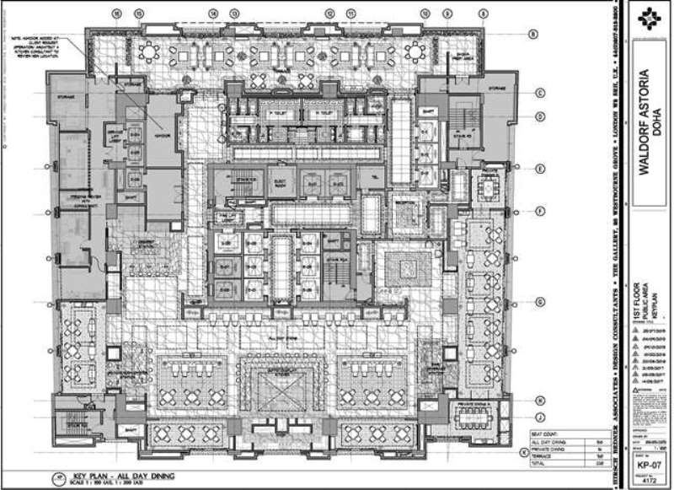

2nd Floor
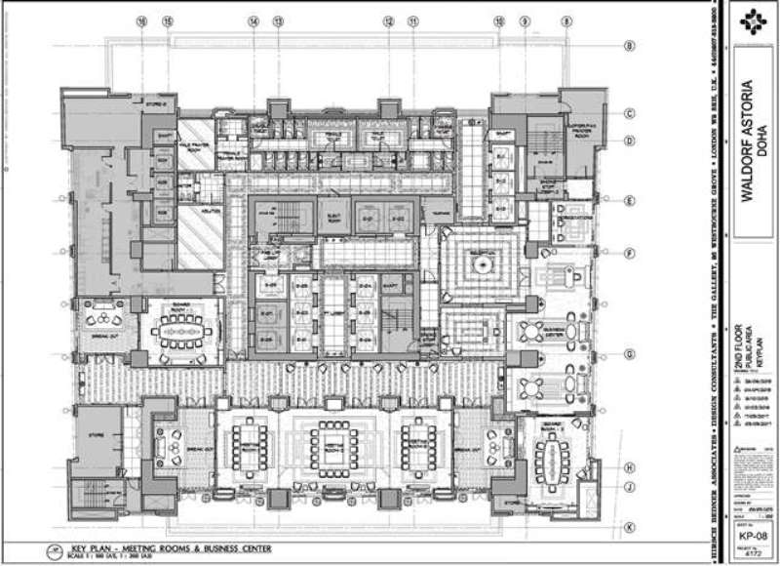

3rd & 4th Floor
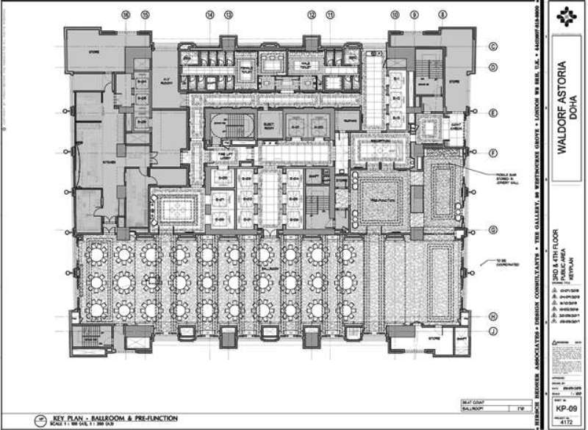

6th Floor
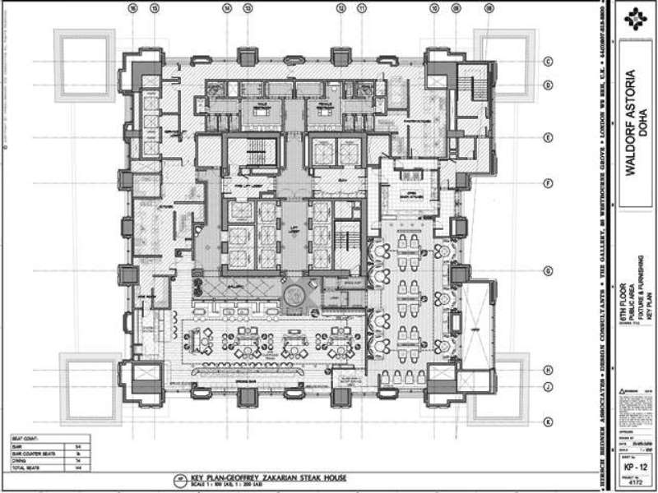

10th – 11th Floor
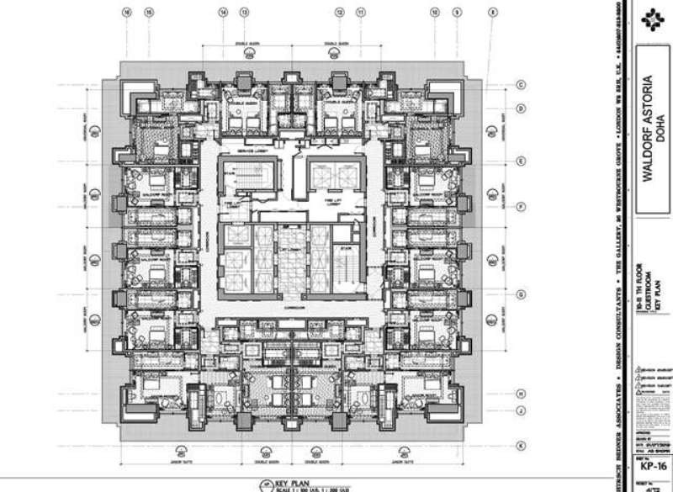

12th – 27th Floor
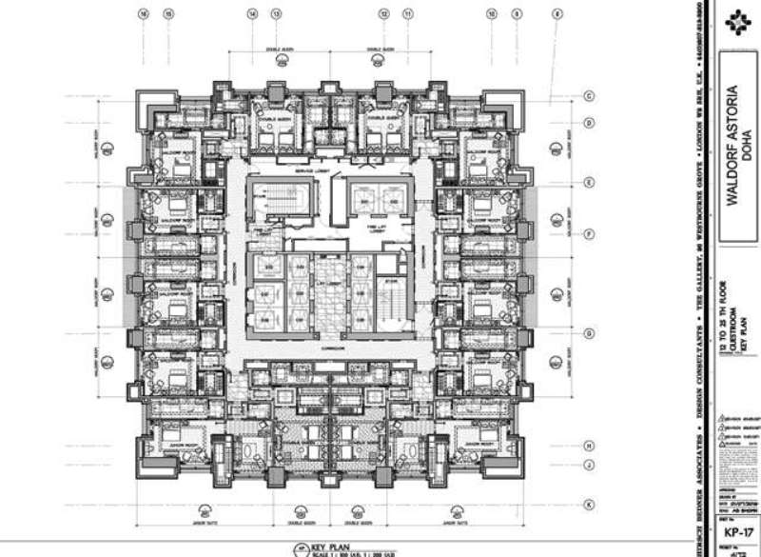

29th to 33rd Floor
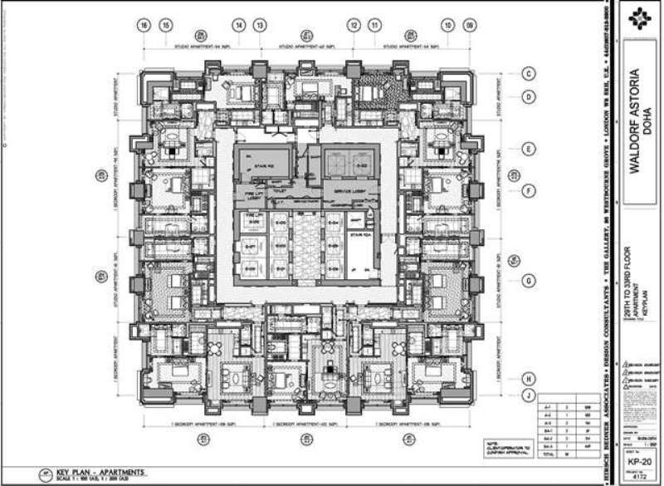

34th to 35rd Floor
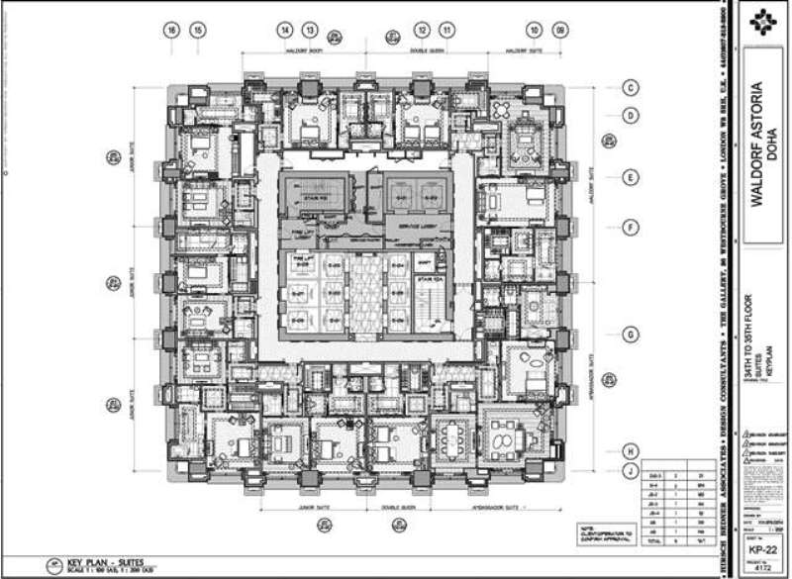

36th Floor
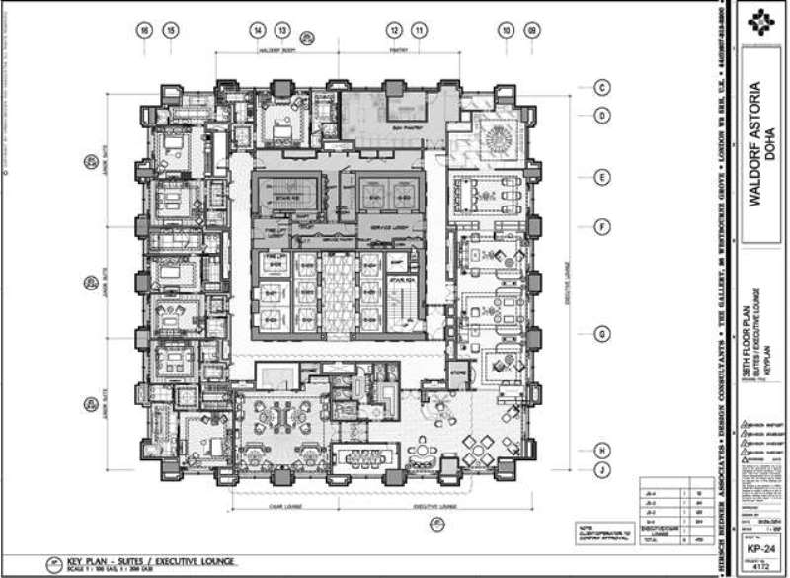

37th Floor
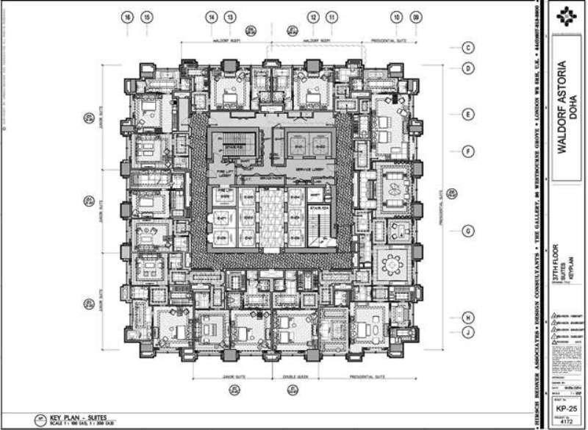

38th Floor
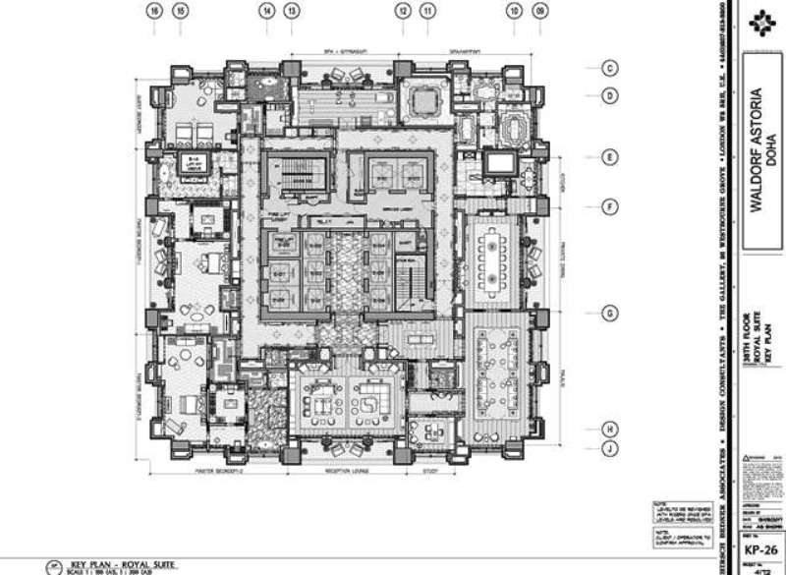

39th Floor
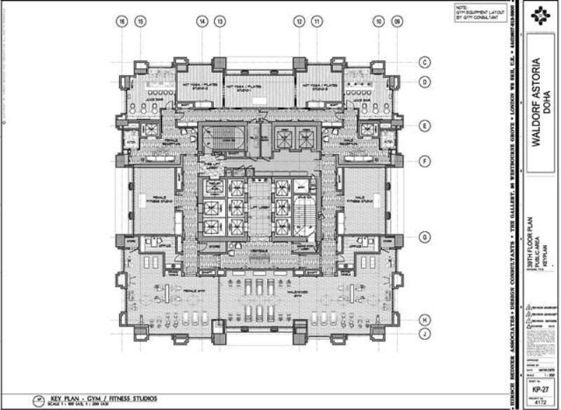

40th Floor
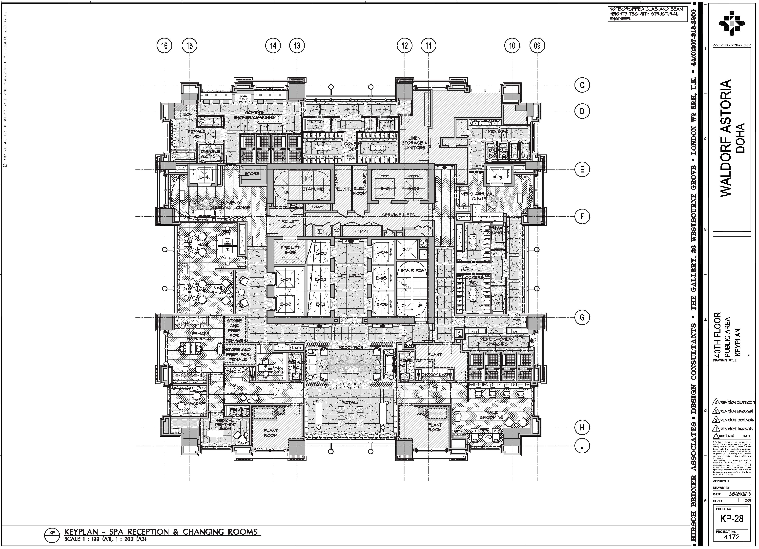

41st Floor
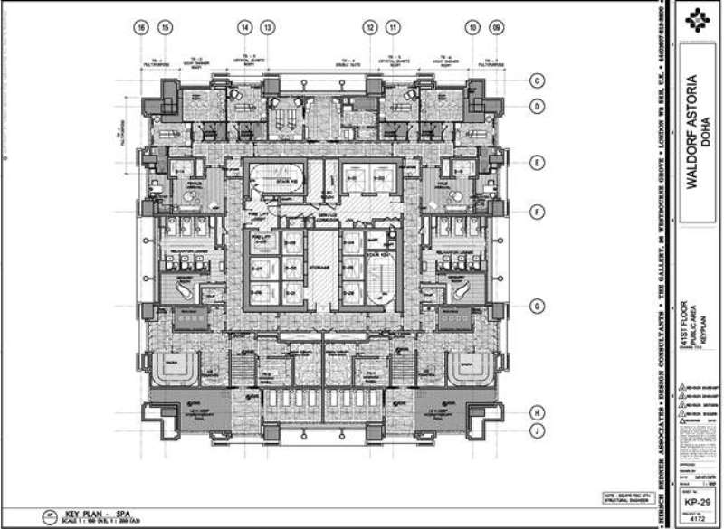

43rd Floor
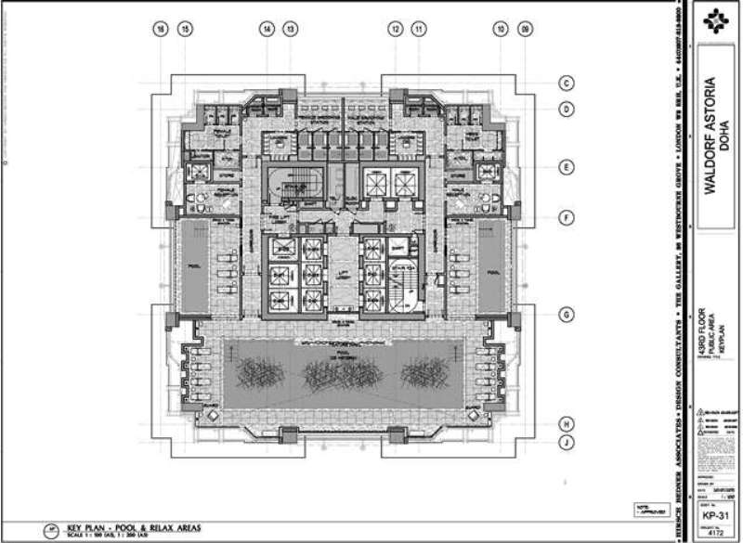

Upper 43rd Floor
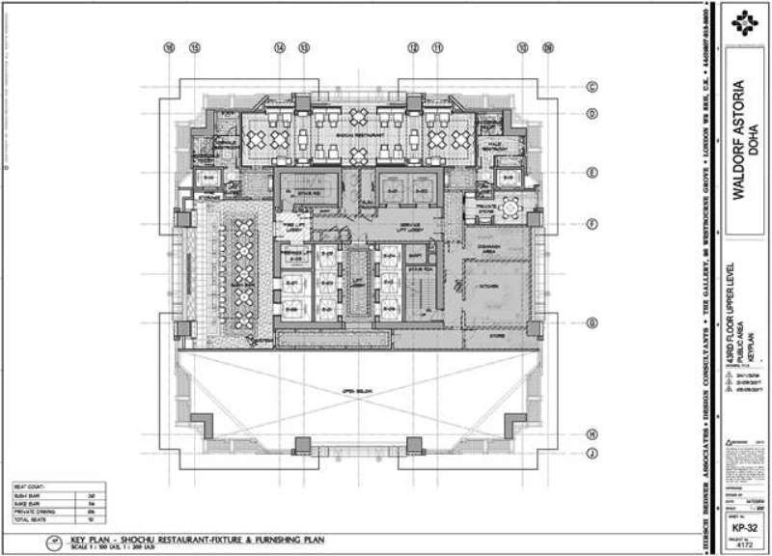

Critical Path.

List of Critical Activities Vital to the Success of the Project (not included in the Construction Program Activities)

a. Minimization of repetitive Re-design of all systems and disciplines
b. Material resourcing specially for long lead items well ahead of time considering the impact of blockade to the region
c. High productivity efficiency of labors which are often expected from experienced skilled tradesmen instead of allocating fresh labors outsourced from outside Qatar
d. Fast Track review and approval of engineering submittals for on-time site execution
e. Fast Track engagement of required ID and Speciality Subcontractors to process the engineering submittals as per time schedule and proceed each procurement process in order to deliver required materials on time.
f. MEP Services Completion and Handing over
g. Site readiness free of obstruction with instruction to commence

The activities as per the Baseline Program are considered to be a “Critical Program” due to its process and execution of works that has limited overall duration. The Program considered the shortest time possible to complete the project as per time requirement in which any delays in this activities will drag and extend the project completion date.
- Kindly refer to the “Baseline Program”
Risks/Constraints anticipated in the Project.

- Resources
- Consultants Approvals
- Materials Deliveries (Long lead Items)
- Contract Agreement

Productivity Data/Analysis and Assumptionsincluded, (Engineers, Foreman’s, Skilled Manpower, Non- Skilled Manpower)

- To be Confirmed upon availability of Contract Bill of Quantities (BOQ)

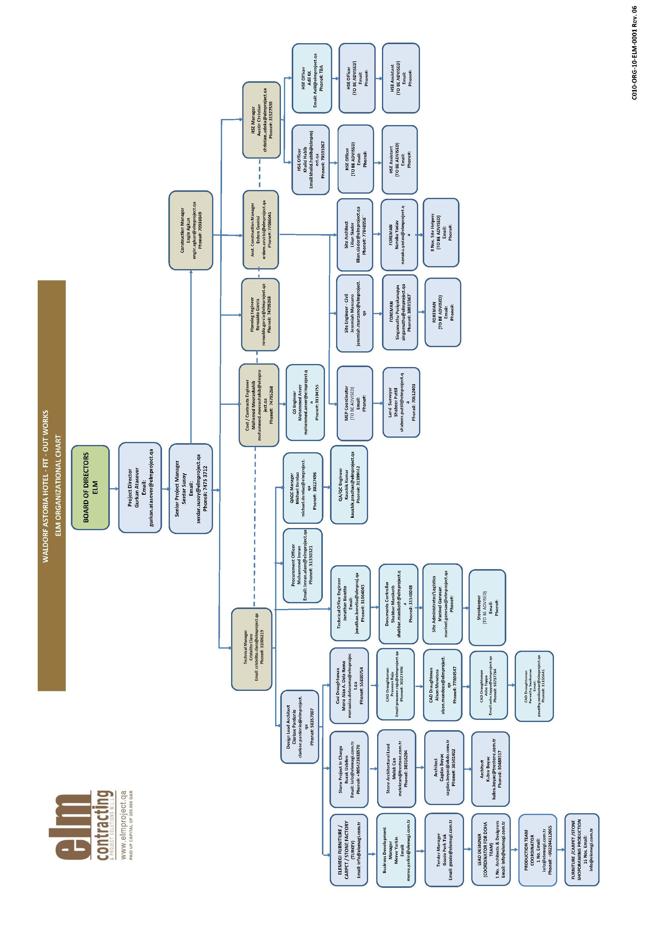Organization Chart

