Story
AS A Broker
I WANT to provide a person applicant which is an US Citizen or Resident for tax purposes
SO THAT Macquarie can receive this information once my loan application is submitted electronically

Scenarios

Scenario 1:
GIVEN a Person Applicant is added
AND General TAB is displayed
THEN a No | Yes field "US Citizen or Resident" is displayed enabled as optional for input
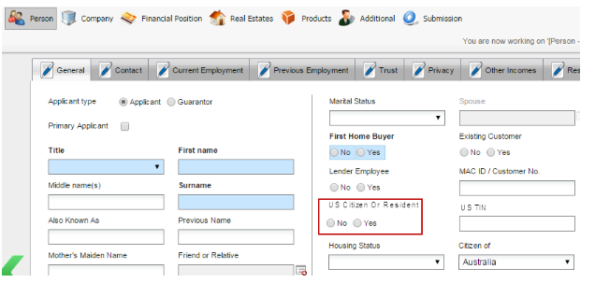

Scenario 2:
GIVEN a Person Applicant is added
AND General TAB is displayed
AND no selection is made for "US Citizen or Resident" field at all
AND this Person Applicant is selected as a Transaction Account Holder on Products > Features panel
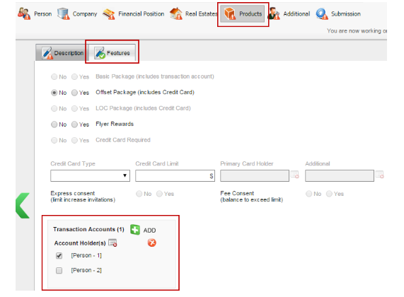
THEN validation error is to be launched advising US Citizen Or Resident selection is mandatory for this applicant
Error message: "US Citizen or Resident - must be provided when applicant is linked to a Transaction Account"

Scenario 3:
GIVEN a Person Applicant is added
AND General TAB is displayed
AND a selection is made for "US Citizen or Resident" (Yes or No)
AND this Person Applicant is selected as a Transaction Account Holder on Products > Features panel
THEN the expected Transaction Account XML Output is created as per below:
/ApplicationBatch/Application/CrossSellSegment/CrossSell/TransactionAccount/AccountHolder@USCitizenOrResident

Important:
- one <AccountHolder> is expected to be outputted for each applicant been selected as an Account Holder
- one <CrossSell> is expected to be outputted for each Transaction Account added

XML Output order expected:
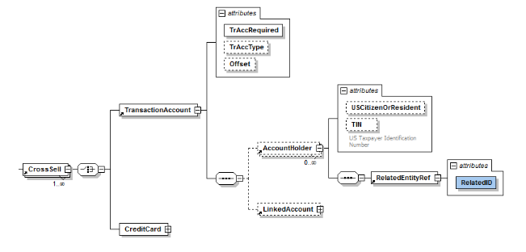

Scenario 4:
GIVEN a Person Applicant is added
AND General TAB is displayed
AND a selection is made for "US Citizen or Resident" (Yes or No)
AND this Person Applicant is NOT selected as a Transaction Account Holder on Products > Features panel
THEN no changes to the XML Output is expected

Scenario 5:
GIVEN a Company Applicant is added
AND General TAB is displayed
THEN US Citizen or Resident field is not available

