SUMMARY REPORT ON PHYSICAL ASSESMENT EVALUATION

**1. POPULATION STRUCTURE**

The evaluation was carried out on a sample population of 1187 people. The population had varied age diversity ranging from 3 weeks to 50years thus representing all demographic aspects of the sample population.55% of the total population was made of females while male constituted 45% of the total population. The youngest and oldest female captured were at 3 weeks (0.0833 years) and 50 years respectively while that of male ranged from 3 months (0.25 years) and 50 years for youngest and oldest respectively. The majority of the population is composed of children which forms 93% 0f the total population.

***Age Distribution***

|  |  |
| --- | --- |
| Median | 7 |
| Mode | 2 |
| Mean | 8.1908457 |
| Standard deviation | 6.768411901 |

***Age Range***

|  |  |  |
| --- | --- | --- |
| Sex | Minimum age | Maximum Age |
| Female | 3 weeks | 50 years |
| Male | 3 months | 50 years |

***Age distribution chart(normal)***

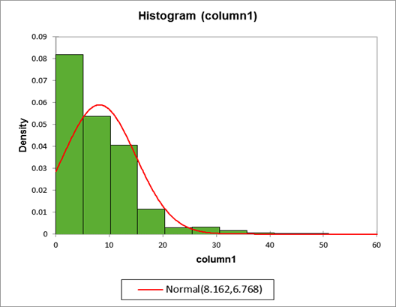

***Population composition***

|  |  |  |
| --- | --- | --- |
| Category | Total | Contributing percentage |
| Children | 1107 | 93.42% |
| Adults | 78 | 6.58% |

***Explanation of key population data***

The key population data through column 1 –colum7 can be summarized by the table below;

|  |  |  |
| --- | --- | --- |
| **Columns #** | **Parameter being represented** | **Explanations of key population descriptive statistic item** |
| 1 | Age | The median age is 7, the largest frequency age is 2years and the population mean is approximately 8 years with a standard deviation of 6.7 years. This shows that the majority of the population lies within 2-14 years. The age has positive skewness an caused by more people in children blankets |
| 2 | T | This value will vary considerably due to effects and age difference. The mean value of the data for population does give much on population. The graph is skewed to right with sharp peak though the population value lies between 0-1000 |
| 3 | P | The value mean is also affected by diversity in age brackets .the peak occurs at 100 and skewedness is to right |
| 4 | R | It doesn’t tell much of population since its affected by age diversity. The histogram shown low weakness is skewed to right |
| 5 | HT(cm) | Also affected by age thus for normal distribution thus histogram has no skewedness but has sharp peak which show that the population mode is approximately at 150cm |
| 6 | Weight(lbs.) | This columns shows weight distribution which is dependent of age thus quite changing |
| 7 | Immunization frequency | The immunization mean frequency is 3,mode is 4.This show most people have undergone 4 times for immunization .This causes the histogram skew towards left with peakdness proximately around it mode |

***Place of birth***

From the data collected the largest fraction was born at hospital/clinics, followed by home, while the least percentage had no information on the birth place which shows that majority of the population has got access to health facilities.

Among the population its realized that different individuals have been brought up under different parental cares. The chart below show various care takers of which mother takes the lead.

**2. POPULATION HEALTH**

***Frequency of immunizations***

Up to 81% of the population have taken 4 immunizations while 12% have no undergone any Immunizati0ns.6% have no information or didn’t not give any viable information on their immunization status. The information can be represented as below:

***Immunization frequency distribution chart(normal***)

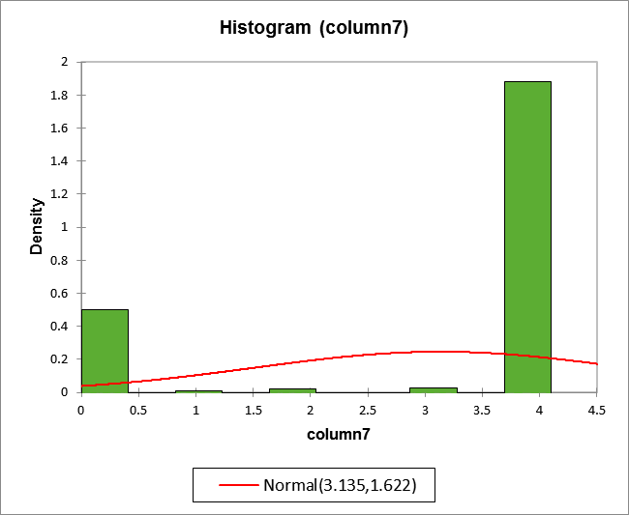

***Malaria occurrence/prevalence*.**

There is a very high malaria prevalence .61% of the population has malaria case within a period of 1 year with only 38% no having the cases in the same period. Majority of those children fall under the age of 5 thus its highly recommendable to educate the people on how to prevent and control malaria as well as launching anti malaria awareness campaigns.

These case are evenly distributed across the entire population since both adults and children have same case of occurrence. The prevalence of malaria is more to the adults than children where the prevalence case is 64% and 62% for adults and children respectively.

***Correlation between immunization frequency and number of time malaria case were experienced.***

The upper immunization frequency (4 times) and lowest frequency (0) were collated to the number of time the malaria cases have been experience which showed that the immunization frequency is just independent of the number of time malaria case have been experienced. For instance, there are more people that have been immunized 4 time but have multiple cases of malaria in a year as compared to those immunized and had malaria cases. Thus no any viable relationship. The key correlation data can be described as below.

|  |  |  |
| --- | --- | --- |
| **1.**  Correlation matrix (Pearson): | | |
|  |  |  |
| Variables | *IF | count |
| *IF | **1** | **0.810** |
| count | **0.810** | **1** |

**2.**

|  |  |  |
| --- | --- | --- |
| p-values (Pearson): | |  |
| Variables | *IF | count |
| *IF | **0** | **0.190** |
| count | **0.190** | **0** |

**3.**

|  |  |  |
| --- | --- | --- |
| Coefficients of determination (Pearson): | | |
| Variables | *IF | count |
| *IF | **1** | 0.656 |
| count | 0.656 | **1** |

***Reasons for visiting the clinic***

There were varied reasons why the people in the sampled population visited health centers. Though different people experiences a combination of several cases and others a single case, the most frequently experienced cases were as below and are represented in a bar graph.



***Assessment and Plan***

For all health problem encountered by the population, most of them have well diversified method of solving them. Most of them are usually small ailments and allergies thus not severe. Below, is a table showing some of the highest occurring diseases/conditions after assessment with the corresponding curative plans/methods that was carried out.



CONCLUSION

After analysis of the data the following can be deduced;

* The common health problem experienced by the population have multiple health solution ranging from exercise, dietary requirement and less severe medications.
* The population is mainly made of children with majority of population being between 2-14 years.
* More people are born in hospital/clinics or medical centers and catered by their own mother thus there is better care.
* Females dominates the populations than males.
* Malaria is the most common health threat among the population.
* The access to health care is relatively good since most people are born in health center/hospital/clinics and have good immunization frequency.
* The number of immunization subjected to the population has got no any relationship with the frequency in which malaria cases are experienced