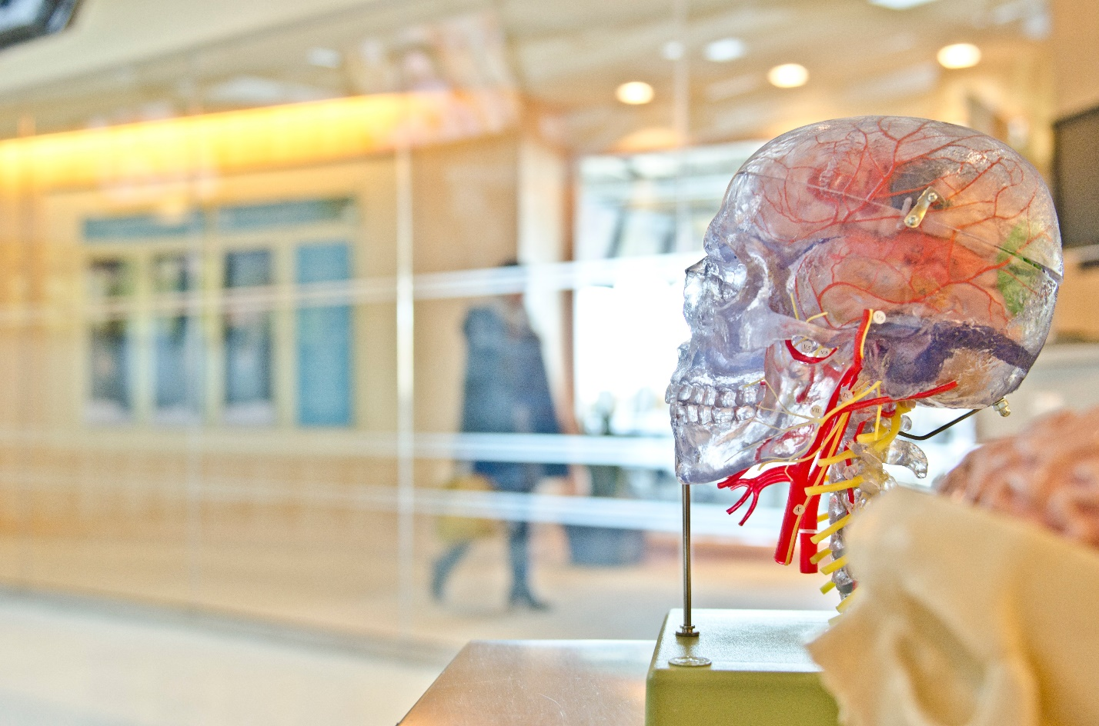07 Neurotech Startups to Watch: Brain-Machine Interfaces, Implantables, and Neuroprosthetics
Today with the innovation in technology, biology and computer sciences have intertwined themselves to a great extent, hence giving birth to digital health sectors which are now even available in apps. Let us look at some of the Neurotechnical startups:
- Kernel:
Bryan Johnson, the founder of online payment companies such as Braintree and the OS Fund, also funded and formed Kernel that is an early-stage brain-machine interface company. Even though it originally had intended to build a memory prostheses that would be able to allow the external storage and subsequent upload of human memories into the hippocampus, the company had since pivoted but now it is working on a method to measure and stimulate the electrical impulses of many neurons at once. The technology would then be used in clinics to cure diseases like depression or Alzheimer’s.

- Dreem:
Dreem is a Neurotechnical startup that was able to develop a head-mounted wearable that is able to monitor sleep. It was founded in France but now it is based in San Francisco. During the time the patient is asleep, the device uses EEG electrodes in order to monitor as well as analyze the brain activity of that patient. After which the devices uses a “bone conduction technology” in order to keep in check the brain activity by emitting subtle sounds at specific moments that the company claims that it is able to enhance the overall quality of deep sleep. The device is linked to an app that displays sleep metrics and personalized recommendations based on the user’s sleep habits.

- Thync:

Thync was able to improve sleep and combat stress by developing a small wearable “pod” that could attach to the back of the neck and thus use neuro stimulation. Thync Relax Pro is their lead product and it uses low levels of electric stimulation in order to activate nerve pathways in the neck and head. The company announced that these pathways help communicate with areas of the brain to provide assistance in controlling stress levels and the quality of sleep. The product is thus targeted towards those consumers who suffer frequently from stress and consequently struggle to sleep.
- Halo Neuroscience:

Halo Sport is a brain-stimulating device that has been developed by Halo Neuroscience. It is based in San Francisco. Weak electrical pulses are sent to the brain with the intention of increasing the physical training efficiency by the device. When this device is paired with physical training it thus results in increased strength, muscle memory and endurance.
As in May 2018, USA Cycling had announced that it was partnering with Halo in order to help train its cyclists. Halo also hired Yasi Baiani, formerly Head of Product Management at Fitbit, as the company’s VP of Product in August 2018, a possible indication of the company’s intentions to pursue the consumer market more aggressively.

- Synchron:

The Stentrode is an implantable device built by Synchron, it aims to provide a safe way for the paralyzed patients in order to achieve a direct brain control of mobility assistive devices. The system thus involves a small and flexible device that is able to pass through the cerebral blood vessels, making it easier to implant in the brain and interpret electrical data emitted by neurons. The company is presently preparing for early-stage clinical trials to evaluate the safety and feasibility of the device to enable patient-directed brain control. Synchron’s founder and CEO, Dr. Thomas Oxley, was named the 2018 Advance Life Sciences Award Winner for his work on the Stentrode.

- BrainCo, Inc.:
BrainCo is best known for its brain-machine interface wearables. It was a product of Harvard Innovation Lab. Focus series that offer wearable headbands for fitness, education and mind-controlling games is the company’s main product line. That company was also able to expand into prosthetics, by working under the name of Brain Robotics. The company is developing a robotic prosthetic hand which can be controlled by the user’s mind. Using machine learning and electromyography, that is able to measure signals from the brain to various muscle groups, Brain Robotics’ prosthesis product is currently capable of reproducing six distinct tactile hand gestures.

- Neurable:

Neurable is presently creating a brain-computer interface that would allow the people to manage software as well as devices by using only their brain activity. The software makes use of machine learning methods to reduce the lag time between analysis of neural activity and output, potentially reducing it down to real-time.

