Portfolio

Binary.com

Website: webtrader.binary.com

Description: The project’s objective was to develop a single page web app for traders.
The design was minimalistic but feature rich, I was the team lead and managed two other telecommuters. I used Webpack for development workflow, AMD modules to deliver different parts of the app on demand, SASS for styling and Rivets-JS for two-way data-binding.
Backend communication was via WebSocket, I used local storage for persistent sessions. Integration tests where in Nightwatch.

Technologies used: Webpack, Es6, AMD Modules, Sass, WebSocket, Travis.

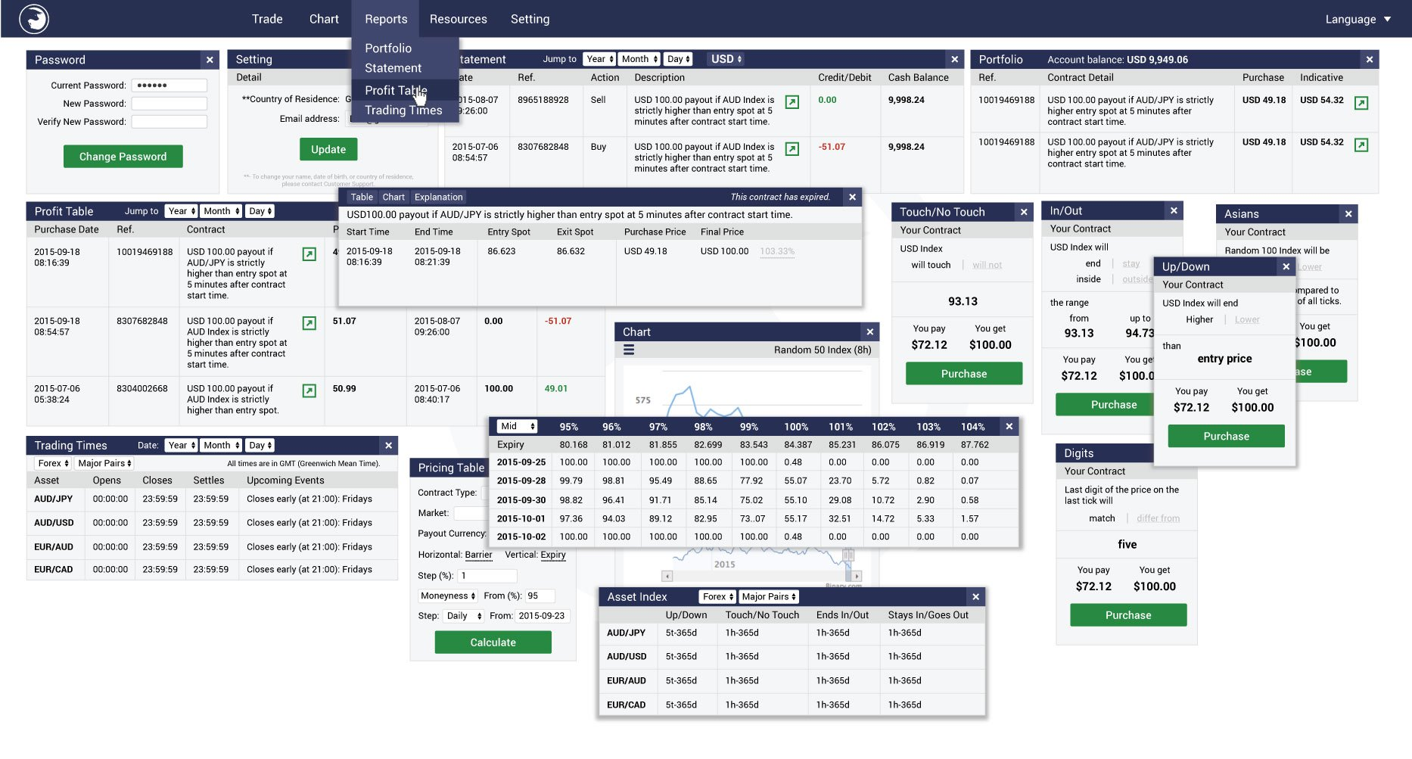

Website: charts.binary.com

Description: A complete charting library for traders, Features like indicators, overlays and draw tools.
I started the project from scratch and delivered the first few major versions, it’s now maintained by a colleague. I used ReactJS and MobxJS for state management, SASS for styling, Webpack and Babel for transpiration,
And Jest for unit testing. This project is both available as a NodeJS library and a standalone web app.

Technologies used: ReactJS, MobxJS, Webpack, SASS, Jest.

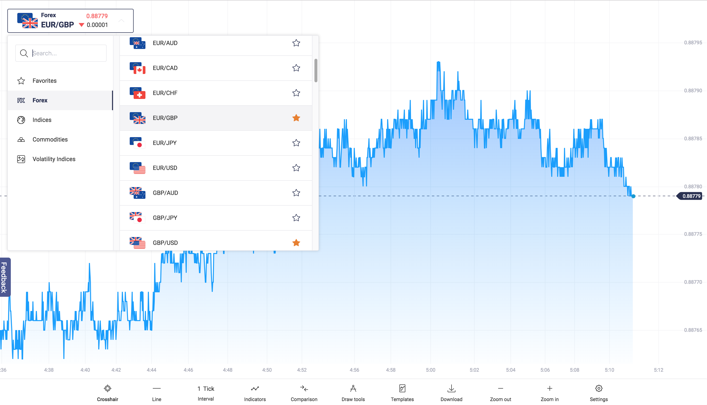

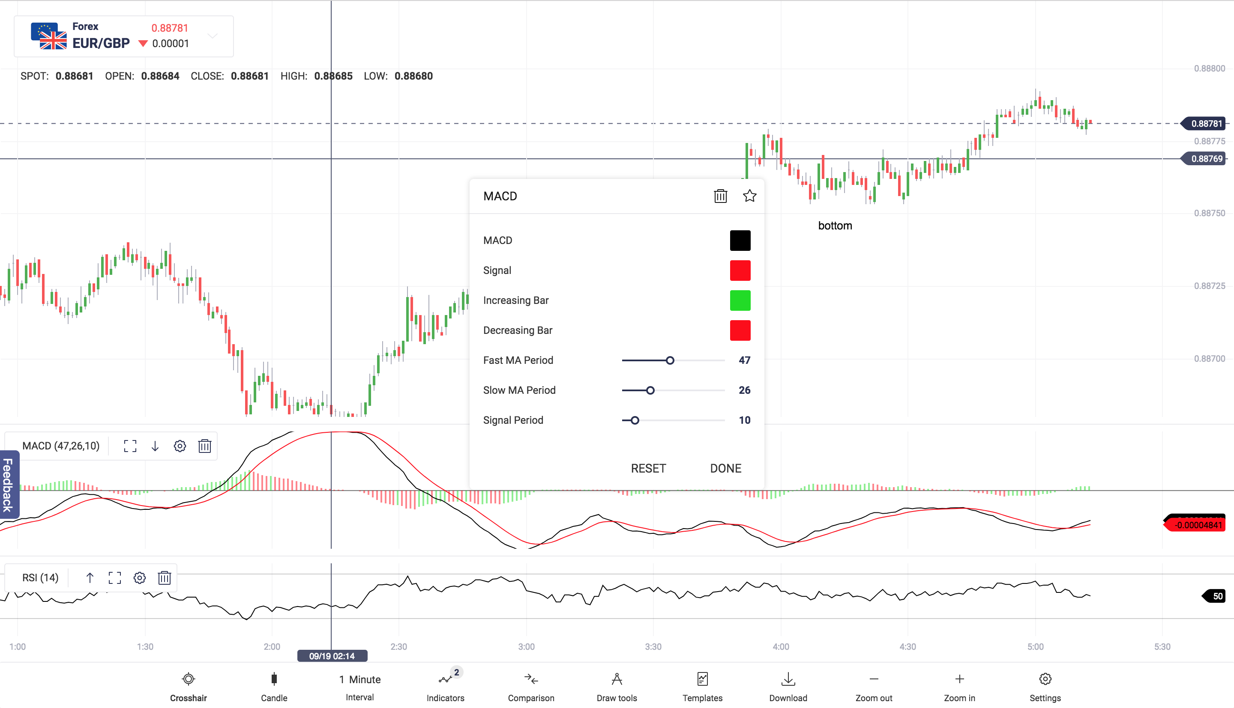

DominateRFID

Website: dominaterfid.com

Description: A simple website explaining what the company is offering, It was an existing project, I used jQuery with some plugins to extend it behind just a few pages, to a complete website, refactored the styles, menus, scrolling and added a few animated svgs. I also extended the python Django server side to send alerts and keep statistics.

Technologies used: jQuery, Django, Restful services.

