Essay on the Economy of England and a comparison with another country.

Table of Contents:
Introduction
Economics Growth
Standard of Living
Conclusion
Harvard Reference list

Introduction
My research countries are The United Kingdom (UK) and Pakistan and compare the real economic scenario.
The United Kingdom is situated in western Europe and composed of England, Scotland, Wales and Northern Ireland. It is bordered by the Atlantic Ocean, The North Sea, and the Irish Sea.
First of all, my research about the United Kingdom population and other factors. The United Kingdom population is 67.61 million which is a much higher population than other neighbour countries (Johnston, 1984).
The United Kingdom is the sixth largest economy in the world. In terms of economy, there exists industry based economic functions which create it as one of the largest industrialist country in the world. The major industries are mechanical instrument supply, medical equipment, modern equipment supply like aviation's materials and so on.

The main sectors of industry:
The United Kingdom is an industrialised country in the world and it was a former European Union member. It is now one of the largest significant raw materials producing country with important civil and military aerospace and pharmaceutical industries. In its economy, the agricultural sector now does not play a vital role but that little agricultural products are very productive. And this is contributed by 0.6% of total GDP. However, the industrial sectors are the main agents of the United Kingdom's economy and there has almost been 18% of the working people involved. And it accounts for 17.4% of total GDP. Industry sector constitutes such sectors- machine tools, transport equipment, chemicals, aviation, mineral resources (United Kingdom Economic sectors, Information about Economic sectors in United Kingdom, 2021)

Economy of the United Kingdom relies largely on the sustainable service sector where more than 81% of the workforce is involved and contributes in large scale more than 71% of total GDP. So, its contribution proves that it is the main driver of the UK's economy. Besides, Banking sector also plays a significant role in the UK's economy. Tourism sector is another force of economic growth. A large number of UK citizens are involved in tourism and hospitality fields and it is considered now the world's seventh most popular tourist destination. Since 2010, tourism has been the fastest-growing sector specially for jobs provided in the UK and it is accounting for 11% of all jobs in the UK.

On the other hand, South Asia's distinct nation Pakistan has a big economy over its huge population. In the perspectives of economic spheres, Pakistan frequently faces economic restrictions and recession. During military regime and other forces involvement, Pakistani economic growth picture blurred several times. Notwithstanding, the 2020s global pandemics also affected Pakistan's economic activities, but its results are surprising. Presently Pakistan faces a huge debt crisis and international Economic Organisations do not help them fully (A. M. G.,2009).
Infact, Pakistan is a Islamic Republic country, which is located in a special zone or hub of south asia and Southeast asia . It is the world's fifth-most populous country with a population exceeding 212.2 million, and has the world's second-largest Muslim population country. Pakistan is the 33rd-largest country by area, spanning 881,913 square kilometres.

Pakistan's major economic forces:
As a middle income titled economy, there exists mixed types of economic activities. Their government owned industry performed well but considerably private enterprises performed better. The major industries are basically privately owned such as textiles, construction industry and remittance.
Now Pakistan's industrial sector accounts for about 24% of total GDP. It indicated that it is becoming an industry based economy. The specialized sectors are Cotton Textile production, apparel manufacturing and the total contribution of this 24% of total GDP. Other specialized sectors include cement, fertilisers, edible oil, and food processing. Presently, Pakistan's economic areas are expanded in other sectors. Automotive industry now plays a significant role for the Economic growth. Pakistan also provided construction materials because of demand from neighbouring states (Major Industries Of Pakistan - Askedon, 2021).

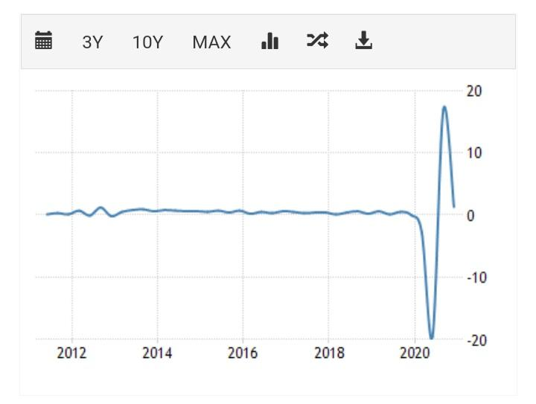
The United Kingdom’s GDP growth

The United Kingdom (uk) GDP growth rate:
The United Kingdom (uk) GDP growth rate is higher than most of the Country. But nowadays it's a little bit lower compared to previous year ,due to the covid 19.
The United Kingdom GDP growth rate All the time from 1955, Averaged is 0.58 percent until 2020.All the higher percentage is 16.90 percent. The United Kingdom GDP growth position in the world is 5th. Also, there GDP growth rate
[1.3% (2018) 1.4% (2019) −9.9% (2020) 6.5% (2021) ]
(the percentage Collect from internet)
On the other hand, the association sector is secure, contributing As good As 80% of GDP. The financial services industry is particularly important, for any Country. If any country wants to grow their GDP then it’s really essential. In (uk)The United Kingdom, London is the second-largest financial centre in the world.
The United Kingdom could be the fastest growing G7 economy up to 2050, with Approximate yearly growth of 1.9%. Staying open to talented workers and developing successful projects.
The main reason for increasing the GDP growth in The United kingdom is, Government consumption, investment, and private consumption. Also, most of the people are self dependent.
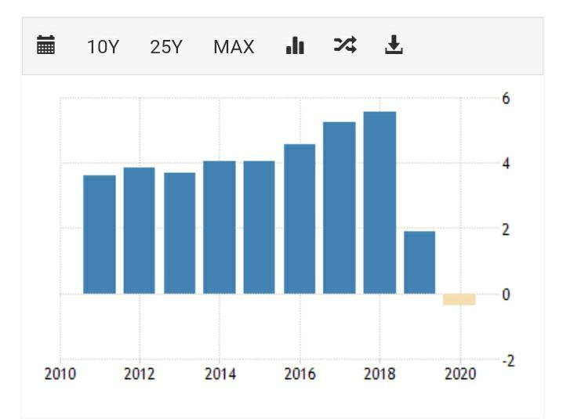
Pakistan GDP growth rate:
Pakistan GDP growth rate is not good enough, compared to other countries. Their economy is so low compared to most of the countries. Their GDP Annual growth rate is -0.38 percent in 2020. In 2019 it was 1.91 percent. It's decreased from 1.91 percent 2019 to -0.38 percent in 2020 Because of covid 19. Usually, their economy is already weak. And this time people are looking at the lockdown, the economy has gone to more weakness because they cannot work. All the industries, factories, offices, shops, shut down the economy in this situation. That’s why so much has changed in just 1 year (1.53) decreased.
Pakistan GDP growth position in the world is 42nd. Also there GDP growth:5.5% (17/18) 1.9% (18/19); −0.4% (19/20) 1.5% (20/21) (the percentage Collect from internet)
On other hand, the industrial sector contributes to 18.3% of the GDP and employs 25.8% of the population. The major industries are textile production (the largest source of foreign exchange revenue), oil refining, metal processing, and the production of cement and fertilisers.
Pakistan GDP growth and economy has been Rising lightly over the past two decades. Also, their industrial sectors profit 18.3% of the GDP and employ 25.8% of the population.

Comparing the standard of living
Standards of Living: Pakistan
The standard of living in Pakistan is comparatively less than the United Kingdom. Basically it differentiates and varies between different classes of society. According to the HDI report Pakistan is a largely developing country and it ranked now 147th out of 170 countries. This index also provided information that there exists low human development. It is observed that Pakistani citizens with low income have more children. As a result it is difficult to support such a big size of the family. Mostly there is only one earning member in the family. So it results in low living standards of the population. Also citizens' security issues are questioned frequently for huge intervention of military officials and other fundamental forces. Women education has faced negativity in this region. So, people are struggling hard to maintain standards of living (Gondal and Gondal, 2021).
Standards of Living: United Kingdom
In the most human being centric sector, the United Kingdom performs very well relative to most other countries in the index of standards of living. The most well performing sectors of the United Kingdom are citizens personal security, environmental quality, civic engagement, social connections, health sector, jobs sector, income and wealth, education and skills and others. In their households the income rate increased day by day, but covid situation deprived them little to. The per capita income was $45741 and there existed little inequality between the richest and poorest, the richest 20% of the population earning 6 times as much as the poorest 20% (Standard Of Living By Country 2021, 2021).
In terms of employment, the UK performed very well than the most other neighbours. 75% of people who are 15 to 64 in the United Kingdom have a paid job. There are little inequalities existing between men and women participation in the jobs sector.
In terms of education, the United Kingdom always focused on education quality. Government provided a good environment for education and achieving skills. Estimated almost 81% of adults aged 25-64 have completed upper secondary education and total illiteracy rate is 99% which indicates a better living place. In terms of health, the UK government's most prioritised sector is the health sector. The government ensures sector is the health sector. The government ensured good medical facilities for every citizen and incentives as a result UK's citizen's life expectancy of therexistsis 81 years.
GDP per Capita
It is one of the important economic factor which indicate nation's economic conditions. It provided the nation's citizen's average income each year. It does not allow us to compromise countries based on their living standards
Uk GDP per capita:
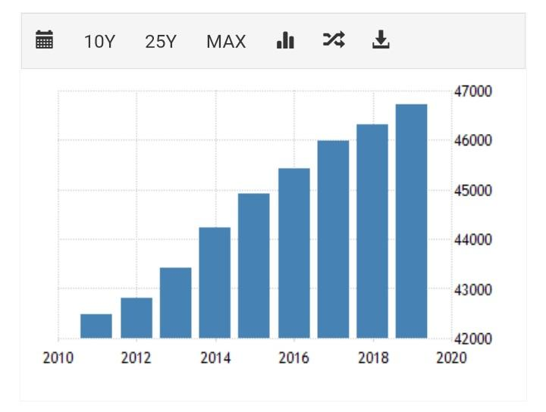
The United Kingdom GDP per capita income is quite better than Pakistan. There is a good living environment, and every economic factors performs very well. Due to covid and leaving the EU, the United Kingdom's economic situation faced some difficulties. By the way, the Gross Domestic Product per capita in the United Kingdom is recorded at $46344.
Pakistan GDP per capita:
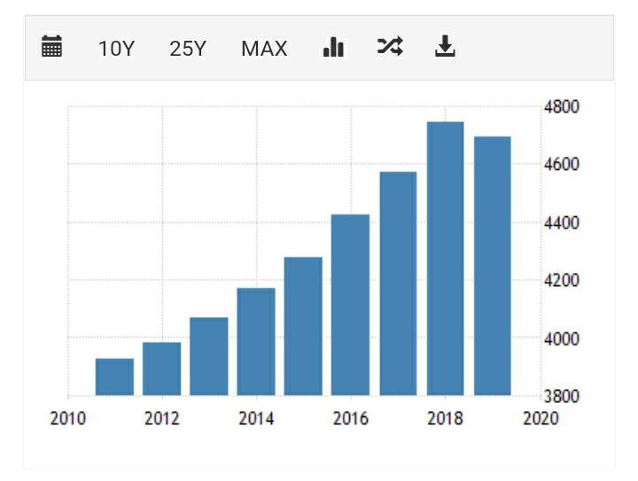
Pakistan has a large population which is almost 220 million, giving it a nominal GDP per capita of $1543 which is less than its neighbours India, Bangladesh and other countries and the difference between UK and Pakistan with distance.
On other hand: The industrial sector contributes to 18.3% of the GDP and employs 25.8% of the population. The major industries are textile production (the largest source of foreign exchange revenue), oil refining, metal processing, and the production of cement and fertilisers.

Comparing both nations standards of Living
There is more positive per capita income in the United Kingdom than in Pakistan at that time. The United Kingdom has a higher GDP per capita and also has a higher life expectancy. At that time the United Kingdom had more goods and services and citizens could usually afford the other good things in life. These things create a good environment and increase per capita income. On the other side, Pakistan now has a vulnerable economy due to covid pandemic and still burdened with huge amounts of debt from internal and external. Besides, all of the goods and services are inadequate there for common people, especially vulnerable communities.
2. Unemployment
Unemployment is a multi-dimensional trend which is characterized by lack of income generated sources. It is a phenomenon for every nation that occurs when a persons who is actively searching for employment is unable to find work.
Uk unemployment rate:
Covid pandemic unemployment hitting young people harder than previous year. Many part-time workers like restaurant employees, travel guides, vehicle helpers, and assistants lost their jobs. Now research showing that there existing unemployment rate almost 5 percent. Also, leaving European Union, it Impact on work sector with negative attitudes (UK unemployment rate 2021, by country | Statista, 2021).
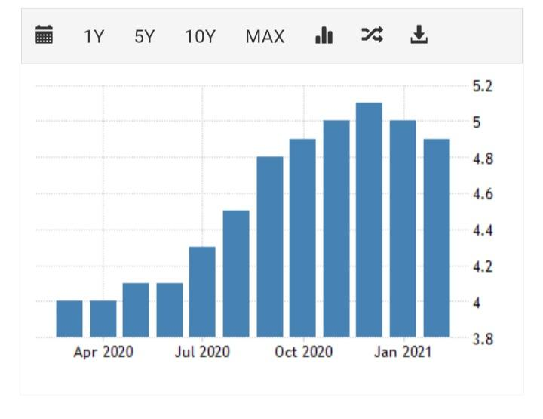

Pakistan unemployment rate

Recent observation showing that the unemployment issues occurred in Pakistan with a large number. The unemployment rate in Pakistan is at approximately 4.45 percent. During the Covid induced lockdowns lots of working people lost their jobs. In April,2020, almost twenty million people faced unemployment issues.
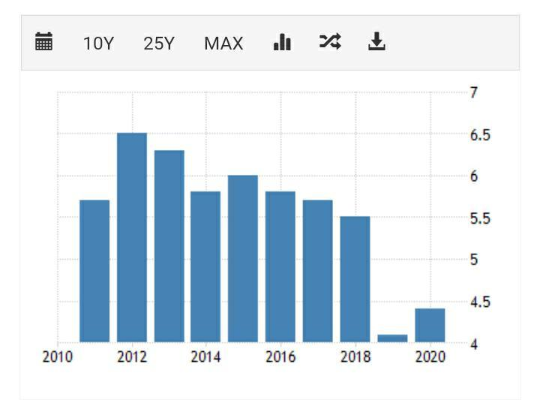

HDI :
HDI or Human Development Index is an index of life expectancy, education, and per capita income indicators. It is used to rank the world's countries on the basis of human development. It was prepared by the United Nations Development Programme (UNDP) in 1990. Basically this index measures the various types of issues which are closely connected with human life such as the level of welfare and development of nations (Human Development Index (HDI) by Country, 2021).
United Kingdom in HDI
In the HDI ranking, United Kingdom achieved 13th ranked and its rate 0.932. According to HDI, the GDP of the United Kingdom almost $2.828 trillion, its per capita income almost $45741 and GDP growth rate is 1.27%. The GDP consists of 80.2% is of services sector, 19.2% industry and just 0.6% is agriculture. The population density is quite same of Pakistan. Besides, the food security comparatively better than Pakistan. Also literacy rate also better than Pakistan showing 99%.
HDI: Pakistan
Pakistan also has increased and decreased its human development issues. It is a medium development country in HDI rankings. In data of HDI, Pakistan has a HDI value of 0.0506, ranking it 144th in the world. In Pakistan now almost 21 percent of parliamentary seats are occupied by women. Also 18.3% of adult women have reached a secondary or higher level of education. In Pakistan, child mortality rate is unexpected. Female participation in the workforce also increased in Pakistan which is 22.7 percent.
Uk Inflation Rate:
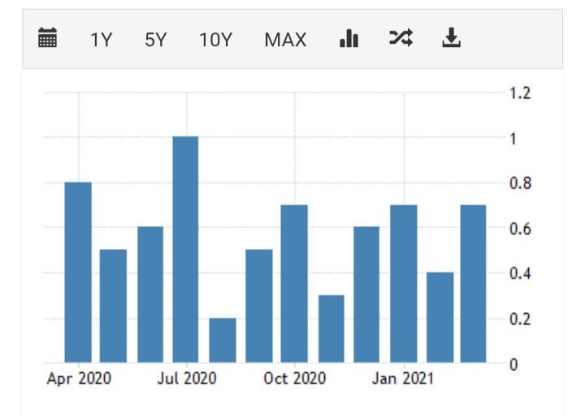
Inflation rates trends changed over the pandemic situations. In 2021, the United Kingdom had increased 1.5 percent which is a negative factor. There increased energy prices which raised transportation costs. And the supply chain is struggling to readjust to the demand. Besides, the accelerations of the consumer price index from the first quarters of the year. Also clothing and footwear cost rose due to covid and other factors.

Annual inflation rate in the United Kingdom edged up to 0.7 percent in March of 2021 from 0.4 percent in February.
Pakistan Inflation Rate:
In the present time, inflation is one of the significant problems faced by the Pakistan economy. Inflation rate in Pakistan is now very high which is already over +0.4%. Due to military regime, most of the officials involved in corruption and black money which increase inflation rate. Besides huge foreign debts are another significant culprits for present inflation situation (Pakistan Inflation Rate | 1957-2021 Data | 2022-2023 Forecast | Calendar | Historical, 2021).
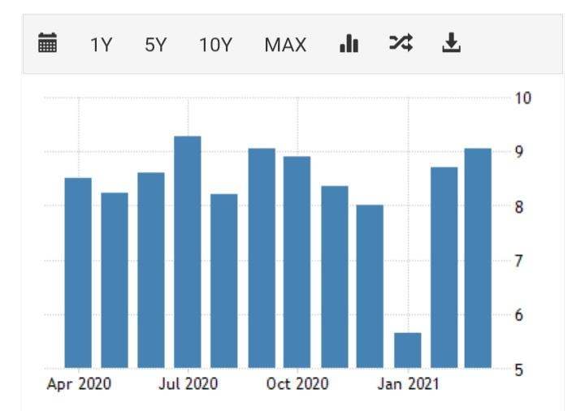

The annual inflation rate in Pakistan increased to 9.05 percent in March of 2021, the highest since July of 2020, from 8.7 percent in February.

Conclusion
Both the United Kingdom and Pakistan are now in a serious crisis due to a pandemic. At the United Kingdom site, their leaving of the European Union incident also impacted its total economy. On the other hand, Pakistan now faced a troublesome period due to the debt crisis. As well as its socio-economic status is vulnerable than previous period
References:
(1) Johnston, R., 1984. Understanding the United Kingdom: The Territorial dimension in government. Political Geography Quarterly, 3(1), pp.86-87.
(2)
Nationsencyclopedia.com. 2021. United Kingdom Economic sectors, Information about Economic sectors in United Kingdom. [online] Available at: <http://www.nationsencyclopedia.com/economies/Europe/United-Kingdom-ECONOMIC-SECTORS.html> [Accessed 24 June 2021].
(3) Statista. 2021. UK unemployment rate 2021, by country | Statista. [online] Available at: <https://www.statista.com/statistics/279990/unemployment-rate-in-the-uk-by-country/> [Accessed 24 June 2021].
(4)
2021. [online] Available at: <http://www.apnapedia.com/unemployment-in-pakistan/> [Accessed 24 June 2021].
(5 A. M. G., A., 2009. Review of Developments in the Pakistan Economy. The Pakistan Development Review, 2(1), pp.114-127.
(6) (Major Industries Of Pakistan - Askedon, 2021) Askedon. 2021. Major Industries Of Pakistan - Askedon. [online] Available at: <https://www.askedon.com/major-industries-of-pakistan/> [Accessed 24 June 2021].
(7) Gondal, W. and Gondal, W., 2021. The Living Standards of Pakistan - Waqas G. [online] Waqas G. Available at: <https://waqasg.com/the-living-standards-of-pakistan/> [Accessed 24 June 2021].
(8)
Tradingeconomics.com. 2021. Pakistan Inflation Rate | 1957-2021 Data | 2022-2023 Forecast | Calendar | Historical. [online] Available at: <https://tradingeconomics.com/pakistan/inflation-cpi> [Accessed 24 June 2021].
(9) Worldpopulationreview.com. 2021. Human Development Index (HDI) by Country. [online] Available at: <https://worldpopulationreview.com/country-rankings/hdi-by-country> [Accessed 24 June 2021].
(10) Worldpopulationreview.com. 2021. Standard Of Living By Country 2021. [online] Available at: <https://worldpopulationreview.com/country-rankings/standard-of-living-by-country> [Accessed 24 June 2021].

