Hi,
I am Surya Sumesh.
Do you have a handful of tasks that needs to be shared?
Then you are at the perfect place.
I have 8+ years of experience in handling various data entry tasks for different clients, and I can be your awesome Virtual Assistant. I have a team of 5 efficient, sincere, and reliable members who can assist in your long hour’s projects.

Our Services include:

- Online Data Entry
- Offline Data Entry
- WordPress Data Entry
- Microsoft Excel, Word, Data Entry
- Lead Generation
- Copy and Paste works
- Form filling tasks
- Finding contact details from Websites
- Data Research and Entry
- Google Spreadsheets Entry
- PDF to Excel Conversion
- PDF to Word Conversion
- Typing scanned images to Word, Excel
- Gathering data from websites and creating spreadsheets
- Real Estate Data Entry into Excel, Report Generation
- Students’ Profile Data Entry into Excel, Report Generation
- Patients’ history Data Entry into Excel, Report Generation
- Books, Authors list, Data Entry into Excel, Report Generation
- Customized Website updating, moving, copying to BigCommerce, WordPress Websites (including Images, Video uploads)
- Proof-reading short-stories & articles.
- Virtual admin assistance.

Work Portfolio:
Web Research & Excel Data Entry:
We are experienced at handling Excel Data Entry based on Web Research. The required data are collected from Internet/Websites, and entered into Excel sheets manually. We can also generate excel reports from source files for Student profiles, Job boards, Hospital/Patient details, Real Estate Property details… you name it!

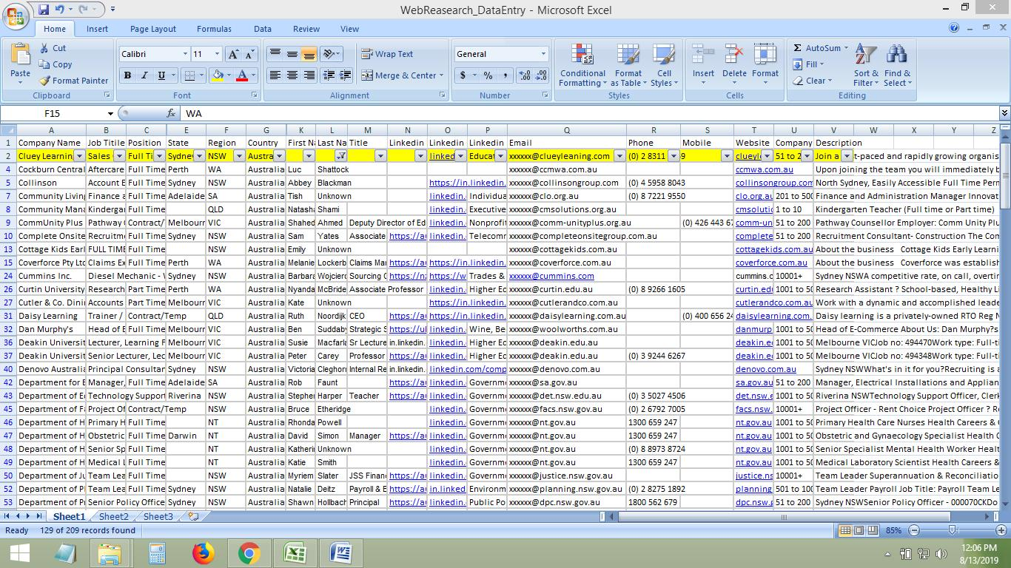
Form Fillings:
We can handle your form-filling projects efficiently, and effectively. Provide us with the source, and the website URL of forms to be filled, and we’ll do it accurately! Student details, Insurance details, Automobile details and the likes will be entered into online forms from source websites or Word/Excel files.
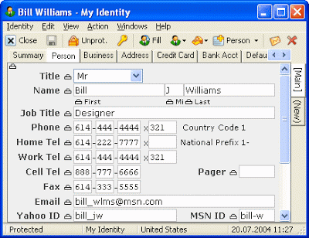

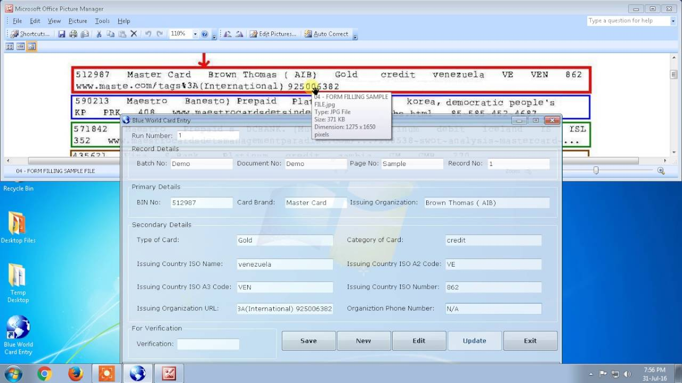
Proof-Reading Tasks:
We can work on your most time consuming, and boring Proof-reading tasks as well. The spellings, grammar, sentences formation will be checked, and corrected at a high satisfactory level. Stories and articles can be proof-read with at least 3 minimal revisions.

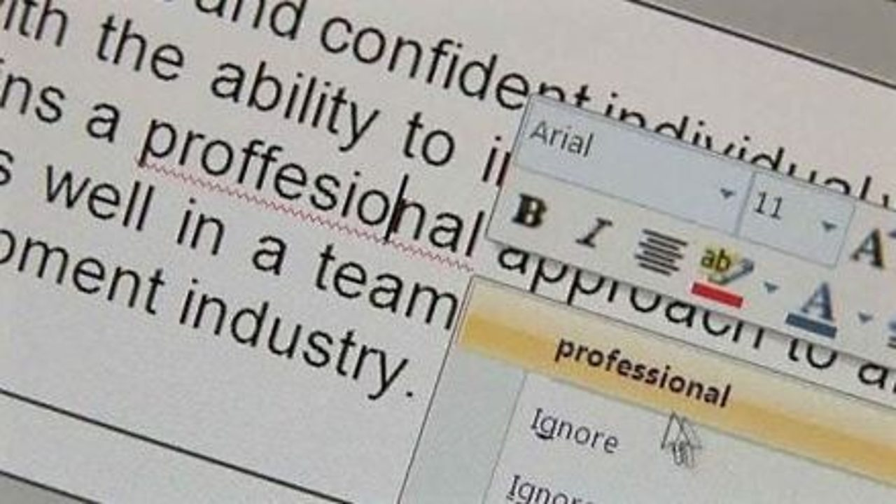

PDF to Excel/Word Conversion:
We have experience in handling PDF conversion, and report generation too. Do you want your PDF files to be converted into an Excel sheet or Word manually? Then you can count on us!
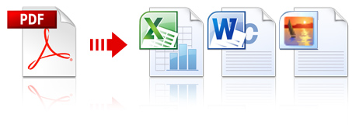
Rest assured! We maintain strict confidentiality, privacy, and security for all the data provided to us!
Need to know more about our services?
Feel free to contact me.

Surya Sumesh
Freelancer
Email - surya.wri@gmail.com
Phone – +91 9495711468

