The Importance of Community for Human Mental Health
First off, what is mental health?
Mental health is an important aspect of our overall health which impacts the state of our social relationships. People with positive mental health can perform daily tasks efficiently while managing stress and hardships as well as building valuable relationships. On the other hand, people with poor mental health are often met with negative effects such as depression, anxiety, drug addiction and even suicidal thoughts. It is important therefore for individuals to prioritize and dedicate resources towards improving their mental health.

Taking care of our mental health is essential for our entire wellness. When it is in good shape, it is easier for us to deal with life's ups and downs. Additionally, we can enjoy rewarding relationships and achieve our goals. There are many benefits of taking care of our mental health, but here are a few:

- Improved physical health: Studies have revealed that there is a strong link between mental and physical health. Chronic illnesses such as heart disease, stroke, and diabetes can be reduced by maintaining good mental health. Taking care of our mental health can lead to engaging in healthy habits like exercise, eating a balanced diet, and getting adequate sleep. Moreover, it increases the likelihood of maintaining these habits in the long run.
- Increased resilience: Life is unpredictable, and we all face difficulties and failures at some point. Developing resilience allows us to better navigate through the ups and downs of life and managing difficult emotions, adapting well to change as well as confronting adversity is easier when our mental health is in good condition
- Better relationships: Our mental health can have a big impact on our interpersonal relationships. Stronger mental health results in stronger personal bonds and professional relationships which have the potential to increase joy in all areas of our lives.
- Higher Productivity: Having good mental health can help us be more productive and achieve our goals. It increases our output levels which improves our professional achievements and results in an increased sense of personal accomplishment. A good mental health is crucial in helping us stay focused and creative and this ensures that we stay on top of accomplishing our goals.
- Increased Life Satisfaction: A good mental health could ultimately lead to greater happiness and satisfaction with life, as it enhances our ability to enjoy what life has to offer and brings us closer to experiencing joy. Our capacity to cope with the hurdles and impediments in our lives will improve and lead us towards a gratifying and enriching existence

Mental health is an increasingly important subject in today's culture. Beforehand it was possible for imus to ignore and neglect such an important factor that impacted our total state of being. However, a range of factors account for this neglect such as the social stigma associated with mental health concerns and lack of acknowledgement regarding it’s significance. Today, people are now more aware than ever before about how essential it is to look after their mental health, and therapy, counseling, meditation, exercise, and medication are among the various methods used to maintain one's mental well-being. The significance of having a supportive community cannot be overstated as it plays an important role in contributing to the mental health of people. We will now look at the value of community in terms of individuals and their mental health.

The Influence of the Community on Mental Health
A sense of belonging arises when individuals with common features, interest or goals form a community. It’s development often stems from the need of individuals wanting to meet with those with mutual objectives. Membership in a strong community has the potential to positively impact mental health as the emotional and practical assistance offered through difficult times could ease anxiety levels.

This is particularly evident in difficult times such as during the COVID-19 pandemic. There were a great deal of individuals who encountered heightened emotions and stress alongside anxiety and sadness. (Bowe & O'Connor, 2022). In times like this, having support from a community can make all the difference. This is because during times of struggle, communities have the potential to offer emotional and practical support that can cut down on stress and anxiousness.

The Influence of Community on Individual Mental Health
On an individual level, mental health is heavily influenced by one's community. Whether it be friends, family members, or other social groups, the people we interact with daily play an important role in our overall well-being. This can be positive or negative, so it is important to consider the ways in which a healthy and supportive environment can be cultivated for people through a community.

- The Provision of Social Support
Social support is vital to our well-being. It can come in many forms, such as practical help, emotional support, and even just being there to listen. The presence of a supportive network can increase resilience and help individuals cope with challenges in their lives. It is important to acknowledge that social support can be provided by anyone, whether it be friends, family, or community members. The act of giving and receiving social support can create a sense of belonging and connection, which can lead to improved mental and physical health.

Communities are crucial for maintaining good mental health as they offer essential social support to individuals. This support can be defined as various types of help that people receive from others, such as emotional, instrumental, appraisal. Emotional support involves emotional comfort, validation, and encouragement during stressful times. Instrumental support offers informational advice, while appraisal provides feedback and validation. All these forms of support can significantly benefit individuals dealing with mental health issues.

Comfort, validation, and encouragement are what social support offers during tough times. This sense of togetherness and helps curb loneliness and makes one feel less isolated. Plus, individuals with anxiety disorders feel less anxious with this kind of interpersonal interaction.

- The Reduction of Mental Health Stigma
Stigma surrounding mental health is gradually decreasing as awareness spreads and people become more open-minded. Various organizations and individuals have contributed to this progress by advocating for those with mental illnesses and promoting positive attitudes towards mental health. However, some areas still need improvement in addressing the stigma, such as increasing access to mental health resources and educating individuals on the realities of mental illness. Despite these challenges, the reduction of mental health stigma is a promising trend that offers hope for a more understanding and supportive society.

Mental health stigma can be a big problem for those with mental illness, often acting as a barrier to receiving care. Communities, by providing social support, can help eliminate this stigma. The consequences of stigma are profound, causing discrimination, loneliness, and rejection which can take a toll on mental health.

The promotion of talks and awareness of mental health issues through campaigns such as the "Time to Change" initiative in the United Kingdom is one way to combat the stigmatization of mental health challenges. By increasing community awareness, understanding, and acceptance of these issues, mental health stigmas can be reduced (Thornicroft et al., 2016).

Due to the negative perception of mental health, numerous individuals opt out of receiving treatment for their mental health issues. This reluctance can lead to ignorance about the support systems that are currently in place. Consequently, it's crucial for communities to inspire people to reach out for assistance when required. They can achieve this by raising awareness of mental health resources, such as counseling services and support groups which, when accessed, are invaluable to those who require them. If needed, they can provide emotional support to people in need and promote professional help-seeking. For those who lack mental health resources or refuse to pursue help independently, this aid is particularly vital.

- The Sense of Belonging
As humans, we have a basic need to belong. It provides a sense of identity and connection to others. Feeling like we belong can help reduce anxiety and increase our overall well-being. Studies show that people who have a strong sense of belonging tend to be happier, healthier, and more resilient. However, when we experience isolation, we can experience deep feelings of despair, sorrow, and loneliness. Therefore, it is crucial for there to be communities and groups that allow us to feel accepted and supported. When we feel like we belong, we are more likely to thrive and reach our full potential. People can alleviate feelings of loneliness and boost their self-esteem by becoming a part of a supportive community,l.

For individuals who face social exclusion or discrimination, it is especially crucial to establish a sense of inclusivity and belonging. A joint effort by communities can promote an atmosphere of acknowledgement and acceptance, disregarding background or identity. This approach can provide relief from emotions of separation and detachment, which may negatively impact an individual's psychological well-being.

Building and Maintaining a Supportive Community
Effort, dedication, and a bit of time are all necessary to build and sustain a rewarding community. To start, discover a group that has values and interests that align with yours; this can be achieved by participating in social clubs, community events or by volunteering. Second, it is important to be actively involved and contribute to the community by sharing your talents, experiences and resources, being open and honest about mental health issues and actively seeking help when needed. Finally, it is critical to create and maintain connections within the community by staying in touch, expressing gratitude, and offering assistance when needed.

Mental health is an important aspect of our overall wellbeing and being part of a support group can have a major impact on it. It benefits not only the individual but also the well-being of others. People who feel supported and connected are more likely to be kinder, more empathetic and compassionate to others, creating a virtuous circle of support and happiness. Together we can work to build a society that prioritizes mental health and provides services to those in need.

Sources:
Li, F., Luo, S., Mu, W., Li, Y., Ye, L., Zheng, X., Xu, B., Ding, Y., Ling, P., Zhou, M., & Chen, X. (2021). Effects of sources of social support and resilience on the mental health of different age groups during the COVID-19 pandemic. BMC psychiatry , 21 (1), 16. https://doi.org/10.1186/s12888-020-03012-1

Bjørlykhaug, K. I., Karlsson, B., Kim, S. H., & Kleppe, L. C. (2021). Social support and recovery from mental health problems: a scoping review. Nordic Social Work Research , 12 (5), 666-697. https://doi.org/10.1080/2156857X.2020.1868553

NAMI (2019). The Importance of Community and Mental Health . Retrieved from https://nami.org/Blogs/NAMI-Blog/November-2019/The-Importance-of-Community-and-Mental-Health

Bowe, M., & O’Connor, C. (2022). The mental health benefits of community helping during crisis: Coordinated helping, community identification and sense of unity during the COVID‐19 pandemic. Journal of Community & Applied Social Psychology.

Thornicroft, G., Mehta, N., Clement, S., Evans-Lacko, S., Doherty, M., Rose, D., … & Henderson, C. (2016). Anti-stigma campaigns: Time to change. The British Journal of Psychiatry, 208(3), 189-196.

National Alliance on Mental Illness. (2019, November). The Importance of Community and Mental Health. NAMI: National Alliance on Mental Illness.
https://nami.org/Blogs/NAMI-Blog/November-2019/The-Importance-of-Community-and-Mental-Health

Head to Health. (n.d.). Connections with community. Australian Government Department of Health. https://www.headtohealth.gov.au/meaningful-life/connectedness/community

BetterUp. (n.d.). Importance of Community — How Collective Solutions Help. BetterUp.
https://www.betterup.com/blog/importance-of-community

Instagram Post
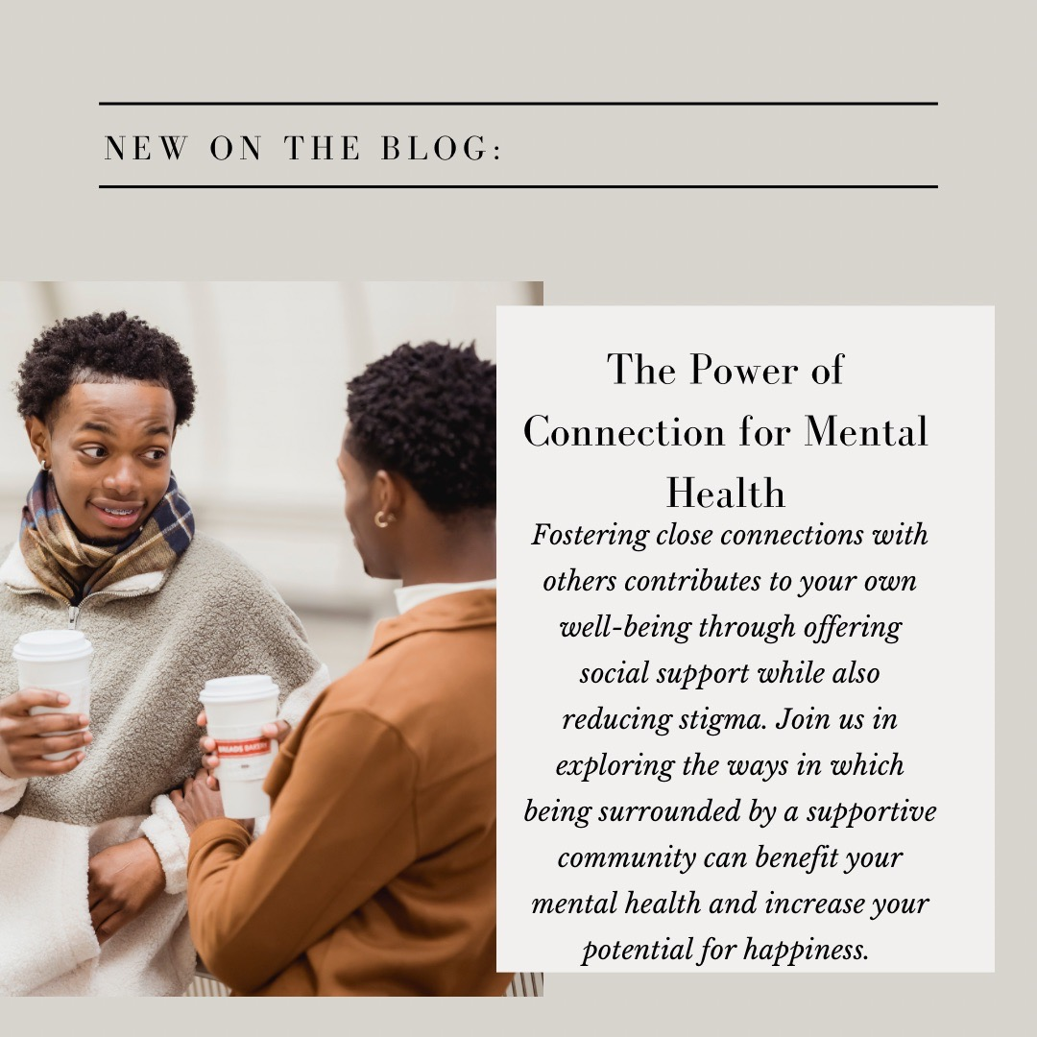

Caption: We all need a good community to take care of our mental health. When we have people who care for us, understand us, and make us feel welcome, we can feel happier and healthier. We can also help others feel the same way by being supportive, respectful, and inclusive.

