About Us

We are a team of developers (Mobile and WEB)and we have more than 5+ years of experience in Mobile development.
We are an Agile team that follows Agile estimation & planning, and Agile Development methodology.
Our value proposition is in delivering high quality solutions in our estimated budget and time-frame.
We promise only what we can deliver. We take pride that for expectations that cannot be met, we know how to say no to clients at the sales level, even if it means to lose business in the short term.

iOS Expertise-
1. Image Manipulation
2. In App Purchase
3. App Localization
4. Networking and service integration (AF Networking)
5. Storyboard
6. iOS All Feature.
7. iAdd and Add Mobs integration
8. Flury and Google Analytics integration
9. Social Media Integration with Auto Login Feature (Facebook, Twitter, LinkedIn, Google Plus, Instagram, Pinterest, Tumblr, Flickr)
10. User Voice
11. Core Data and SQLite
12. Mac OS data binding and Mac App Development
13.-Chat using Quick Blox.

Android Expertise-
- Facebook and Twitter Integration
- Google cloud messaging(GCM)
- Ads Integration
-Call and Message Tracking
- XMPP based chat application
- Scoring app for Golf and Cricket
- VOIP Implementation
- Inapp - purchase
- Social Mobile App Development
- Photo/Camera App Development
- Push Notification
- Video Streaming , Audio Streaming
- Android Development
- GPS Apps
- Near field communication(NFC)
- Barcode and QR Code Scanner
-IoT Based Application (MQTT, Zigbee, UART, I2C, Serial Communication).
-Bluetooth App/BLE Connection.
-WI-FI P2P.
-Chat using Quick Blox.
-Android TV

Portfolio-

VidLib mac-https://itunes.apple.com/in/app/vidlib-for-imovie-final-cut/id524355307?mt=12c

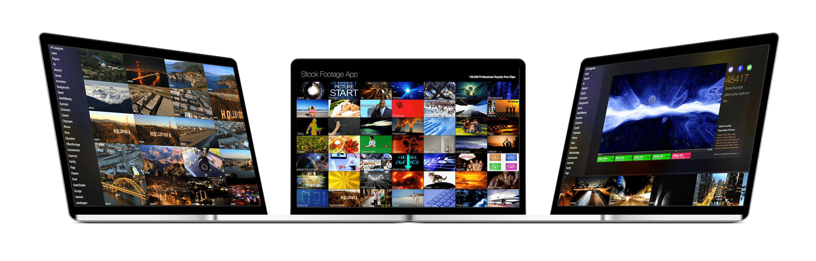

Jolly Biscut-https://itunes.apple.com/us/app/jolly-biscuit/id639070998?mt=8
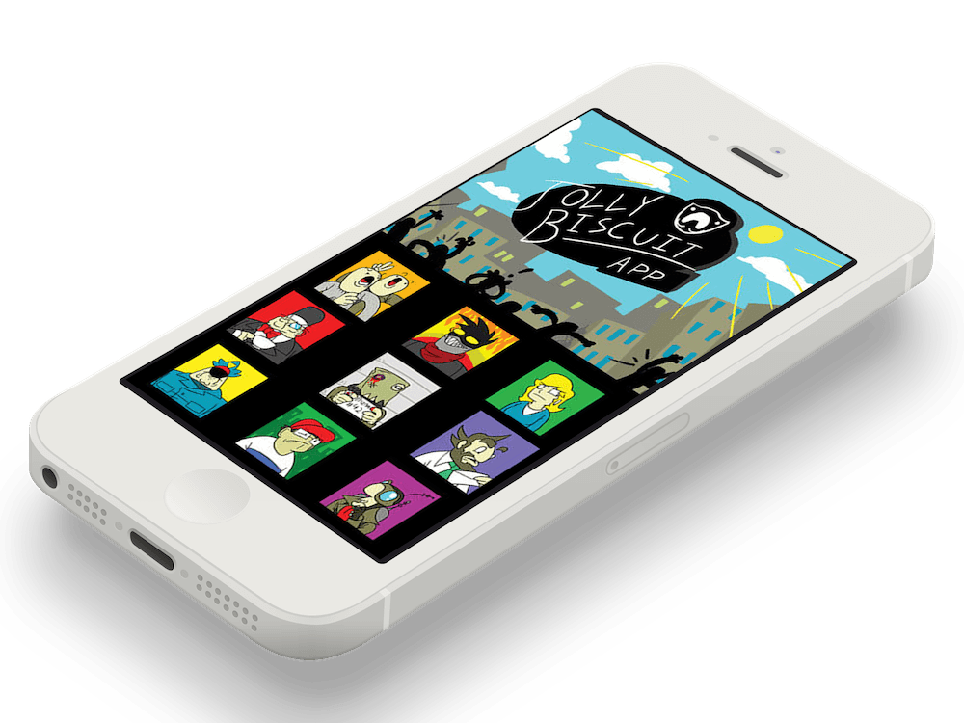

eWay-https://itunes.apple.com/au/app/eway-mobile-app/id585093974?mt=8

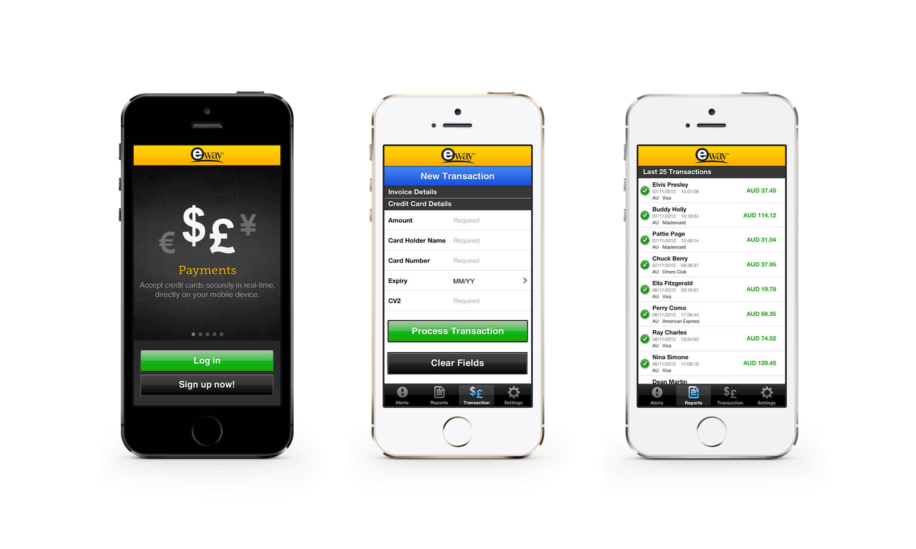

VidLibiOS- https://itunes.apple.com/us/app/vidlib-contributor/id524346654?mt=8

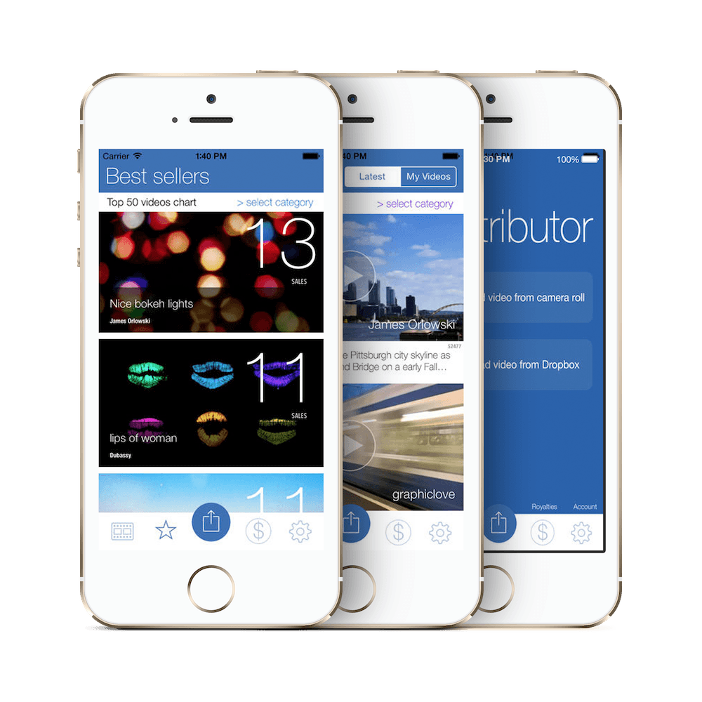

Kuawit Wedding- https://itunes.apple.com/kw/app/kuwait-wedding-rs-kwyty/id579269794?mt=8

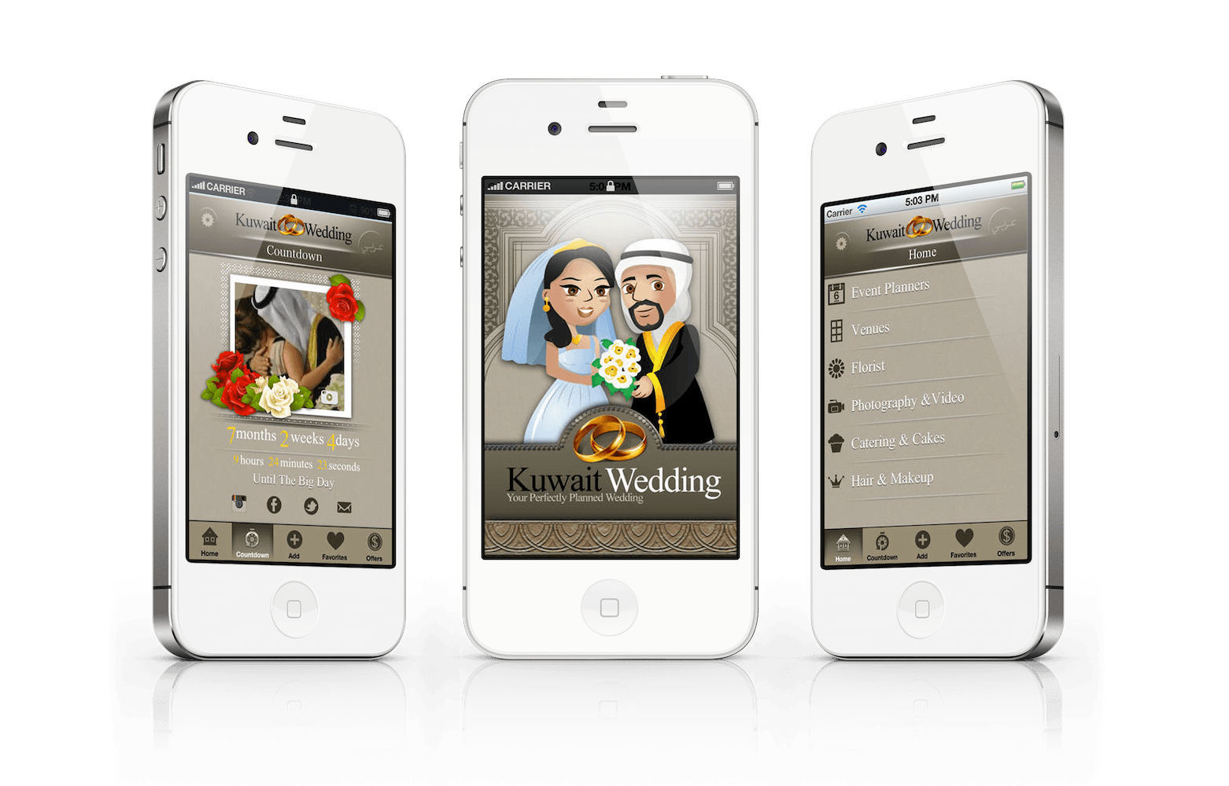

My Check Register- https://itunes.apple.com/in/app/my-check-register/id566812758?mt=8
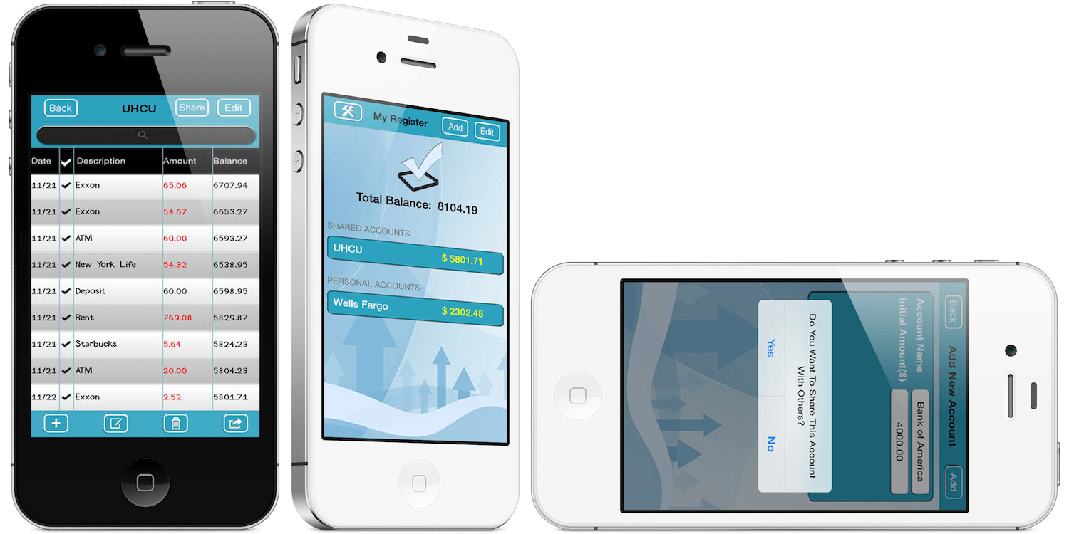

Goddess Tarot- https://itunes.apple.com/en/app/goddess-tarot-full-version/id323238904?mt=8
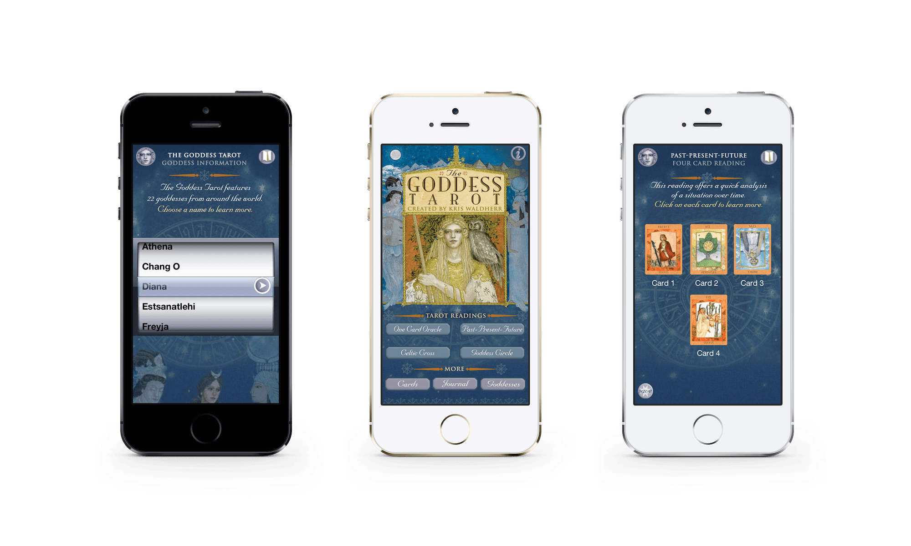

ModMeBooth-https://itunes.apple.com/us/app/modme-booth/id558448445?mt=8
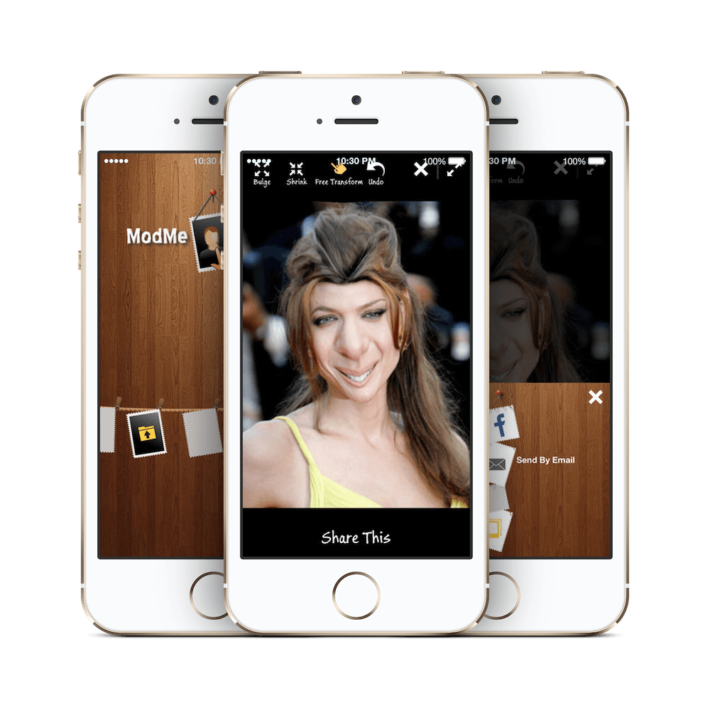

DisguiseMeBooth-https://itunes.apple.com/in/app/disguise-me!-picture-accessories/id544380452?mt=8

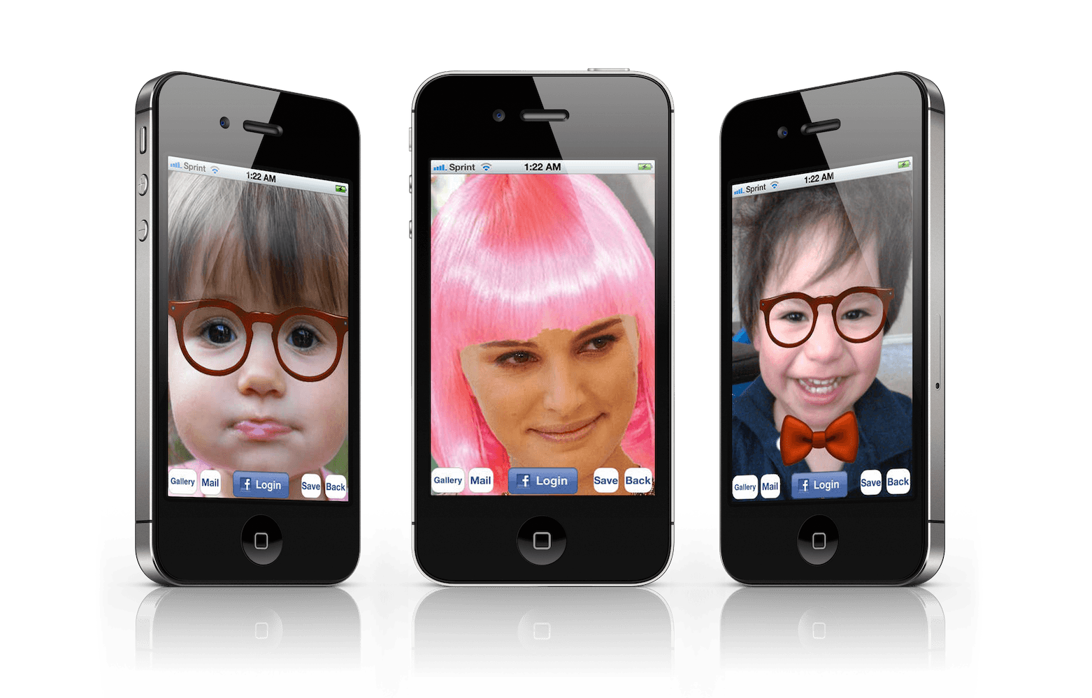

PortFolio
MySportsDiaryhttps://play.google.com/store/apps/details?id=com.approutes.mysportsdiary.view&hl=sv

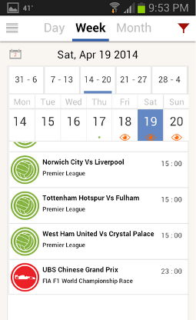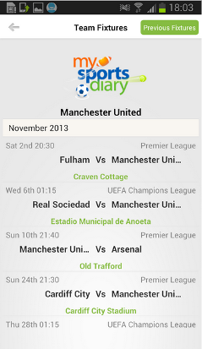
Amber Alert GPS-https://play.google.com/store/apps/details?id=com.tmd&hl=sv

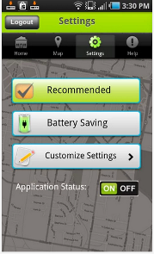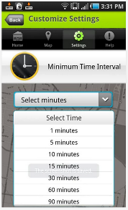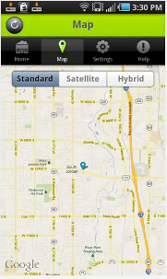

Fake Police Call-https://play.google.com/store/apps/details?id=com.approutes.fakecall&hl=sv

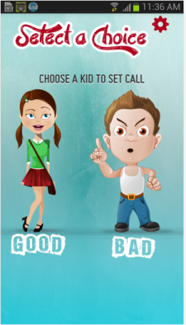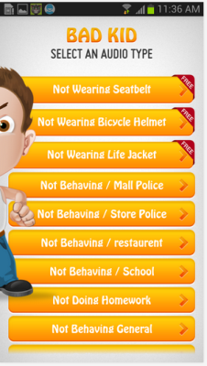

KonsumentSkydd-https://play.google.com/store/apps/details?id=com.callerapp&hl=sv

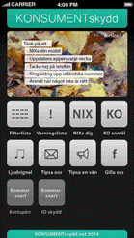

Baby Scale- https://play.google.com/store/apps/details?id=com.trignodev.babyscale&hl=sv

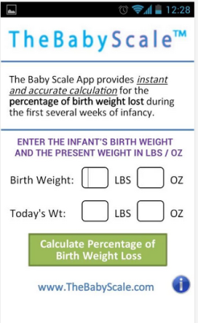

Kids Fever-https://play.google.com/store/apps/details?id=com.kidsfever_free

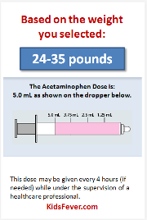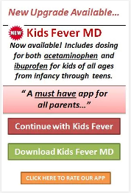

MySchoolNow :- https://play.google.com/store/apps/details?id=com.geeks.schoolmanagement

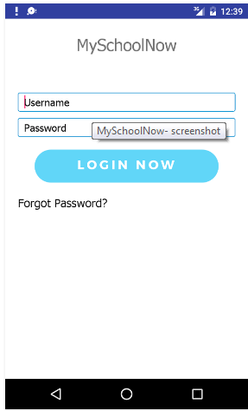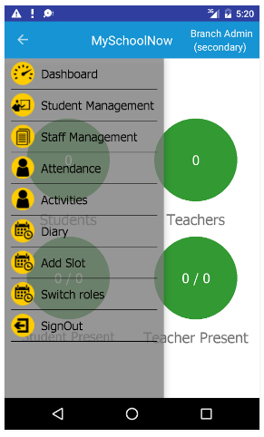

We've created lots of Android application based on IoT some are :-

Project Name: PUB/SUB MQTT
Description: This application implements a MQTT Broker as an Android.
MQTT is a publish-subscribe based light weight messaging protocol for use on top of the TCP/IP protocol. It is designed for connections with remote locations where a small code footprint is required and/or network bandwidth is limited. The broker is responsible for distributing messages to interested clients based on the topic of a message.

Project Name: Sarvochi
Description: It is an application used to control Low energy Bluetooth Bulbs (RGB or dimmable) turn on or off as a same time or change the color of that bulbs.

Project Name: USB Interfacing
Description: This application work over USB with Beagle Bone Black using the Android open accessory protocol

Project Name: Bluetooth Arduino Terminal
Description : By using this application you can connect Arduino with android smart phone over HC-05 or HC-06 and check the serial communication between them.

