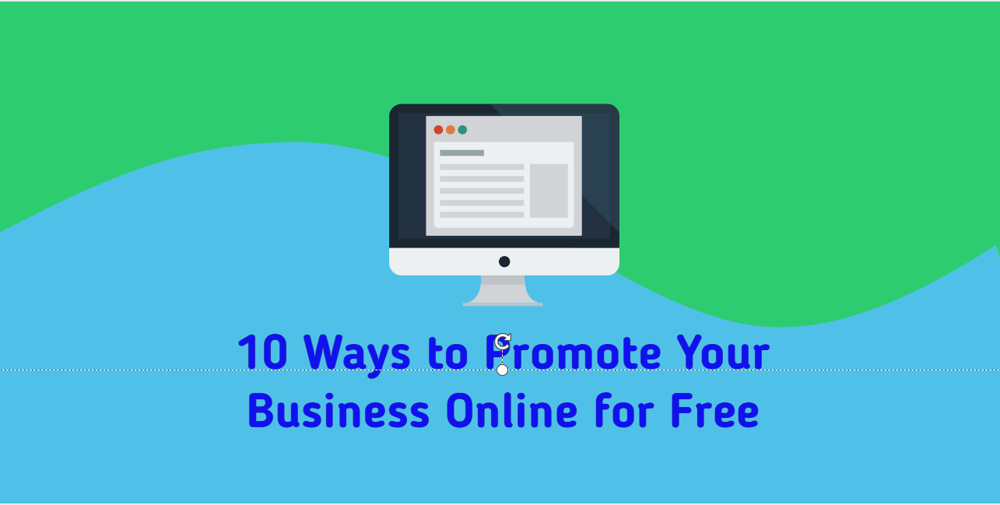

10 Ways To Promote Your Business Online For Free
August 18, 2019 By SURESH
Hello Friends, Today We Will Talk About How To Promote Off Business In Online Markets. If You Are Also A Businessman, Then You Should Read This Publication Until The End. You Can Market Your Business Without Spending Money With The Methods Mentioned In It.

All Business Owners Want To Deliver Their Products And Services To The Customer. There Are Many Ways To Do It So That Businesses Can Promote Themselves And Stand Before People. Those Who Have Very High Budgets Promote Their Businesses By Spending Money Easily. But Those Whose Budget Is Low, Cannot Resort To Advertising.

Everyone Will Know That To Advertise On Television, They Must Pay Rs Million For A Few Seconds. This Method Is Not For Ordinary People Like Us.
When Many People Start Their Business Online Or Offline, They Are Very Concerned About Promoting It. Always Find Free Ways To Promote Your Business Online.
Have A Business Offline / Online, You Can Promote Your Business Online. If You Have A Good Budget, You Can Do It Very Easily. If Your Budget Is Low, There Are Many Ways On The Internet Through Which You Can Inform People About Your Business.

In This Post, We Will Tell You About This. If You Have Also Started Your Business And Want To Market It For Free, You Can Follow The Methods Detailed Below.

1.Create Your Business Website
Table Of Contents
- 1.Create Your Business Website
- 2. Promote Your Business Online Through Google My Business Account
  - 3. Add Your Business Website To Search Engines
  - 4. Use Social And Promote Your Business Online
    - 5. List Your Products In Business Directories
    - 6. Give An Offer Discount And Coupon Code
    - 7.Press Releases
      - 8 Answer Questions
      - 9 Create Video And Promote Your Business Online
      - 10 Promote Your Online Business Through Email Marketing

Currently, A Website Is Very Important For All Online Or Offline Businesses. People Build Their Websites Even For Small And Small Businesses. Today, Many Stores Are Creating Websites And Selling Products Online.

Similarly, By Creating A Website For Your Business, You Can Also Sell Your Product And Service Worldwide. If You Wish, You Can Create Your Website On Blogger Or Weebly For Free. If You Have Money, I Suggest You Host A Blog Through WordPress.

With The Help Of Add-On, You Can Easily Create Your Online Store Or E-Commerce Website. In This, You Don’t Have To Hire Any Developer. You Can Bring Online Business By Creating A Free Blog On Blogger.

2. Promote Your Business Online Through Google My Business Account

Google Has Given A Very Good Option For The Entrepreneur, Through Which You Can Easily Promote Your Business Online. The Best Part Is That It Is Absolutely Free. This Benefits Both The Entrepreneur And The Customer.

Actually, When You Verify Your Business On Google My Business When You Search On Google, You Will Get Complete Information About Your Business. For Example, If You Have An Energy Store In Patna And Have Verified It On Google, Every Time Someone Searches On Google By Typing “Electrical Store In Bargarh”, There Is A Description Of Your Store, Address, Contact Details. , The Images Will Be Displayed.

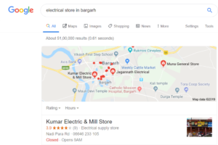My Business Account

This Will Benefit Both You And Your Client. You Will Find A Customer And A Customer Who Has Not Been To Your Store Before Will Know.
According To Search Engine Watch, 71% Of New Buyers Go To Google And Get Their Address And Contact Information. Today It Has Become Very Common.
If You Want To Promote Your Business Online For Free, I Think This Is A Better Option For You. So Far You Have Not Verified My Business On Google, You Can As Soon As Possible.

3. Add Your Business Website To Search Engines

When You Create A Website For Your Business, People Must Also Incorporate It. You Can Get Traffic To Your Website In Less Time Than Advertising. You Can Get Visitors To Your Website For Free Through Search Engine Optimization.

For This, You Must First Submit And Verify Your Blog On Popular Search Engines Such As Google, Yahoo, Bing. After This, Your Blog Will Start Appearing Gradually In The Search Engine.

4. Use Social And Promote Your Business Online

We All Know That Our Prime Minister Modi Took Advantage Of The Power Of Social Networks To Win The Elections Of Lok Sabha In 2019. New York Time Has Called Him A Social Media Politician. He Has Also Written A Case Study On Social Media Strategies.
You Can Also Benefit From This And Grow Your Business. You Must Have Seen Ads From Many Companies While Using Social Networks. Through This, Many People Have Improved Their Visibility.

Use Social And Promote Your Business Online

If You Wish, You Can Promote Your Business Online Here For Free. For This, You Must Create Popular Social Networks Such As LinkedIn, In Your Social Account Such As Facebook, Twitter, Google Plus. With This, You Cannot Sell Your Product Or Service Directly, But Through It, You Can Make Your Business Accessible To People.
When People Know Your Business, They Will Definitely Want To Try Your Product Or Service. But First, You Have To Spend A Little More Time And Build Your Brand. So People Can Easily Trust You.

5. List Your Products In Business Directories

This Method Is Also Very Good, By Which You Can Promote Your Business And Get Millions Of Viewers. At This Time, Many Customers Search The Internet Business Directory To Buy Something. If Your Business Is Listed, There Will Be A Show And The Customer Can Contact You.

You Can Store Your Business In Popular Directories Such As IndiaMart, Trade India And Indian Yellow Pages. The Free Plan Is Also Available Here.

If You Want To Sell Directly To Customers, Add Your Business To The Just Dial List. It Provides Mobile Applications And Can Be Used To Generate Great Traffic For You.

If You Sell Software, You Can Add It To The Software Suggestion. List According To These Different Categories Such As Human Resources, CRM, ERP, Etc.

6. Give An Offer Discount And Coupon Code

You Know Everyone Loves Offers. When You Buy An Item, You Are Waiting For The Offer To Get A Discount. Similarly, You Can Also Expand Your Business By Making Good Deals With Your Customers.

You Can Add Your Offer Coupon Code Or A Link On Popular Sites Like Groupon And Coupon Dunia. They Have Millions Of Users And With This, You Can Get Great Customers. You Will Also Have To Visit On Each Special Occasion.

7.Press Releases

If Your Business Is Something Of Journalistic Interest, You Can Include It In A Press Release. Many People In The Press Can Publish Their Business News. You Must Have Seen Many Corporate Websites, Where You Will Find The Press Release Page.

There Are Many Websites Where You Can Add Your Press Release For Free. You Can Add Press Releases To Popular Sites Such As Public Relations Records And Press Releases 24/7.

8 Answer Questions

When We Don’t Know Much About Anything And Want To Buy It, Search The Internet To Find Out And Post It On The Forum For Advice From People. Here Are Many Experts Who Give Us Good Advice.

Similarly, You Can Also Get Customers By Connecting To Popular Question And Answer Sites Such As Quora And Yahoo Answers And Helping People Who Participate In It. People Also Ask Their Questions In LinkedIn Groups.

How Would You Benefit? When You Connect To It, You Should Find The Question Related To Your Product Or Service. And You Also Have To Mention Your Product On It. As I Offer The Hosting Service, I Have To Look For Any Questions Related To It In Forums Such As “Best Cheap Unlimited Accommodation” And, In Response, Explain About Your Accommodation And Its Features.

9 Create Video And Promote Your Business Online

Youtube Is A Great Platform Where You Can Share Videos Related To Your Services, Products And Industry Experience. With This, You Can Spread Your Products And Services Easily Throughout The World.

You Can Know That On YouTube More Than 40 Million Videos Are Watched Every Day And Their Number Increases Day By Day. In Such A Situation, You Can Make A Video About Your Business And Upload It To YouTube. With This, People Will Get Good Knowledge About Your Product Or Service.

10 Promote Your Online Business Through Email Marketing

Email Marketing

If You Want To Promote Your Business Online For Free, You Can Take Advantage Of Email Marketing. If You Provide An Online Service, It Is Definitely A Very Good Option For You. It Can Also Be Used For Offline Businesses.

There Are Many Large Companies That Focus Too Much On Email Marketing. You Can Also Use It. For This, You Can Use Google-Feedburner. In Addition, You Can Send More Than 12,0000 Emails And More Than 2000 People Using The Free MailChimp Plan.

You Can Provide Information About Your Product Or Service To People By Email. You Can Say Your Specialty. You Can Also Share Offers With This. This Will Help Attract Customers.

In All These Ways, You Can Promote Your Business For Free. All These Methods Have To Be Creative And Followed. In The Methods Mentioned Above, You Will Get Very Fast Results In Some Methods, But Some Methods May Take Some Time.

I Hope You Enjoyed Reading This Post. If You Have Any Related Questions, Then Comment. Share This With Your Friends.

