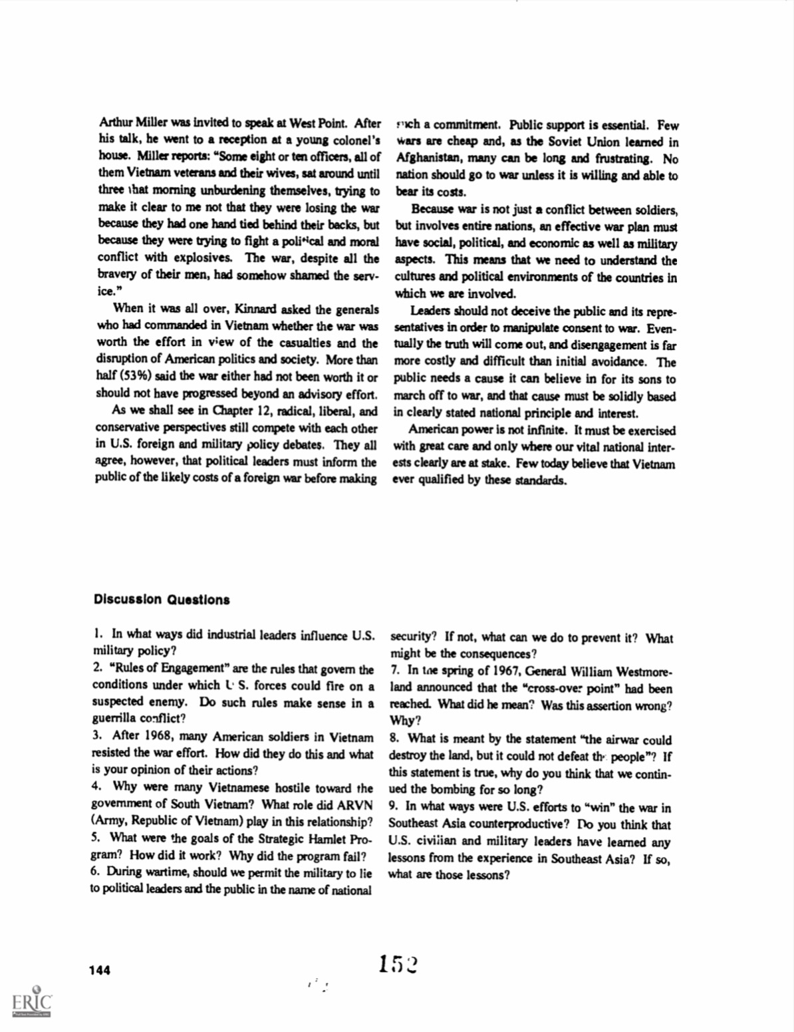Arthur Miller was invited to speak at West Point. After his talk, he went to a reception at a young colonel's house. Miller reports: "Some eight or ten officers, all of Vietnam veterans and their wives, sat around until nation should go to war unless it is willing and able to three that morning unburdening themselves, trying to bear its costs. trying make it clear to me not that they were losing the war because they had one hand tied behind their backs, but because they were trying to fight a political and moral with explosives. The war, despite all the bravery of their men, had somehow shamed the service."
When it was all over, Kinnard asked the generals who had commanded in Vietnam whether the war was worth the effort in view of the casualties and the disruption of American politics and society. More than half (53%) said the war either had not been worth it or should not have progressed beyond an advisory effort.
As we shall see in Chapter 12, radical, liberal, and conservative perspectives still compete with each other in U.S. foreign and military policy debates. They are all agree, however, that political leaders must inform the public of the likely costs of a foreign war before making
such a commitment. Public support is essential. Few wars are cheap and as a Soviet Union learned in Afghanistan, many can be long and frustrating. No nation should go to war unless it is willing and able to bear its cost.
Because war is not just a conflict between soldiers, but involves entire nation, an effective war plan must have social, political and economic as well as military aspects. This means we need to understand the cultures and political environment of the countries in which we are involved.
Leaders should not deceive the public and its representatives in order to manipulate and consent the war. Eventually the truth will come out, and disagreement is far more costly and difficult than initial avoidance. The public needs a cause it can believe in for its sons to march off to war, and that cause must be solidity based in clearly stated national principle and interest.
American power is not infinite. It must be exercised with great care and only where our vital national interests clearly at a stake. Few today believed that Vietnam ever qualified by these standards.
Discussion Questions
1. In what ways did industrial leaders influence U.S. military policy?
2. "Rules of Engagement" are the rules that govern the conditions under which l S. forces could fire on a suspected enemy. Do such rules make sense in a guerrilla conflict?
3. After 1968, many American soldiers in Vietnam resisted the war effort. How did they do this and what is your opinion of their actions?
4. Why were many Vietnamese hostile toward the government of South Vietnam? What role did ARVN (Army, Republic of Vietnam) play in this relationship?
5. What were the goals of the Strategic Hamlet Pro- gram? How did it work? Why did the program fail?
6. During wartime, should we permit the military to lie to political leaders and the public in the name of national security? If not, what can we do to prevent it? What might be the consequences?
7. In the spring of 1967, General William Westmoreland announced that the "cross-over point" had been reached. What did he mean? Was this assertion wrong? Why?
8. What is meant by the statement "the airwar could destroy the land, but it could not defeat the people"? If this statement is true, why do you think that we continued the bombing for so long?
9. In what ways were U.S. efforts to "win" the war in Southeast Asia counterproductive? Do you think that U.S. civilian and military leaders have learned any lessons from the experience in Southeast Asia? If so, what are those lessons?
152
144
ERIC

