CHAPTER 1
Data Collection
The data can be collected by four basic methods in order to evaluate the satisfaction of consumers. These are the following basic data collection strategies
- Observation
- Questionnaire
- Interviews
- Focus group discussions
As compared to the rest, the best mode of data collection which we will be going to utilize in our business is a questionnaire, because the primary purpose of this method is to facilitate the data extraction from the respondents. The questionnaire allows the consistent recording of the responses as well as it facilitates the analysis of data. Questionnaires are cheaper to use and will help us to collect the responses in short-time. They are easier to analyses for a company and quicker to administer the task.
Primary Data:
The growth patterns of the catering activities of our company will be studied thoroughly in comparison to the other catering services. The assessment of consumer satisfaction with our catering company will be required to fulfil this objective. A list of catering undertaking will be utilized for this study and will be likely to collect from the food authority nearby offices. This data will help out in comparison and will also provide the authorized framework of the catering establishments. In order to justify the remaining objectives, a self-administered questionnaire will be used.
Questionnaire Design:
A questionnaire will be designed with the support of reviews and also will be studied by different authors specifically after referring the experts from the various industries and institutions. The questionnaire will be likely to comprise of three parts.
Part A) Collection of demographic profiles of the consumers.
Part B) Record of consumer’s satisfaction (based upon the 5 points Likert scale)
- 5 will be representing the extremely satisfied remarks
- 4 will be representing the very satisfied remarks
- 3 will be referred to as Neutral
- 2 will be representing the slightly satisfied remarks
- 1 will be representing the not satisfied remarks
The scale will be like this:
Indicate your opinion about the following statements using the scale below:
How satisfied were you with our food at Eastern Heroes?
1= Not Satisfied
2= Slightly Satisfied
3= Neutral
4= Very Satisfied
5= Extremely satisfied

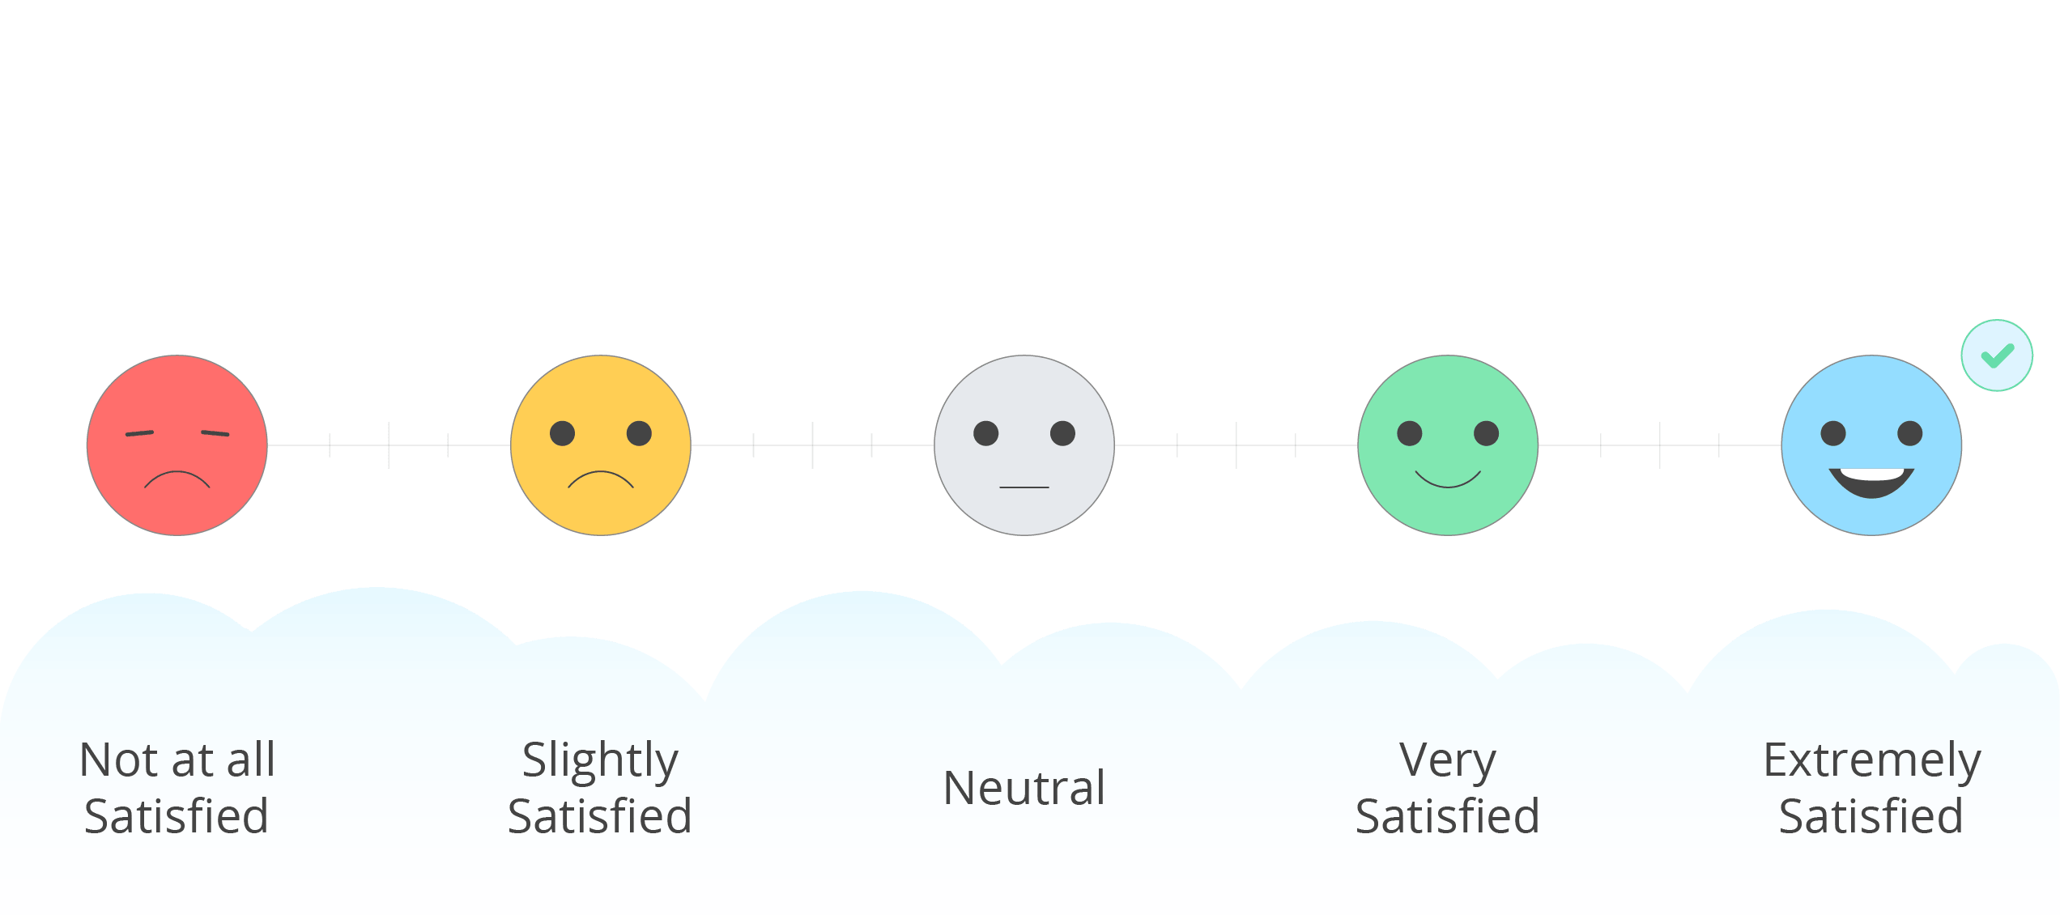
Part C) It will designed to register the perception of consumers regarding ambience, on which the response of the consumers will be recorded. A five-point Linkert scale will also be used for this purpose in which
- 5 will be rated as very good
- 4 will be rated as good
- 3 will be rated as average
- 2 will be rated as bad
- 1 will be rated as very bad
The scale will be like this:
How was our ambience while providing you with the services at Eastern Heroes?
1 | 2 | 3 | 4 | 5
Very Bad | Bad | Average | Good | Very good

Secondary Data:
As this study will be empirical in its nature, therefore, primary data will be mainly utilised for its completion. Though secondary data will also be used and likely to gather from the detailed review of literature, and the other pieces of information published from time to time in newspapers, books, research paper as well as from the printed materials about the sampled catering activities. The review of available literature will be helpful for our business in developing the new ideas, moreover, the formulation of the context will likely to be done effectively

Data Analysis
The collected data from the questionnaires will be analyzed by employing the Statistical Package of Social Sciences, SPSS (11.5 version). These are the following statistical tools which will be utilized in our business to analyze the results obtained from the study.
- Factor analysis with the varimax rotation in SPSS will be utilized. The factor analysis is important in businesses because it can categorize those important factors which influence satisfaction and perception of consumers in our various catering activities.
Note: Barlett’s test of sphericity and KMO will be applied before determining the data for factor analysis
- KMO and Barlett’s sphericity will provide the confirmation that either correlation exists among the different variables or not.
- KMO and Barlett’s sphericity will check that data is appropriate for applying the factor analysis or not
- Standard deviation (descriptive statistics) will be utilized to determine the gaps regarding the service quality among the satisfaction and perception of our consumers.
- The t-test will be utilized to determine the significance of the gap between satisfaction and perception.
- One way ANOVA will also be utilized to test the hypothesis
- One way ANOVA will also be utilized to compare the satisfaction of our respondents and the perceived performance of the catering activities.
CHAPTER 2
Marketing Plan
Situational Analysis
Eastern Heroes is a catering company by Kwoklyn Wan, which offers be-spoken menus for every single customer. Eastern heroes offer a meal of high quality. Their list of services include:
- corporate Catering
- Event Catering
- Venue Hire
- Private Dining
- Private Parties
- Bubble Tea Workshops
- Stag/Hen Parties
- Birthdays
- Weddings
- Street Food

Eastern heroes contain the fully-furnished bar. Their products have received a strong response from the customers. Marketing will be one of the most critical steps to developing a significant demand for products.

Market Summary
Kwoklyn Wan has apprehended good information about the market and he knows a great deal about the common qualities of the target customers. Kwoklyn utilises this information in order to understand the need for customers who are served.
Social Media Marketing
Marketing through social media enables the business to get blooming. Kwoklyn Wan’s business has been getting a remarkable response from the clients due to social media marketing. Their website http://easternheroes.co.uk.
Facebook: https://web.facebook.com/EasternHeroesCatering?_rdc=1&_rdr
Twitter: https://twitter.com/EasternHeroes contributes to getting them into a business. Social media platforms help him to connect with the customers and consumers, it boost the sale and lead of the company. Social media marketing is growing so rapidly because this platform is being used by more than three billion people every month around the globe.

.media marketing benefits businesses by creating brand awareness.

