Unveiling the Shadows: A Comprehensive Q&A on Mossad’s Intelligence, Covert Operations, and Counter-Terrorism Strategies
Mossad is tasked with intelligence gathering, executing clandestine operations, and combating terrorism. The director reports exclusively to the Prime Minister.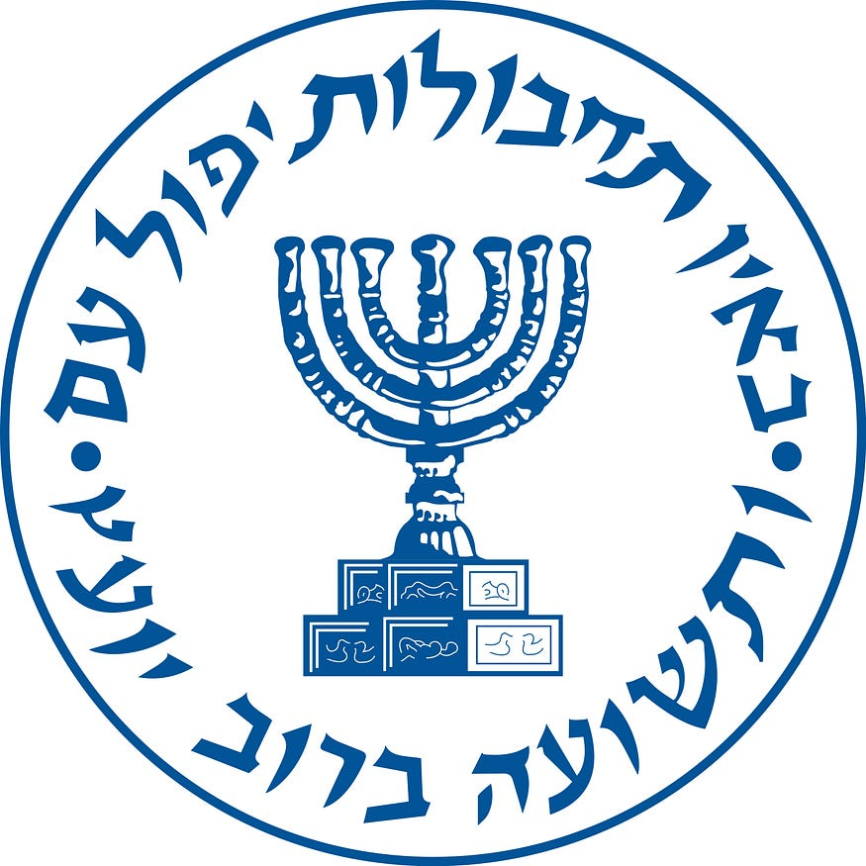

What are the missions of the Mossad?
Mossad, (Hebrew: “Central Institute for Intelligence and Special Operations”), one of the three major intelligence organizations of Israel, along with Aman (military intelligence) and Shin Bet (internal security). The Mossad is concerned with foreign intelligence gathering, intelligence analysis, and covert operations.
How strong is Mossad?
With an annual budget of about $3bn and 7,000 staff, Mossad is the second-largest espionage agency in the Western world after the CIA. That makes the person chosen to be the head of Mossad very powerful. David ‘Dadi’ Barnea took over from Yossi Cohen in June 2021.
What is Mossad motto?
By Way of Deception Thou Shalt Do War: Motto of Israeli Intelligence Service MOSSAD.
What is the story of Mossad?
Mossad’s general focus is broad foreign intelligence and counterterrorism operations. Initially, from 1949–1951, it was overseen by Israel’s foreign ministry. Since 1951, however, it has responded directly to Israel’s prime minister. Mossad is sometimes compared with the CIA (Central Intelligence Agency) in the US.
What is better CIA or Mossad?
TLDR The CIA is the most powerful intelligence agency in the world, with the capability, wealth, and modern technology to be the most sought-after partner, while Mossad goes to any lengths to protect Israelis and France’s DGSE is the biggest threat to US security.
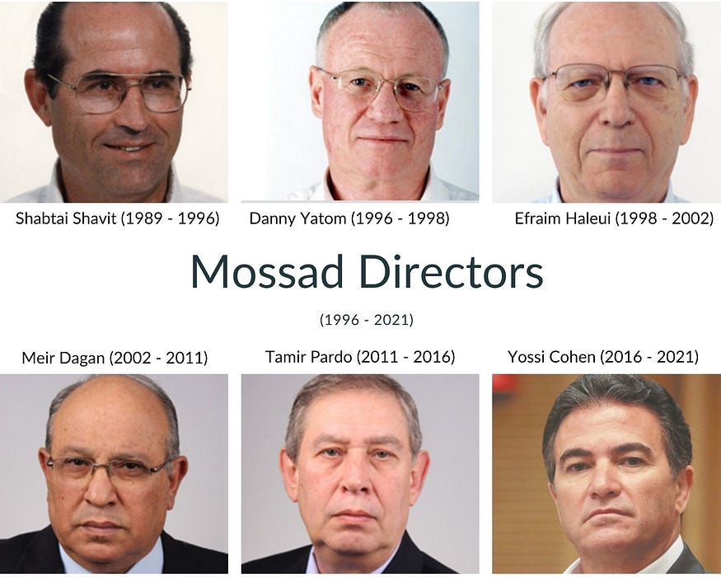
What are the Mossad’s greatest achievements?
Here are the thrilling stories of daring top secret missions, including the capture of Adolf Eichmann, the eradication of Black September, the destruction of the Syrian nuclear facility, and the elimination of key Iranian nuclear scientists.
Who is the boss of Mossad?
David “Dadi” Barnea (Hebrew: דוד (דדי) ברנע; born 29 March 1965) is the current Director of the Mossad, having taken over from Yossi Cohen in June 2021.
Can I join Mossad?
Seriously speaking, basically anyone can join the Mossad… who can pass security checks (and your spouse can do so as well) and has the skills/temperament/aptitude/position that is of use to Mossad .

What is Mossad short for?
In Hebrew, Mossad means “the Institute,” but the name is short for Mossad Merkazi le-Modiin ule-Tafkidim Meyuhadim, which means, “Central Institute for Intelligence and Special Operations.” Comprised of 10 separate departments, the Mossad as it exists today was formed via a directive during the leadership of Prime
What is the special unit of Mossad?
Mossad — Israel’s covert intelligence and special operations agency abroad. Kidon — a department within Mossad that is allegedly responsible for selective high-profile assassination.
What Mossad best quotes?
The dirtiest actions should be carried out by the most honest men. Without stratagems would a people fall, and deliverance is in a wise counsel. To protect civilians, the state needs sometimes to do things that are contrary to democratic behavior.
Which movie is based on Mossad?
The Debt (2010)- based on two Mossad operations‍
The Debt is loosely based on the hunt for Eichmann and another Nazi war criminal, Josef Mengele, a physician and Nazi SS officer who performed deadly experiments on prisoners at the Auschwitz II (Birkenau) concentration camp.

