The 10 best apps to trace phone numbers
How to locate the caller?
To receive calls at the very odd timings sometimes at different hour of the day and sometimes at night is very irritating. Those never finishing calls infuriate the person and in the end there is none other choice than tracking the phone number of the scammer to report them. To irritate the receiver more, callers don’t even tell about the location of their whereabouts and their names. The very pre-eminent solution for solving this matter is to simply use the mobile number trackers. These apps to trace phone number have the made the lives very easier and uncomplicated for the receivers in order to identify the true identity of the caller and report them. Tracing phone numbers not only helps us find the scammer but it also helps parents to locate their children location and find them. Due to this call scamming, many companies have introduced the different types of phone number trackers Apps, in which the user simply has to input the number and can easily locate the target’s number. These Apps are mainly free for Android and IOS users but some are paid, so try searching an authentic App to facilitate yourself. Below are the Apps to trace phone numbers of the best phone number trackers which you should use or recommend others, that are:
- Mobile number locator:
It is considered Android aligned free phone number tracker App which trace mobile number exact location on map and provides you unrivalled pliability when you are tracking a target’s number form this App.
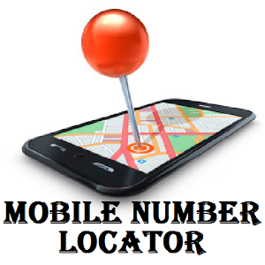

Features:

- This App occurs with a completely practical Google map in 3D.
- Every code which is used around the world is present in this App.
- This App is made in such a way that it tells you the identity of the person calling you before even attending the call.
- This App traces mobile number exact location on map.
Pros:
- Without having an internet connection, you can easily use this App, and it’ll function properly.
- Calls and messages can even be sent through this App, so you don’t have to use pre-inducted messages and calling platform with the Android.
- With this App, you can even check your call logs where the calls will appear with the caller name and the area caller is calling from
Cons:
- This App service is only available in the countries like USA, Canada, Pakistan and India.
- This App cannot the trace the number which is mobile ported.

- Mobile Number Tracker:
User can easily locate the number which is from their locality through this mobile number tracker App.

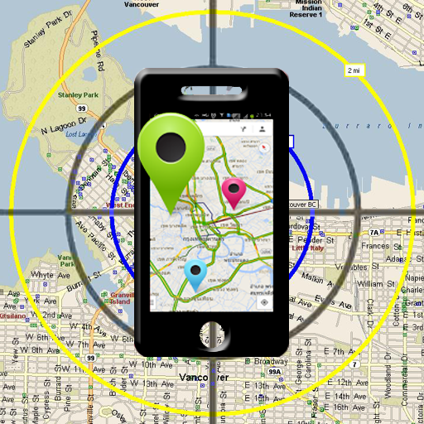
Features:
- Through this App, target’s mobile number can easily be tracked by doing two simple steps.
- It assists State, CDMA providers of mobile and GSM.
- This mobile number tracker App comes with a pre-install GPS to track the targets number.
Pros:
- You can track any number easily nevertheless whoever the network provider is.
- This App takes only two basic steps to recover the number.
- The usage of this App is free without and charges
Cons:
- This App to trace phone numbers only works in India.
- According to reviews of the people, complains about their offering service has been recorded.
- User needs an internet connection to use this App.

- Caller ID and Number locator:
If any of the users is checking for the most workable and reliable phone number tracking for free, you don’t have look anywhere else as you have caller ID and number locator. This is a Free Spy App for Android without target Phone. This App provides you with a conjunction of caller location and identity of the caller.

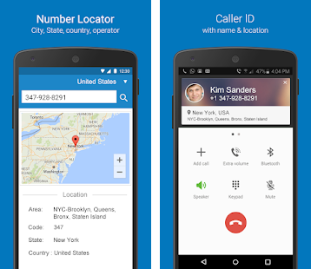
Features:
- This App of caller ID and number locator have added 12,982 cities database in their system.
- This App allows checking the name and location of the caller calling you before answering.
- It also has a call blocking feature installed in it.
Pros:
- This App doesn’t need any internet connection to be used.
- Caller ID and number locator allows you to locate the caller and his/her identity.
- This App allows searching any number from the list of countries around 200.
- Any scammer can be blocked through this App.
- Pre-installed map which helps you in finding the exact location of the caller.
Cons:
- User having android version below than 4.0 cannot use the facility of this App.

- True caller Phone Tracer:
It has been known to everyone that true caller has been the most popular App used by all over the world for tracing the phone numbers.
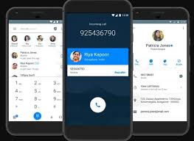
Features:
- This App facilitates you with the blocking service of numbers that are not needed, annoying and disturbing.
- It allows you to see the photo and name of the caller that is calling you.
- They have a strong database which can trace any unknown number around the globe.
Pros:
- This App to trace phone numbers doesn’t allow your personal contacts to appear online like any other Apps.
- If your number is searched by any unknown person, you will get to know with this App.
- Calls can directly be made via the App.
- Their locating and tracking services are the best as they have around 200 million users.
Cons:
- You cannot register yourself without entering your phone number.
- An internet connection is needed to use this App.

- Trace Mobile Number:
This App can only be used by the Android users. These Apps can track your Childs Phone without Them Knowing and Trace mobile number App can also track the very live location of the target. Many different service providers network are accessible inside this App. Only Android devices which have an Android version above than the 4.0 can avail this App.
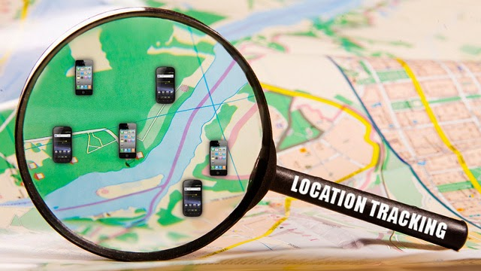
Features:
- This App gives you the very exact and accurate location of the target.
- Trace mobile number App can be used for tracing mobile numbers even without having an internet connection.
- The App’s developer provides you with the very strong database and also adds new features and functions after sometime.

Pros:
- In every outgoing and incoming call, you can also see the name of the network providing of which the target is using network of.
- You don’t want to have computer skills or knowledge for using trace mobile number App.

Cons:
- This App is only limited inside India and some other neighboring regions.
- Many Advertisements appear while using this App.

- Number Locator:
This App is an iPhone based type of an App which was made by the Elegant Recursion Inc. By just entering the number of the target and clicking on the search button, you can track the caller’s location.

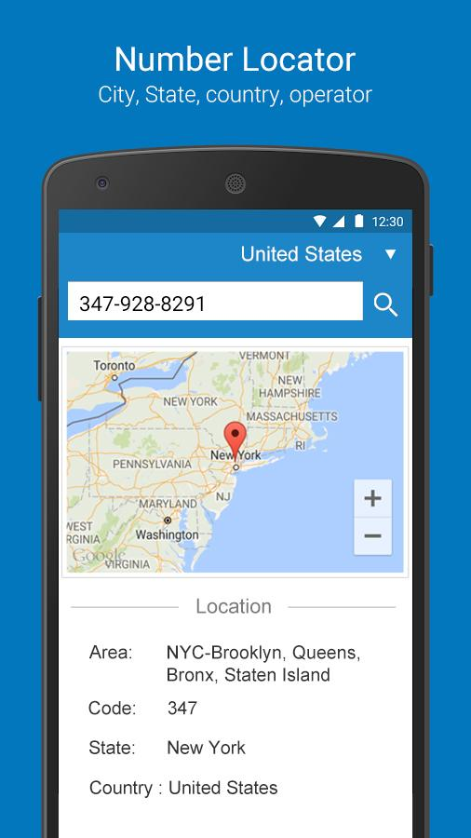

Features:
- This number locator App works perfectly fine whether its offline or online.
- They have given attractive and stunning graphic design which looks soothing to the eyes.
- This App has stored all the codes of the area.
- Number locator has a tab of auto-updating.
Pros:
- This App to trace phone numbers allows you to use swiping signals.
- You can use this App on iPhone, iPod and ipad or to track an iphone by number online free
- This App has installed many soothing graphics which makes the experience of tracking more entertaining.
- This App search results of the target you are searching for in just seconds.
- Number locator doesn’t need an active internet connection for searching the number.
Cons:
- If you want to avail extra features of this App, you will have to pay a small amount of $0.99.
- Frequently using this App can stall the using of this number locator App.

- Mobile Number Tracker Pro:
If you have ever used App like how to track an iPhone by phone number then this mobile App is the best which provides you with unrivalled options of tracking to ensure that you can easily locate the owner of the number.
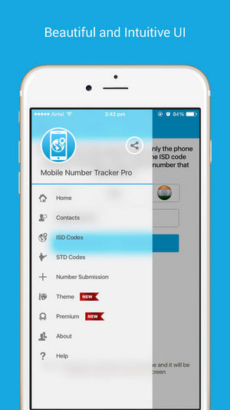
Features:
- This Mobile number tracker Pro has a very strong database which encloses around countries numbering to 200 all over the world.
- They have a very wide range of user interface that the user can choose from easily.
- They own a notification center which tells you if the number you are locating has been located or not.
Pros:
- This App allows you to track numbers from all over the world.
- Mobile number tracker pro has a very interactive user interface which makes it very easy for the user to use and choose from.
- This App allows you to make calls and send messages directly through the App instead of using mobile’s pre-installed features.
- This App also allows changing the theme of your choice by choosing from the variety of themes installed inside the App.

Cons:
- It has been reported that sometimes this App makes an error while locating the exact location of the target.
- To use this App of Mobile number Tracker Pro, an active internet connection is needed.

- True Caller Phone Number Tracker:
As everybody knows about the popularity and fame of true caller which makes them the most perfect App for the iPhone users to track an iphone by number online free.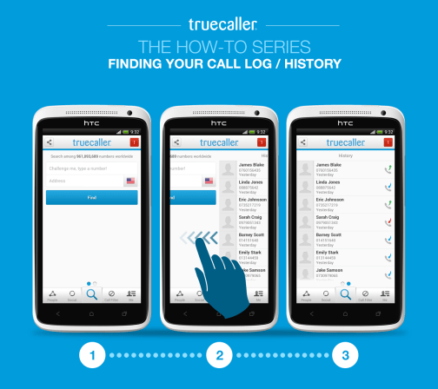
Features:
- This App to trace phone numbers assists the actions of 3D touch
- This True caller phone number tracker has an updated list of scammers which gets automatically updated.
- This App bug searching feature attached with a fixed clipboard.
Pros:
- Before even picking and answering the call, the name and location of the caller will be in front of you in order to know who is calling.
- The actions of 3D touch allow you select different types of actions from the App.
- Call history of all the calls made can be removed with just one tap.
Cons:
- IOS 8 or above is needed to use this App.
- An active internet connection is also needed in order to use this App and get yourself facilitated

- Mobile Number Tracker Location:
This App is an authentic and reliable for the tracking phone numbers of the scammer but it can only be used by IOS devices to track an iphone by number online free. It can easily be downloaded from the App store, free of cost. And it tracks the live location of the calling number.
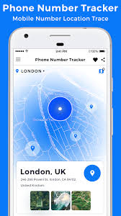
Features:
- People living in these countries like Asia, Canada, Europe and USA can easily use this App and enters into the actual time location of the mobile device of the target without anyone noticing.
- This App provides fully clear and accurate information regarding the target’s location.
Pros:
- Mobile number tracker location has the databases which have details of the customer of +200 countries such as United Kingdom, China, Pakistan and etc.
- Tracking of the device via this App can be done very easily by 3D Google maps.
Cons:
- According to the people comments and reviews, this App sometime shows the incorrect information about the location of the target.

- Mobile Number Tracker Pro-SIM:
It is the one of the most wanted by the users mobile tracking App, which traces mobile number exact location on map and was made by the person named Aditya Neelkanth. With this App, you can easily check the location of your kids, spouse and family.
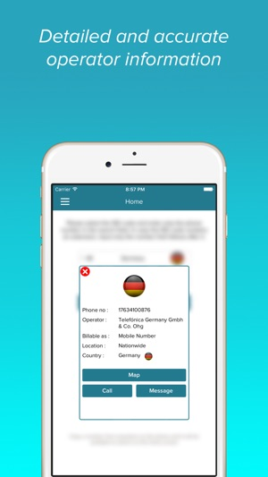
Features:
- This App to trace phone numbers is available in the different parts of the world ranging from Asian countries to the United States.
- This App has the most unique features, as it can help locating your kids and family.
- IOS users can easily download this App from the Apple App store for free and without any charge.

Pros:
- This App doesn’t require any extra services for using this App.
- Mobile number tracker pro-sim is very fast in accessing the details of the targeted devices.
Cons:
- This App requires an internet connect, 3G or LTE connection to use its services.

Why people install these Apps?
These apps to trace phone numbers are installed by the people in order to get rid of the scammers and spammers who have annoying habit of calling from different countries. They don’t even tell their location and named if asked for, there have been many frauds which have happened due to this calling process.
Why trust these Apps?
These Apps to trace phone numbers do take your personal information in order to get registered and start, but they are the good people of society who have gone through the same issue and want to finish it. They take your personal information in order to check fake and people that have doing fraud.
These above mentioned apps to trace phone numbers are the best Apps you will ever come across, so if you are having problem with the calls, then try these Apps, it will help you in picking out the culprit, and to have a check and balance on your family for their security purpose.

