The 10 best remote cell phone spy software without target phone
Why these remote cell phone spy software without target phone are used?
There have been lots of options available in the market; hence it is not easy to choose from them. While using these spy software, you can easily track and spy on your phone in order to ensure your mobile phone is safe from the robbers. There are many free spy apps for android without target phone and free spy app for android undetectable in which you don’t have to pay anything and you easily avail their services. These remote cell phone spy software without target phone have their customer service available for 24/7. Users can rely on their services to help them out in their registration process.
These free spy apps for android without target phone and free spy app for android undetectable helps you out in your daily life routine. To put a check and balance of your kids mobile’s browsing history, their call logs, their emails, Skype, Viber, Whatsapp messenger and many more. In order to locate the scammer or the target’s phone there are many best free hidden spy apps for android and IOS which will help you out. You can also track your cars using these apps if you have a tracker installed in your car. This software can be best fit for you.

Their features are the most efficient and effective in order to spy on your mobile phones. This software includes monitoring your chats and calls, which also gives you the access of unlimited multimedia massages and chats on messenger. That software which is free spy apps for android without target phone and free spy app for android undetectable provides you a free charged service so that you don’t have to worry about the fees and charges. There are many best free hidden spy apps for android in the market which gives you the best of their services are described as below:
- XNSPY:
This spy software is not free but has an affordable price for their users. It is not for the use of the children but instead it is used for your staff working inside the company.
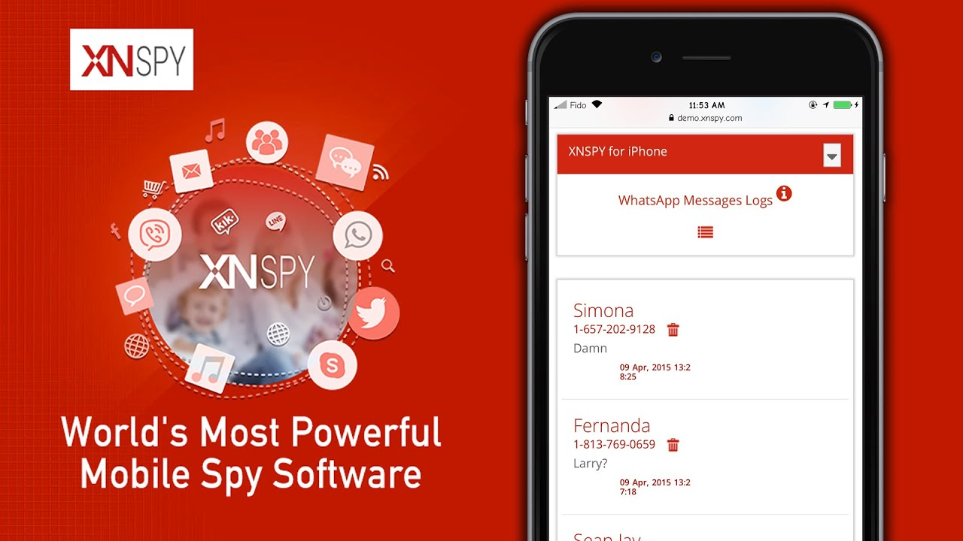

Features:
- It provides you with a facility of monitoring all of your messages, phone calls, multimedia messages, all of the messenger chats, email browsing, tracking via GPS location and etc.
- The developers working at the back end of this software keeps making changes for their users.
- It compatibility is for both, IOS and Android.
Pros:
- It has around 30+ features to help you in tracking and spying your mobile phone.
- Android and IOS both are compatible with it.
- They provide you with a demo test version to understand every feature and can easily use the software.
- It also has a feature of offline tracking service in which you don’t need an internet connection or a Wi-Fi.

Cons:
- You can track or spy only one phone at a single license.
- This XNSPY spy software doesn’t provide you to monitor your phone via PC or computer.
- Only mobiles and tablets can use this software.
- They charge $12.49 for their services rendered.

- TrackMyFone:
This spy software is considered as the second number spy software for its best features and service. While using this software, you can track your children in order to ensure their safety and protection.

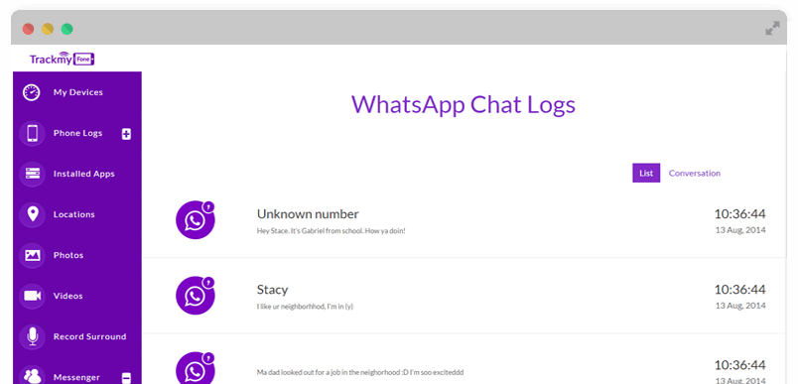
Features:
- Monitoring of SMS, calls, browsing history, IMs alerts, GPS location, phone books and emails.
- It is mainly used for monitoring children.
- They have very user-friendly customer service with availability to 24/7.

Pros:
- This software is compatible with the Android and IOS both.
- In order to use this software, you don’t have to jail break your iPhone.
- This software is known as the solution for 3 in only 1, as it helps you monitor your kids, family and employees.
Cons:
- They don’t have the best features for IOS users.
- Rooting of phone is required to use Apps like IM chat.

- Cocospy:
This software is known as best free hidden spy apps for android and IOS. You just have to create an account and enter your ID to login. Nobody will even notice you spying on the phone.
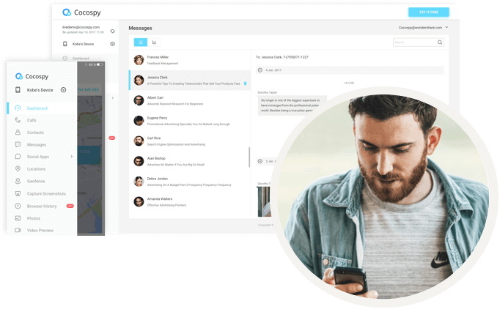

Features:
- It provides you with facility of observing chats, phone calls, contact, messenger chat and many more.
- They facilitate you with 24/7 customer service availability.
- This is the free spy apps for android without target phone.
Pros:
- You don’t have to pay anything for it.
- Compatible with both, the devices android and iPhone.
- All chats that are being conveyed online by the targeted phone will be in your records.
- It is the free spy apps for android without target phone and IOS without the target phone.
Cons:
- Their software works very slowly for the tracking or spying of the mobile phone.
- Their customer service provides you the confidence in using their software but not the exact solution.

- Spyzie:
If you are in dilemma and wanted to snoop up on someone so this software is the best software for you. They have been in the market for a very long time, and slowly and gradually they are upgrading themselves to come up in top position.
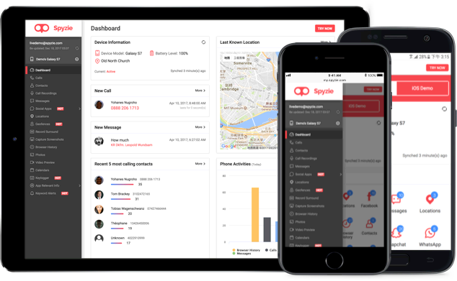

Features:
- Geo-fencing facility, GPS location, monitoring of chats, calls, IMs and etc.
- Compatible with both of the devices of android and IOS.
- Screenshots capturing and preview for the videos facility is also available.
Pros:
- Employees and kids can be monitored from the remote area.
- Very friendly user interface for the users that can be easily be used.
- Rooting or jail breaking is not needed.
Cons:
- Their features don’t work on all types of phones, as iPhone users cannot use their feature of tracking location.
- Deletion from the targeted phone of their calls or SMS cannot be retrieved by the Spyzie software.
- Their service charges are $49.99 per month.

- MobiStealth:
They have all kinds of different packages available like from basic to advance. It remote cell phone spy software without target phone and helps you in tracking the target.
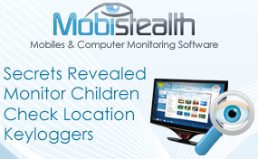

Features:
- Viewing and monitoring of pictures, browsing history, emails, calls, instant messenger chats, IMs, call recording, tracking locations, Gmail logging and etc.
- It is compatible with many devices like Mac, Android, PC and IOS.
Pros:
- Their prices are considered good for the services and features they are providing.
- They provide their users with advanced facilities of Messenger, facebook and how to spy on whatsapp messages without target phone which are mainly supported by the android devices.
- It also supports the monitoring form the smart phone and desktop.
Cons:
- Alert features for the keywords are not available.
- Downloading and installation of this software sometimes doesn’t work properly.
- Blocking of contact and websites support is not available.

- iSpyoo:
This software protects your children from all those hazards lingering around in the world of online. It helps you monitor your employees and make their reports.
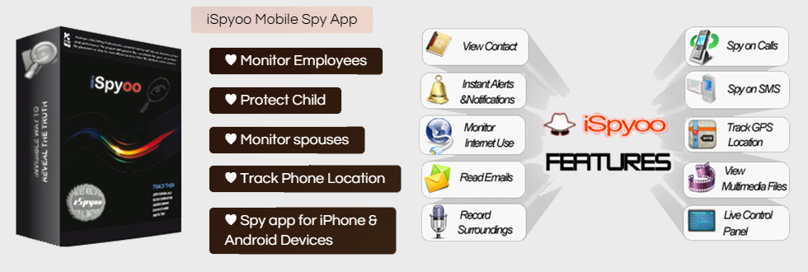
Features:
- Allows you to monitor the calls, Skype, Viber, SMS, call recordings and etc.
- They also provide their users with a free trial version to check their features and services.
Pros:
- User can easily monitor 3 devices from this software of iSpyoo at a single time.
- They provide you with 48 hours of free trial version.
- Your calls on Skype or Viber can be monitored easily via this software.
Cons:
- They provide a fully limited assistance for the compatible devices.
- You have to jail break your iPhone for using this software.
- Rooting of device is necessary to use their features available in premium or gold membership.
- The basic charge for their services is $19.99 monthly.

- StealthGenie:
It provides you the solution for how to spy on whatsapp messages without target phone. It has a facility of monitoring the activities on the phones like Black berry, IOS and android.
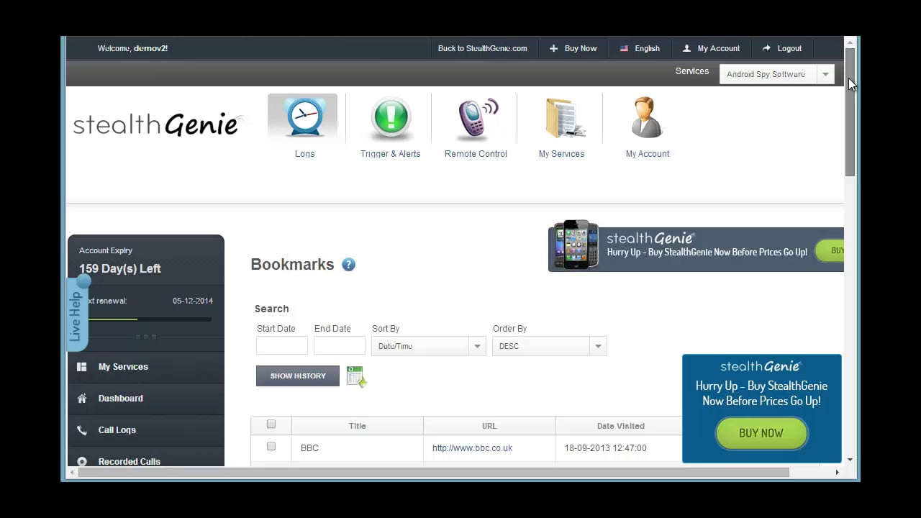

Features:
- Monitoring of messages which are outgoing and incoming.
- Intercepting of the calls, messages, GPS location and Emails.
- It is compatible with the Android, Blackberry and IOS devices in order to remote cell phone spy software without target phone.
Pros:
- Their users’ especially caring parents can use their advanced features to monitor their children.
- They have affordable prices for their software and services as compared to other software.
- Their software comprises of different, premium, gold and basic packages for their users.
- Compatible with the android, blackberry and IOS.
Cons:
- Their reputation is affected due to the non-complying with the legal standards set by the government.
- They won’t entertain you if you want to refund your money in order to use other software.
- Jail breaking is required for the iPhone users to use this software.
- Poor technical support, which doesn’t even help you during the installation process of the software.
- Their basic fees for their services are $8, though less from the other spying companies.

- mSpy:
This software’s main aim is to help parent in monitoring their children. They don’t provide very much features in their software. It ranking can be seen as the 8 in number in the list of best remote cell phone spy software without target phone.
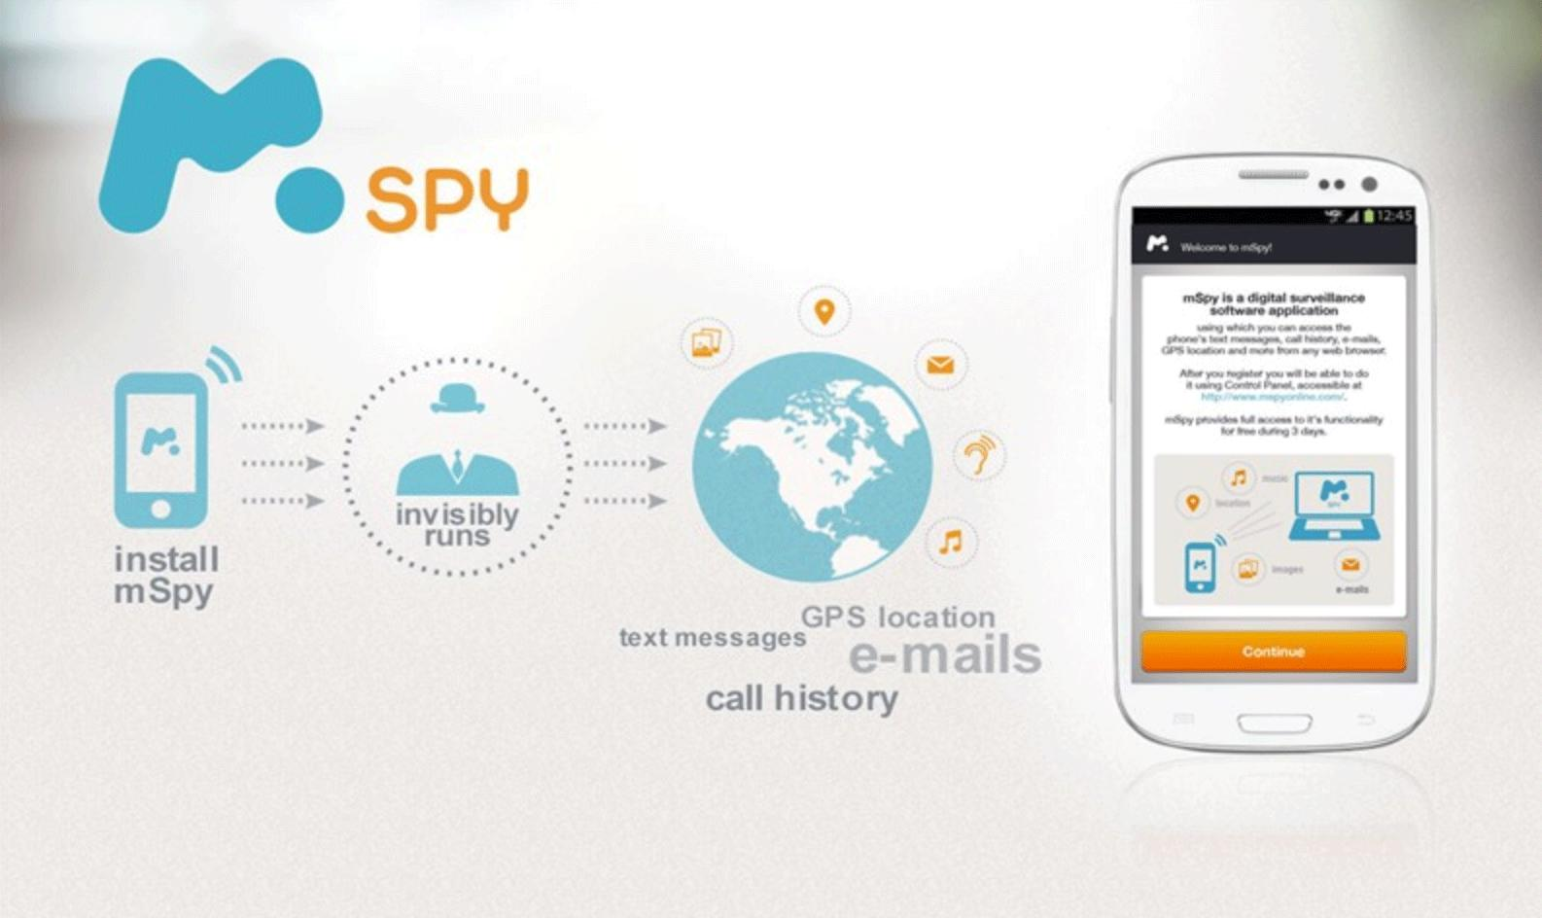
Features:
- It facilitates its users with location tracking service, monitoring of calls, SMS, contact list, browsing history and multimedia files.
- This software is compatible with all the android and IOS devices.
Pros:
- This software works smoothly on android devices and the tablets.
- Free trial version for 7 days for its users to check the software properly.
- They provide you with the monthly subscription offer.

Cons:
- Their plans of subscription are very expensive for the users.
- Only Android having version 4.0 or more can use this software, and iPhone having IOS version 7.0 or more can use this software.
- Rooting of android device is necessary for monitoring of the instant messaging Apps.

- SpyAdvice:
This software allows you to obtain and monitoring of targeted cell phones, especially for the SMS, as mostly people convey their messeages through SMS and MMS.

Features:
- This software works in the stealth mode which makes it untraceable.
- This is the free spy apps for android without target phone and also the free spy app for android undetectable.
- It allows you to remote cell phone spy software without target phone.
Pros:
- SpyAdvice provides their users with the security of their personal information.
- This software is the best free hidden spy apps for android and iPhones, Nook, Samsung and etc.
- It won’t allow your personal information to be visible for the target.
- It also your question of how to spy on whatsapp messages without target phone for free.
- This software if free of any cost.
Cons:
- Their customer support service is very slow.
- Although their service is free, but you would have to pay if you want to avail their gold and premium packages.
- They don’t provide very much features.

- MobileSpyAgent:
If you have a low budget and you are looking for spying software with limited features than this software is only for you. They are considered as the reliable and simple tracking mobile software with efficient services.

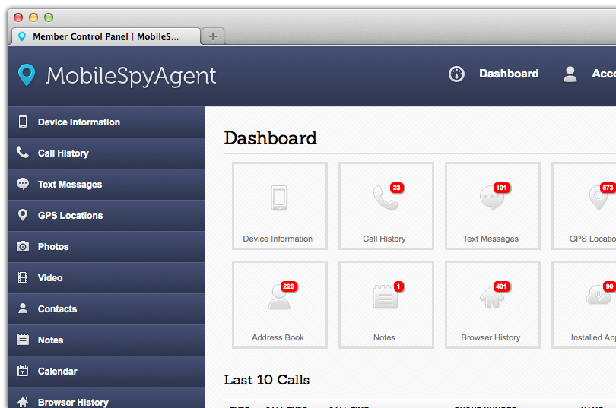

Features:
- Accessing and monitoring of text messages, call histories, location tracking, IMEI number, browsing history, images, videos and memory usage of the device.
- This software compatibility can be measured by the IOS and android devices.
Pros:
- All of those spying features that a user wants are available inside this software.
- They have friendly user customer support service.
- Their software is easy to use and handle for every user.

Cons:
- Customer service is though not available for 24/7, that’s why users have to generate a ticket in order to get their problem solved.
- Jailbreak and rooted devices can use this software.
- Limited features for the users.
Conclusion:
These above mentioned software for spying and tracking to remote cell phone spy software without target phone are the top best software. In order for the parents to locate their child and check their mobile phones, this software works the bet. If you don’t have budget for buying these software than there are many free spy apps for android without target phone and for IOS which are also considered as the free spy app for android undetectable and IOS. Many parents have problem in checking their children whatsapp messages, so these above Apps are the answer for the parent’s question of how to spy on whatsapp messages without target phone. This software also works as the security and protection for your children. The employer can even check his employees under him through the use of this software. I would highly recommend you to use this software and tell your friends and colleagues about it, in order to help them in spying and tracking down the target by their phones or desktop. These are the best to remote cell phone spy software without target phone software.

