Top 10 best GPS to track a car
What is GPS?
GPS also known as the global positioning service is the navigation system bases on the satellite for more than around 24 satellites in number. It can be used to track anybody’s location in any harsh environment. GPS is used for discovering many new locations, tracking the car if it has been stolen and mainly for locating people around and an answer to their question of “How to Track a Car with GPS For Free”. Due to the increase in the crime rate, these GPS system are playing a very important role in our daily life. This helps a lot in GPS tracking for fleet vehicles. These GPS have many different types of uses as it can calculate:
- Trip distance
- Sunset and sunrise time
- Speed of a moving object
- Destination and the distance
How to Track a Car with GPS For Free?
These GPS includes tracking of fleet by observing the location of the vehicle, it can accurately tell about the nature and behavior of the driver as it provides with the report of speeding, sudden stop of the car and many more. Many different companies have introduced the best GPS to track a car device and an option of “How to Track a Car with GPS For Free” in order to prevent accidents and take precautions before the incident. This GPS facility provides you the control over your car, if you have given your car to the driver. In order to look after your car you need to have installed the best GPS to track a car to take proper measure, and those best GPS for tracking a car are as follows:

- Samsara:

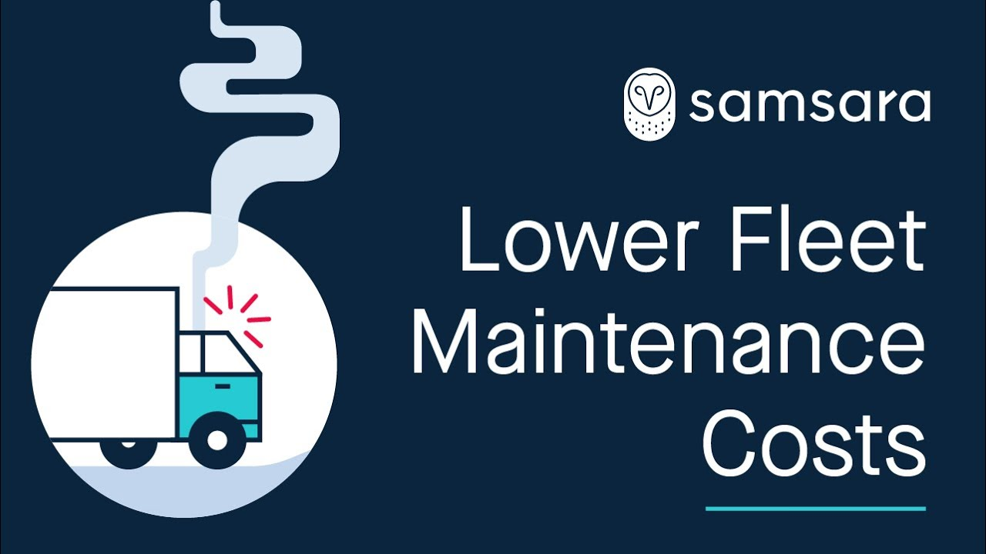
Features:
- This GPS tracker provides you with the consolidated management system for fleet that is far better than the ordinary tracking system for GPS fleet.
- This Samara tracker has many kinds of different option available inside it like real time GPS tracker for car, cooling wireless sensors, camera features for the dashboard and digitalizing of the process of delivery via application of document.
Pros:
- This GPS tracker provides you with the facility of analyzing traffic through the actual time
- Tracking of temperature which is around the products which are refrigerated.
- Monitoring of the behavior of driver via cameras inserted at the dashboard.

Cons:
- You can be at the losing end if you didn’t control the exemptions applied to your business for the timings of the work.

- Advanced tracking Technologies Inc.:
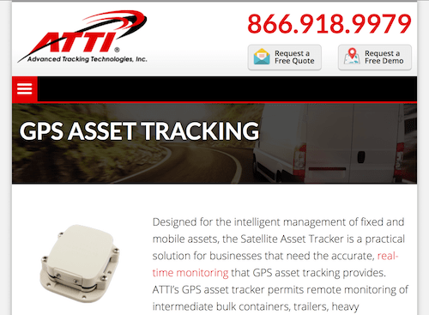

Features:
- The short form of advanced tracking technologies can be described as ATTI by which it is popular in the market.
- This GPS tracker records the usage of your vehicle, behavior of the driver, consumption of the fuel, problems which have occurred in your car and needs maintenance and the location of your car.
- They are the best GPS to track a car.

Pros:
- Optimized with the cell phone devices and can be used easily.
- Geofence feature available which allows you to authorize the use of your car only to your driver.
- It provides you GPS tracking for fleet vehicles which allows you to watch out for big vehicle like containers, trailers and the equipment that is heavy.
Cons:
- ATTI provides you with a hardware which cannot be installed easily while their platform which is usually used is far easier to use.

- UsFleetTracking:
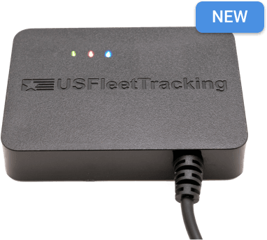
Features:
- They are known for their various hardware options they provide for many different kinds of vehicles.
- UsFleetTracking gives you an uncomplicated pressure device which doesn’t require any wiring process.
- They also provide different GPS tracking device for car.

Pros:
- They don’t have a very complicated process of downloading their software; just by entering all of your details can make their GPS work.
- Weather forecasting system and actual time trafficking are also available.
- They provide their customers with the geofencing feature, warning for the ignitions, usage of the car neutrally and calculation of mileage.
Cons:
- UsFleetTracking provides you with management of system with many different options for hardware, but it doesn’t provide many ways for them to work.

- Geotab:

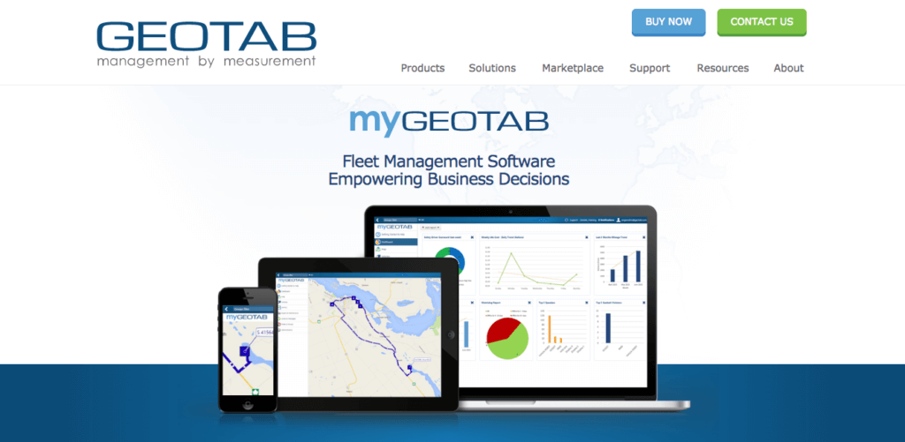

Features:
- This GPS provides with the solution for fleet management with their vital focus on the areas like compliance of the fleet, safety procedures, optimization and productivity.
- Accurate and fully detailed record for trip for your car can be control from this GPS.
Pros:
- Provides you the alert for the safety measures, putting on a seatbelt and speed at which your car is running.
- Before any accident, the action of the driver can be seen.
- Reports you about the conditions of the road where certain precautions should be used while driving.
Cons:
- Their GPS provided is the best GPS to track a car but they are underrated if a bureau page of better business is used.

- GPS Trackit:

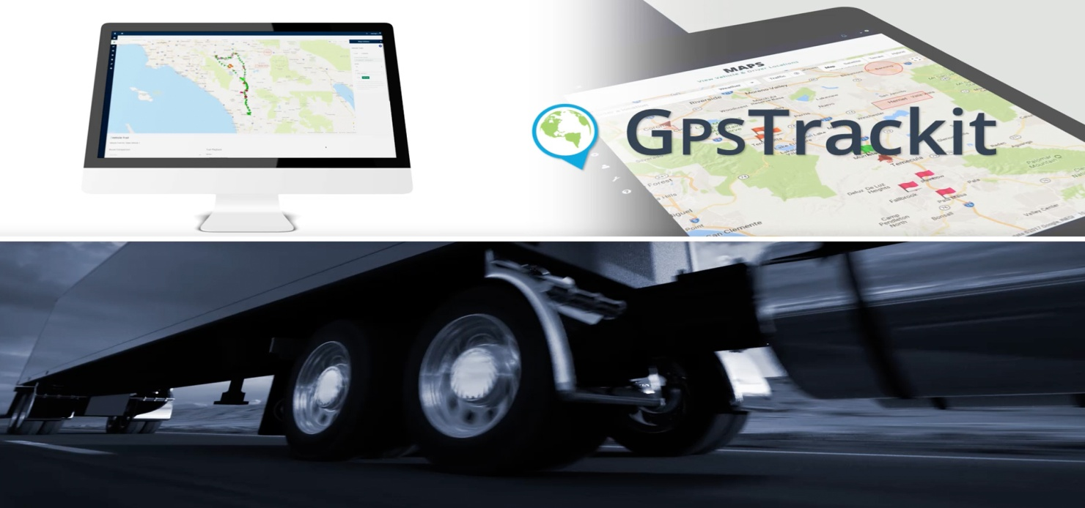

Features:
- This GPS provides with GPS tracking for fleet vehicles software that gives you the report for actual time tracking vehicle service.
- They tell their customers about theft alerts, temperature alerts and movement of their car if unauthorized person is using it.
Pros:
- Monitoring of many vehicle or only vehicle can be done at a same time.
- Fully comprehensive report for the usage of the car.
- This GPS also provides you with the location of your items in order to take measures for the theft and burglary.
- Preventing the temperature to rise up inside the trucks by signaling the owner of the truck.
Cons:
- It has been tried out, that there GPS actually sometimes fail to function.
- They don’t provide you with the actual solution; just make promises to give you the best service.

- Verizon Connect:

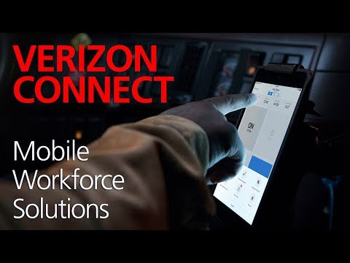

Features:
- They are popular for providing the best GPS tracking device for car and GPS tracking for fleet vehicles.
- Provides you with a range of many different software solutions which are customized.
- Various options for reporting and signals.
Pros:
- Complying with the DVIR, HOS and LED.
- It provides you with a monitoring service of different types of resources.
Cons:
- It makes you irritated by updating mostly right after 90 seconds.
- It is complicated to use this GPS via phone, than the desktop.
- Nextraq:

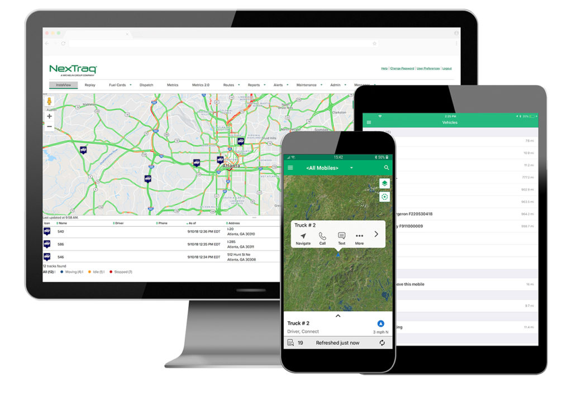
Features:
- This GPS tracking device provides the best GPS to track a car.
- It provides their customers with the facility of real time GPS tracker for car, management of mobile workforce and monitoring of the vehicle.
- Different resources with GPS facility.
Pros:
- Dispatching of driver and his movements can be monitored.
- Saving of all records of driving with option inserted in dashboard.
- Different types of programming which enables the solutions for fleet controlling.
Cons:
- They have mostly negative reviews and remarks given by the people.
- Their GPS fails to work properly sometime.

- Teletrac Navman:
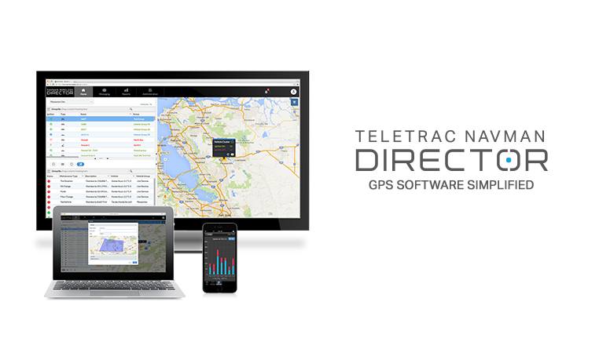
Features:
- Reducing the costs of operating in order to improve the safety of the driver.
- They core focus is on the GPS tracking for fleet vehicles.
Pros:
- Reduction in the rental cost of the operating system by the software of device administration.
- Different analysis reports for the driver’s safety are generated via dashcam and telematic.
Cons:
- Teletrac navman also have many bad reviews given by the people in spite of their services rendered.

- Azuga Fleet:

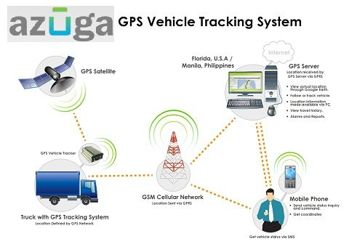

Features:
- It covers all the most important features of the security of fleet, monitoring and controlling of resources and telematics.
- They do provide the GPS tracking device for car.
Pros:
- They give drivers rewards that drive carefully.
- 24/7 availability of customer service.
- They motivate their employees to do a perfect job and achieve their goals.
Cons:
- It takes a lot of time while installing, due to which clients have to wait very much.

- Spy Tec GPS:

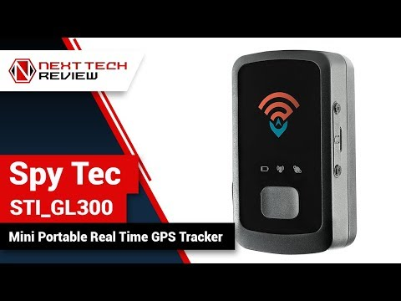
Features:
- If you are looking for the best GPS to track a car and GPS tracking for fleet vehicles than this tracker is for you.
- They give you access for this GPS tracker for around one year of time.
- Pinging GPS after some seconds to make sure that the GPS is providing accurate location.
Pros:
- After every few minutes, this device will provide you with most updated location of your vehicle.
- They provide you with real time GPS tracker for car.
- All information regarding over speeding will be recorded and send it to you.
- If in any case of theft or car stolen, it can track through the Google map feature inside this GPS.
Cons:
- They have high rates than many other GPS manufacturing companies.
- They don’t provide many additional features which are needed in this time.

Why people should evaluate and use GPS tracking for fleet vehicles?

GPS tracking for fleet vehicles and GPS tracking device for car have now become the most essential part of your life. In order to put a check and balance on your driver and vehicle, you need to have this GPS tracker installed. It can help in form the prevention of over speeding which can lead to accident. These above mentioned GPS tracker is best GPS to track a car and fleet vehicle as it can guide you to the very best route in order for you to save the extra cost of your fuel. Your schedule for the month which you had planned would work effectively and efficiently with these GPS trackers installed in your vehicle. Your consignment won’t be delayed and it will be exact on time. This GPS tracker tells us the solution for “How to Track a Car with GPS For Free” and report you about every single activity happening in your vehicle with the camera installed in the dashboard. It also forecasts the temperature reports for you so you don’t have to face any kind of accident while driving in the harsh weather. With these GPS trackers, you can even save the best possible routes guided by this GPS if by chance your GPS tracker stops working and you are in the middle of nowhere.

How can my car be tracked?

There are many people who think about “How to Track a Car with GPS For Free” and that’s had been the real cause problem for many people. But after the introduction of these GPS trackers, life has been very easy. We are living at that face of life where the advancement of technology has risen which had made many things from impossible to possible in our daily life. You can easily control your car and its activities with just a tap of your finger. There is a GPS tracker named as SPYSAT which provides you with free service of tracking your car or vehicle via GPS. There are some proper steps to be followed in order to get the answer for “How to Track a Car with GPS For Free” and those steps are to be followed:

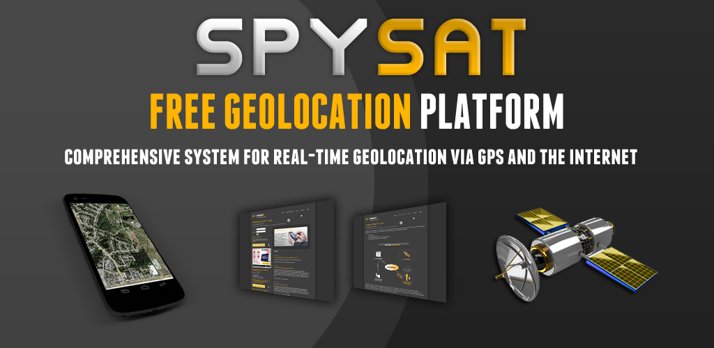
- The very first step to be taken is to download a SpySat App from the google App store of your phone.
- After downloading the software, you just need to make an account from the sign up option to start the process of tracking via GPS.
- After signing up, click on the SpySat logo to direct yourself to their main page where you can log in yourself.
- After signing in, you just have to add the mobile device from which you want to track your vehicle.
- After all this, just make sure that the GPS tracker device is inside your car by which you can easily track your car’s location, its speed and many other things.
- No doubt there are some pros and cons in this GPS usage, but you will be able to track your vehicle easily.

Conclusion:

These above mentioned are the top 10 best GPS trackers for the vehicles; it will help you in the daily phase of your life. You can even track your children via these GPS trackers, these GPS trackers are the best option available for your safety. These GPS trackers provide you with a GPS tracking for fleet vehicles preventing your vehicle from getting theft or robbed. You won’t have to worry about your vehicle while you are shopping, eating or sleeping if these GPS trackers are installed in your vehicle. I would personally recommend you to buy these GPS trackers as they are not much costly, provides you the response for your most concerned inquiry of “How To Track a Car With GPS For Free” and are available at the most affordable rates. No hidden charges with customer service supporting you 24/7. You can also tell your relatives or colleagues about these GPS trackers for their safety purpose and to avoid any kind harm with their consignments and family while driving on the road.

