RIGHT IS WRONG
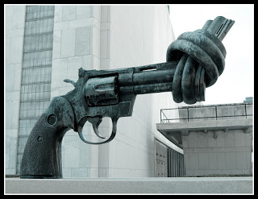
Sometimes I feel, things that are happening around us should not be like the way it is, i.e., the things we have defined as wrong and the things which are right. The concept of right and wrong is totally baseless. What is wrong and what is right? How can we define and who are we to define? Let me ask you some questions, tell me what is terrorism? Is it some particular group of people are determined to kill thousands and show their dominance in different parts of the world? Does terrorism have any boundary? No terrorism has no boundaries, it’s happening everywhere so it is wrong. Now tell me what the throne is doing? Authorized terrorism? In the name of protection we made a group of dressed up authorized people to kill someone like his mirror image just divided by means of language, religion or a stupid line, the so called border. Did you ever think whom you are killing actually? You are killing someone from your kin. Why are these boundaries created and by which basis they are continued till today? Whatever USA is doing in Afghanistan isn’t it terrorism? The way I see the world, it’s like using any weapon is terrorism. Actually we are blind to see the real side of everything, it’s not only USA, it’s done by every single country. So tell me, is this authorized terrorism right? More than ninety percent of Indian budget is spent on protecting border and buy weapons, where one percent of that budget is used for education and millions of people are out there without shelter and food every single day. So which is right? Protecting the border and killing the people inside it, starving. Okay for one second I am with the concept of creating boundaries, but why to protect them? From whom we should protect ourselves? They are same human beings, may be just speaking a different tongue or following some different rules, but they are us only on the other side. Sometimes I feel like we all are remote controlled and just one percent of the world population are controlling us. This one percent is extremely powerful and they have created a cycle of war and money and the rest of the world is the victim of this never ending cycle.

