education technology
COURSE NAME: EDUCATIONAL TECHNOLOGY 2 + FIELD STUDY 3
SECTION CODE: CE92
DATE SUBMITTED: MARCH 15, 2018
STUDENT’S NAME: KRISTINE JEREMY R. FERMANO
PROFESSOR’S NAME: PROF. RYAN GLENN C. NARVASA, LPT, MAED

Capitol University
College of Education
Professional Education Department
“Center of Development for Teacher Education”
Certificate of Teaching

PERSONAL BACKGROUND:
NAME: KRISTINE JEREMY R. FERMANO RELIGION: Roman Catholic
GENDER: Female CIVIL STATUS: Single
AGE: 37 YRS OLD CITIZENSHIP: Filipino
BIRTH DATE:February 8, 1981 WEIGHT: 52 kgs.
BIRTH PLACE: Cagayan de Oro city HEIGHT: 5’3’’
ADDRESS: Youngsville Igpit, Opol, Misamis Oriental
CONTACT NO.: 09172466511

EDUCATIONAL BACKGROUND:
PRIMARY: Montessori de Oro
SECONDARY: Montessori de Oro
TERTIARY: Bachelor of Science in Commerce major in Finance
Liceo de Cagayan University

When we are going to say 21st century teaching it is an altogether phenomenon, the recent technological advances have affected many areas of our lives, the way we communicate, collaborate learn and the way we teach.
I am a 21st Century Teacher because I have those characteristics of a 21st century teacher; when we allow our learners to make their own choices, they own their learning, increase intrinsic motivation and put in more effort- one idea recipe for better learning outcomes.

I am more open to learn new technologies, in order to be able to offer students choices, having one’s own hands-on experience and expertise will be useful, since technology keeps developing, learning a tool once and for all is not an option. I consider myself as a 21st Century Teacher because I am open to changes and adapt easily what is the trends and keep on learning.
Education technology is a complex, integrated process involving people, procedures, ideas, devices and organizations for analyzing problems and devising, implementing, evaluating, and managing solutions to those problems involved in all aspects of human learning. It consists of the designs and environments that engage learners and reliable techniques or method for engaging learning such as cognitive learning strategies and critical thinking skills.
The purpose of this portfolio is to see how far I achieve the goals in my Field Study 3 Which is to develop and utilize appropriate technologies that are being used in teaching learning process. This is one of the things that I will value most because it contains my experiences on the said goals of this subject. This will serve as the evidence of my success in this subject though there is more that I will meet in the future. So, this portfolio will be part of me.This portfolio will remind me of the memorable and a success from a headache moments in performing those contents of these. Fulfillment is one of my goals and I must work on it I hand. I have to give more sacrifice to aim the goal of life

I believe it is important as an educator to keep learning and continue to modify your approach to find the best ways to relate material to your students. Our world is constantly being influenced by technology and I believe it is crucial to use that technology to improve educational strategies. As a future educator, I plan to not only learn from the experience of current professionals, but also to keep up on new innovations and incorporate them in my classroom. Today’s generation is immersed in the rapidly changing world of technology. It is something they are constantly using at every moment, whether it be texting, instant messaging, e-mailing, face booking, or listening to their iPods, it is a significant part of their lives. It has become their mode of communication and it is engraved in almost everything they do. What better way to teach someone than to speak in their language. I think it is atrocious that with all the technology we have today, most of our classrooms are generally the same as 100 years ago. I believe that students should be taught using web quests, emails, creative computer programs, PowerPoint, movies, discussion boards, social networking sites, podcasts etc. There are so many opportunities available at our fingertips if we would just put them to use. You can find almost anything on YouTube today to help make your lesson realistic. For example, if you're teaching a text that takes place in Pakistan, show your student Pakistan or create a social networking program with a school in Pakistan. There are so many exciting ways to use technology in the classroom to engage students and to authenticate learning and I plan to utilize them in every way possible.

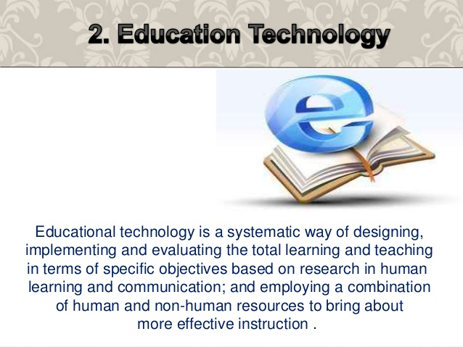

Graphic Organizer on Terminologies in Educational Technology

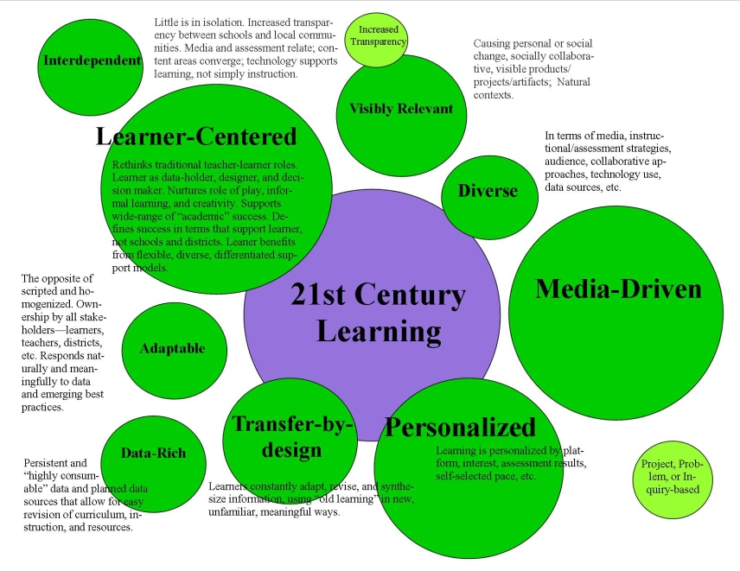

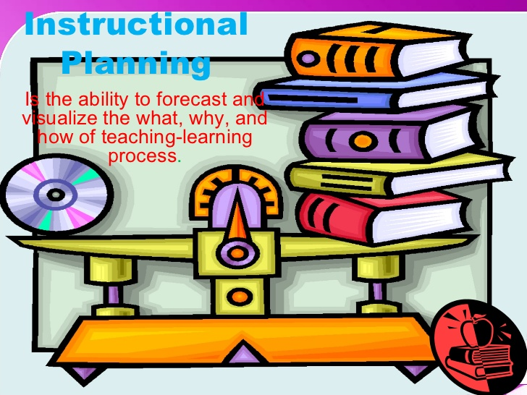

In today's world, computers are used for almost every task imaginable. Routine activities such as paying bills, buying groceries, or communicating with a friend can be done with a computer. That is why it is important not only to know how to use a computer, but also to understand the components of a computer and what they do.
Recent studies report that almost 40% of homes surveyed have personal computers, and this number is growing. Given the widespread use of computers, computer literacy - a knowledge and understanding of computers and computer uses - has become an essential ingredient in the recipe for success in today's world.

The processor is that part of the computer that does all the work of computation. It does this in collaboration with the computer's main memory where live data is kept and fetched by the processor for processing. A processor is distinguished by its speed measured in Gigahertz (GHz). The higher the speed, the faster the PC.

Main Memory stores live data and loses it once the power source is turned off. The processor fetches instructions or data from main memory to process. Generally, the more Random Access Memory (RAM) you have, the better the PC will run when using several programs at once. A typical office PC can run well with 512 megabytes (512MB) of memory and this is a good minimum specification.

The hard disk is used to store the data that you create. This may be your business data or data on class work for students or games. It has a larger capacity than the RAM. A typical office computer has about 40 gigabytes (40GB) of hard disk space. Larger data stores may require a larger capacity hard disk. Where that storage serves the purposes of several users in a network, the disk may be used to service those needs of users and may be set up as a Server. The file server (with accompanying software) may be mounted in a separate (dedicated) PC.

The monitor is the display screen. There are two types of monitor - flat screen or cathode ray tube. Flat screens are more expensive but are becoming more widely used as they use less desk space and generate less heat. Select at least a 17 inch monitor for desktop use.

The keyboard and mouse usually come as part of a bundle. They may come as connected (wired to the PC using a cable) or as a wireless device. The wireless devices make desktops neater.

Hyperlinked PowerPoint Presentation of a Lesson Plan

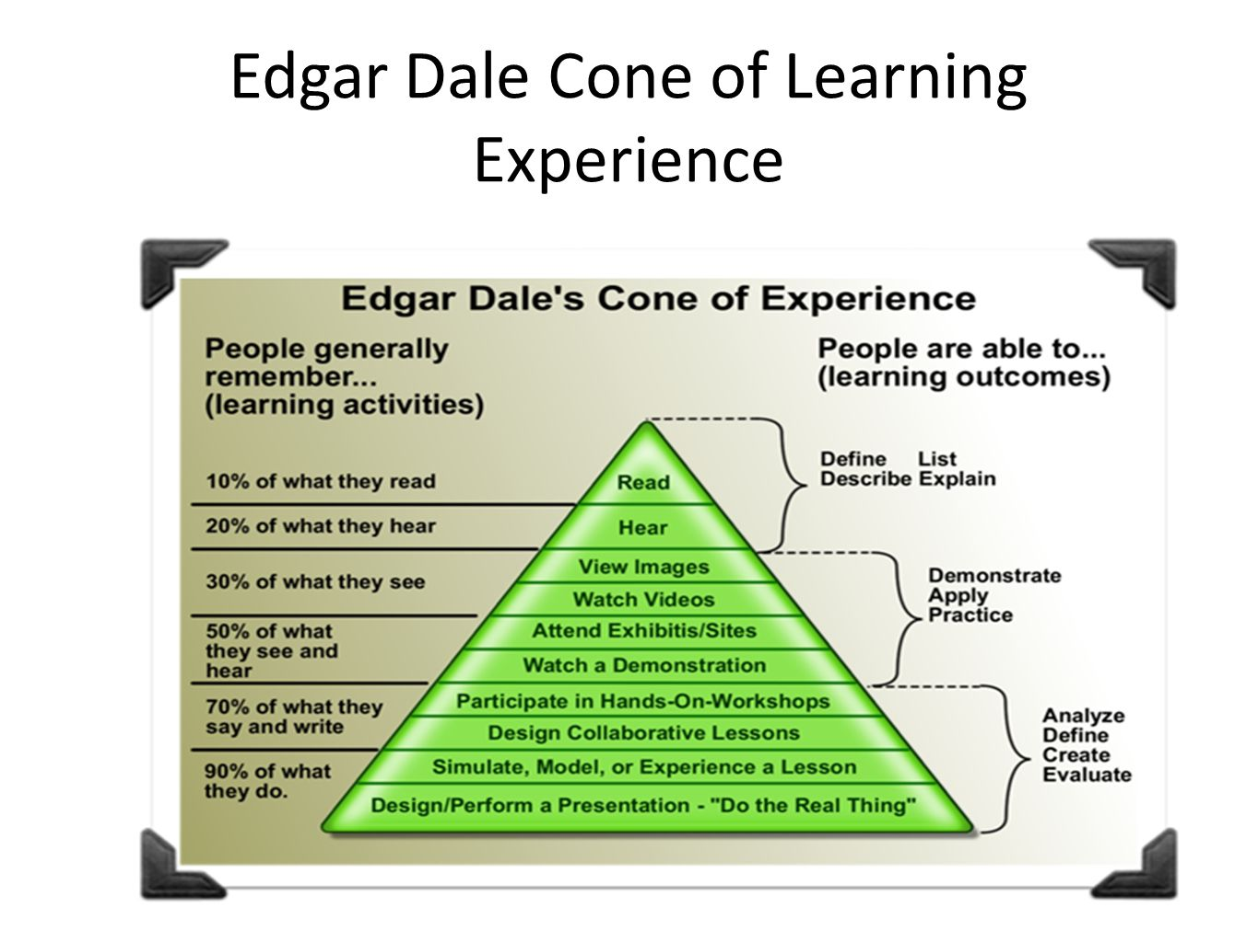

Matrix of Instructional Media according to uses and description

- Real object and models
- Printed text (books, handouts, worksheets)
- Printed visuals (pictures, photos, drawing, charts, graphs)
- Display boards (chalk, bulletin)
- Slides and filmstrips
- Audio (tape, disc)
- Video film (tape, disc)
- Television (live)
- Computer Software

- The Web
It is located in many of the general purpose and technology enhanced classrooms on campus with a document camera, you can display documents, books, graphics and three-dimensional objects and projects them so even students at the back of the class can see.
FSU has replaced the ubiquities chalkboards with white boards in most classrooms. The whiteboards is one of the most basic forms of instructional media and is best used for emphasizing essential information and developing ideas as the class progress.
This electronic technology allows instructor to monitor attendance, conduct real-time surveys in classroom, and elicit student performance feedback through quizzes and real-time surveys.

Should augment the presentation, they are not meant to be the entire presentation. It should be kept simple, with minimal wording. They should always e readable from a distance.
WEB
Used with computer projects an image into a screen or blank wall-and provide more instructional flexibility in the types of content that can be used in a classroom.
Is provides a way for students in different locations to collaborate on solving and learning.
Used in classroom instruction has advantage of presenting abstracts ideas in a realistic context, which helps student grasp the abstract ideas more easily and to retain the material longer.

PERSONAL RESPONSE SYSTEM

DOCUMENT CAMERAS
CHALK
My Matrix for the Learning Experiences and Tools

LCD

VISUAL AIDE

VIDEO or FILM

First of all, it's important to understand exactly what this question is asking, as it is quite a complex question filled with jargon. The term disparity refers to inequality or unfairness, while educational technology advancement simply refers to the level and quality of technology available for students to assist in their studies. As a result, an answer to this question would require a comparison between a country such as America, and the Philippines, in order to understand the differences between the technologies available within the field of education.

In the Philippines, technology is still not particularly prominent, although it plays a major role in education in other Asian countries. While higher education institutes such as universities offer specialized courses in computing, there is less influence in elementary education, and education of younger students. The minor role of computing and information technology in the educational system of the Philippines is demonstrated by the influence of figures such as William Padolina. Padolina was expressing concerns about the importance of technology, and the lack of the technology in the Philippines, as early as 1996 at the International Conference on the Development of Information Infrastructure. He is a passionate advocate of the use of technology in all walks of life in the Philippines, and especially in education.

On the other hand, in the first world country of America, computers and other forms of technology are used on a daily basis by students of all levels. According to government figures from 2008, 100% of public schools in America possessed computers with internet access, which could be used by their students. In addition, an estimated 58% of schools had laptop computers stored on carts, which could be placed in any classroom which needed them. As you can see, the difference between the availability of technology in schools is staggering:
- More American than Filipino children have access to a computer at school
- More American than Filipino children have access to the internet at school
- More American than Filipino children are confident in using computers to aid in their education
- More American than Filipino teachers incorporate the use of computers into their lessons

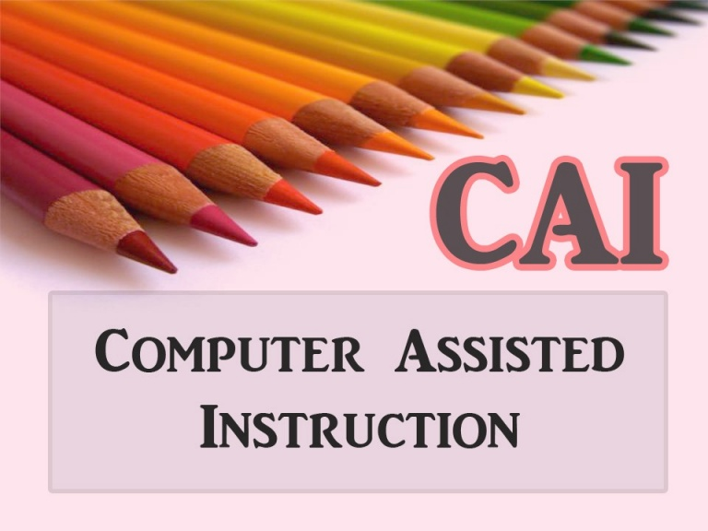

Discussion
- Do you believe CAI in some future time can replace teachers in the classroom?

I don't believe that CAI will replace the teachers in the classroom, because I think if it will happen the teachings will not be an effective because not all students can do individualized learning. In some progressive countries, it is possible that CAI will replace the teachers but not in all ways. Today's teachers can interact well to their students and as well as students can raise a question to their teachers, that's why I can say that CAI can never be an effective teacher in the classroom. Teachers are the deliverer and the learning environment controller of the students. They are the one who plan an activities and appropriate learning strategies for the effective teaching and learning process.
Computer is a tutor but it does not replace the teacher.

- Since it is admitted that CAI relates to lower learning skills, what grade levels would CAI drill-and-practice software materials be Useful? Do you think those in college will still want the drill-and-practice learning activities that provide memorization and brain processing pain like a mere computer?

It is still important to exercise behaviourism and cognitivist of college students but they have to be given more challenging activities compared to the challenges given to the pupils but of course, are still included in the lower thinking skills which are behaviourist and the cognitivist learning.

- What problem can be encountered if a school (such as in poor countries) cannot afford to provide enough computers to students? Will CAI work at all with whole school using a single computer?
Other students may not benefit from the computer since many others are using it and they don’t have the chance. CAI may be applied to those who are able to use it but will not be applied to all.

- What can the school neighbourhood community or non-government organizations do to put public schools on a first track for the integration of technology in public education?
They can help through contributing money for educational purposes or the school may solicit enough money for the supply of computers and other learning materials.

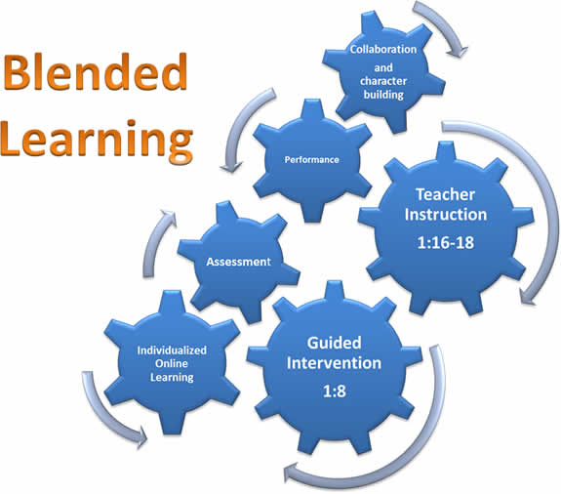

6 Models of Blended Learning
As school districts look for ways to give their students a personalized learning experience without expanding their budgets, blended learning can be an effective option. This approach to schooling combines face-to-face instruction with online learning and has yielded strong results since officially being researched as an education strategy. This may be partly due to the fact that this rapidly growing model not only increases the flexibility and individualization of student learning experiences, but also allows teachers to expand the time they spend as facilitators of learning. Schools make the switch to blended learning for a variety of reasons. In addition to considering the age of the students, the reasons for choosing a blended model generally dictate which of the six models they choose to implement:

1) Face-to-Face Driver Model
Of all the blended learning models, face-to-face driver is the closest to a typical school structure. With this approach, the introduction of online instruction is decided on a case-by-case basis, meaning only certain students in a given class will participate in any form of blended learning. The face-to-face driver approach allows students who are struggling or working above their grade level to progress at their own pace using technology in the classroom.

Some schools have also found this model to be a helpful way to engage English language learners (ELL), who sometimes fall behind not because they are incapable of understanding a concept, but because they’re not native speakers. A 2009 study of the Round Rock Independent School District in Texas found that the math and reading test scores of third and fifth grade ELLs increased following the implementation of blended learning and the use of interactive whiteboards.

2) Rotation Model
In this form of blended learning, students rotate between different stations on a fixed schedule – either working online or spending face-to-face time with the teacher.

3) Flex Model
Schools who are supporting a large number of non-traditional or at-risk students often choose the flex model of blended learning. With this approach, material is primarily delivered online. Although teachers are in the room to provide on-site support as needed, learning is primarily self-guided, as students independently learn and practice new concepts in a digital environment. Students at Advance Path spend most of their time in a computer lab learning online.

4) Online Lab Model
As schools face increasingly tighter resource constraints, the online lab model of blended learning is a viable option for helping student’s complete courses, including those not offered at the specific school site. In this scenario, students learn entirely online but travel to a dedicated computer lab to complete their coursework. Adults supervise the lab, but they are not trained teachers. This not only allows schools to offer courses for which they have no teacher or not enough teachers, but also allows students to work at a pace and in a subject area that suits them without affecting the learning environment of other students.

5) Self-Blend Model
Popular in high schools, the self-blend model of blended learning gives students the opportunity to take classes beyond what is already offered at their school. While these individuals will attend a traditional school environment, they also opt to supplement their learning through online courses offered remotely. In order for this method of blended learning to be successful, students must be highly self-motivated. Self-blend is ideal for the student who wants to take additional Advanced Placement courses, or who has interest in a subject area that is not covered in the traditional course catalog.

6) Online Driver Model
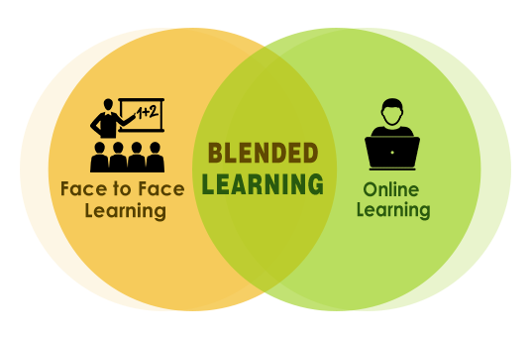
At the opposite end of the spectrum from face-to-face driver we have online driver, which is a form of blended learning in which students work remotely and material is primarily delivered via an online platform. Although face-to-face check-ins are optional, students can usually chat with teachers online if they have questions. This model of blended learning is ideal for students who need more flexibility and independence in their daily schedules. This approach is becoming increasingly popular – each year, the number of students participating in online driver programs increases by about 15 percent.

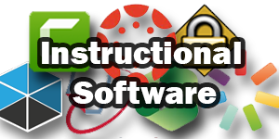

Instructional Software
Educational/Instructional software was first used as a tutoring tool for students in the 60s and 70s, but over the past 30 years, it has evolved into software that incorporates some or all of the five functions for helping students learn including drill and practice, tutorial, simulation, games, and problem solving. As you will find from the many examples in this Web site, it is difficult to define many of the instructional software packages into one category. Universities, software companies, and open source projects have all developed software for educational purposes that blends two or more of these five categories of instructional software. Today's instructional software also uses both objectivist and constructivist learning concepts in its design, which benefits the learner since both concepts are valuable to accomplishing educational goals for students. Educational software is valuable to all ages of students for many reasons including making learning more fun, motivating students, helping with long-term memory of the material, and providing a thorough educational experience that incorporates many proven learning concepts into the curriculum. Educational software is best used to augment classroom curriculums, but in most cases, should not be the only instructional method for learning. Educational software no longer is thought to be a replacement for teachers, but a tool that helps teachers do a better job of teaching their students. There are literally thousands of educational software packages that provide learning tools for all subject areas. Before purchasing any educational software, it is best to research the product to ensure it provides the intended learning goals for you and/or your students.
What is Drill & Practice?
As an instructional strategy, drill & practice is familiar to all educators. It "promotes the acquisition of knowledge or skill through repetitive practice." It refers to small tasks such as the memorization of spelling or vocabulary words, or the practicing of arithmetic facts and may also be found in more supplicated learning tasks or physical education games and sports. Drill-and-practice, like memorization, involves repetition of specific skills, such as addition and subtraction, or spelling. To be meaningful to learners, the skills built through drill-and-practice should become the building blocks for more meaningful learning. Drill and Practice activities help learner’s master materials at their own pace. Drills are usually repetitive and are used as a reinforcement tool. Effective use of drill and practice depends on the recognition of the type of skill being developed, and the use of appropriate strategies to develop these competencies. There is a place for drill and practice mainly for the beginning learner or for students who are experiencing learning problems. Its use, however, should be kept to situations where the teacher is certain that it is the most appropriate form of instruction.
How can I do it?
Drill and practice software packages offer structured reinforcement of previously learned concepts. They are based on question and answer interactions and should give the student appropriate feedback. Drill and practice packages may use games to increase motivation. Teachers who use computers to provide drill and practice in basic skills promote learning because drill and practice increases student acquisition of basic skills. In a typical software package of this type, the student is able to select an appropriate level of difficulty at which questions about specific content materials are set. In most cases the student is motivated to answer these questions quickly and accurately by the inclusion of a gaming scenario, as well as colorful and animated graphics. Good drill and practice software provides feedback to students, explains how to get the correct answer, and contains a management system to keep track of student progress
Constructivist teaching is based on constructivist learning theory. This theoretical framework holds that learning always builds upon knowledge that a student already knows; this prior knowledge is called a schema. Because all learning is filtered through pre-existing schemata, constructivists suggest that learning is more effective when a student is actively engaged in the learning process rather than attempting to receive knowledge passively. A wide variety of methods claim to be based on constructivist learning theory. Most of these methods rely on some form of guided discovery where the teacher avoids most direct instruction and attempts to lead the student through questions and activities to discover, discuss, appreciate and verbalize the new knowledge.
Their theories are now encompassed in the broader movement of progressive education. Constructivist learning theory says that all knowledge is constructed from a base of prior knowledge. Therefore children learn best when they are allowed to construct a personal understanding based on experiencing things and reflecting on those experiences.

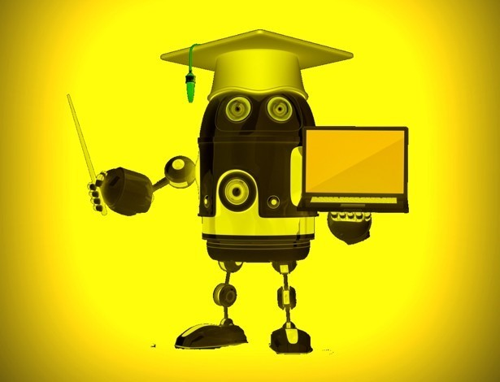

SEMI DETAILED LESSON PLAN IN INFORMATION AND COMMUNICATION TECHNOLOGIES (ICT)

- Objectives

At the end of the lesson, the students are expected to:

- Identify the Elements of Computer System
- Discuss the different categories of Hardware
- Point out and demonstrate how to disassemble and assemble parts of System Unit.

- Subject Matter
Topic: Introduction to Computer System

- Materials
Hand-outs, Whiteboard marker
Laptop, Projector and System Unit

- Procedure

- Preparation
Greet the students and then ask them to seat properly.

- Motivation
Make the students Imagine that Computer does not exist, ask them how they feel.

- Lesson Proper (Presentation)
Introduction to Computer System
A computer is an electronic device used to manipulate data into useful information. It responds to a specific set of instructions in a well-defined manner and it can execute a prerecorded list of instructions.
A computer system is an interaction of three major components namely hardware, software and human ware. The three components are integral in that none of them is functional without the others.
Computer hardware components are the physical devices that make up a computer, allowing software to run on them.
Computer software includes, programs and data which run on hardware components. It makes hardware components runs. For example, Operating System and Application Software.

Human ware refers to the user of the computer. The following types of people interact with a computer system:

(a) System Analysts: People who design the operation and processing of the system.
(b) System Programmers: People who write codes and programs to implement the working of the system
(c) System Operators: People who operate the system and use it for different purposes. Also called the end users.

The Four Main Categories of Computer Hardware Devices
The typical computer set can be broken down into four distinct hardware categories. The combination of this breakdown actually defines what a computer does: a programmable electronic device which inputs raw data by use of input peripherals; uses the microprocessor to process received instructions into information; outputs this data or information via the monitor or print; and stores data and information derived onto appropriate media for future use.
Computer hardware devices are thus grouped under four major hardware categories:
- Input devices
- Processing devices
- Output devices
- Storage devices
1: Input Hardware
All computer hardware components used to feed raw and other data to a computer system are categorized as input hardware devices. A microphone is an example of sound input device
The following is a list of commonly used input devices:
Keyboards
Pointing devices:

Mouse
Touchpad
Touchscreen
Multi touch screen
Pen input
Motion sensor
Graphics tablet
Interactive smart board
Game controller devices:
Joystick
Gamepad
Steering wheel

Audio input devices:

Microphone
Midi keyboard

Visual and Imaging devices:

Webcam
Digital camera
Digital camcorder
TV capture card
Scanner
Barcode reader

2. Processing Hardware
Computer hardware components that manipulate raw and other data, into information are referred to as processing devices. Processing hardware is not as populated as other categories of hardware parts. Typically, the microprocessor is the major processing devices in the computer. It is also important to note that the microprocessor works closely with computer memory devices during its operations.
An AMD microprocessor is an example of a processing device.
3. Output Hardware
Hardware components that disseminate and display both data and information are of the output category. All computer output forms are the culmination of the purpose the computer is tasked to accomplish.
Output devices are categorized under softcopy output and hardcopy output. Softcopy output is usually related to the experience the user derives from interacting with the computer.
The user derives visual pleasure by watching a movie he downloaded from cloud storage. This is usually by monitor display output.
A collection of old CR monitor display units. The CRT monitor is an output device
The school teacher will however need to have his grammar exam transferred to tangible hardcopy output in order to have students write appropriate answers on them.
Softcopy output
- Display output

Monitor
Projection display
Electronic smart board

- Sound output

Speaker
Headphone and earphone

Hardcopy output

Impact printer
Dot matrix printer
Non-impact printer
Inkjet printer
LaserJet printer
Thermal printer
3D printer
Cloud printing

4: Storage Hardware
The parts of the computer that are used to store data in whatever form are classified as storage devices. Computer storage is either primary or secondary and is either volatile or nonvolatile.
Primary memory is commonly used to mean random access memory (RAM) but actually refers to all memory that work in tandem with the processor. The central processing unit (CPU) read instructions stored in primary memory and execute the instructions as required.
Secondary memory is secondary because data stored within secondary storage media (usually disks) cannot directly communicate with the microprocessor. Data stored in such media first is transferred to main memory (RAM) from where manipulation by the processor can occur.
Primary storage

RAM
ROM

Secondary storage
Internal storage & External storage (Magnetic storage, Optical storage, Flash storage)
An SSD for laptops is an example of flash storage
The Typical Computer
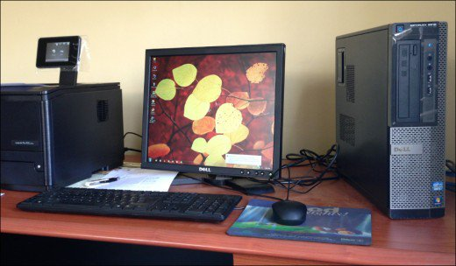
A typical Computer consist of Mouse, Keyboard, Monitor, Speaker, Printer and System Unit.

System Unit

The system unit, sometimes called the chassis, is a box-like case housing the electronic components of a computer that are used to process data.
What’s Inside the System Unit?

Inside the system unit are

- Motherboard
- RAM
- Power supply
- Hard disk drive
- Video Card (optional)
- CD-ROM/DVD Drive (optional)
- LAN Card (optional)

- Activity/Application:

System Unit Disassembling and Assembling.

- Generalization
Recognize the importance of knowing elements of computer system and the different parts of the System Unit.

- Evaluation
Get a one whole yellow paper and answer each question.
1-3. What are the elements of Computer System?
4-7. What are the components of Hardware?
- What is the primary storage or memory of Computer?
9-15. What are the parts of System Unit?
- Assignment
Find out what are the types of Software?
Write it on a one whole sheet of yellow paper,

- Reference: http://study.com/

