Principles of Teaching
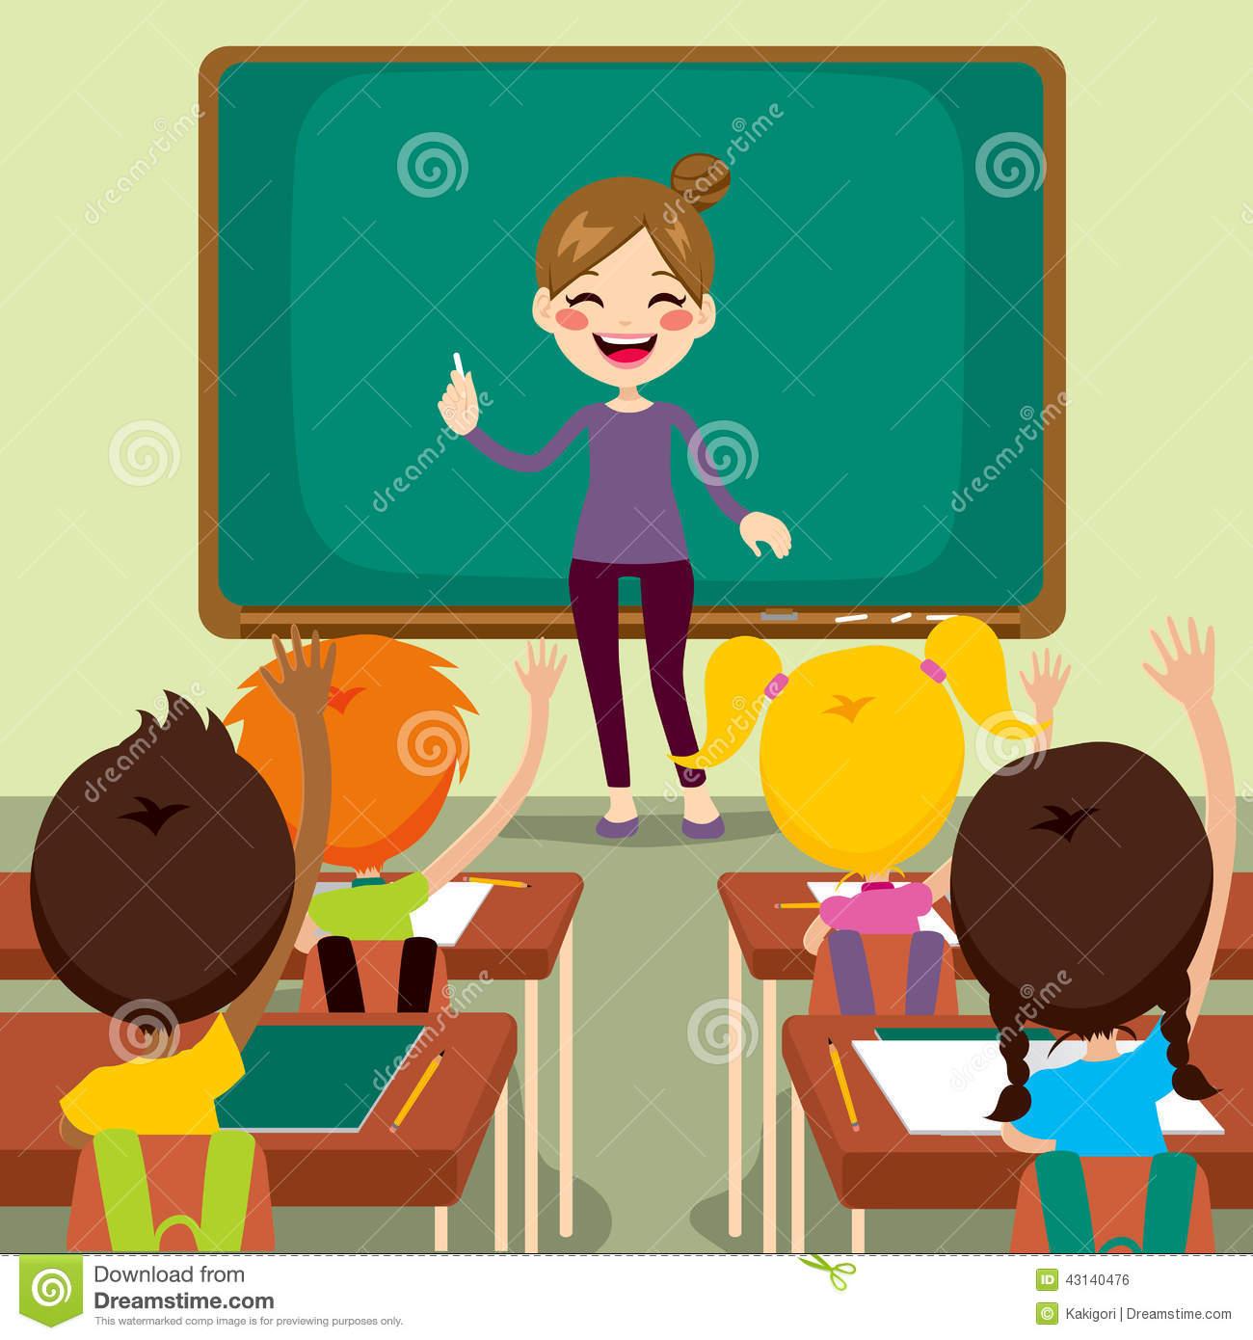

Submitted by:
Kristine Jeremy R. Fermano
COT – Student

Submitted to:
Prof. Janet Cruz-Parpa PhD
Capitol University-College of Education

AUTOBIOGRAPHY

I am Kristine Jeremy R. Fermano, a resident of Youngsville subd., Igpit, Opol, Misamis Oriental. Daughter of Mr. Rogelio Fermano and Mrs. Semadar Fermano a very supportive parents. I have two siblings, Ms. Katherine R. Fermano, who’s 32 years old and currently working at ATOS a German Company at Cebu City and my youngest sister, Ms. Klarisse R. Fermano, who’s 27 currently working at ACOLADE RESOURCES INC.-Cagayan de Oro City. I am 37 years old and God blessed me a loving son Alexander Keane Fermano.
I graduated my bachelor’s degree at Liceo de Cagayan University last 2002 taking up BS Commerce major in Finance.
I am currently working as a Credit Committee at 1st Valley Bank Inc. It was when one of my friends advised me to proceed to Professional Education and also because most of my friends already enter the world of teaching and I find myself interested in teaching and I can also see myself a successful educator someday.

I am so blessed and happy and so much excited for taking up COT and got units to be able to qualify and take the Licensure Examination for Teachers. I am so much excited to share my Gods given gift to help our learners to develop morally responsible and successful.

Module One

Elements of Teaching
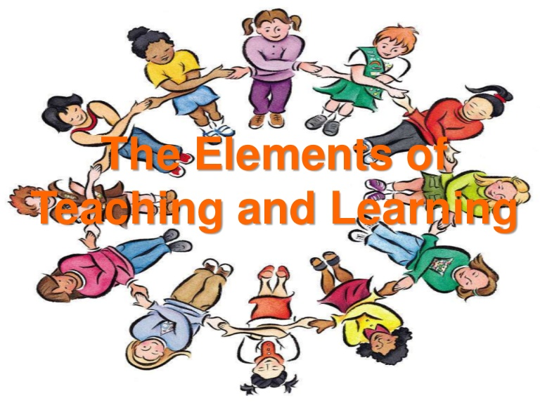

- Reflection paper:
“The teacher who changed my life was, serendipitously, my English teacher during my 3rd and 4th year in high school. Ms. Nacaytuna taught me how to write eloquently (I hope!), and she had this unexplained faith in me that really galvanized me as a student. What she taught me stuck with me through college and beyond.”
- Learning Atmosphere that is Conducive for Learning
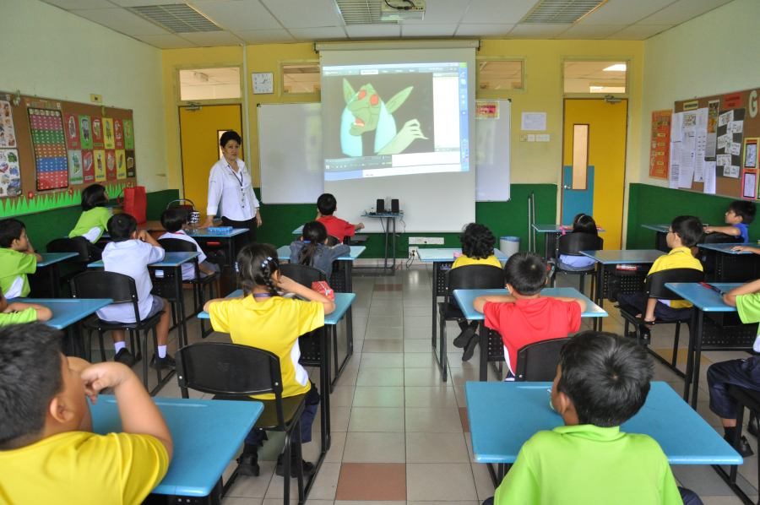
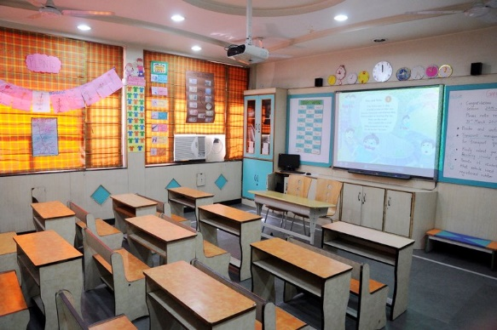

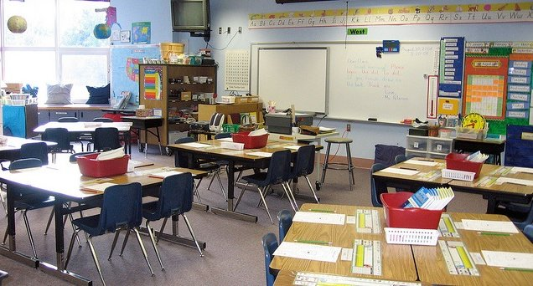
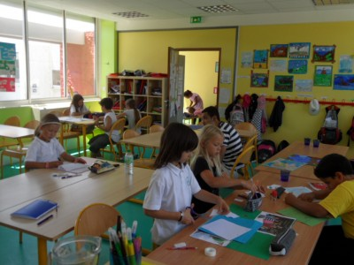

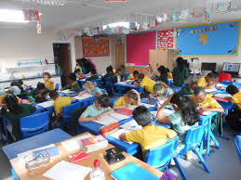
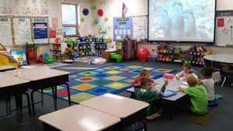
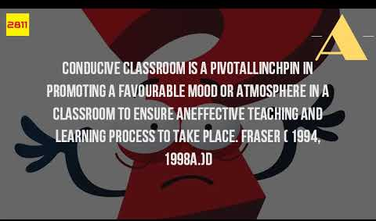

Module Two

Principles of Learning

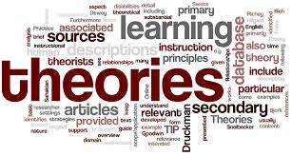
Principles of Learning

The mediocre teacher tells. The good teacher explains. The superior teacher demonstrates. The great teacher inspires. ~William Arthur Ward
The principles of learning can help understand the different intelligences of the person. Teaching for me really isn’t just a profession. It is a vocation. It requires self-sacrifice, and being able to offer oneself for the sake of the students. This job may not be one of the highest paid jobs in this world, but I think it is on top of the most rewarding and self-fulfilling job man has created. It is so because teaching creates other professions. This may sound cliché but this really is true. We will never have doctors, lawyers, architects and any other profession if not for a teacher who has painstakingly taught us and saved us from ignorance.

Being a teacher as far as my experience is concerned has opened my eyes to a lot of things. A teacher who may have exemplary credentials on his/her back can never be sure if he/she will be successful inside the classroom. It hit me in my head that I should not be complacent about myself. That there are things I need to improve and change about myself. I need to think creatively, innovatively and resourcefully in order to make my class successful. I need to prepare each and every day. Every day is always a brand new day. What happens inside the classroom is always unpredictable.

I personally believe that teachers are most remembered not on how they have made students learn, but rather on how they have made the students feel. And because of this, I learned to be very sensitive with the way I deal with my pupils. I learned to let them feel the care, concern and warmth of a teacher. I may sometimes hurt my students’ feelings intentionally or unintentionally, but I hope they know that learning sometimes is a painful process. We have to offer sacrifices and that includes giving up our old, comfortable but wrong ways. And to wake ourselves up from these wrong ways, we have to slap our face (and I don’t mean this literallyJ). I sometimes do this not because I want to but I have to.
Based on my experiences, I learned that we need first and foremost to motivate our learners. As Horace Mann said, teaching learners without motivating and inspiring them is like hammering a cold iron. As a teacher, I need to make them appreciate and develop the love for learning. They will never, ever learn unless they allow learning to occur in their minds. Learning is an experience which occurs inside the learner and is activated by the learner. This poses me a challenge, that as a teacher, I really need to think of various, creative and enjoyable activities that can arouse my students’ desire to learn.

Smart Learner’s Objective
Three Domain

Topic: Microsoft Word
After the discussion the students will be able to:
- Cognitive: Indicate the names and functions of the Microsoft word interface components.
- Affective: Manipulate documents using functions such as find and replace; cut; copy and replace
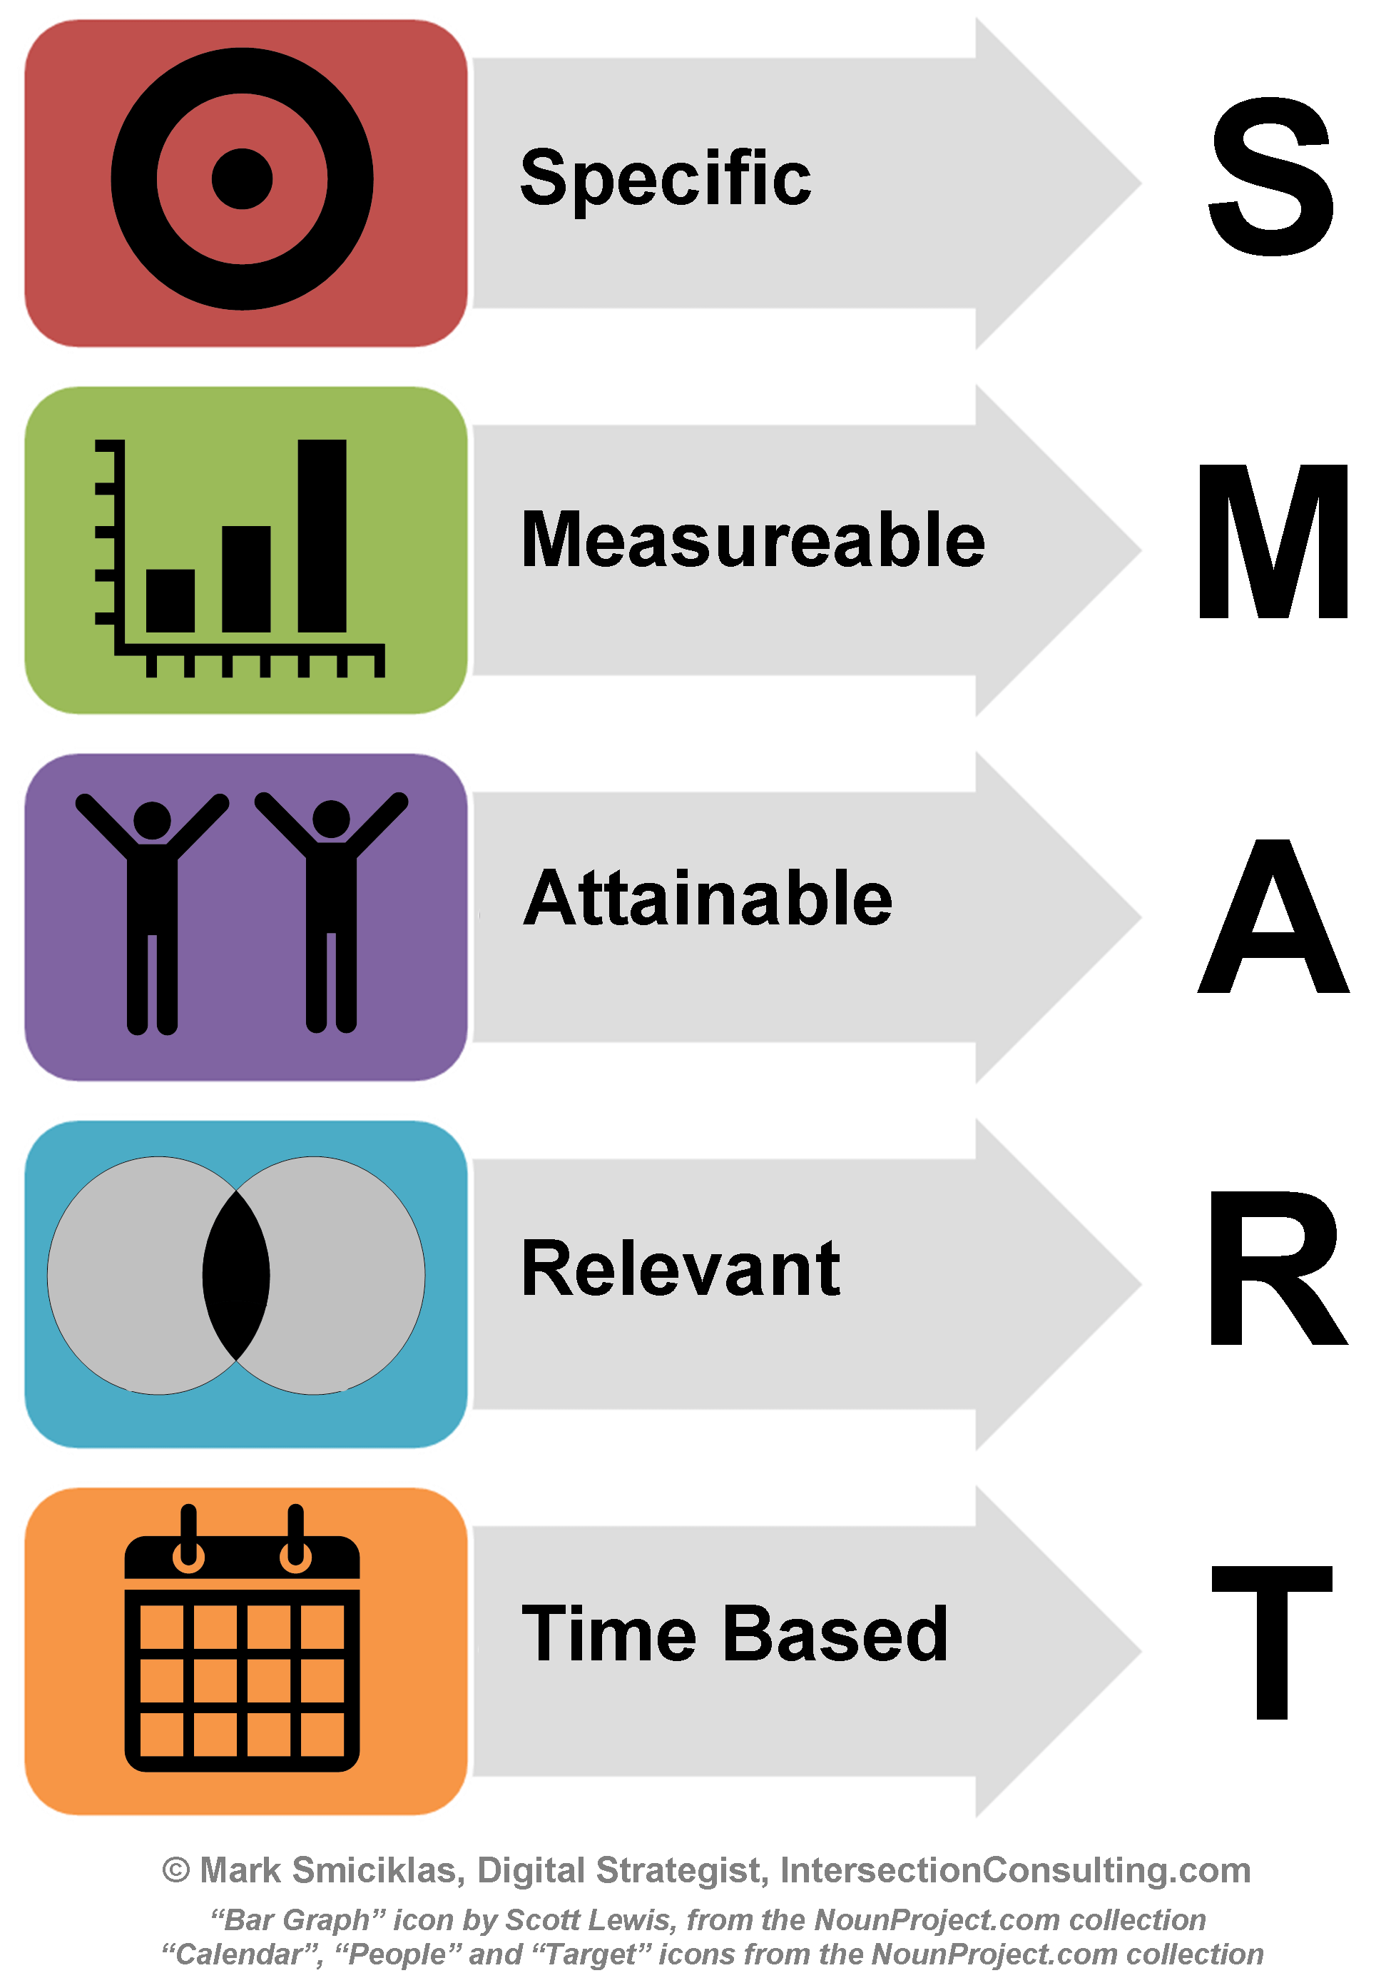
- Psychomotor: Create, edit, save and print documents to include documents with lists and tables.

Learning Objectives
Behavioral Verbs for Effective Learning Objectives in the Cognitive, Affective, and Psychomotor Domains
Objectives are precise, measurable results that the learner is expected to accomplish
Knowledge | Comprehension | Application | Analysis |  | Synthesis |  | Evaluation
define | discuss | compute | distinguish |  | diagnose |  | evaluation
list | describe | illustrate | Analyze |  | propose |  | compare
recall | explain | operate | differentiate |  | design |  | assess
name | identify | perform | Compare |  | manage |  | justify
recognize | translate | interpret | Contrast |  | hypothesize |  | judge
state | restate | apply | categorize |  | summarize |  | appraise
repeat | express | use | appraise |  | plan |  | rate
record | convert | practice | classify |  | formulate |  | choose
label | estimate | predict | outline |  | arrange |  | decide
Organize

Affective verbs

Receiving | Responding | Valuing | Organization | Value Complex
sit erect | answer | join | adhere | act
reply | greet | share | integrate | practice
accept | Read | complete | organize | discriminate
show | Report | follow |  | influence

Psychomotor verbs

Perception | Set |  | Response | Mechanism | Complex | Guided | Origination
 |  |  |  |  |  | Adaptation
identify | react |  | display | display | display | adapt | create
detect | respond |  | manipulate | manipulate | manipulate | revise | compose
differentiate | start |  | work | work | work | change | arrange
 |  |  | perform | write | operate

Words to AVOID

know | really know | approach | think critically | grasp the significance of
learn | understand | appreciate | expand horizons | expand understanding

Examples

After attending this activity, the participant will demonstrate the ability to:

- Recognize four common causes of shoulder pain

- Compare and contrast several management strategies for patients with chronic shoulder pain

- Describe the current clinical practice for the treatment of metastatic brain tumors in adults

- Evaluate the process of translating laboratory research into clinical trials for patients with malignant gliomas

- Outline current advances in molecular biology, immune therapy, stem cell therapeutics, and drug delivery systems for brain tumors

- Identify challenges caregivers face in caring for patients with brain tumors

Recognize quality of life issues for patients with brain tumors and the effectiveness of measurement

Detailed lesson plan
I. Objectives
At the end of the lesson the student should be able to:
- Define what is a computer, its major parts and functions.
- Appreciate the importance of computers in our daily life.
- Experience the hands-on use of computer.

II. Subject matter
Topic: Computer
Sub-topic: Parts and functions of a computer

III. Materials
Laptop, projector, video slides

IV. Daily routine
Greeting
Prayer
Checking the cleanliness
Attendance
Review of the previous lesson

V. Method
- Motivation

- The students should arrange the jumbled pictures and tell something about it.

- Activity

- Group the students into 3 and let them re discuss the lesson through skit or any strategy

- Evaluation

- Quiz

Identify the following
1. It is the brain of the computer
2. Device use to communicate with the CPU by typing its keys
3. Device used for display
4. It produces sound
5. It is a pointing device serve as your hand pointer
6. Shows the answer worked out by CPU on paper
7. It is a fast electronic machines that perform arithmetic and logic operations and can store process data and produce meaningful information

E. Assignment
Research the following
- Limitations of computer
- Advantages and disadvantages
- Capabilities

Lesson Proper
Teacher activity | Student’s activity
    - Good morning class!
- Before you sit down class please pick up the scattered pieces of paper on the floor.
Okay Mr. Ford please lead the prayer. | - Holy mighty one let your love flow out for us Open your mercy so that we may grow in learning to serve our fellow man and to remain grateful to you. Amen.
Okay please be seated
- Ms. Secretary is there anyone absent today? | There is no one absent for today ma’am
I’m glad to hear that thank you Ms. Secretary
So class what is our lesson yesterday? | Ma’am we have discussed about the history of computers, about when it was first invented and who the father of a computer is. (1st student) this a speaker ma’am wherein we can hear the sounds that a computer produces
Okay very good! About the history of the computers. So now we are going to discuss our next topic. But before we start our next lesson you can see that there are jumbled pictures here on the board, you should arrange it and tell me its name and something about it. | (2nd student) this is a mouse it is used to point any commands or tabs on a computer screen
- Okay very good! Thank you class, you’ll be given extra point for your participation. So now class, do you have now an idea what is our topic for today? | - Yes ma’am, all about parts of a computer.  - (some students will raise their hand)
- Very good class! So who among you here has a Computer? | Most of the students raising their hands.
- Okay so almost all of you have, computer is very necessary to us because it perform a lot of things it can be used in working out drawing, playing music, typing reports playing games and many more. Computer is also a fast electronic machine that performs arithmetic and logic operations. But class a computer will no longer useful without Its major parts,
- Okay class have you met before a person who is suffering from a nervous break-down? | Yes Ma’am!
- So what happened to that person? Okay Ms. Ivy can you say something? | Ma’am he can is able to move his body parts he became disable
- Okay thank you Ms. Ivy, she is right class a person who is suffering from that illness will become paralyzed or disable, that is how important the brain is. Just like the first major part of a computer the CPU or (central processing unit) w/o this part a computer is no use at all.
- Do I make myself clear class?  - Students at the back do you think you will be Interested if you cannot here from there? | Yes Ma’am!  No Ma’am
- Okay Ms. Lopez why do you say so? | Because we cannot understand you ma’am and we cannot follow your discussion so instead of forcing ourselves to here you we rather not to listen, and other things.
- Okay very good Ms. Lopez
- So class do you think you will enjoy watching concert or movies w/o sounds? | No ma’am its very dull and boring
- Very good! And our next major part is a speaker you can enjoy computer using some site or netsurfing especially using you tube through the use of a speaker, because it produces sound. And the next major part is a printer, this is where we print out all the information that we stored in a computer, it is called a hard copy.  - Okay class have you tried or experience writing a love letter to someone you admired with?  - So what did you use to write? | Yes ma’am many times.  (student 1)Ball pen ma’am  (student 2)I print it out ma’am because my hand written is not that good
- Okay very good class!
- So the next major part is keyboard, so like what you have said class some of you printed it out because of your unpleasing hand written so that means you used keyboard to typed right class? Without key board we can never write anything on a computer or use it easily. The next part is a mouse it is a pointing device to manipulate a computer easily for commands and tabs.
- So class was there a time that you don’t want to see your crush?  - Okay will you enjoy life without your sight? Why Ms. Aura? | No ma’am, because I always want to see my crush  No ma’am!  Because I cannot see the beauty of this world without having my eye sight
- Very good! Without your sight you can never appreciate anything in this world and the last major part is a monitor through this part we can see all the information we stored, we can watch movies, and we can see and appreciate the outcome of your work.
- So class is it clear class the parts of a computer and its functions? | Yes Ma’am!
- Again what are the major parts of a computer? | CPU, mouse, speaker, keyboard, monitor and printer
- Very good class!
- So now we are having our group activity group yourselves into two (2). Listen to the instruction class, now each group should re discuss the lesson through a skit or any strategy. I will give you 3minutes for it. So let us hear from the first group.
- Okay very good!
- Let us have now the second group
- Very good so both group performed very well
- Now you are having your short quiz, please bring out one fourth intermediate paper numbers your paper from 1-7
- Are you done class?
- Okay pass your paper from your left to right then forward.
- Now bring out your note book and copy the assignment for tomorrow.
- Are you done copying?
- Okay that’s all for today see you tomorrow class goodbye
- We are going to re discuss the lesson through song.

LESSON PLAN

A LESSON PLAN IN COMPUTER EDUCATION
I. OBJECTIVES
At the end of the lesson, the pupils should be able to:
a. name the different parts of the computer;
b. describe the function of each part of the computer; and
c. group the different computer parts according to their uses
II. SUBJECT MATTER
PARTS OF A COMPUTER
Materials:
* Flashcards on which are written the parts of the computer
* CDs * printer
* Diskettes * speakers
* Jigsaw puzzle * Joystick
* Keyboard * monitor
* Mouse
III. LESSON
A. Motivation
1. Divide the class into five groups. Provide each group with a jigsaw puzzle. Instruct the pupils to solve the puzzle within five minutes.
2. Ask: What object was formed when you put the puzzle pieces together?
3. Tell the pupils that each puzzle piece is important. If a piece is missing, the picture cannot be completed.
4. Liken the pieces of the puzzle to the parts of the computer. Explain that the computer has different parts. Each part is needed to make the computer whole.
B. Lesson Proper
1. Show the different parts of the computer. Have the pupils name each part as you show it.
2. Explain the function of each part.
3. Discussion

IV. Evaluation:
A. Directions: Identify the parts of the computer and the computer devices shown. Choose your answers below.
* Mouse * speakers * hard disk * diskette
* Keyboard * central processing unit * compact disc
* Printer * monitor * joystick

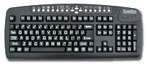
1. _______________________________ |  |  | 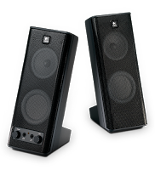
2. ________________________
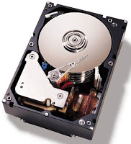

3. ____________________

5. ________________________

4. ____________________

6. ________________________

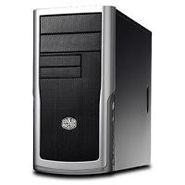
7. ______________________

8. ______________________

Module Three

Selection and Use of Teaching Strategies/Different Approaches and Methods

Micro Teaching
Topic:
Basic Parts of Computer
Computer
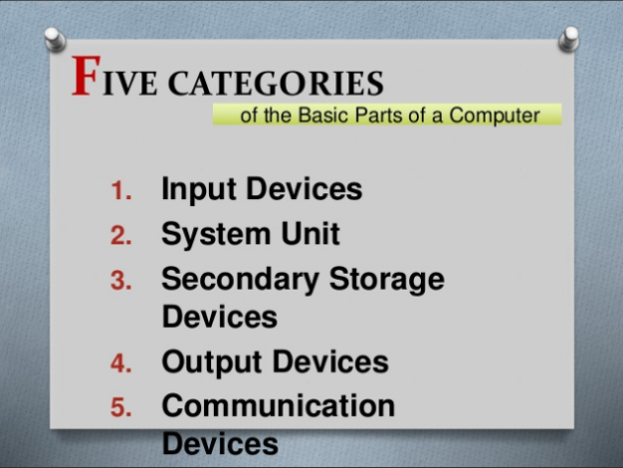
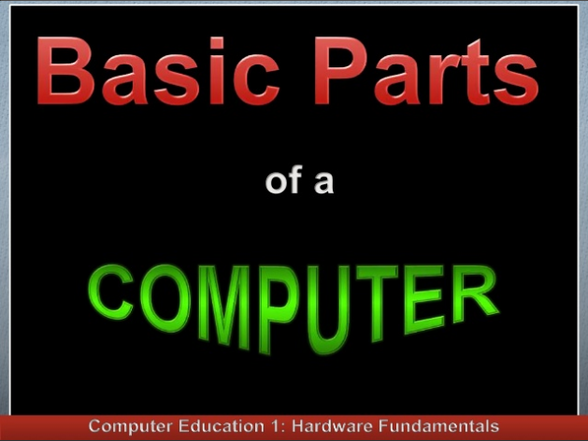
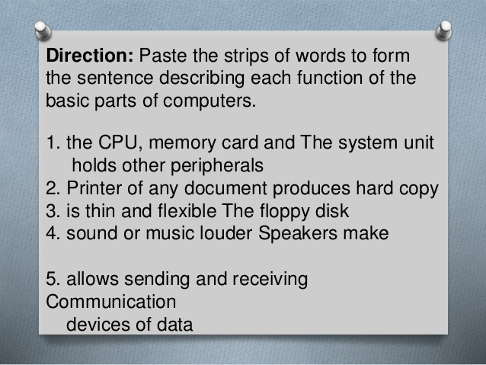
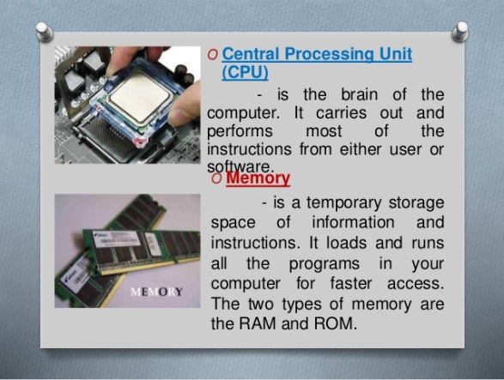
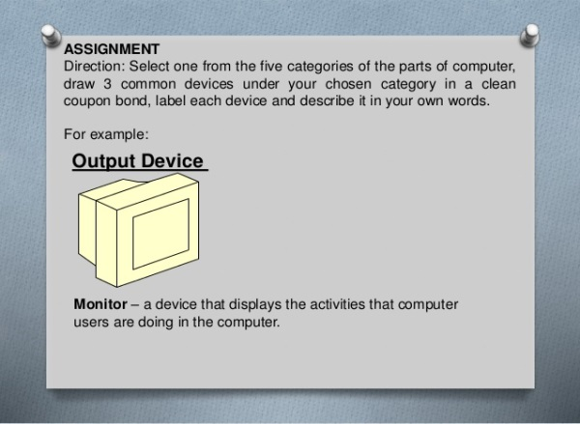
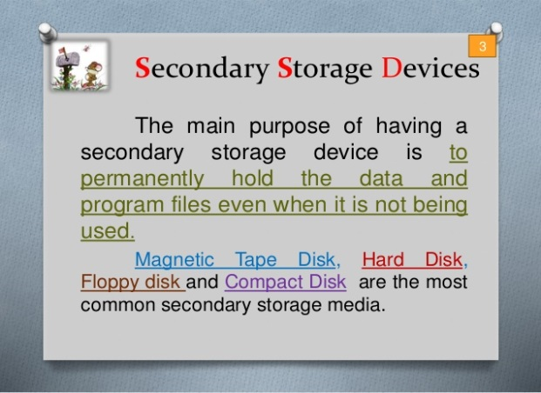
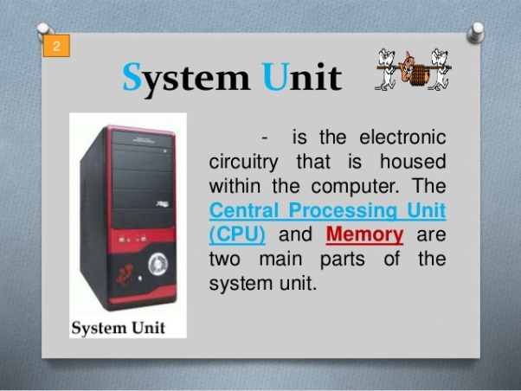
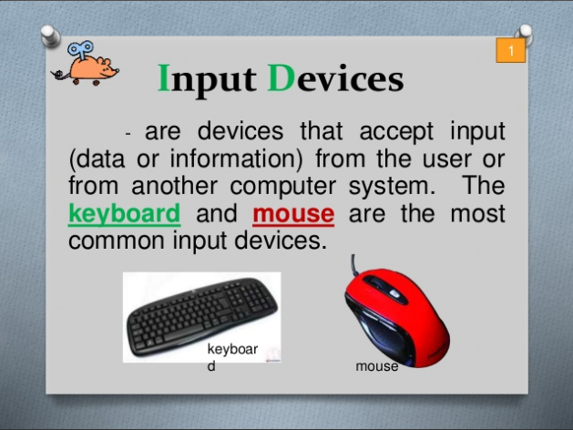
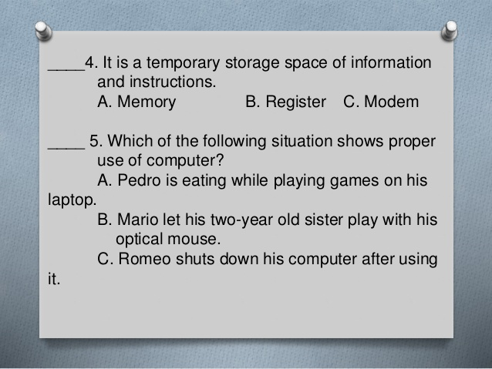
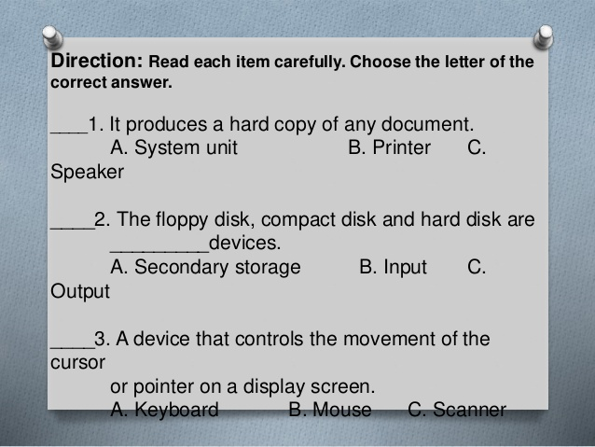
- 1. FIVE CATEGORIES 1. Input Devices 2. System Unit 3. Secondary Storage Devices 4. Output Devices 5. Communication Devices of the Basic Parts of a Computer
- 2. Input Devices - are devices that accept input (data or information) from the user or from another computer system. The keyboard and mouse are the most common input devices. keyboard mouse 1
- 3. System Unit - is the electronic circuitry that is housed within the computer. The Central Processing Unit (CPU) and Memory are two main parts of the system unit. 2
- 4. O Central Processing Unit (CPU) - is the brain of the computer. It carries out and performs most of the instructions from either user or software. O Memory - is a temporary storage space of information and instructions. It loads and runs all the programs in your computer for faster access. The two types of memory are the RAM and ROM.
- 5. Secondary Storage Devices The main purpose of having a secondary storage device is to permanently hold the data and program files even when it is not being used. Magnetic Tape Disk, Hard Disk, Floppy disk and Compact Disk are the most common secondary storage media. 3
- 6. Common Secondary Storage Devices Floppy Disk Compact Disk
- 7. Output Devices - are devices that translate and represent the processed information from the computer’s CPU into human readable forms. The most common output devices are monitor or video display screen, speaker and print device. 4
- 8. Communication Devices - are devices that allow sending and receiving of data and application programs from one computer or secondary storage device. Modem and Network Interface Card are the most commonly used communicating devices. 5
- 9. Direction: Paste the strips of words to form the sentence describing each function of the basic parts of computers. 1. the CPU, memory card and The system unit holds other peripherals 2. Printer of any document produces hard copy 3. is thin and flexible The floppy disk 4. sound or music louder Speakers make 5. allows sending and receiving Communication devices of data
- 10. Direction: Read each item carefully. Choose the letter of the correct answer. ____1. It produces a hard copy of any document. A. System unit B. Printer C. Speaker ____2. The floppy disk, compact disk and hard disk are _________devices. A. Secondary storage B. Input C. Output ____3. A device that controls the movement of the cursor or pointer on a display screen. A. Keyboard B. Mouse C. Scanner
- 11. ____4. It is a temporary storage space of information and instructions. A. Memory B. Register C. Modem ____ 5. Which of the following situation shows proper use of computer? A. Pedro is eating while playing games on his laptop. B. Mario let his two-year old sister play with his optical mouse. C. Romeo shuts down his computer after using it.
- 12. ASSIGNMENT Direction: Select one from the five categories of the parts of computer, draw 3 common devices under your chosen category in a clean coupon bond, label each device and describe it in your own words. For example: Output Device Monitor – a device that displays the activities that computer users are doing in the computer.
- 13. Answer Keys: Application: 1. the system unit holds the CPU, memory card and other peripherals. 2. Printer produces hard copy of any document. 3. The floppy disk is thin and flexible. 4. Speakers make sound or music louder. 5. Communication devices allows sending and receiving of data.
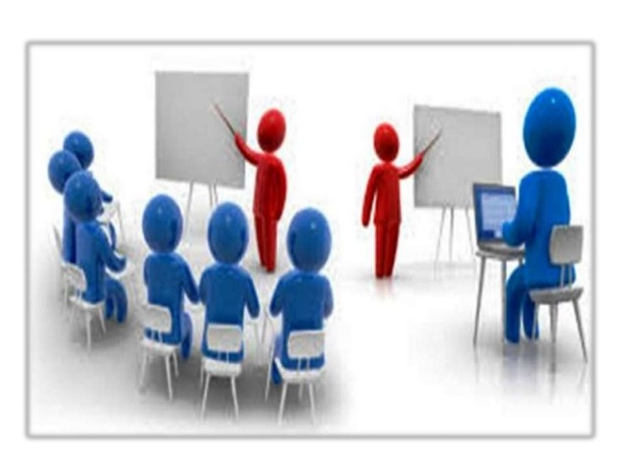
- 14. Evaluation: 1. C 2. A 3. B 4. A 5. C

Module Four

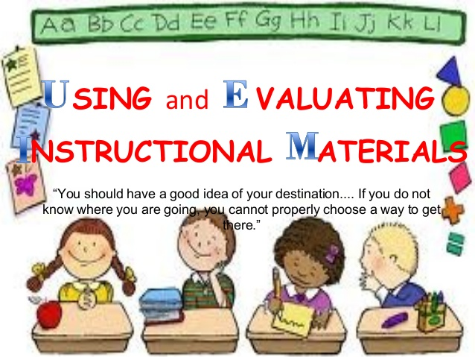

Basic Quality Tools that can be help in classroom presentation

Module Five

Classroom Management
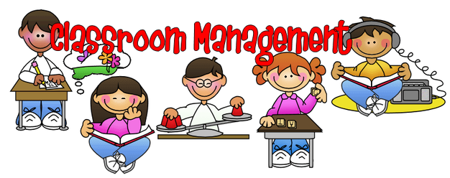

Classroom Management

Classroom management refers to the wide variety of skills and techniques that teachers use to keep students organized, orderly, focused, attentive, on task, and academically productive during a class. When classroom-management strategies are executed effectively, teachers minimize the behaviors that impede learning for both individual students and groups of students, while maximizing the behaviors that facilitate or enhance learning. Generally speaking, effective teachers tend to display strong classroom-management skills, while the hallmark of the inexperienced or less effective teacher is a disorderly classroom filled with students who are not working or paying attention.
As I observed a class in Oloy Roa Elementary School at Calaanan, Cagayan de Oro City in Grade 4 class of Ms. Michelle Love Palonpon he has 43 students. The lesson during that time is Mathematics. At the beginning teacher Michelle states the lesson objectives. She put into practice the following principles, learning is an active process, and learning is meaningful when it is connected to the students, and learning is a collaborative process. She knows how to handle his class when the students are very noisy. The classroom is conducive for learning.
Classroom management is certainly concerned about behavior, but can also be defined more broadly as involving the planning, organization, and control of learners, the learners, the learning process and the classroom environment to create a maintain an effective learning experience in which expected pedagogical outcomes achieved.

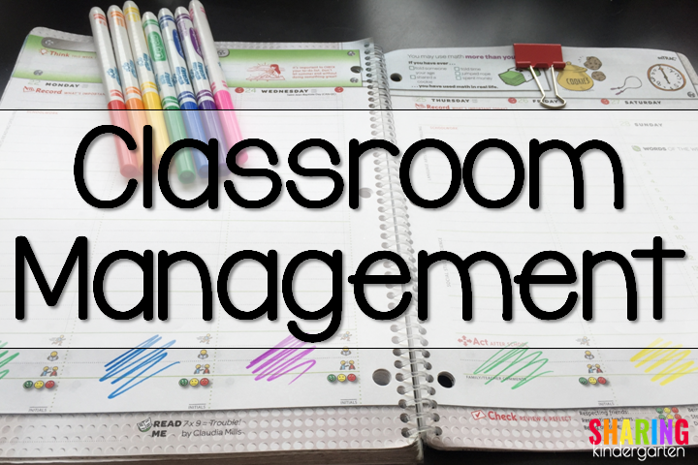

Module Six

Managing the Physical Environment
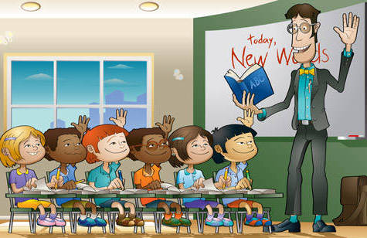

Seating Arrangement
Traditional Classroom

In a traditional class all the desks are facing the chalkboard and teachers desk. This classroom layout is very effective if your lesson often uses projectors, slides and a chalkboard. The layout is suitable for teacher centered classes such as lectures, it encourages focus on the educator and content and is easy to implement with large classes.
The problem with this layout is that the teacher is very far away from students sitting in the back rows. Students sitting in the last rows are more likely to be distracted, lose focus and converse with others. Students can easily become disengaged during the lesson. This layout is not useful for classes designed for conversation and interaction and not easy for the instructor to observe students in the mid and back rows.
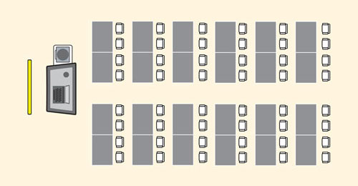

U-Shaped Layout

For smaller classes that want more interaction between the student and educator, a U-Shaped layout is a better option. A U-Shaped desk arrangement encourages discussion and makes it easy for the teacher to observe students and provide one on one help. Classroom size and number of students can make it difficult to use, for you may not be able to fit a U-Shape pattern in a small room with a large number of students. The layout spreads children out considerably so that it can be hard to address them all and makes group work harder because the desks can’t easily be moved around. Easy to see and hear everyone in the group. Front of room commands the group’s attention. Unity is created by ganging all the tables together. Openness gives trainees a sense of freedom and encourages participation. Best set up to view audio visual presentations. Works well with role-playing and other physical activities.

Circle or Half Circle Arrangements

Desks or chairs arranged in a circle or half circle promote community and encourage all students to participate. Everyone sits in the front row. It also allows the instructor to see everyone from an equal distance and communicate easier with students. Involves everyone in the group. There is no table in the middle, therefore people are unobstructed and can speak directly to each other. Creates equality among the group, with no designated “leader” position.
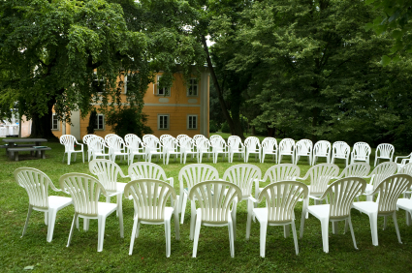

Pods (Groups, Pairs)
The pod or pair arrangement can be designed with rectangular, circular or trapezoidal tables, or individual desks. With regards to stations, instructors can place several tables together to form student groups (e.g. 3 - 4 students), or pairs. This arrangement can be especially advantageous when students will work in groups or pairs with their classmates for a large portion of class time. More generally, this arrangement communicates a learning community where students are expected to work with one another.
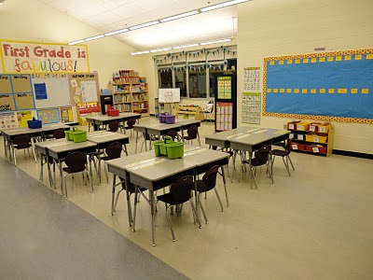

Bulletin Board Structuring
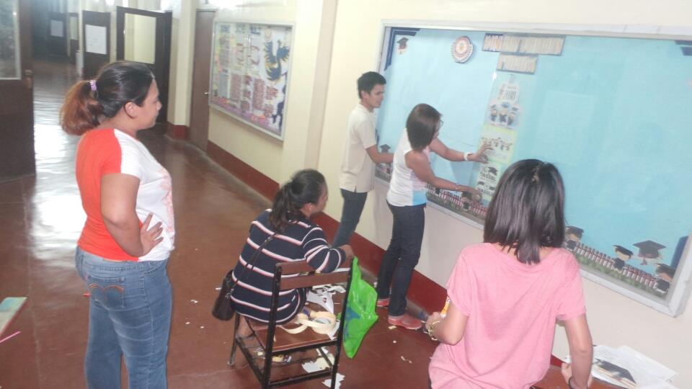

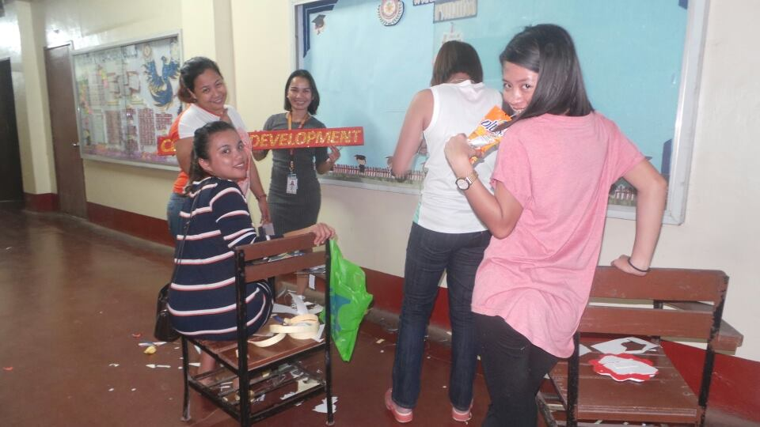

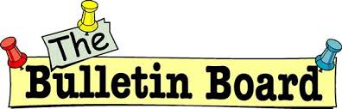
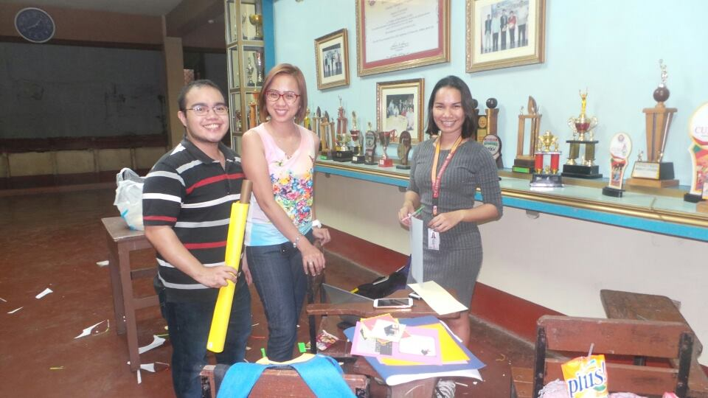

Module Seven

Motivation

Motivational Strategies

Intrinsic motivation is defined as performing an action or behavior because you enjoy the activity itself. Whereas acting on extrinsic motivation is done for the sake of some external outcome, the inspiration for acting on intrinsic motivation can be found in the action itself.

Advantages of intrinsic motivation: Intrinsic motivation can be long-lasting and self-sustaining which typically promote learning and focuses on the subject rather than rewards or punishments.

Disadvantages of intrinsic motivation: Intrinsic motivation efforts can be slow to affect behavior and may require special attention or preparation.

Extrinsic motivation refers to behavior that is driven by external rewards such as money, fame, grades, and praise. This type of motivation arises from outside the individual, as opposed to intrinsic motivation, which originates inside of the individual

Advantages of extrinsic motivation: Extrinsic motivation more readily produces behavior changes and typically involve relatively little effort or preparation.
Disadvantages of extrinsic motivation: Extrinsic motivation can often distract students from learning the subject at hand and may be challenging to devise rewards and punishments. Over time, the rewards and punishments have to be escalated to achieve the same outcome.

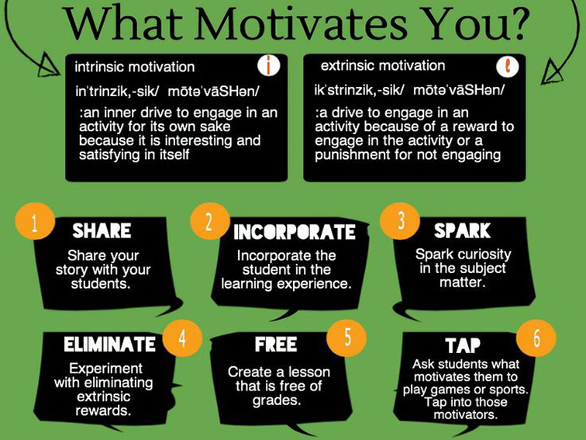
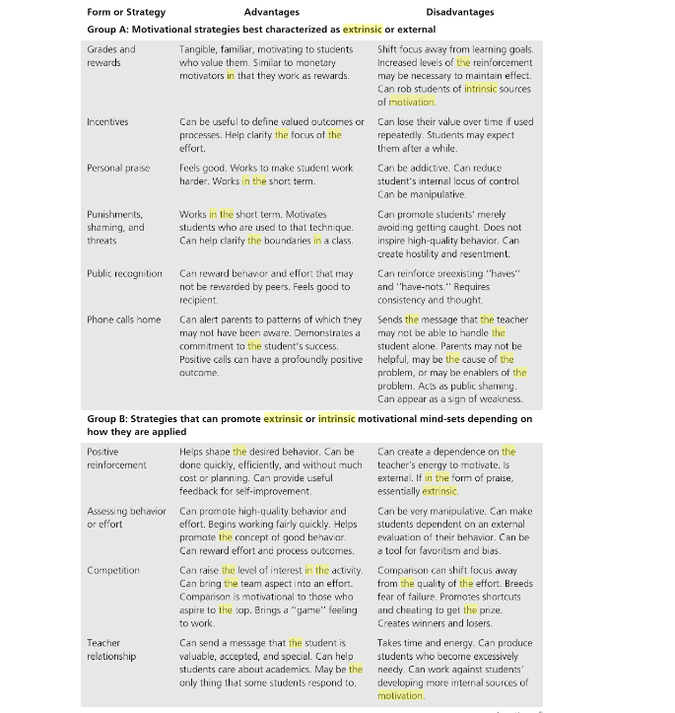

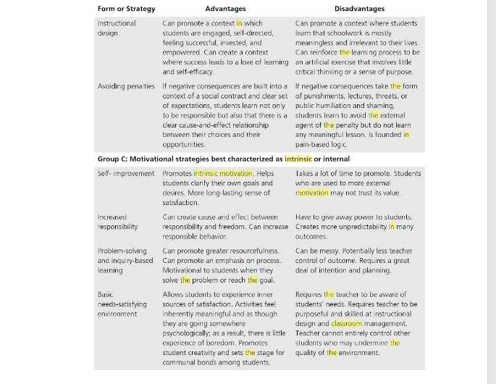

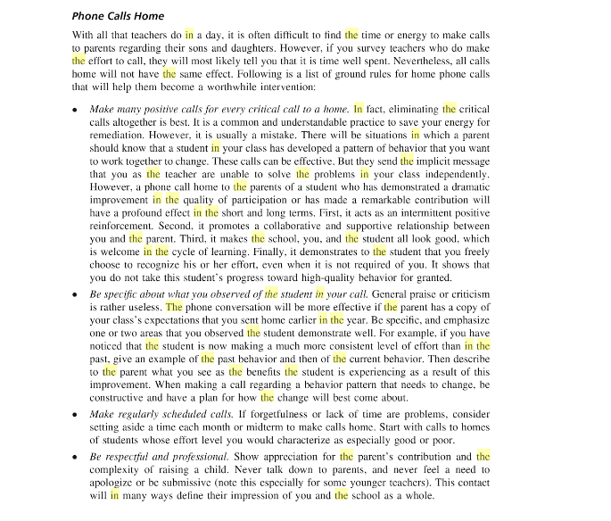

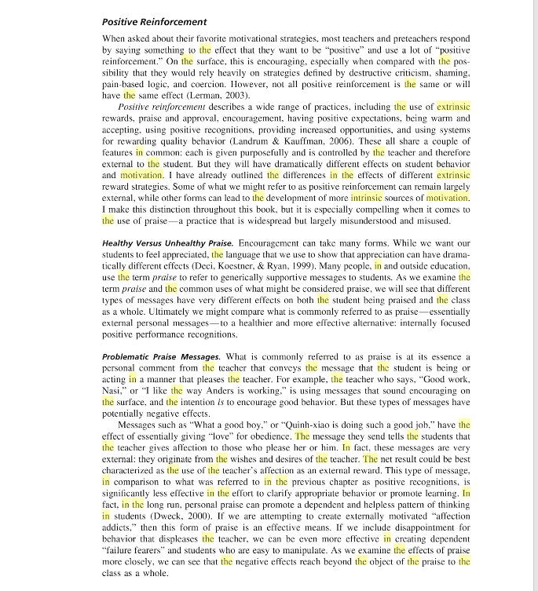

Module Eight

Effective Questioning and Reacting Techniques

Frame Questions According To Purpose

- For Assessing Cognition
What is likely happen if we continue to cut trees in the mountain?
- For Verification
Why lightning seen before thunder is heard?
- For Creative Thinking
Design your ideal robot to keep at home: what would you they look like and what function would they have to help you and your family?
- For Evaluating
Was the lesson fluently and effectively delivered by the teacher?
- For Product Thinking
How can we apply the law of Conservation of Energy?
- For Motivating
Do you want to know how to keep your grades high?
- For Instructing
What are the steps in solving a problem?

Convergent and Divergent Questions
Convergent questions are those that typically have one correct answer, while divergent questions, also called open-ended questions, are used to encourage many answers and generate greater participation of students. Besides engaging students’ memory through recall, convergent questions can be used to guide students’ observations, perhaps during a demonstration.
Divergent questions, on the other hand, stimulate student creative or critical thinking, encouraging students to be better observers. These open-ended questions can guide students as they discover information for themselves, analyze data, make inferences, and identify relationships.
Examples of convergent questions:
- When will the two years be added?
- What is K-12?
- How K-12 works?
- Will the kindergarten overlap the daycare of LGU?
- Who will benefit to the K-12?

Examples of divergent questions:
- What will happen to the subjects?
- What will happen to the curriculum?
- What would be the assurance to the K-12 graduates to be employed?
- Will the K-12 address the dropout problems?
- Why are we implementing 12 years of basic education?

